User Manual

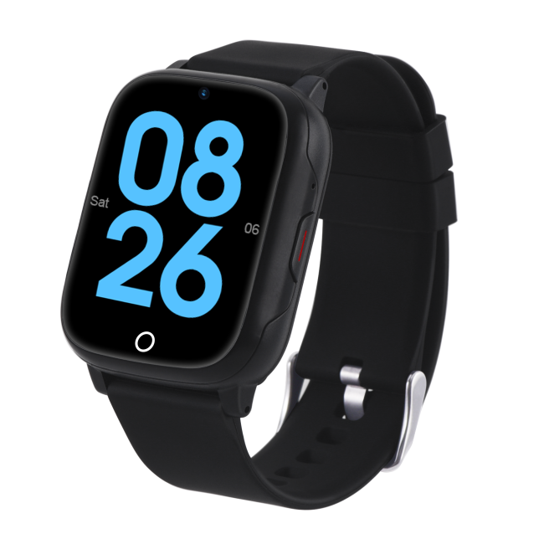



Use only a high-quality 5V max output charging head for the watch. Avoid fast chargers and low-quality chargers.

Before use:
Do Not turn the watch on until the SIM card has been installed correctly.
1.SIM Card:Install the SIM card before turning on the watch.
2.Charge Fully:Ensure a full charge before first use.
3.Find Reg Code:Locate the Reg code on the GPS watch's touch screen menu.
4.SIM Requirement:Requires an active mobile SIM with text, call, and data.

1) SIM card installation method:

Please must install the SIM Card according to the following picture:

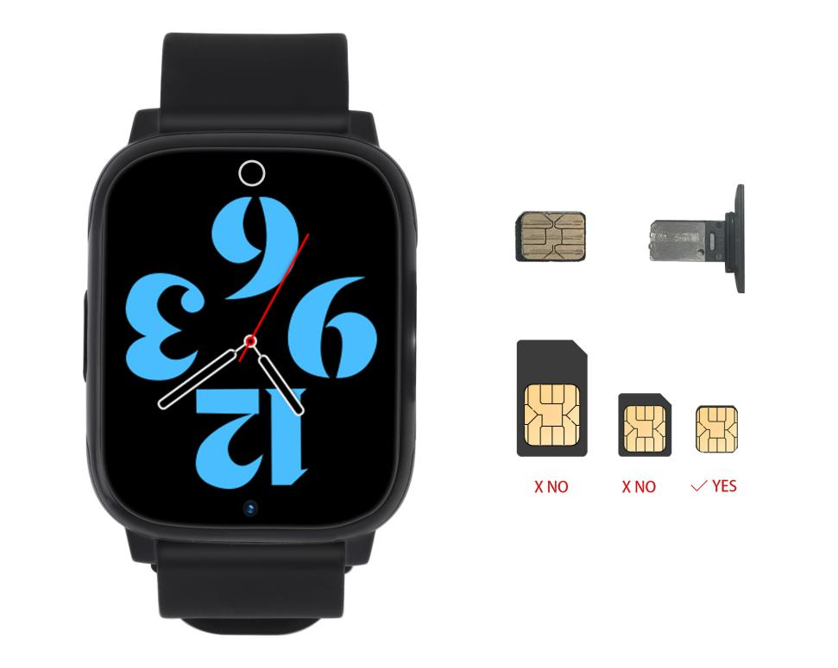

Installing the SIM Card:

1.1. Place the Nano SIM card on the SIM Card Tray with the metal side facing up. Align the card's notch with the tray's notch. You can use double-sided tape to secure it in place.
1.2. Once the SIM card is in place, insert the tray into the watch.
1.3. After installing the SIM card, power on the watch. Check for the SIM card signal grid in the watch's status bar.
1.4. Swipe down on the watch's main screen. If you see the SIM card signal grid, the SIM card is successfully installed. If there are up and down arrows on the signal grid, your SIM card has an internet connection. If not, follow the APN setup instructions in this user manual.

Important Notes:
- Ensure the screws are securely fastened to prevent water damage.
- Do not remove the SIM card while the watch is powered on to avoid damaging the card or the card slot.

- Simple usage

2.1. Download and install the App “AIBEILE Plus”
(Option1) - Scan the following QR code, download and install the App
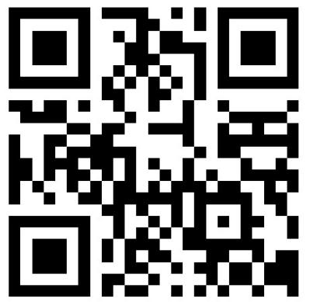

(Option 2) - Search “AIBEILE Plus” in the App Store - Apple or Google Play

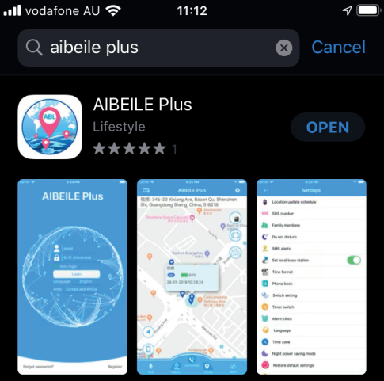

(Option 3) - Scan the QR code in the GPS watch in ‘More’ - QR code - App download

Note: During installation, the phone prompts whether to trust the APP or whether to allow access to phone location, etc. Please select trusted and allowed all the time.

- Registering the Watch and log in:

Open the App, new users will need to register a new account by clicking on the right bottom “Register” button, complete the registration steps.

Please use a short email address (max 30 chars) .
Note: Register a new account, must choose correct [Area] you are located in.

For example: In Europe countries, then choose [Europe and Africa]. If you’re in Australia, you need to choose “Area” as “Asia and Oceania”. You also need to input a correct email address to ensure you can reset your password if required.

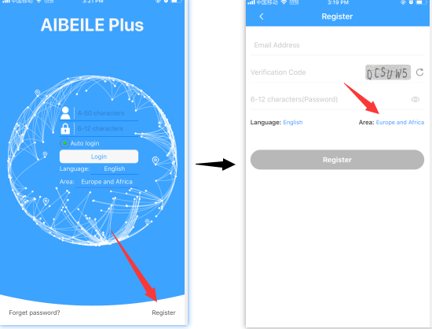

Must bind your device first: Input the [Reg Code]

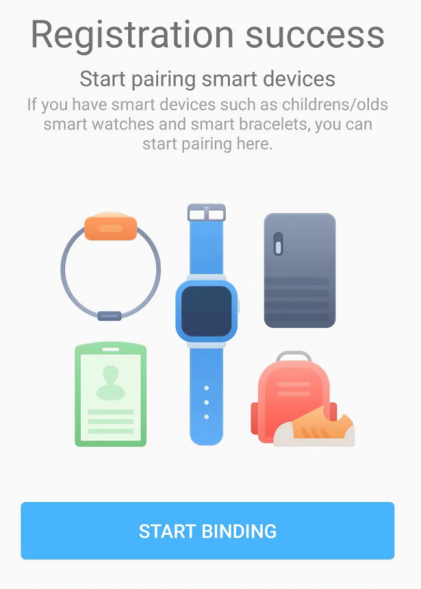

How to Connect Your Device (Bind your device):

3.1. Create an Account: Start by creating a new account and logging in.
3.2. Connecting Your Device: Once you're logged in, you'll be prompted to connect your device. It's essential to do this to access the main app interface.

Note:
3.3. Locating the Registration QR Code (Reg Code): You can find the Registration QR code (Reg Code) on the GPS watch's QR code menu, which you can access via the touch screen. Please remember that this code is different from the IMEI number. You'll only see the Reg Code after inserting a SIM card and ensuring the GPS watch is correctly connected to the internet with the right APN settings. If the device isn't connected to the internet correctly, you won't see the Reg Code, or you may encounter a Reg Code error. In such cases, please consult the APN setting instructions in this manual and set it up using SMS.

3.4. Registration on an Apple Mobile Phone: If you are registering on an Apple mobile phone, there won't be a dedicated registration interface. Instead, you'll receive a "registration successful" message.

Successful Pairing:
Once your device is successfully paired, you can start using its functions. If you want to add more devices to the app, please refer to section 4. If not, you can skip this step.
4) Pair more devices:
After login to the account, select ‘More’ Device list Add device, input or scan the QR code [Reg Code] to pair the device.

5) How to Use the Watch:
5.1. Power On: To turn on the watch, press and hold the power button for 3 seconds.
5.2. Power Off: You can turn off the watch:
- Option 1: On the watch, go to 'More' > 'Setting' > 'Power off' > 'OK'.
- Option 2: When the watch is online, via the app, go to 'More' > 'Remote Shutdown' > 'OK'.
5.3. Battery Charging: To charge the watch's battery:
- Use the included magnetic charging lead; it attaches to the back of the device in only one direction.
- Connect the cable's other end to the supplied USB charger (5V2A) or another 5V source. Avoid fast chargers to prevent issues.
- Be careful to prevent a short circuit with the magnetic charging lead.
5.4. Choosing the Right USB Charger: We recommend a 5V USB charger from trusted brands to avoid potential harm to the GPS watch.
5.5. Avoid High Voltage USB Chargers: Do not use USB chargers with 9V or 12V outputs; the USB charger should have a maximum output of 5V.

6) Watch Parameters:

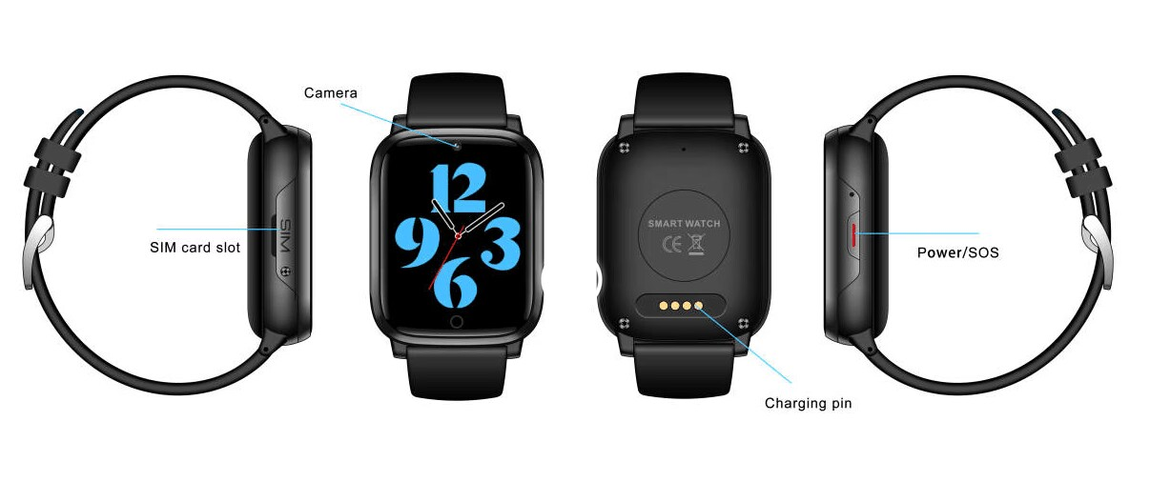

7) Product Features:
                - Real-time GPS, WIFI & LBS location
- Historical track, Geo fence
- Calling (Contacts, SOS call button, two-way communication)
- Voice Chat message
- Camera function
- Health pedometer
- Alarm clock
- Reject calls from strangers
- Prohibit dial keypad
- Disabled in class
11.Other settings and functions

8) Function Description:
8.1. Real-time GPS, WIFI & LBS location
Click “Locate” on the main interface menu bar,You can manually obtain the current device location.
Location Update Schedule Modes:
There are three location update modes. User can switch the working mode via mobile phone APP, Click ‘More’ Settings ‘Location
update Schedule’.
- Normal mode:
Updates location data to APP every 10 minutes when there is continuous movement. It is the default mode.

- Power saving mode: Updates location data to APP every hour when there is a continuous movement. It is more power saving comparing with the normal mode.

(3)Sleep Mode: Geo-fence (safe zone) and location updates are both invalid. this mode is the best way to save battery.

Note: ① Real-Time Location Check: You can check the device's current location in real-time using the app in any of the three modes mentioned above. Open the app, go to the map interface, and click the "locate" button. The GPS tracker will quickly update the position.
② Color-Coded Location Types: On the map, different location types are represented by colors: orange for Wi-Fi positioning, blue for GPS positioning, and purple for LBS positioning.
③ Movement Tracking: In 10-minute or 1-hour movement tracking mode, the GPS tracker will update the location on the app's map page and history if it's continuously moving..
④ Location Tracking Technologies: The device supports GPS tracking (outdoor), Wi-Fi tracking (outdoor and indoor), and LBS tracking (outdoor and indoor). GPS uses satellites for outdoor tracking, while Wi-Fi and LBS use network signals. GPS works best outdoors; if there's no GPS signal, it will switch to Wi-Fi or LBS tracking. Wi-Fi tracking is more accurate indoors compared to LBS tracking.

8.2. Historical Location Playback and Geo-fence (safe zone)
In the main page of the APP, click “History” button at the bottom, you can
check the location history playback within the last three months.

This feature defines a Geo-fence (safe zone) perimeter and sends the
user a push notification if the tracker has left or entered the safe zone.
The user can still manually locate the tracker when the safe zone is turned
on/off.

Click ‘More’ ‘Geo-fence’ click the "+" icon in the bottom input
the zone nameClick and drag the map to set the center point Click on the "+" "-" icon or slide Horizontal line to Change the range of the circle radius of the Geo-fence Click the “save” button at the bottom.

Note:
- App will show leave geofence alarm information (History alarm
information can be viewed in APP Information Centre, which is in the upper left corner of the map interface).
- The APP may not notify user immediately of a geofence breach - it will
only check as often as the time interval is set, the GPS positioning time interval is shorter, the alarm information will be sent faster.
- User can set up to three Geo-fences.

8.3. Calling:
(1) Contact:
① Add a contact : Click APP More Settings Phone Book - Add New Number input name, number (can be set up to 15numbers), and finally click save.
② Edit Contact: Click APP More Settings Phone Book Find the number you want to edit Click the three-dot icon  Edit contact save.
③ Delete Contact: Click APP More Settings Phone Book Find the number you want to edit Click the three-dot icon Delete (delete information will be synchronized in both of watches and app).
(2) SOS Numbers
Click APP More Settings SOS/family number - input SOS phone numbers, click save.
(3) Call
① Use phone book to call: Click the “Contact” icon in the GPS watch
to view the contact list, slide up and down to select a contact to Call.
② One-Button SOS: in case of emergency, press the power button for
3 seconds to trigger the emergency call SOS. At this time, the GPS
watch will call the 3 preset emergency numbers circularly.
③ Call dialing: Click the “Phone”icon in the GPS watch, input phone numbers manually, the telephone dial-out. APP More Settings Switch setting -disable Dialing function save,It can lock the dialing function,Means that the watch can only call the phone number in the phone book.
Note: Do not input special characters in phone book, such as "-", "()" etc.

8.4. Voice Chat message:
① From APP send to GPS watch: Click the“Chat” icon in the lower-left corner of the main page, voice or short text messages can be sent to the Watch.

② From Watch send to APP: Click “Chat” in the Watch, holding to talk button to speak - release your finger to complete the recording.
Note: Watch can receive a short text message sent by APP, but cannot send a text message from the Watch (only voice).

8.5. Camera function:
(1) Taking pictures remotely: APP More  Remote camera  click Photograph to start.
(2) GPS Watch to take pictures: Click "Camera" in the GPS watch to enter the camera interface, click on the icon in the middle of the camera to take pictures. APP More Album, you can view, delete pictures, Upload to app.

8.6. Health Pedometer (Health Steps)
Pedometer feature set: APP More Health Click one of the menus to edit Set pedometer period of time (up to three),step, Weight, and turn on the switch. Exercise/Sports is the same setting.

8.7Alarm clock
APP More Settings Alarm Clock, The alarm frequency can be set once, every day, day of the week.

8.8Reject calls from strangers
APP More Settings Block unknown phone calls Turn on blocked unknown phone calls, then only the phone book/SOS numbers can call into the watch.
(Restrict incoming calls)

8.9 Prohibit dial keypad
APP:More Settings Switch setting Dialing function,then the watch can only make outgoing calls through the phone book/sos number.
(Restrict outgoing calls)

8.10Disabled in class
You can set 4 groups of Do Not Disturb time periods. During the set time period, it is not allowed to call in。APP click More Settings Disabled in class.

8.11.Other settings and functions
This watch also has many other functions, such as Stopwatch、Calculator、Screen lock、time switch、Time zone setting etc, users can operate and use through the device or mobile phone APP.

9 ) How to Set Geofence/safety zone
To create a geofence or safety zone use the app ‘Geofence’ setting: Electronic fence. Tap on the “+” in the upper right corner, then move the map to set the circular area (you can set the radius of the circular area by the slide bar), name your geofence(e.g. home, school) and tap save. The Geofence is suggested to be set as bigger as possible in order to get less false alerts.

Emergency SOS
In case of emergency, press the SOS Button (power button) for 3 seconds to trigger the emergency call SOS. The GPS watch will call the three preset emergency numbers in a loop, twice. If the two times are not answered, the loop will be terminated, and the call will not be continued. Open APP More Settings SOS number, Enter SOS phone numbers, tap Ok. Do not input special characters in the SOS number or Phone book, such as "-", "()" etc.

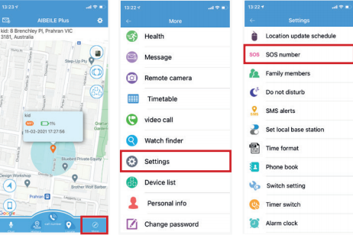

Call & Message
The Watch can receive a short text message sent by APP, but cannot send a text message from Watch (only audio messages).
9.1. Send message App to Watch: Tap on the "Chat/voice" icon (bottom left on the main screen). Voice and short text messages can be sent.
9.2. Send message from Watch to App: Tap Chat icon on the Watch -holding down the talk button to speak - release your finger to complete the recording.
9.3. Call dialing: Tap on the Phone icon in the GPS watch, enter phone numbers manually, the telephone dial-out.

Location Update
Your GPS Watch will update its location based on the set location update schedule. This interval will directly impact the battery life of your Watch. APP More Settings Location update schedule.
Normal mode: Updates location data to APP every 10 minutes when there is continuous movement.
Power saving mode: Updates location data to APP every hour when there is continuous movement.
Sleep Mode: Location will not automatically update. The user will need to request a location with the "Locate" button manually. In this mode, Geo-fence (safe zone) will not work. This mode is the best way to save battery.
To locate Watch, tap on the 'locate' button, and the GPS tracker will update its position as soon as possible.

10) APN settings
Setting up the APN (Access Point Name):

10.1. What is the APN?
The APN is essential for the Watch to connect to your SIM's mobile data network. It allows the Watch to connect to your App. Without the APN, the Watch can make calls, receive calls, send and receive SMS, but you won't find the Reg code in the GPS watch menu, and the device cannot be online.

10.2. How to Get APN Information?
Option 1: Check your APN information on your carrier's official website.
Option 2: Insert the GPS watch SIM card into an Android mobile phone (not an iOS phone), and find the APN in the network profile settings of the Android phone. You can search online for instructions on how to check APN settings on an Android phone.

Gather the Following Information:
1. APN name
2. Username (usually not required)
3. Password (usually not required)
4. MCC (Mobile Country Code)
5. MNC (Mobile Network Code - Operator Code)
- For example, Germany's MCC is 262.
- The combination of MCC and MNC codes should be entered as PLMN without spaces. For operators that don't require a username and password, leave those fields blank.

10.3. Manually Configuring the APN:
With the APN data you gathered, you can manually configure the APN by sending an SMS to the SIM number in the device. Use the following SMS format (replace values with your operator-specific information):
pw,123456,apn,APN name,username,password,PLMN#

Example 1:
- APN name: telstra.internet
- Username:
- Password:
- MCC: 505
- MNC: 01
SMS command:
pw,123456,apn,telstra.internet,,,50501#

Example 2:
- APN name: tmobil.cl
- Username: wap
- Password: wap
- MCC: 730
- MNC: 2
SMS command:
pw,123456,apn,tmobil.cl,wap,wap,73002#

Important Notes:
- Use lowercase letters for SMS commands.
- Even if username and password are empty, include commas.
- MNC should be at least 2 digits (e.g., 02 instead of 2).
- After sending the SMS command, you'll receive a reply. It's essential to restart the device afterward.

11) Adding a Secondary Administrator Account:

The first account that registers the GPS Watch becomes the primary administrator. If you want other users to monitor and interact with the watch, you can share it with a secondary account. When the secondary account attempts to add the same GPS watch, the primary administrator will receive an authorization notification. The primary administrator must approve access for any new account.

Note:
- A single APP account can connect to multiple GPS trackers.
- A single GPS tracker can also be linked to multiple secondary accounts with authorization from the primary administrator.

The screen below shows the notification that the primary administrator will receive after the secondary administrator scans the same watch QR code into their App.

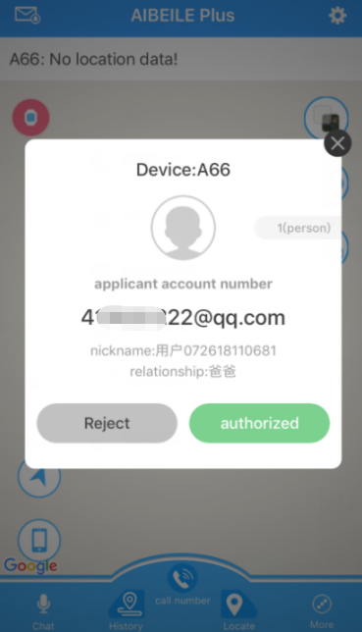
Authorization interface

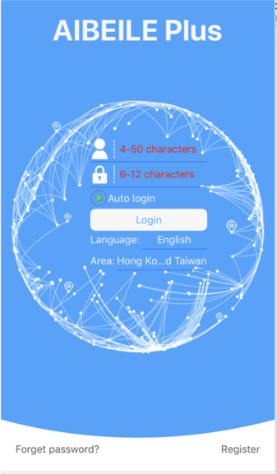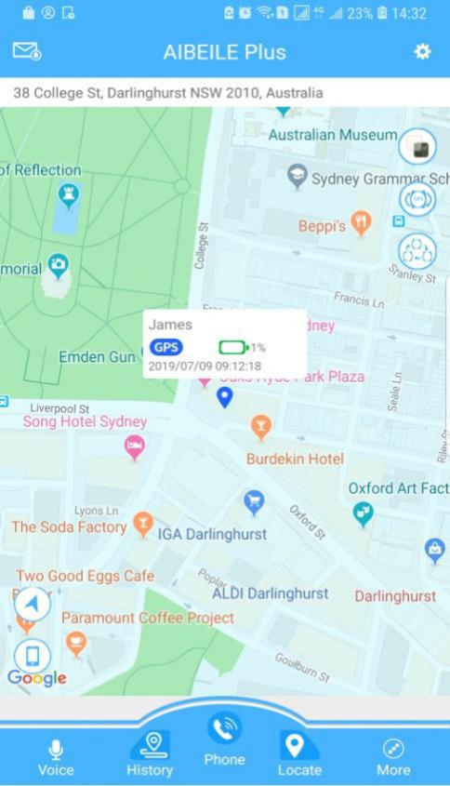
Login screen Main page with map, click “More”

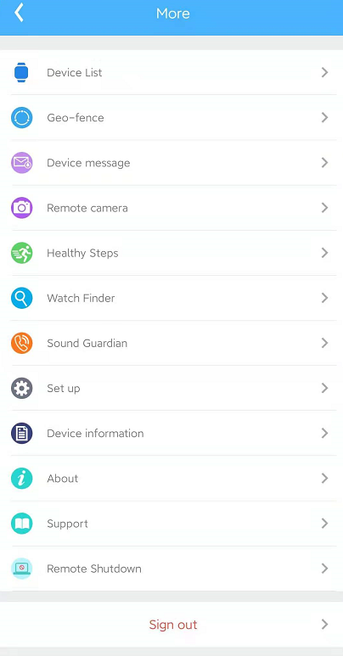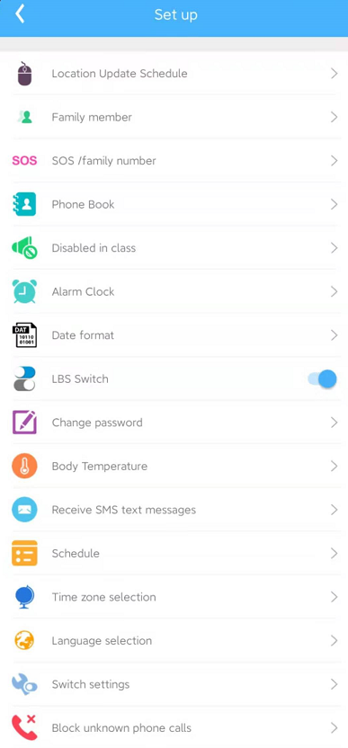
More page Set up page

12) Delete a GPS watch from the APP account
‘More’ Device list Edit in the upper right corner - find the device you want to unbindDelete OK.
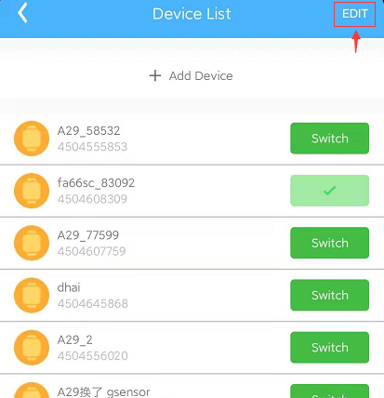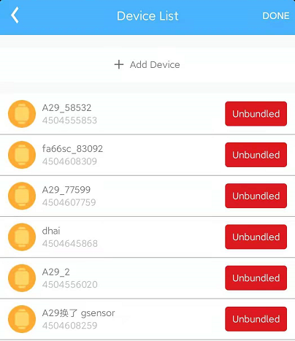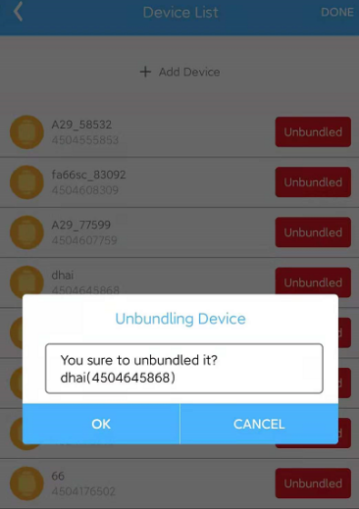

Important Information:
Warranty:
- Do not tamper with the product casing to maintain warranty.
Usage Disclaimer:
- Manufacturer not liable for illegal product use.
Precautions:
- Use of GPS tracker implies acceptance of precautions. If not understood or accepted, discontinue use.

13) Troubleshoot & tips

My device is showing “offline” on app
There may be a number of reasons your Watch is not appearing online on your App; we suggest you check the below points:
1. Check if the Watch is on and charged.
2. Is the SIM card installed correctly and detected?
3. Is SIM active with data and credit?
4. Ensure that the APN is set correctly.

Watch doesn’t power on and/or charge
1. Disconnect the USB cable.
2. Short-click the reset button once.
3. Reconnect and charge for 30 minutes.
4. Restart by holding the power button for 20 seconds if needed.
5. If the problem persists, follow these steps:
5.1. Clean the Charging Contacts: Use an eraser or soft fabric to clean the metal contact points on the back of the watch. These points may oxidize over time, causing charging issues.
5.2. Recharge via Computer: After cleaning, reconnect the watch to a computer using the USB cable and charge it for 30 minutes.
Note: Short-pressing the reset button will not alter any settings or impact the device's pairing with the app.

No SIM card detected (!) on Watch
Reboot your Watch and take it outside for a quick walk or call.
1. Turn the device off
2. Reinstall active SIM (ensure SIM is correctly inserted and not loose)
3. Turn on the device
4. REBOOT watch
5. A sticky double-sided tape can help fix the sim card on the sim card tray correctly.
Reboot Instructions: Press side button on watch > more > settings > reboot

Watch Positioning Methods
The device supports GPS tracking (Outdoor), Wi-Fi tracking (Outdoor and Indoor), LBS tracking (Outdoor and Indoor). GPS uses satellites that orbit around the Earth to
triangulate the user’s location, whereas Wi-Fi locating technology uses relative network signal strength gathered at network access points. GPS tracking is
available indoors but not recommended, as the location is prone to bouncing. When the GPS watch doesn’t find a GPS signal, it will use Wi-Fi or LBS tracking.
Wi-Fi tracking is better for indoor comparing with LBS tracking. Positioning accuracy
GPS/AGPS: 5-15m WIFI:15-100mLBS:100-1000m

Reasons for inaccuracy:
1. If GPS tracker is indoors, it will now have a clear line of sight with at least three GPS satellites.
2. The environment around GPS tracker plays a big part in its accuracy. Any environmental obstructions such as mountains, tin roofs, buildings, or even heavy
tree cover can skew the satellite’s connection.
3. Ensure you have set your GPS positioning interval to 1 minute, 10 minutes OR 1 hour.
NOTE: In order to save battery power, if the tracker is not moving, it will not upload data positioning to the APP. You can use the ‘Locate’ button in the App to request a live location position to be sent to the App.
Watch shows a different time with app
You can use the app to adjust the time zone in the app settings.
More, Settings,Time zone -chose the timezone- then tap OK

Factory reset
Please use the dial pad to enter the following command, which includes the stars, in the dial panel
*#174714#*

14) Safety Guidelines:
1. Avoid Liquids and Chemicals: Keep away from liquids, including saltwater and detergents.
2.Shower Precaution: Don't wear in the shower to prevent damage from shower products or hot water.
3. Extreme Conditions: Avoid fire, heat, and high temperatures.
4. Keep Away from Children: Keep out of children's reach.
5. Use 5V Chargers Only: Use 5V chargers or USB ports only to avoid damage.
6. Charging Safety: Avoid attaching the charger to metal objects; it may cause short circuits.
7. Overheating Warning: Disconnect if the battery overheats during charging.
8. Initial Battery Charge: Fully charge the battery before first use.
9. Watch Overheating: Remove if it gets hot while wearing; turn off in settings or the App.
10. Avoid Damaged Chargers: Never use damaged chargers or swollen batteries to prevent explosions.
11. Location Function: When powered off and outside the service area, location function is disabled.

