Sidra

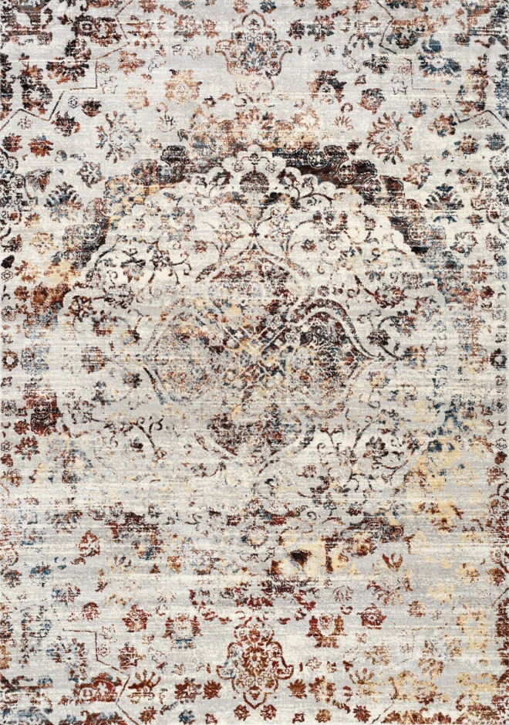

B858/2747 Polyester

2'0" x 7'7" $PRICE

2'8" x 4'11" $PRICE

5'1" x 7'7" $PRICE

7'7" x 10'6" $PRICE

Sidra



B858/2747 Polyester

2'0" x 7'7" $PRICE

2'8" x 4'11" $PRICE

5'1" x 7'7" $PRICE

7'7" x 10'6" $PRICE