Naturals

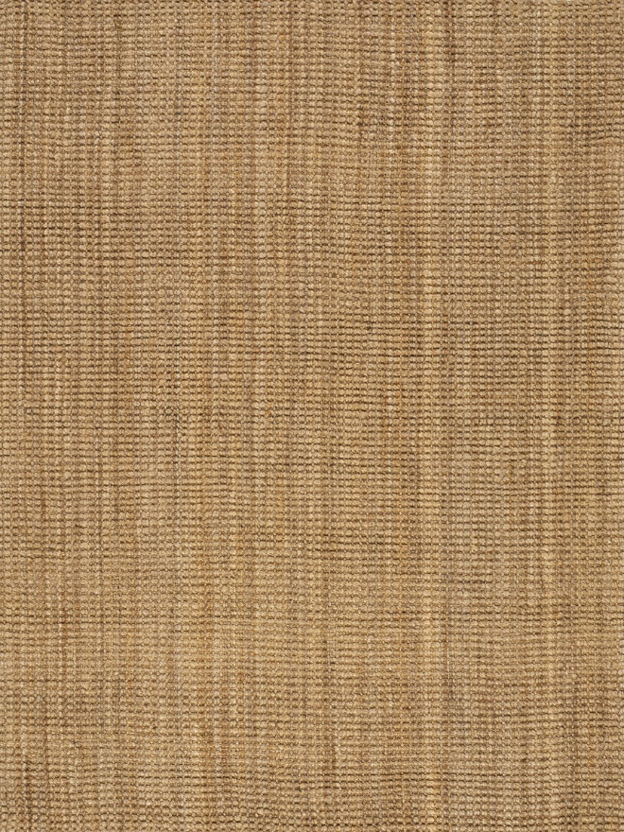

2235 Jute

2'8" x 4'11" $PRICE

5'3" x 7'7" $PRICE

7'10" x 10'6" $PRICE

Naturals



2235 Jute

2'8" x 4'11" $PRICE

5'3" x 7'7" $PRICE

7'10" x 10'6" $PRICE