Intrigue
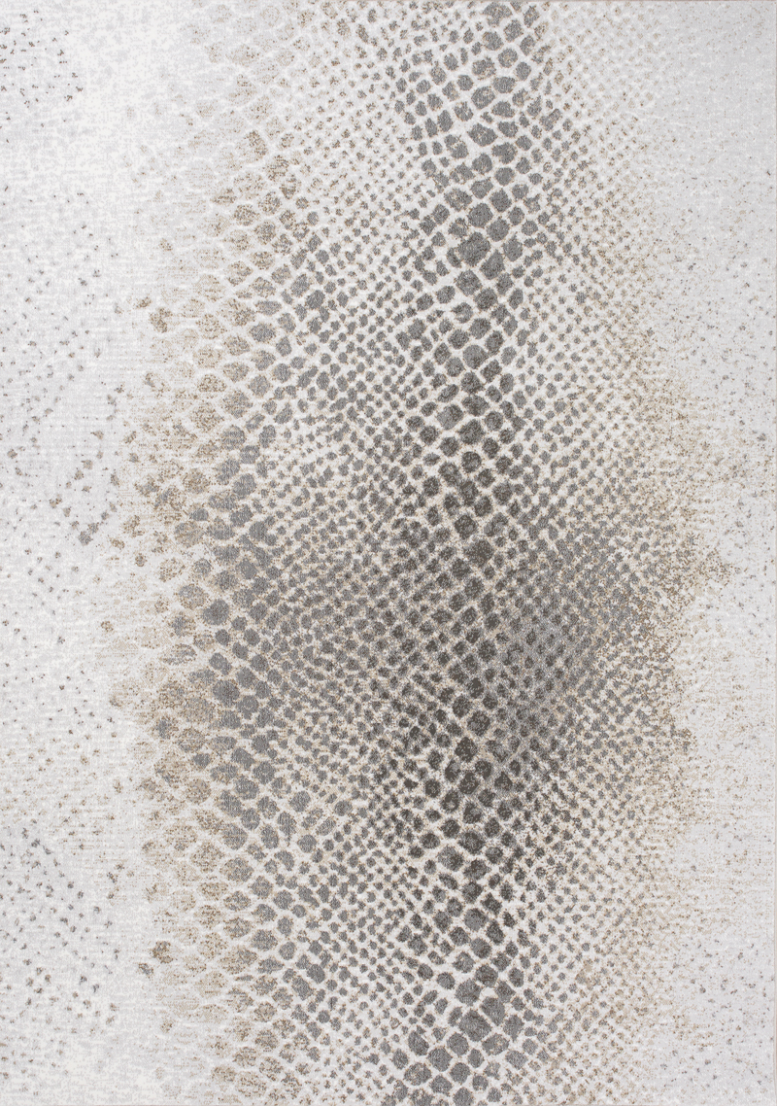
12263/910 Heatset Polypropylene
5'3" x 7'7" $PRICE
7'10'' x 10'6'' $PRICE
Intrigue
12263/910 Heatset Polypropylene
5'3" x 7'7" $PRICE
7'10'' x 10'6'' $PRICE

