Focus

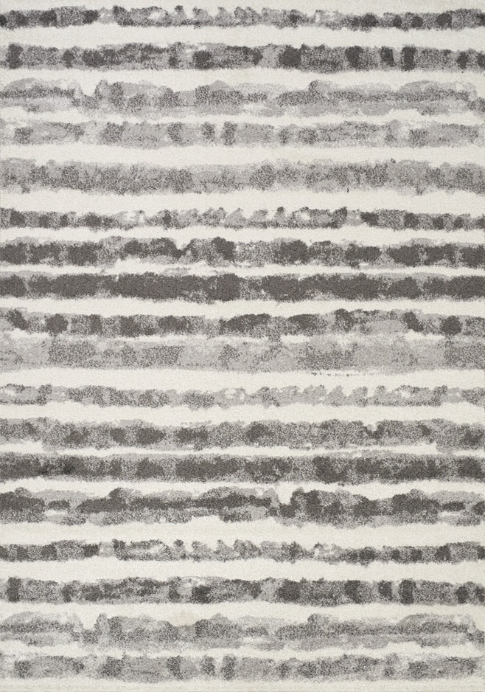

8911/9343 Heatset Polypropylene

2'0" x 3'7" $PRICE

5'3" x 7'7" $PRICE

6'7" x 9'6" $PRICE

7'10" x 10'6" $PRICE

Focus



8911/9343 Heatset Polypropylene

2'0" x 3'7" $PRICE

5'3" x 7'7" $PRICE

6'7" x 9'6" $PRICE

7'10" x 10'6" $PRICE