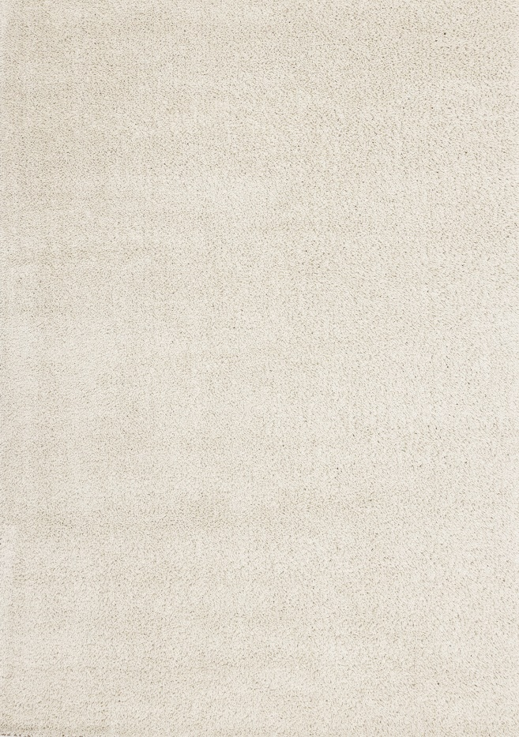

Canyon

2144/AY01

Recycled Polyester

5'3" x 7'7"

$PRICE

Canyon

2144/AY01

Recycled Polyester

5'3" x 7'7"

$PRICE

7'10" x 10'10"

$PRICE

7'10" x 10'10"

$PRICE