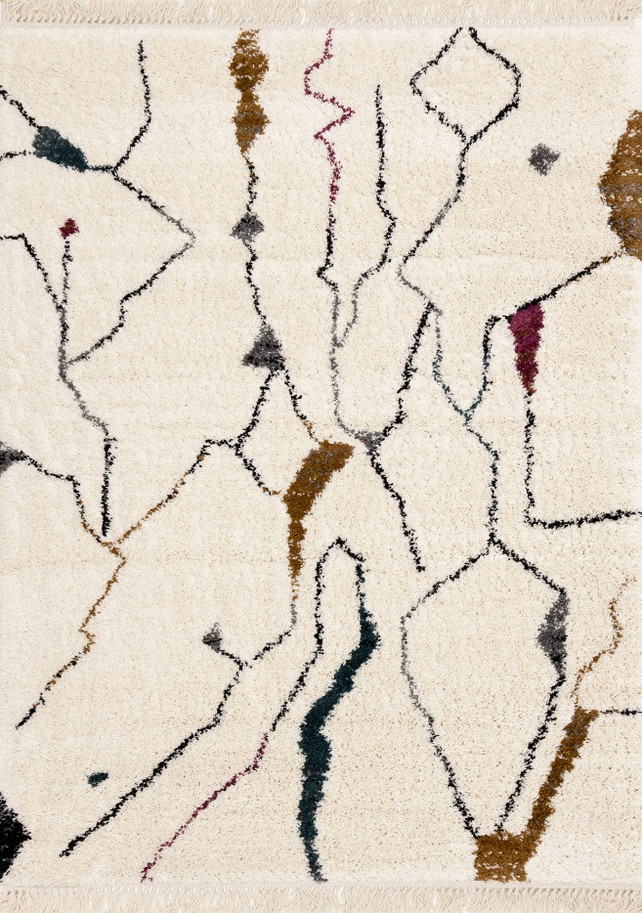

Bora

A201/X601

Heatset Polypropylene

5'3" x 7'7"

$PRICE

Bora

A201/X601

Heatset Polypropylene

5'3" x 7'7"

$PRICE

7'10" x 10'10"

$PRICE

7'10" x 10'10"

$PRICE