

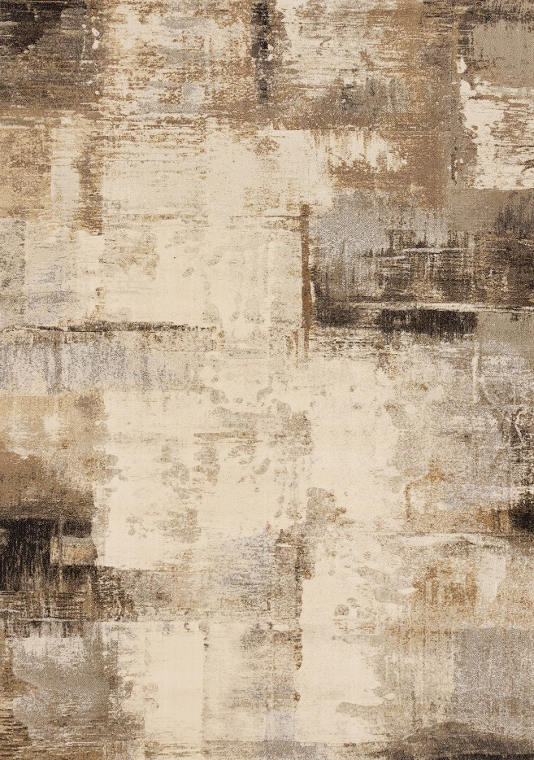

Aurora
63723/6282
Heatset Polypropylene
5'3" x 7'7"
$PRICE

Aurora
63723/6282
Heatset Polypropylene
5'3" x 7'7"
$PRICE
7'10" x 10'10"
$PRICE
7'10" x 10'10"
$PRICE

