***Product Specification Sheet*** 07/2021

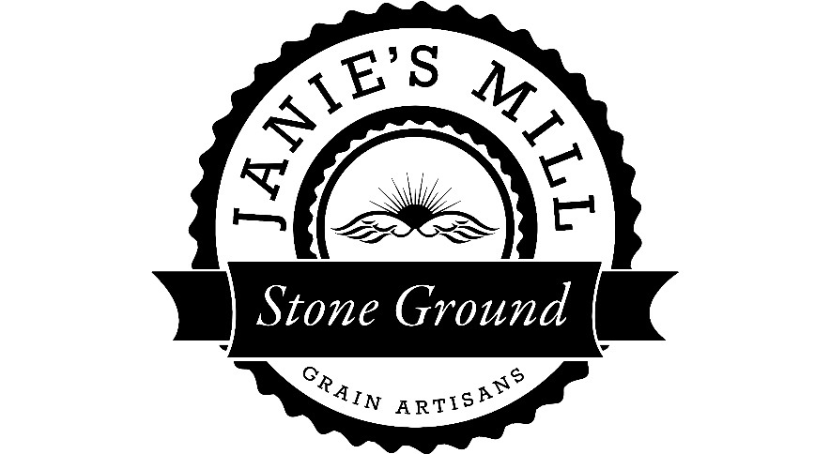

405 N. 2nd St. Ashkum, IL 60911

815-644-4032

[jill@janiesmill.com](mailto:jill@janiesmill.com)

*Product Name:* **“Organic** **Wapsie Valley Polenta/Grits”**

Lot# FGFC2021721

*Ingredient Statement:* 100% Organic Wapsie Valley Corn

*Physical Characteristics:* Product is the corn milled to a medium-coarse grind. Color is golden yellow with flecks of red and purple. Odor is fresh and mild, free of any rancid or other off smells.

*Analytical Specifications (results based on Wet Basis testing):*

*Moisture:* 13.8% (max. 14%)

*Protein:* 8.2 % (max. 10%)

*Packaging Specifications:* Product is shipped in properly sealed and labeled multi-walled paper bag. Pallet is shrink-wrapped.

*Shelf-life Statement/ Storage Recommendations:* When the product is stored in a clean, dry ambient condition, the shelf-life is *6 months* from the date of bagging. Janie’s Mill recommends storage conditions at 40-60 degrees F, and less than 60% humidity.

*Processing Specifications:* All products are produced under the Food and Drug Administration guidelines for Title 21, Mixed Type Facility. Facility is inspected by Illinois Department of Public Health.

*Organic Certifying Agency:* OCIA, Organic Crop Improvement Association

*Kosher Certifying Agency*: CRC, Chicago Rabbinical Council

*Other Information:* Fumonisin – less than .2 ppm detected.

Aflatoxin – less than 3 ppb detected.

* All grain is from Non-GMO grains.