Module 4: traffic signal design

Lesson 1: TRAFFIC SIGNAL DESIGN

GRADE LEVEL: 9 – 12

This STEM lesson introduces students to Intelligent Transportation System (ITS) concepts whereby the transportation infrastructure of roadway sensors, signals and communication networks, in combination with our own vehicles, can control traffic signals to minimize wait times and maximize traffic flow efficiency. To introduce and reinforce these ideas, students will observe and count traffic at a real intersection or on a video, calculate wait times, and explore ideas about how active signal control can maximize flow effectiveness.

Created By:

NanoSonic, Inc.

Giles County

Public Schools

Leidos

Lesson 1: Traffic Signal Design

**Contributed by:** NanoSonic, Leidos, Giles County Public Schools

|  |  |
| --- | --- |
| **Grade Level:**9-12 | **Lesson in this Module:** 1 of 1 |
| **Time Required:**120 minutes | **Lesson Dependency:** None |
| **Keywords:** transportation engineering; intelligent transportation systems; traffic signals; turning movements; delay; | |

**Related Curriculum**

|  |  |
| --- | --- |
| **Subject Areas** | Science; technology; engineering; mathematics |
| **Curricular Units** | Intelligent transportation systems |
| **Activities** | Intersection Data Collection; Traffic Data Analysis; Traffic Delay Calculations and ITS Introduction |

**Educational Standards**

This lesson plan and its associated activities are correlated to the national standards in the each of the core discipline areas of STEM: Next Generation Science Standards, American Association for the Advancement of Science Standards, Standards for Technological Literacy, International Society for Technology in Education Standards, Common Core Mathematics Standards, and the National Council of Teachers of Mathematics Standards.

**Pre-Requisite Knowledge**

None.

**Learning Objectives**

* Through discussion, data collection, and various activities, students will recognize the need for traffic signals.
* Students will use the engineering process to effectively evaluate a signalized intersection.
* Students will identify specific ITS technologies that can be used to improve traffic flow and reduce vehicle delay.

**Introduction/Motivation**

All of us have been frustrated while sitting at a traffic light that never seems to change. This STEM lesson introduces students to Intelligent Transportation System (ITS) concepts whereby the transportation infrastructure of roadway sensors, signals and communication networks, in combination with our own vehicles, can control traffic signals to minimize wait times and maximize traffic flow efficiency. To introduce and reinforce these ideas, students will observe and count traffic at a real intersection or on a video, calculate wait times, and explore ideas about how active signal control can maximize flow effectiveness.

**Lesson Background & Concepts for Teachers**

Traffic signals are used to control traffic that flows in different directions at intersections. Intersections consist of multiple approaches, as seen in the figure to the right. Traffic signals use red, yellow and green indicators to permit different approaches to enter the intersection at different times. These indicators, frequently referred to as red lights, yellow lights, and green lights, tell traffic whether it is their turn to go through the intersection or make the turn that they want to make.

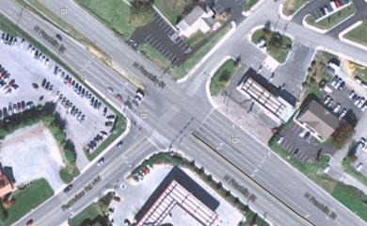

Approach 1

Approach 4

Approach 3

Approach 2

Traffic signals work by alternating the ability for vehicles to travel on each approach using different phases, which can have set or varying phase lengths. Phase lengths are the amount of time assigned to each green, yellow, or red phase.

* ***Green Phase***: the amount of time allocated for a green indication in a particular direction. Green phases may last between 20 seconds to 120 seconds or more.
* ***Yellow Phase***: the amount of time allocated for a yellow indication. This phase allows vehicles enough time to travel through the intersection if they are unable to stop for the red indication.
* ***Red Phase***: the amount of time allocated for a red indication. The red indication will be shown for any approach or traffic lane that is not allowed to enter the intersection while another approach has a green indication. Unlike the other phases, the red phase may include an all-red time in which all intersection approaches receive a red indicatior at the same time. This all-red phase lasts approximately ½ seccond to 1 ½ seconds and provides an extra layer of protection in case any vehicles have disobeyed the traffic signal.

The total time it takes for a traffic signal to cycle through all phases at an intersection once is called the cycle length. The cycle length is the amount of time it takes for the traffic signal to alternate from the moment one approach or direction receives a green indication, to the time when the same approach receives a green indication again, after all approaches have been cycled through and serviced with green lights of their own.

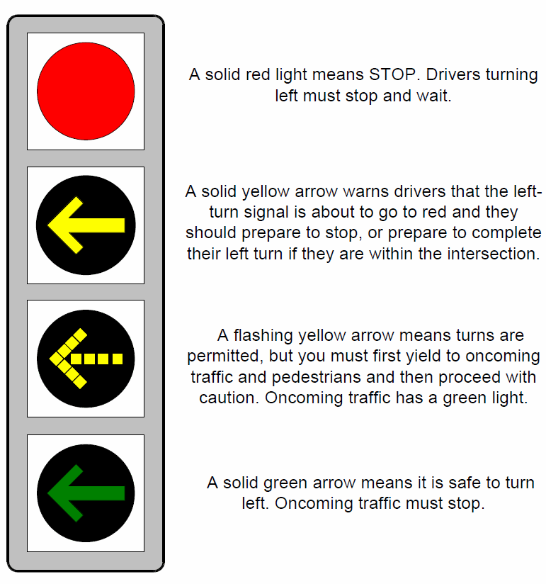

A solid red light means STOP. Drivers turning left must stop and wait.

A solid yellow arrow warns drivers that the left-turn signal is about to go to red and they should prepare to stop, or prepare to complete their turn if they are within the intersection.

A flashing yellow arrow means turns are permitted, but you must first yield to oncoming traffic and pedestrians and then proceed with caution. Oncoming traffic has a green light.

A solid green arrow means it is safe to turn left. Oncoming traffic must stop.

Traffic signals can operate in a variety of different time-dependent settings. For example, some signals are programmed to flash the yellow indicator on the main approaches late at night while the minor approaches receive a flashing red indicator. In this case, the drivers who see a flashing yellow indicator are allowed to proceed with caution while the drivers who see the flashing red indicator are required to treat it as a stop sign. Another means of programming a traffic signal is to display red, yellow, or green arrows to indicate when drivers may turn at a high-volume intersection. These indications are described in the figure to the right.

## Intersection Movements

There are three main movements that drivers may complete at an intersection: left turn, right turn, or through movements. The turning movements are further described as being either protected movements or permissive movements. A *protected turning movement* allows a vehicle to turn without having to worry about oncoming traffic or pedestrian crossings. In other words, they will have a clear path with no conflicts. Protected turning movements at an intersection can be symbolized by either a green left- or right-turn arrows. Through movements (traveling straight through an intersection) are always characterized as protected movements. *Permitted turning movements* are those in which drivers must yield to opposing traffic or pedestrians. Drivers must wait until there are acceptable gaps in opposing traffic or pedestrian crossings in order to safely progress through the intersection. An example of a permitted movement is turning left at a traffic signal with a flashing yellow arrow.

## Traffic Signal Designs

Traffic signals may be pre-timed to allocate a certain amount of green time for each approach, or they may utilize specialized technology to identify when certain approaches need to receive a green indication. A *pre-timed traffic signal* has been programmed to allow a certain amount of green time per approach per cycle length. As a reminder, a cycle length is the time it takes for one approach to go from green to green again, after all other approaches have been cycled through. Unlike the next two traffic signal designs, pre-timed signals do not automatically change the cycle length or green time length based on the traffic demand. An example of a pre-timed system would be giving each approach 30 seconds of green time to move through the intersection, regardless of whether there are 100 cars waiting on a certain approach or zero cars waiting to go to the intersection. Traffic signals can sometimes have multiple pre-timed settings that are assigned to different times of day. For example, if a side street may have a high demand during morning rush hour, but not as high during other times of the day, the signal could be pre-timed to allow longer green times on the side street from 7am-9am, but shorter green times at all other times.

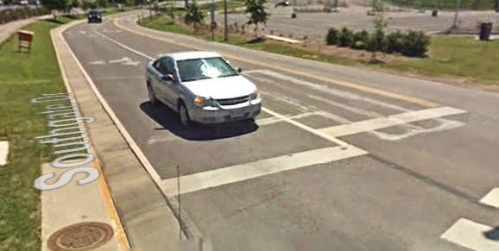

*Semi-actuated traffic signals* have phase timing that changes based on the amount of traffic on some, but not all, approaches. Semi-actuated traffic signals are typically found at intersections where traffic demands are much higher on the main street compared to the side streets. The traffic signal will maintain a green indication for the main street as long as no vehicles are detected on the side street. When a vehicle does pull up to the intersection from the side street, the indication for the main street will briefly turn yellow then red and then the indication for the side street will turn green. Detectors should be a vocab. Special detectors help semi-actuated traffic signals to know whether there are vehicles or pedestrians waiting or approaching the intersection. These detectors can be electronic units installed in the pavement, cameras mounted at the intersection, or pedestrian push buttons near the sidewalks.

*Fully actuated traffic signals* use detectors on all intersection approaches in order to determine how to allocate the green times for each approach. Each phase’s timing is dependent on the amount or frequency of traffic detected on each approach approaches. These signals are typically found where two major roadways intersect and traffic flow varies over time.

## Advantages and Disadvantages of Traffic Signals

There are many advantages and disadvantages of installing traffic signals. When a traffic signal is installed in an appropriate location, as described in the Traffic Signal Warrants section, it can:

1. Increase the traffic capacity of (or the ability to move lots of vehicles through) the intersection,
2. [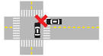](http://www.google.com/url?url=http://www.fcgov.com/traffic/rtangle_crashes.php&rct=j&frm=1&q=&esrc=s&sa=U&ei=tQY0VNmKF8qjyATczIHgCA&ved=0CBoQ9QEwAg&usg=AFQjCNHpRPipvqtJa6ByCRVXADRHefg19g)Reduce the number of some types and severity of crashes (specifically right-angle crashes, see image to the right),
3. Provide continuous or nearly continuous movement of vehicles through the intersection, and
4. Allow traffic from the lower volume road to safely cross or turn onto a higher volume road.

When traffic signals are installed they could provide some the following disadvantages, especially if they are installed in inappropriate locations or if the traffic signals are not well-timed:

1. Increased delay (or time to get where you are going),
2. Disobedience of the traffic signal (e.g., running through a red indication and causing a severe crash),
3. Increased traffic volume on typically lower-volume roadways (i.e., traffic using other routes to avoid long delays at a red indication), and
4. Increases in certain types of crashes (especially rear-end crashes).

Traffic engineers can alleviate some of these disadvantages by paying close attention to the design and allocation of the cycle length, partially or fully actuating the signal, or improving a driver’s ability to see and respond to the traffic signal.

## Traffic Signal Warrants

Traffic signal warrants (or “rules”) describe the minimum conditions that must be present on a roadway in order to determine if a traffic signal could improve safety or traffic flow at certain location or intersection. The traffic signal warrants are defined in the Federal Highway Administration’s Manual on Uniform Traffic Control Devices (MUTCD). This section of the manual can be found by visiting <http://mutcd.fhwa.dot.gov/htm/2003r1/part4/part4c.htm>. In order to decide whether an intersection would benefit from a traffic signal, the traffic signal warrants must be evaluated, along with an engineering study that looks at the safety and mobility (efficient traffic flow) of the intersection.

There are eight different traffic signal warrants or rules:

1. Eight-hour vehicular volume: describes traffic flow that must be met for at least eight hours of the day (not necessarily continuous)
2. Four-hour vehicular volume: describes traffic flow that must be met for at least four hours
3. Peak hour vehicular volume: describes traffic flow that exists for the one continuous hour of the day with the highest traffic flow
4. Pedestrian volume: describes conditions for roadways with such heavy traffic that it causes delays for pedestrians
5. Nearby school crossing: used in places where children cross a major roadway to get to school
6. Consideration of coordinated signal systems: describes the presence of and coordination with other traffic signals on the same roadway at nearby intersections (allows lines of traffic to move continuously without being broken up by red traffic signals)
7. Crash experience: regards the types and amount of crashes that have previously occurred at the intersection
8. Roadway network: describes the conditions that need to be met for a traffic signal to be installed to permit traffic to move smoothly and safely through an intersection

## Rural vs. Urban

While intersections can be found in both rural and urban locations, the functionality or purpose of a traffic signal may differ from location to location. In rural areas, there is typically less traffic flow, fewer pedestrians, and higher vehicle speeds as compared to urban areas. Rural intersections may rely heavily on semi-actuated or fully-actuated intersection designs.

Urban areas are more likely to have a higher amount of intersections due to the increased traffic volume and higher number of pedestrians. An example of this is New York City, where there is a traffic signal on nearly every block. These signals are more prone to be pre-timed to allow for signal coordination to help move traffic through a corridor as smoothly as possible.

**Vocabulary/Definitions**

|  |  |
| --- | --- |
| Vocabulary Word | Definition |
| Intersection | A location where several travel paths cross. |
| Intersection Approach | The portion of a roadway intended for use by vehicular or pedestrian traffic approaching an intersection. Intersections typically have three or four approaches. |
| Traffic signal | Electrically operated traffic control device that provides allows roadway users to advance their travels by giving each approach and movement the opportunity to move. |
| Conflict | An event involving two or more moving vehicles approaching each other in a traffic flow situation in such a way that a collision would ensue unless at least one of the vehicles performs an emergency maneuver. |
| Cycle Length | The length of time that it takes a signal to complete one cycle (from the beginning of approach 1’s green indication to the beginning of approach 1’s next green indication). |
| Phase | Amount of time a signal indicates a certain color (red, yellow, or green) |
| Pre-timed signal | A traffic signal that has fixed, pre-determined phase and cycle lengths that are not dependent on the number of vehicles or pedestrians present. |
| Semi-actuated Signal | A traffic signal that uses vehicle or pedestrian detectors on one or two approaches to activate a particular phase only when vehicles or pedestrians are present or to extend green phase time based on the amount of traffic that is traveling through the intersection. |
| Actuated Signal | A traffic signal that uses vehicle or pedestrian detectors to activate a particular phase only when vehicles or pedestrians are present or to extend green phase time based on the amount of traffic that is traveling through the intersection. |
| Intelligent Transportation Systems | Advanced technologies that transportation engineers use to improve transportation safety and traffic flow. In this module, actuated or semi-actuated traffic signals represent one form of intelligent transportation systems. |
| Traffic Signal Controller | A roadside device that alternates service between conflicting traffic movements. This device is frequently housed inside a big metal box right next to an intersection. It allows traffic engineers to manually reprogram a signalized intersection. |
| Coordinated Signal Systems | A series of signalized intersections that work together to maximize the flow of traffic along the main road. Coordinated signal systems frequently allocate green indications in a manner that minimizes the number of stops and the amount of time that vehicles on the main road have to wait for a signal to display a green indication. |
| Urban | A highly populated area that is frequently used to describe cities with lots of man-made buildings and infrastructure. This is the opposite of a rural location (see definition below). |
| Rural | A sparsely populated area that may be described as farmland or forests. This is the opposite of an urban location (see definition above). |
| Traffic Delay | Traffic delay is the additional time traffic congestion adds to a normal trip. |
| Peak versus Off-Peak Times | A peak time is a time period in which traffic is the heaviest and the most congestion occurs (example, during rush hours, 7-9am and 5-7pm).  Off-peak times are all hours that are not considered peak hours (example, late at night, 12-4am. |
| Traffic Volumes | Traffic volumes are the amounts of cars that travel on a roadway during a specific period of time. |
| Turning Movement Counts | Turning movement counts are used to measure the movement of vehicles through an intersection by counting the number of vehicles that turn left, turn right, or continue straight. |
| Major Roadway | Describes the main roadway that travels through an intersection. It is a roadway that is frequently traveled, servicing many vehicles at a time. |
| Minor Roadway | Describes the lower-volume roadway that travels through an intersection. It is a roadway that is frequently traveled, servicing fewer vehicles at a time. A minor roadway often refers to a side street instead of a main road. |

**Associated Activities**

* **Activity 1 – Discussion on Traffic Signal Purpose and Design**
  + Why do some intersections have traffic signals and other intersections do not?   
    *The decision to place a traffic signal is dependent on the amount of traffic at an intersection. Intersection traffic may include the number of vehicles that use the intersection and also the number of pedestrians or bicyclists that use an intersection over the course of a set time.*
  + What type of intersections do we observe around our city/town?  
    *Student answers will vary based on local transportation infrastructure. Answers may include signalized intersections, stop-controlled intersections, and intersections with yield signs. Other characteristics that students may identify may include T-intersections (three-way intersections), four-way intersections, interchanges, roundabouts, and other alternative designs. Some signalized intersections may operate differently based on the time of day. For example, a signalized intersection near a school may only display the traditional red/yellow/green indications during school drop-off or dismissal – it may display flashing yellow (on the main road) and flashing red (on the access road) all other times.*
  + How might traffic signals operate differently in a rural versus urban area?  
    *Traffic signals in rural areas likely have much lower amounts of traffic that utilize each intersection. Students may indicate that traffic lights in rural areas either have long wait times while you wait for the signal to turn green (pre-timed signal) or they may automatically turn green when there is very little traffic on the road (semi- or fully-actuated signals).   
    Traffic signals in urban areas often see much more traffic during the day. The signals may be designed to allow certain traffic movements to go before other traffic movements. For example, vehicles turning left may get to turn left before the straight vehicles receive the right of way. Some traffic signals in urban areas may prohibit right turns on red due to high amounts of oncoming traffic, or due to the inability to have a clear line of sight.*
  + What signs or other objects do you observe near the intersection? (i.e., signs, cameras, signal control boxes, etc.)  
    *Traffic signals may have special cameras pointed at the traffic or electrical components embedded into the pavement to determine when vehicles are waiting for a signal to turn green. Some signals may also have advanced warning signs to warn drivers that there is a signalized intersection up ahead – this is more commonly used in rural areas that have very few traffic signals along a given road.   
    Traffic signals also have a traffic control box where engineers can re-program the lights on-site. This may be necessary in case of an emergency or a special event that requires special signal programming to maximize the flow of traffic.*
* **Activity 2 – Intersection Data Collection**
  + As a class, choose an intersection in your city/town that you think may benefit from adding or removing a traffic signal. Students will visually observe traffic at this intersection by visiting the intersection. If students will be collecting traffic data on-site at the intersection, the teacher should coordinate with the local or state DOT to obtain recommendations for positions that provide a safe place for students to monitor the intersection. If desired, the teacher may pre-record traffic at this intersection using a video camera.
  + Students will collect data on the number of vehicles, wait time of each vehicle, and their turning movement for each intersection approach. This data can be collected using a mobile device or tablet application (for example, <https://play.google.com/store/apps/details?id=com.portablestudies.classroom.tmc&hl=en>) or by using pen and paper with the attached worksheet. The downloadable app is available free of cost for educational purposes, but it will require a license number obtained through the app developer.
* **Activity 3 – Traffic Data Analysis**
  + Create a bar graph of the number of vehicles and pedestrians that arrived at each approach in 5-minute intervals.
  + The Intersection Volume graph (above) can be made in Excel by creating three columns titled Time, Vehicle Movements, and Pedestrian, respectively, and then filling in the columns with the relevant data.

|  |  |  |
| --- | --- | --- |
| **Time** | **Vehicle Movements** | **Pedestrians** |
| 8:00 | 3 | 1 |
| 8:05 | 5 | 0 |
| 8:10 | 3 | 0 |
| 8:15 | 4 | 2 |
| 8:20 | 6 | 0 |
| 8:25 | 2 | 1 |
| 8:30 | 3 | 2 |

* + To turn this into an Excel graph, select all three columns of the data, go to the Insert tab near the top of the Excel window, and select Charts. Select a column graph. After making the selection, the graph will appear.

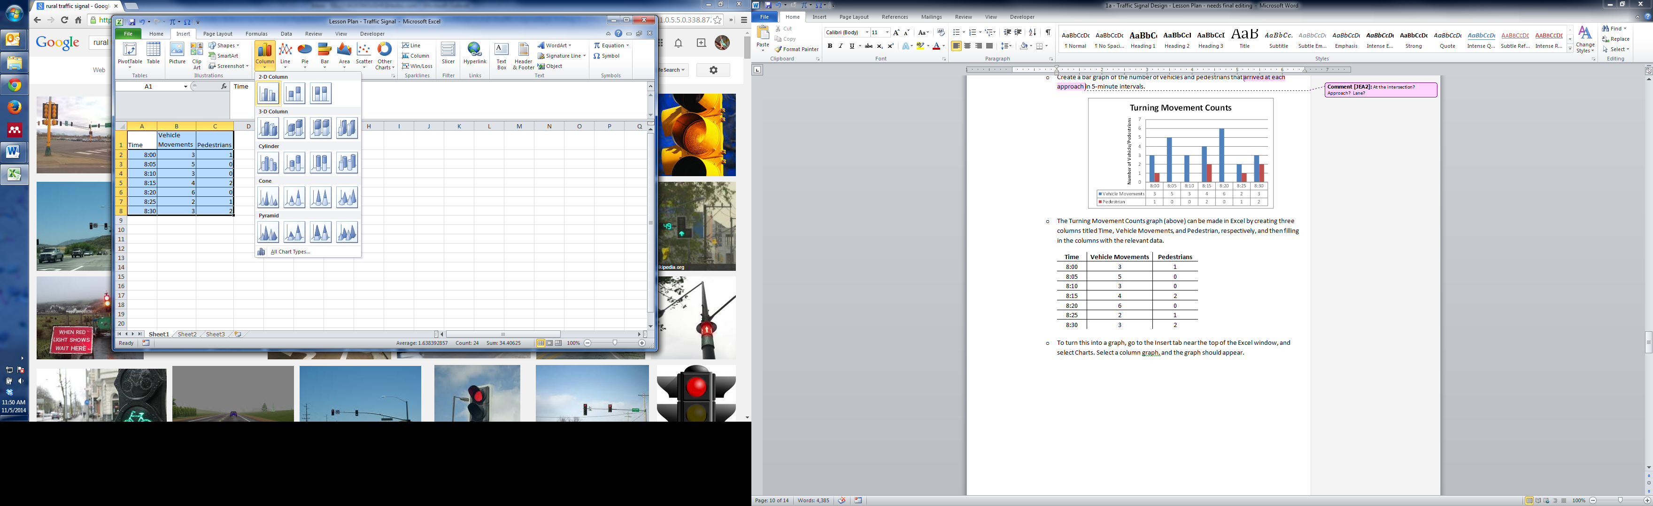

* + After making the graph in Excel, the specific number of vehicle movements and pedestrians can be shown below the graph using a data table. To do this, click on the chart (making sure the entire chart is selected), and a tab at the top called Chart Tools should appear. The computer will default to the Design Tab.

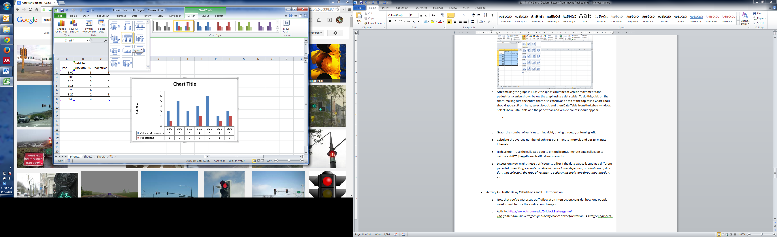

* + Under the chart layout option, select the following icon.



* + Edit the chart to add a chart title and axis title.
  + Use similar methods to graph the number of vehicle turning right, driving through, or turning left.
  + Calculate the average number of vehicles per 5-minute intervals and per 15-minute intervals.
    - Average left: 0.86 vehicles per 5-minute interval
    - Average through: 2.29 vehicles per 5-minute interval
    - Average right: 0.43 vehicles per 5-minute interval
    - Average left: 2.5 vehicles per 15-minute interval
    - Average through: 7.5 vehicles per 15-minute interval
    - Average right: 1 vehicle per 15-minute interval
  + Discussion: How might these traffic counts differ if the data was collected at a different period of time?   
    *Traffic counts could be higher or lower depending on what time of day data was collected, the ratio of vehicles to pedestrians could vary throughout the day, etc.*
* **Activity 4 - Traffic Delay Calculations and ITS Introduction**
  + Now that you’ve witnessed traffic flow at an intersection, consider how long people need to wait before their indication changes.
  + Traffic engineers design traffic signals to reduce intersection delay times and, therefore, reduce driver frustration. Ask the students if they think they can manage the flow of traffic and while keeping driver frustration to a minimum.  
    Link to game: <http://www.its.umn.edu/GridlockBuster/game/>
  + This word problem demonstrates a simple method for calculating delay.   
    A northbound traffic indication turns red. 15 seconds later, a blue van stops at the red indication. 8 seconds after that, a green car arrives and stops behind the blue van. 12 seconds later, two vehicles arrive simultaneously. If the total red indication time is 90 seconds, calculate the delay time per vehicle and the average delay for this intersection approach.   
    *Show these arrivals on a number line. Delay is the amount of time a vehicle has to wait until the light turns green. For example, the blue van’s delay is 90 seconds minus 15 seconds (75 seconds). The green car’s delay is 90 seconds minus 15+8 seconds (67 seconds).*
  + Discussion: Using ITS to reduce delay   
    <https://www.youtube.com/watch?v=OtukPI-9IeQ>
    - Why is it good to coordinate traffic signals?

*It is good to coordinate traffic signals to ensure vehicular flow is consistent on a roadway with lots of intersections and traffic signals. Uncoordinated traffic signals can lead to congestion and vehicular backup on roadways that might not be able to accommodate a large number of vehicles waiting on a traffic light.   
Additionally, by coordinating traffic signals, drivers receive more consecutive green lights thus decreasing driver frustration (reduced delay) and decreasing vehicle pollution and gas usage (caused by idling and accelerating vehicles). Coordinated traffic signals also reduce the number of rear end crashes and red-light running. Overall, coordinating traffic signals improves the operation of the roadway.*

* + - What happens when the system does not work well?

*If the system does not work well, traffic congestion and vehicular backup at intersection approaches can occur. Vehicles may be stuck waiting at a red indication when there is no one crossing in the opposing direction, creating unnecessary delay. Also, a bad system can cause drivers to disobey traffic signals, leading to higher risk of running red indications and causing crashes.*

**Lesson Closure**

* Based on your data collection, evaluate the intersection. Is the intersection good the way it is, or should it be improved somehow?

*A good intersection effectively manages the flow of traffic from each direction, or approach. If a traffic signal allows for continuous movement of vehicles and pedestrians through an intersection without creating backup or excessive delay on any approach, the traffic signal can be considered effective.*

* How could connected vehicle technology improve traffic flow at signalized intersections?

*Connected vehicle technology allows for wireless communication between vehicles and transportation infrastructure (i.e., traffic signals). When a vehicle approaches the traffic signal, it sends out a beacon with up-to-date information on a vehicle’s speed, trajectory, and acceleration or deceleration data. The traffic signal can then calculate the time at which the vehicle will enter the intersection and can adjust the traffic signal to display a green indication for that vehicle. If there are multiple vehicles coming from all directions, the traffic signal can prioritize which approaches receive the green indication and for how long in order to reduce the intersection’s overall delay. With the ability to dynamically control which vehicles have the right of way, there would be fewer intersection-related crashes such as right-angle crashes and rear-end crashes.*

*Connected vehicle technology could provide drivers with a countdown for when the signal will change from one color to another. This will allow vehicles stopped at an intersection to start moving simultaneously as soon as the traffic indication turns green. This would reduce the delay caused by the fluctuations between vehicles starting to move again when a red indication turns green. On the other hand, by warning drivers that a light will turn yellow/red within a few seconds, drivers can prepare to slow down to avoid running a red light or crashing into the vehicle in front of them.*

**Attachments**

* Turning Movement Data Collection Worksheet and Lab Report
* Turning Movement Data Collection Application: <https://play.google.com/store/apps/details?id=com.portablestudies.classroom.tmc&hl=en>
* Online game: <http://www.its.umn.edu/GridlockBuster/game/>
* Video demonstrating intersection ITS: <https://www.youtube.com/watch?v=OtukPI-9IeQ>

**Extensions/Multimedia**

* Interview your parents. What do your parents think of a particular local signalized intersection? The teacher may assign a specific intersection, or students may ask their parents to identify a good or bad intersection and explain why it is good/bad.
* If the students determined that a traffic signal is warranted, consider scheduling a meeting with a local transportation engineer. If results are confirmed, consider meeting with the city/town council to discuss adding a signal.
* Utilize Edmodo ([www.edmodo.com](http://www.edmodo.com)) to provide further questioning and discussion between students and teacher. Edmodo is safe social learning website made specifically for teachers and students. It is a way to collaborate on assignments, homework, projects, and after-school STEM programs and is used as a communication tool to provide additional questioning and feedback from teachers and students.

**References**

* "FHWA - MUTCD - 2003 Edition Revision 1 Chapter 4C." FHWA - MUTCD - 2003 Edition Revision 1 Chapter 4C. Federal Highway Adminstration, n.d. Web. 01 Oct. 2014.
* "Intersection Safety." - FHWA Safety Program. N.p., n.d. Web. 30 Sept. 2014.
* "Intersection Safety Issue Briefs - Issue Brief 5: Traffic Signals." - FHWA Safety Program. Federal Highway Adminstration, Nov. 2009. Web. 30 Sept. 2014.
* John, Patricia L., and Reynnells, Louise. "What Is Rural?" National Agricultural Library, n.d. Web. 30 Sept. 2014.
* "Traffic Control Systems Handbook: Chapter 7. Local Controllers." Federal Highway Adminstration, n.d. Web. 30 Sept. 2014.
* Wing, JP. "Glossary - The Upstate N.Y. Roads Site." Glossary - The Upstate N.Y. Roads Site. N.p., n.d. Web. 01 Oct. 2014.