

Linear L-411/L-421

Technical Data Sheet

**Description**: an expertly formulated high build epoxy primer sealer/surfacer designed for excellent adhesion, chemical resistance, and corrosion protection. Designed with an inorganic-organic corrosion inhibitor and anti corrosive pigment to encapsulate and neutralize rust. This product includes moisture scavenger properties and has also been designed for superior build and sandability.

**Compatible topcoats:** 2k topcoat systems, 2k urethane surfacers/sealers, single stage and basecoats, urethane and epoxy sealers, spray polyesters

*\*contact Linear for more information on topcoats*

**Required products:** L-421 hardener

Solids by vol 65% +- 2%

Solids by weight 76% +- 2%

**Surface Prep:**

**As an epoxy over bare metal:** thoroughly sand bare metal with NO FINER than 80g or sandblast. Sandblasted parts do not need to be sanded but can be with no finer than 80g.

DO NOT USE AN ETCH PRIMER

*\*Not all blasting medias are suitable to be coated, do not use soda blast. Contact linear for more information on suitable blasting media.*

*Metal prep systems such as SX579/520 may be used.

*Clean bare metal thoroughly with a quality acetone cleaner before coating.

**As a high build primer surfacer over body work or fiberglass:** finish sand substrate with 150-240g, clean with a quality wax and grease remover

**Mixing:** mix ratio is 4:1

4 parts L-411 to 1 part L-421

***Gravimetric Mix Ratios (for 100% mix ratio accuracy, weighed by grams on scale)***

*8 fluid ounces (1/2 pint)*

L-411 328.0

L-421 55.2

*16 fluid ounces (pint)*

L-411 656.0

L-421 110.4

*32 fluid ounces (quart)*

L-411 1312.0

L-421 220.8

*64 fluid ounces (1/2 gallon)*

L-411 2624.1

L-421 441.5

*128 fluid ounces (gallon)*

L-411 5248.2

L-421 883.0

*\*contact Linear for more gravimetric formula mix sizes*

**\* 20 MINUTE INDUCTION TIME REQURED!! Do Not use if panel temp is below 65 degrees F. Always keep panel temp at 65 F or above for at least 48 hrs after application.**

*can be reduced up to 10% with a quality urethane reducer such as DT1575 or comparable. **10% Reduction by volume only recommended for bare metal application**

**Pot Life:** 2-3 hrs at 75 degrees F.

**Application:** HVLP 1.4-1.8 tip size 20-30 psi at regulator

RP 1.4-1.8 tip size 8-15 psi at regulator

**\*SPRAY IN A WARM ENVIORNMENT!** Do not allow panel temp below 65 degrees for at least 48 hrs. If you cannot keep panel temp above 65 degrees F for 48 hrs do not use L-411.

Over bare metal: apply 2 medium wet coats (reduced 10% by vol) 30 minute flash time between coats

As a high build primer/surfacer: apply 2-4 medium wet coats, 4:1 mix, no reduction. 30 minute flash time between coats.

**Dried Film Build per coat:** 3-5 mils

Do not exceed 10 mils dry after sanding

**Dry times:**

set to touch: 4-5 hrs @ 75 degrees

dry to handle: 7-8 hrs @ 75 degrees

Dry to sand: 24-48 hrs (48 hours recommended)

Dry to topcoat: 48 hrs and must be sanded/scuffed

**Recoat:** L-411 must be sanded before a topcoat is applied, minimum time allowed before recoat is 48 hours and sanding/scuff IS REQUIRED. If applying body filler over L-411, L-411 must be sanded thoroughly with 80-180g before applying filler or glazing putty.

**Adhesion:** Excellent adhesion tocold rolled steel, hot rolled steel, galvanized, stainless steel, aluminum and composite fiberglass (terminated with wax not silicone)

**Video product explanations:**

**Proper use and application of L-411 as a high build:**

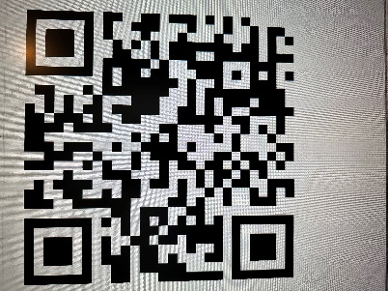

**Proper Use of L-411 over bare metal:**

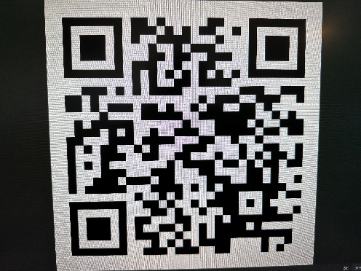

The data information in this bulletin is accurate to the best of our knowledge, however no guarantee of accuracy is given or implied. We are constantly improving our coatings and formulas so data may vary slightly from time of bulletin. Due to variations in customer handling and application methods beyond our control we assume no responsibilities for coverage, mil thickness, performance, or injury or damage resulting from use. Consumer/user responsible for substrate compatibility verification.

Caution: in case of skin contact flush with water. For eyes flush with water for 15 minutes and seek medical attention. If exposed to high concentrations of vapors remove to fresh air. If swallowed call a physician or poison control immediately at 1 800 222 1222