

**YOUR SCHOOL NAME HERE  
GINGERBREAD HOUSE EVENT**

We are excited to be running a Gingerbread House Decorating Event! Join us for a night of fabulous gingerbread house making fun and Christmas spirit with our community. Delicious and premium quality Gingerbread House Kits from Gingerbread Folk include gingerbread parts, baseboard, quick drying royal icing plus cellophane and ribbon to wrap your creation to take home. (Add in any extras your Committee is offering such as ‘supper’, ‘refreshments served’, and if you’re ordering lollies be sure to include that in the list)

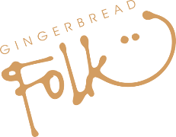

We’ll be holding a competition on the night so bring your creative and competitive edge

**WIN**

If you are holding a competition’ include this section, otherwise delete it from your poster’

**EVENT WILL BE HELD:**

* Delicious gingerbread made with the finest pure ingredients
* all natural and free from added colours, flavours and preservatives
* all products are dairy, egg-free & nut free
* gluten free option same price!
* Step-by-step co instructions on Youtube!

**Book by INSERT DATE HERE**

**INSERT DATE HERE**

**Gingerbread House Kit: $INSERT PRICE HERE   
Gluten Free Gingerbread House Kit: $INSERT PRICE HERE**

**Facebook.com/groups/INSERT GROUP NAME HERE**

