White Musk (10% in non-hazardous base)

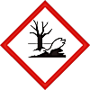

Toxic to aquatic life with long lasting effects.

Avoid release to the environment. Collect spillage. Dispose of contents / container to approved disposal site, in accordance with local regulations.

Contains: Geraniol, dl-Citronellol. May produce an allergic reaction.

Company Name, Company Address, Company Telephone Number

