BLOUSE SPECIFICATIONS

1. GENERAL
a. The most popular style of blouse is the "V" neck pullover, having a soft pointed collar and tuck-in tail. Options such as a hard collar, split fronts and backs and built-in waistband are available and are to be described later in the styling specifications.

b. The basic style and specifications are to be for the standard, popular style.

2. PATTERNS
a. Basic patterns for blouse construction consist of separate pieces for front, back, sleeves, cuffs, and collar.

b. Fabric is to be cut from a full range of sizes, using a computerized system for marking, grading and cutting.

3. SEAMS (see illustration #1)
a. Seams connecting the major parts are to be safety stitched and serged to prevent raveling.

b. The bottom hem all around the body is turned and welted with a lock stitch with no exposed edge.

c. The collar is "set" into the body of the blouse by a finished seam all around the neck, eliminating any rough exposed edges.

4. SOFT COLLAR (see illustration #2)
a. The collar is a wide wing, measuring 5 1/2" from point to collar base on a size 38R. Narrow wing is also available on request.

b. There is a bartack at the base of the "V" neck opening.

c. Collar is reinforced with light weight Pellon SF134 for shape retention and body.

5. CUFFS (see illustration #3)
a. Cuffs are one piece, turned and sewn with a safety stitch around ALL edges.

b. The under portion of the cuff is to have two rows of looped Velcro, 2" long and 1" wide set horizontally. The upper portion of the cuff has a 2 1/2" long and 1" wide vertical strip of hooked Velcro.

6. SLEEVES
a. Sleeves are fully "bloused", and measure 18" wide at the elbow on a size 38R.

b. Sleeve tapers in slightly to meet the cuff, and is "felled" into the cuff, allowing fullness in fit and appearance.

c. At the junction of the sleeve bottom and the cuff top, there is to be approximately 2" additional fabric to the sleeve, eliminating any gaping. A "vented" sleeve is NOT acceptable.

7. HARD COLLAR (see illustration #4)
NOTE: Normally, a 6" front neck zipper is utilized with the standing hard collar. These zippers are metal, NOT plastic or nylon. They are sewn into the front opening edges and securely bartacked at the bottom. The zipper tape is "piped" into the neck front opening in such a manner to form a fabric welt on each side. When the zipper is in the closed position, it is "hidden" by these welts.

a. The inner core foundation of the standing collar is .014 Mylar.

b. There is a laminated layer of non-woven Pellon P15 on the inboard side of the entire foundation.

c. A stainless steel riveted hook and eye is to be the front closure. The hook and eye are riveted through the Mylar, Pellon and two layers of collar lining material. It is to be placed at the optimum angle to insure proper tension and comfort.

d. A “sewn” hook and eye is not acceptable.

e. The collar lining consists of two layers of Burlington Mills Cramerton fabric, which is 65% polyester and 35% combed cotton, pre shrunk and non-wicking.

f. Seven male gripper snaps are placed through both layers of the collar lining material. The snaps are supported on the inside by the laminated non-woven Pellon, which also serves as a protective layer between the Mylar and the snaps. Female gripper snaps applied to the collar lining are unacceptable.

g. The outboard side of the standing collar is to be covered with a whipcord fabric, as specified by the design specifications.

h. The whipcord fabric is doubled over the top of Mylar base, along with the two layers of collar lining, and stitched along the top edge. This 4-layer construction results in a "beaded" edge and serves as a protection all along the top edge of the liner.

i. A single layer of fusing tape or bridle-tape is not sufficient protection in this area and is not acceptable.

j. The bottom edge of the standing collar is to be sewn through and through, to attach the double layers of Cramerton lining to the outer layer of whipcord. This row of stitching is immediately below the bottom edge of the Mylar foundation.

k. Construction of the collar in this manner provides the most dimensionally stable garment, without the additional rows of needle holes.

l. Braid trim, fabric welt, and embroidery must be applied to the outer fabric collar, before assembly. This prevents sewing the trim “through” the Mylar core with additional rows of needle holes.

8. COLLAR LINER (see illustration #5)
a. The fabric used in the construction of the washable snap-in, replaceable liner is two layers of VISA treated polyester whipcord. The VISA treatment offers soil release properties in this washable area of the garment.

b. The liner is to be die-cut in a curve to allow it to lie properly against the neck of the wearer.

c. There are seven female gripper snaps evenly spaced and secured through both layers of liner fabric. These are to match up with male gripper snaps on collar lining.

d. The top, bottom and rounded side edges of collar liner are to be bound with a finished binding of non-absorbent Cramerton fabric.

e. There is to be a bartack at each end of the binding.

f. The liner is to be positioned to extend 1/8" above the whipcord collar fabric.

- Each liner is to be sized to corresponding collar and numbered to match coat size.
Illustration #1
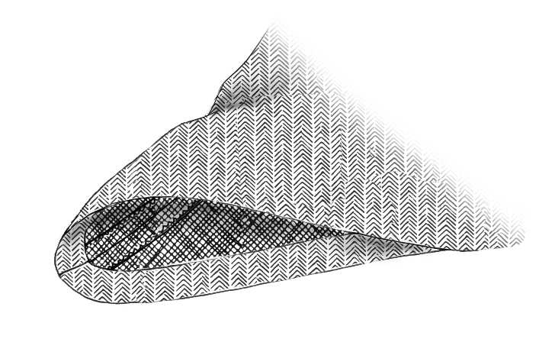

Illustration #2
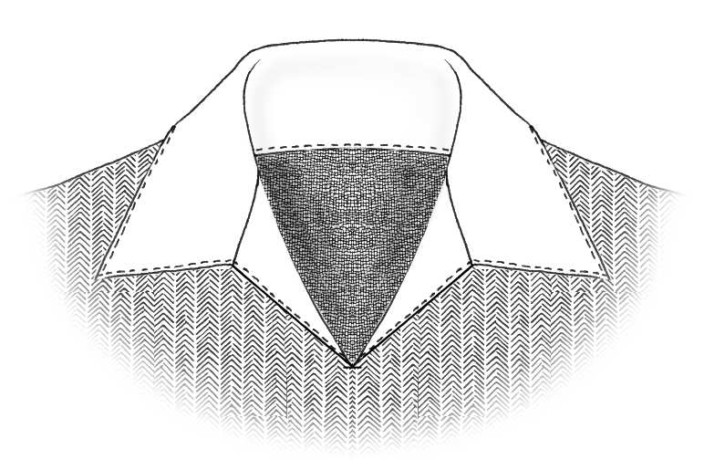
Illustration #3
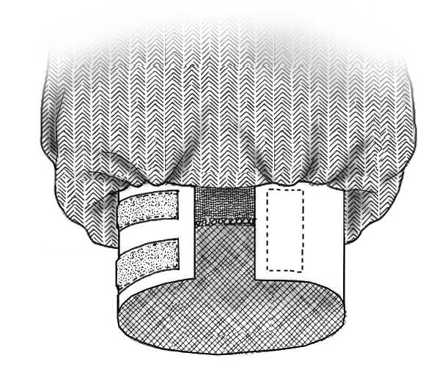

Illustration #4
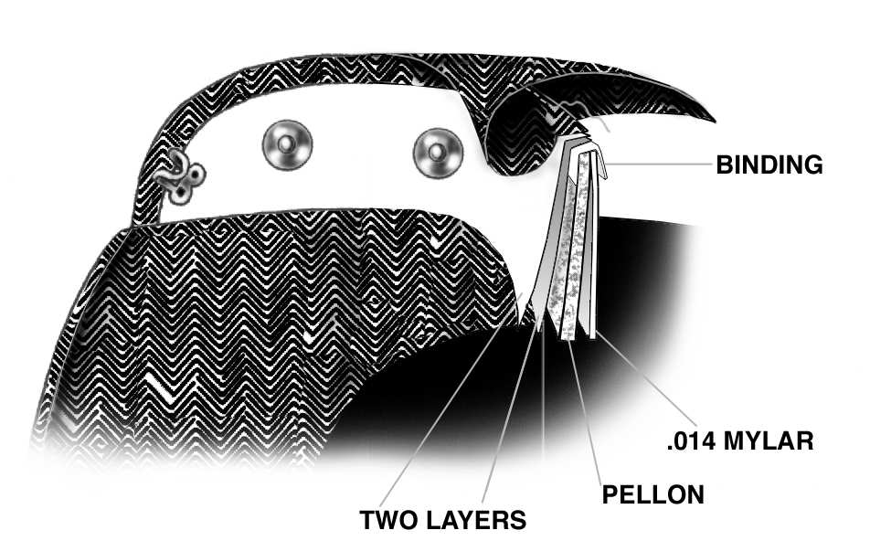
Illustration #5
