G925 - QUICK INSTALLATION GUIDE
SUNSPOT W1

A. PRODUCT PRESENTATION

FEATURES:
- RGB backlight with multiple selectable lighting schemes
- Instantly adjust and improve your aiming precision with a press of a button at your fingertip
- Ultra-lightweight, as low as 72 g, thanks to special chassis design with a perforated honeycomb pattern
- Rubber scroll wheel for enhanced precision

TECHNICAL SPECIFICATIONS
Sensor: PMW3325+HT68B571
DPI: 800-1600-2400-3600-5000-10000
Buttons: 7
Switch rating: 10 million clicks
Backlight: RGB
Interface: USB 2.0
Cable length: 1.7 m
Weight: 72g
Size: 125.5 x 65 x 37 mm
OS support: Windows 7 or newer

SYSTEM REQUIREMENTS
PC system or compatible with one USB port available, Windows 7 or newer operating system.

B. SAFETY NOTES
- Keep the equipment dry. Keep away from precipitation, humidity, all types of liquids and condensation.
- Do not use the product with wet hands.
- Do not use or store the equipment in dusty or dirty areas.
- Do not store the equipment under high-temperature or low-temperature conditions (this may damage it).
- Do not drop, knock or shake the equipment as it may damage it.
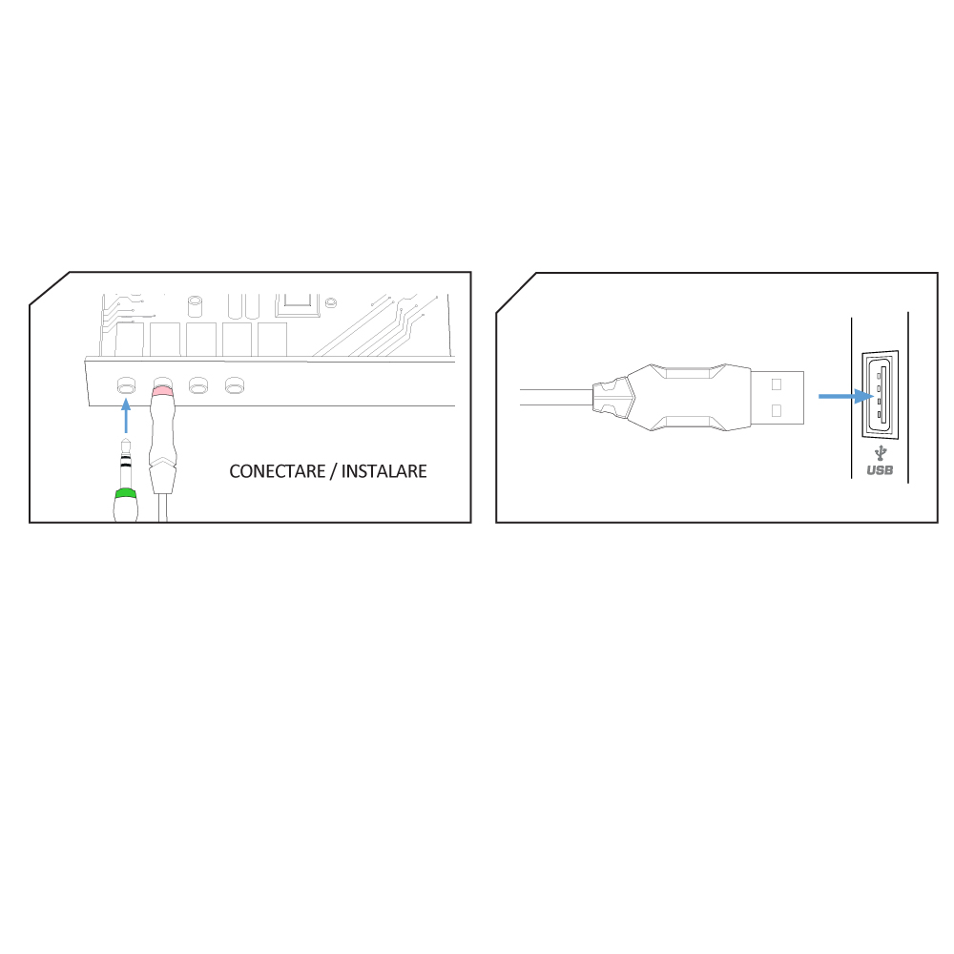
C. INSTALLATION
Connect the mouse to an available USB port on your computer. When connecting for the first time, wait 15 seconds until the generic driver is installed.

For advanced mouse configuration, please download and install the specialized driver at www.marvopro.com (an Internet connection is required):
- download the driver and double-click the executable file;
- follow the on-screen instructions and install the application;
- after installing the application successfully, an icon will be displayed in the taskbar;
- double-click this icon to launch the application.

D. USE
Press the DPI button below the scroll wheel to change the sensitivity according to predefined DPI steps.

Mouse driver use
Key Setting
Select “Keys” tab and set user-defined function of each key as following graph. 1 for Left Click, 2 for Right click, 3 for Middle Click, 4 for forward, 5 for back, 6 for DPI loop, is kept as default.
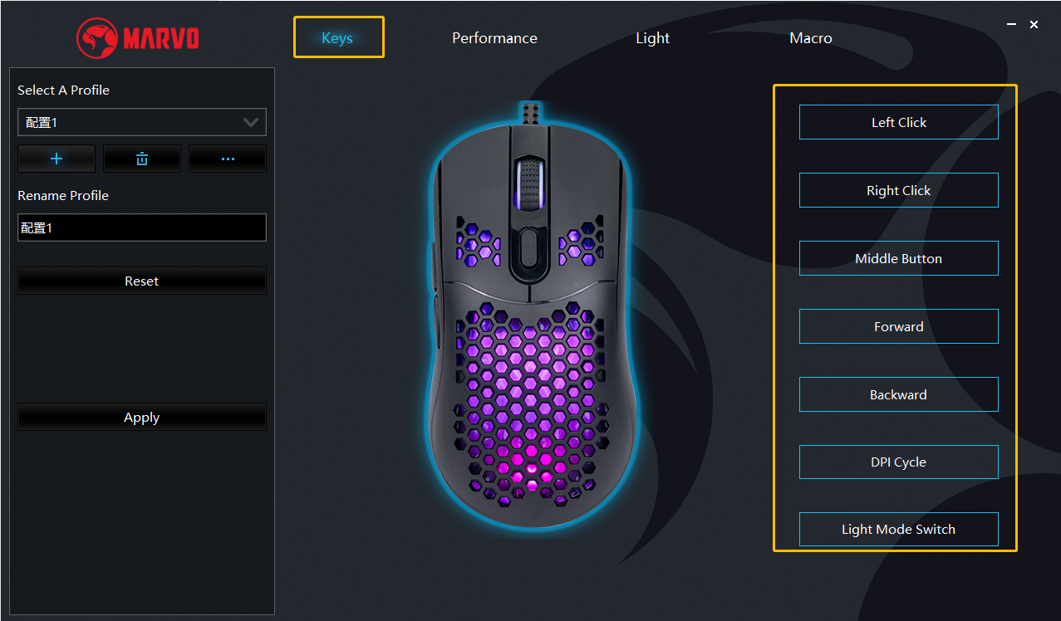

Click “Apply” to save the setting.

Performance Setting
One click the key you want to set then choose a new functions, and set Lighting colors/ Polling Rate/ Move Speed/Scroll speed/Double Click Speed/Key Response as following graph.

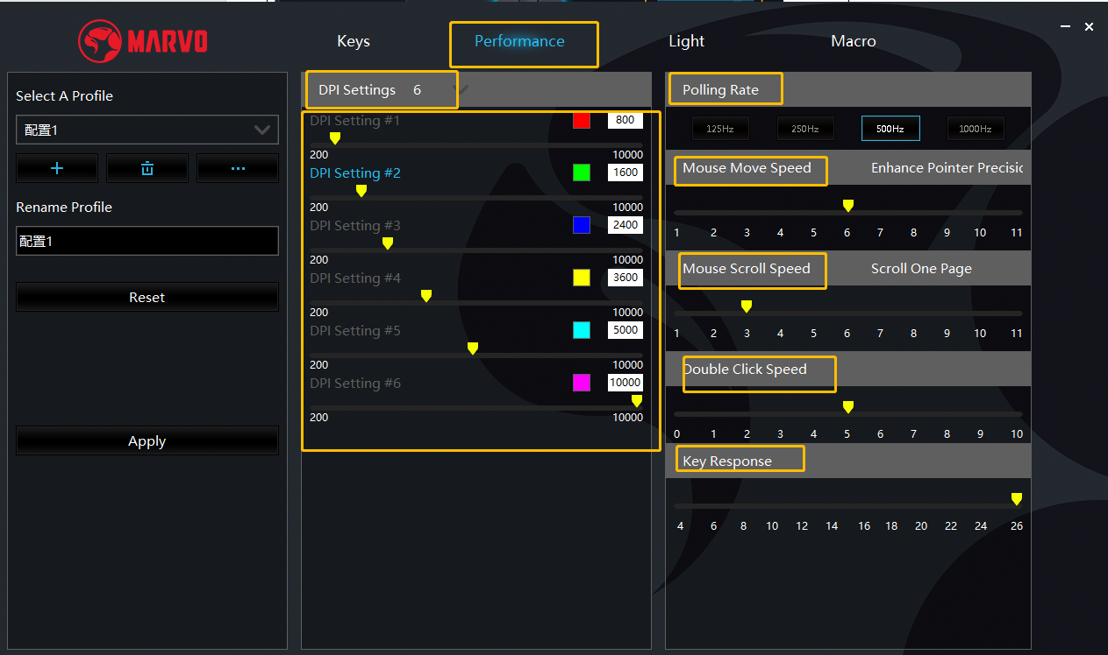

Click “Apply” to save the setting.

Lighting Setting
One click the key you want to set then choose a new functions, and set Lighting effects/ Parameter setting/ Intensity/Pulsation as following graph.
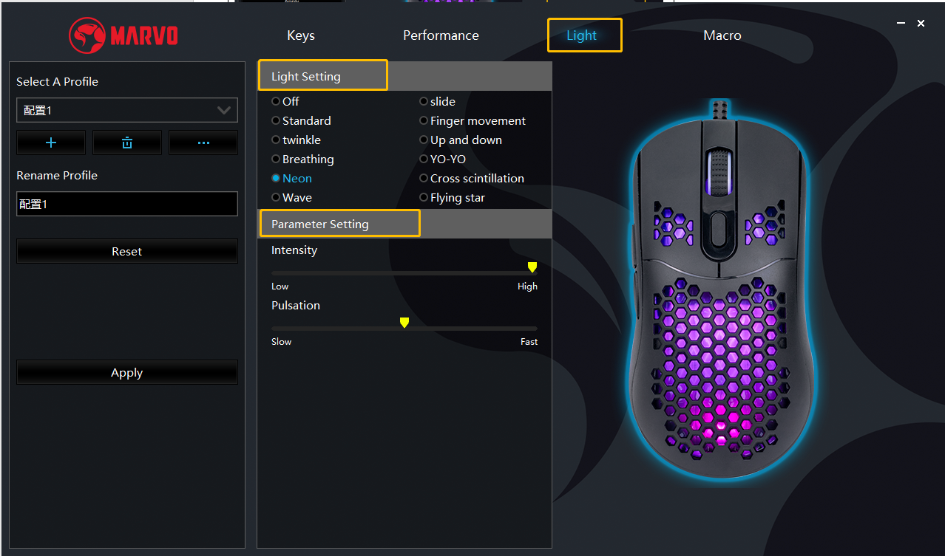

Click “Apply” to save the setting.

DPI Setting
The default DPI: 800-1600-2400-3600-5000-10000, you can set the DPI from 800-10000, and set DPI color at right part of this tab.
Click “Apply” to save the setting.
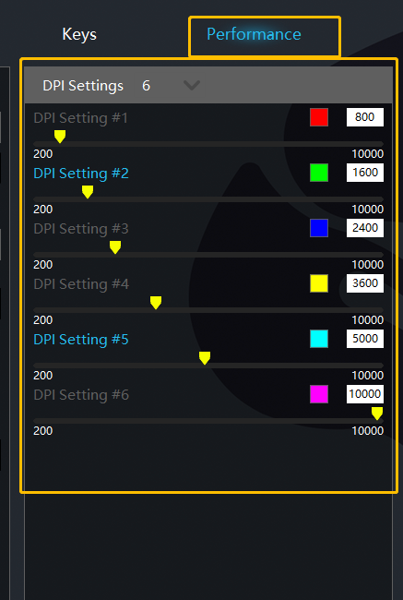

Macro Setting
Macro management can record any keys of keyboard, the time of keys reaction and the number of keys cycles.
Right Click and click “New Macro” to create a new file, such as a, b, c
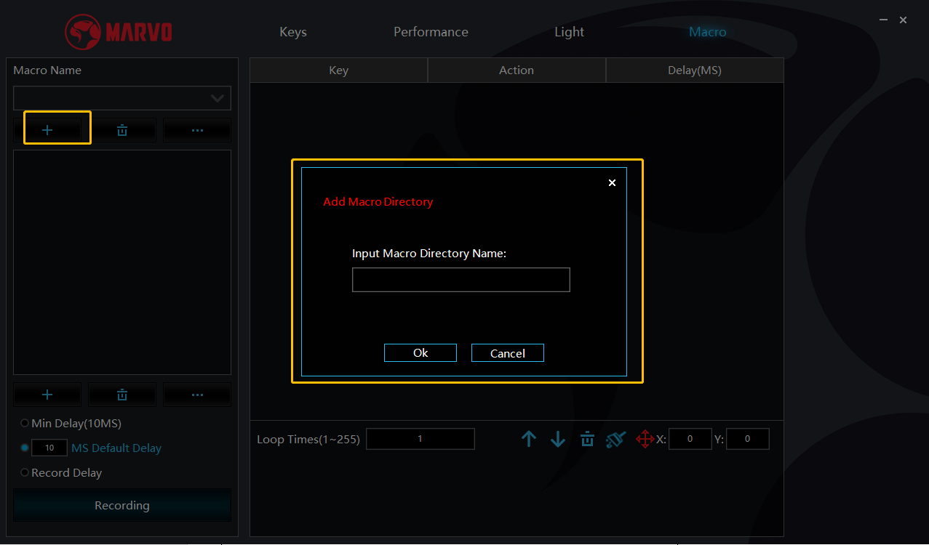
Click “Start record” and start recording any keys of keyboard. The keys you recorded will display in the macro edit box.
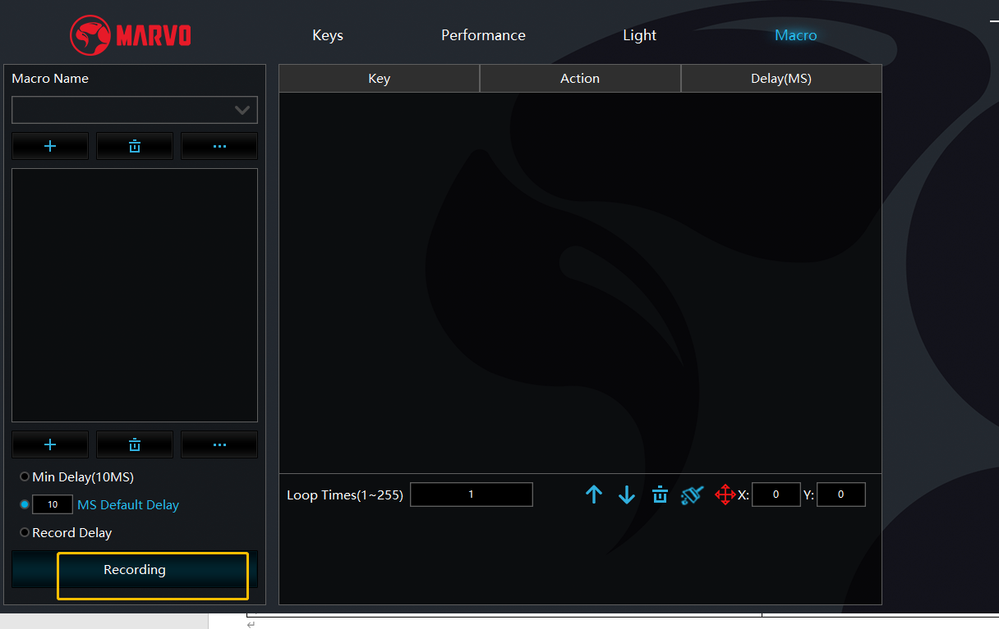
After the recording, click “Stop record” again to finish.

After recording is completed, just exit the macro recording interface, no need to click the confirmation keys.

Execute a macro, such as the mouse button “4” key set to “macro functions”, after recording is complete, press the mouse “4” key to play the recorded content.

E. TROUBLESHOOTING
In case of incorrect operation follow the steps below:
- Check the integrity of the connectors;
- Check the connection to the computer;
- Check your computer settings;
- Disconnect and reconnect the equipment; restart the computer.
If the problem persists, please contact your local seller.

F. GENERAL INFORMATION
- Unauthorized repairs or disassembly of the product will void the warranty and may cause its damage.
- This product is safe and complies to EU requirements.
- This product is manufactured conforming with the European RoHS standard. This standard was introduced to reduce the amount of electrical and electronic waste emitted into the atmosphere.
- Using the WEEE symbol (the crossed-out bin) indicates that this product is not household waste. When recycling waste properly, you protect the environment and people health. Segregated household waste collection, aids recycle materials and components used for the production of this device. For detailed information about recycling, please contact your retailer or a local authority.

Warranty Card
Product Model：
Product Serial No：
Date of Purchase：
Customer Name：
TEL：
Address：
Distributor Name：
TEL：
Warranty Card is the important certificate for after-sale service of Marvo products, please keep it appropriately.

