LGMLED2 - Epsilon Wired MMO Gaming Mouse
Customised Software
- For more customised functions, please visit the below link to download and install the software
https://www.lycangamer.com/downloads
- After installing the software, locate the shortcut to the Epl mouse software on your desktop.
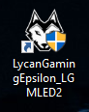
- Keys
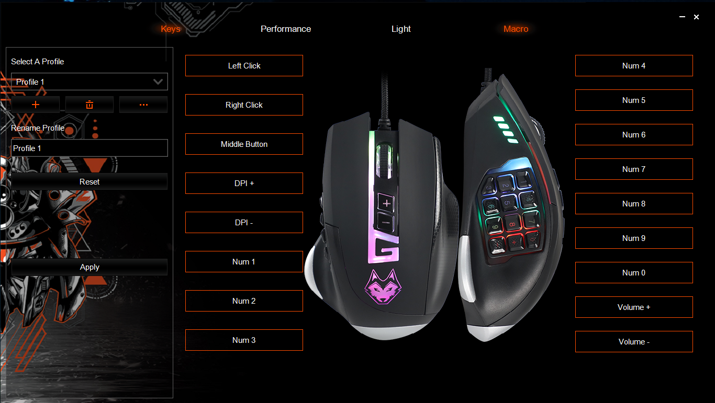
Profiles are featured on the left side of the windows for you to save and apply different profiles for your mouse.
17 Buttons can be assigned to function as regular buttons or alternative functions.
Assign Buttons:
- Basic Function
- High Order Function
- Button off
- Shortcut
- Macro
- DPI
- Report
- Multimedia
- Windows
- Office
- Advanced

Reset is the default setting on the mouse. After making key changes, you can save the mode setting and load pre-saved settings.

- Performance
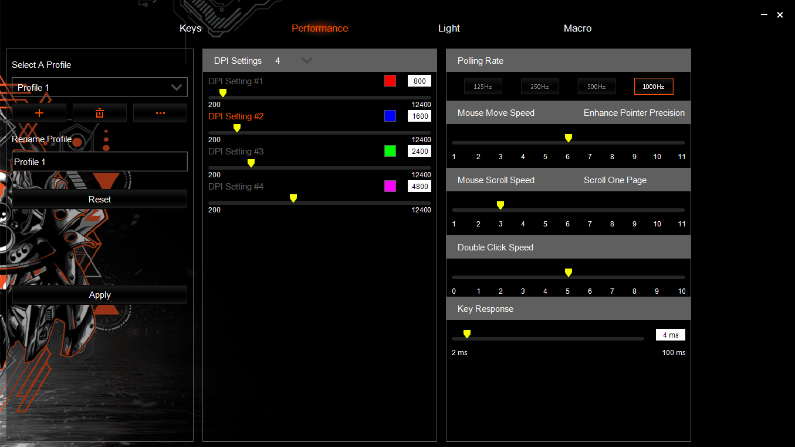
DPI Settings are hardware settings for the mouse laser before the software mouse sensitivity is applied. DPI stands for dots per inch or, in gaming terms, pixels per inch. DPI determines how far a cursor moves per inch of mouse movement. 800 DPI = 1-inch mouse movement, moving the cursor 800 pixels. The lower the DPI, the less sensitive your mouse is.
1 – 8 DPI settings you can preset and scroll through using the DPI Loop button on the mouse. You can also assign an LED Colour for each of the DPI Settings.
Polling Rate is the Hz rate at which the laser scans the surface.
Moving Speed is a mouse movement setting with the added function of the Enhance Pointer Precision to dial in your preferred mouse speed.
Double Click Speed is a setting for opening documents and other functions requiring a double click.
Rolling Speed is the scroll speed setting for browsing websites, documents and folders with the added feature to Scroll One Screen At A Time
Key Response is the speed at which the mouse responds to your clicks.

- Light
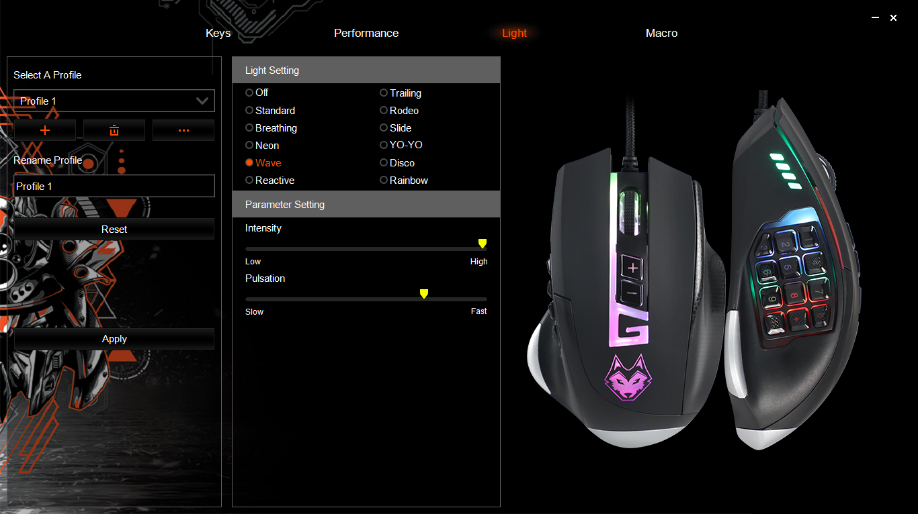
The Light menu is for setting up the LED lighting effects on the mouse, including power status and the adjustment of brightness settings.
The lighting features up to six colour modes and the breathing speed of the colour effect.
- Light Off
- Standard
- Breathing
- Neon
- Wave
- Reactive
- Trailing
- Rodeo
- Slide
- YO-YO
- Disco
- Rainbow
Intensity is the brightness of the RGB Lights.
Pulsation is the speed of the RGB Lighting Effect animation.

- Macro
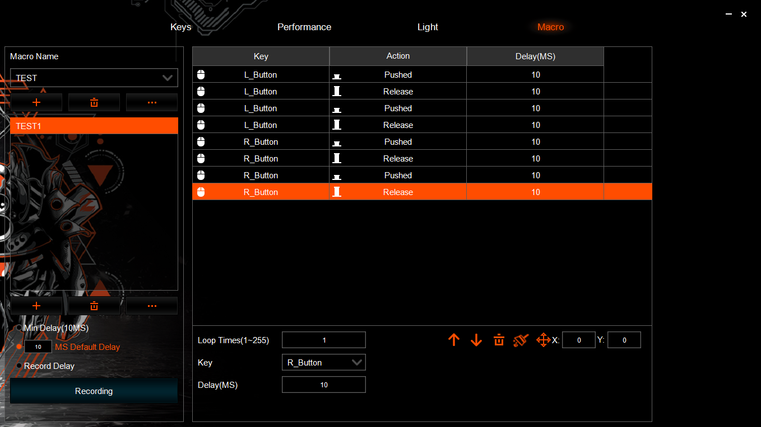
The Macro section is for creating and assigning settings for macros, including a list of commands with or without delays and the ability to save macro content on the mouse.
Set your default Min Delay (10MS) before recording.
Assign a Macro Directory name, Add an input macro name, and then record the list of commands. After the recording has been made, you can adjust the commands and save the macro.
Once the macro has been created, you can assign the macro to a button in the Keys section.

