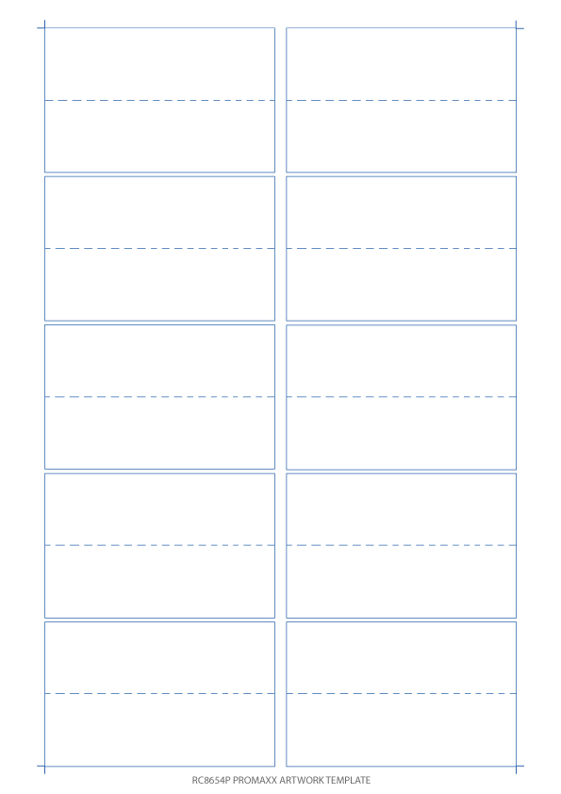­­­­­

Insert Text / Image

Insert Text / Image

Insert Text / Image

Insert Text / Image

Insert Text / Image

Insert Text / Image

Insert Text / Image

Insert Text / Image

Insert Text / Image

Insert Text / Image

Insert Text / Image

Insert Text / Image

**WHEN DESIGNING**

If you wish to have background colours in the design, make sure they go outside of the template lines to allow for any misprint.

**WHEN PRINTING**

Print a tester before you use our card templates to make sure your design prints in the same direction/orientation.

**­­WHEN PRINTING**

Print a tester before you use our card templates to make sure your design prints in the same direction/orientation.

**HOW TOs AND MUST DOs**

* Place writing in the design by inserting text boxes.
* When placing images onto this template make sure to ‘Text Wrap’ in

‘Image Format’.

* Before printing your designs make sure to delete the template layer by simply clicking on an empty section of the page and pressing delete.

**TOP TIPs:**