`

Requirement | Information
Supplier Details | Name  Address  Phone  Fax  Technical  Sales Representative  Crisis Management  Quality Coordinator | The Flour Shop  1435 Boundary Road, Wacol Qld 4076 Australia  61 7 3271 1616  61 7 3271 2814  Matt Harper  David Casey  Matt Harper  Stacey Wouters
Product Name | Poppyseed Bagel
Product Code | 131
Product Description  Appearance  Colour  Falvour  Odor  Texture | White dough bagel topped with poppy seeds  -See below  -

Product Picture

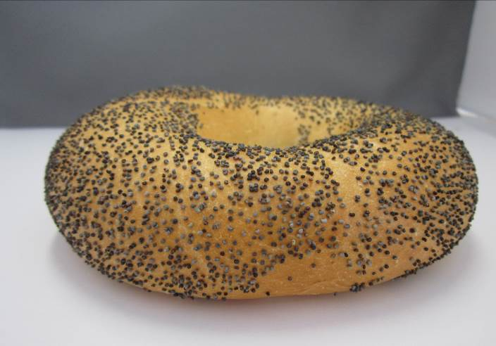
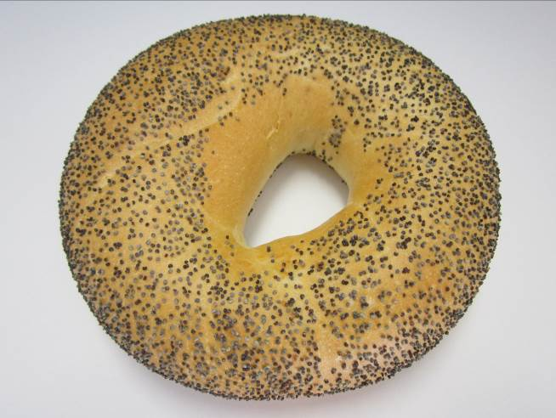

Regulatory Criteria  Labeling | Labeling of finished products is in accordance with:  - State Trades, Weights & Measures legislation  - Australian Food Standards Code labeling requirements  - Inclusion of nutritional analysis information  - Labeling of allergens  - Suitable for freezing
Country of Origin | Made in Australia.
GMO | Based on current regulation definitions and supplier information, this product does not require labeling under Standard 1.5.2 of the Food Standards Code.
Microbiological Specification  Aerobic Plate count  Yeast and Mold | Test method | Standard Tolerance | Min. Test frequency
 | External Lab | <50,000 cfu/g | Annual
 | External Lab | <10, 000 cfu/g | Annual

Allergens | This product contains:  Wheat  Soya Flour  This product may contain traces of: nuts, rye, oats, barley, Sesame seeds.

Raw Ingredients | Wheat flour, Water, Sugar, Yeast, Veg Oil, Iodised Salt, Soya Flour, Emulsifier (481, 472(e)), Malt Flour, Vitamins (Thiamin and Folate), poppy seeds.

131 Poppyseed Bagel

NUTRITION INFORMATION
Servings per package: 1
Serving size: 80g
 | Average Quantity per Serving (80g) | Average Quantity per 100g
Energy | 1600kj | 2000kj
Protein | 11.1g | 13.8g
Fat, Total | 3.1g | 3.9g
- Saturated | 0.4g | 0.5g
Carbohydrate | 74.6g | 93.3g
- Sugars | 2.6g | 3.3g
Sodium | 778mg | 973mg

Physical Specifications |  | Standard & Tolerance | Test Method | Minimum Test Frequency
Physical Specifications | Dimensions | Length N/A  Width 125mm(+/-5)  Weight 80g (+/- 15) | Random samples Measurements | Hourly
Physical Specifications | Defects | Colour – Too dark  Shape - tapered | Visual inspection of finished product | Every unit
Physical Specifications | Foreign Material |  | Flour Seive (2mm) | Every unit

Slicing | N/A
Topping | Poppyseeds

Packaging | N/A

Shelf Life | 3 Days Ambient (20 - 30 Celsius)
Transport Conditions | Enclosed food transport vehicle.
Customer Preparation | Ready for use
Storage Conditions | Keep in airtight container for freshness ambient or chilled
Food Safety – HACCP | The Flour Shop Bakery is committed to the production of high quality, safe food products. To this end we have developed and implemented a food safety program that meets the requirements of 3rd Party HACCP and Spotless Certification.

The product information contained in this specification is based on data considered to be accurate and reliable at the date of the compilation of the specification, to the best knowledge and belief of the manufacturer. The user should therefore use any necessary precautions to ensure the safe and suitable use of the product during handling, storage and disposal as this is beyond the control of the manufacturer.

Authorised by: … … … … … …… … …… … ..… ..… … … … …01.07.2014

UNCONTROLLED COPY
Will not be updated unless requested

