**Greetings!**

By now, you should have heard from a representative of your bottling company about the Beacon roll-out program in vending.

In an effort to enhance the consumer experience, we have developed a simple solution that allows our vending machines to provide messaging to smartphones and other connected devices.  These notifications will not only inform consumers that a vending machine is nearby, but it will also let them know exactly how many purchases remain until they **earn their next free Coke** to drive more incidence.

We have completed a successful pilot across many markets and are excited to further expand the offering to your market. In this box, you will find individual beacon devices that are assigned to specific outlets. We ask for your assistance in deploying these beacons to their respective outlets.

**Deployment Process**

1. Our technology provider has packaged a bluetooth beacon in a small zip-loc bag for each machine and labeled it with an outlet number/address for easy identification.
2. Each sales center will receive a box of beacons for the venders in their territory addressed to the Full Service Supervisor.
3. Each Full Service Supervisor should conduct a quick training on the experience and how it works. Each supervisor will then staple the beacons to the appropriate route card for drivers to take on their daily trips.
4. During each visit to the vending machines, the driver should bring their box of beacons, find the one that matches the outlet number, and simply plug it into the telemeter.
5. Full Service Supervisors will track each beacon installation and report back to the spreadsheet provided to them.

The following page contains **Training Points and Installation Instructions** for the drivers. Should there be any questions, please don’t hesitate to reach out to me directly.

Thanks for your partnership with this roll-out!

**Billy Koehler**



**Consumer Experience – Push notifications from vending machines within 30 feet of the consumer.**

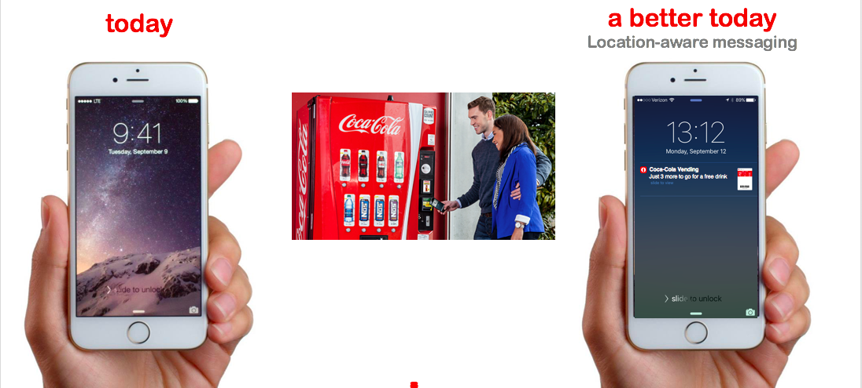

**Consumer Enrollment – 3 easy steps through a text message.**

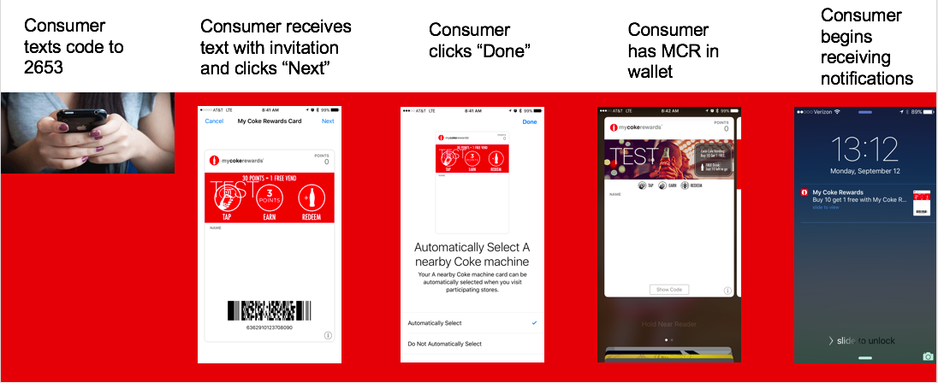

**Installation Instructions**

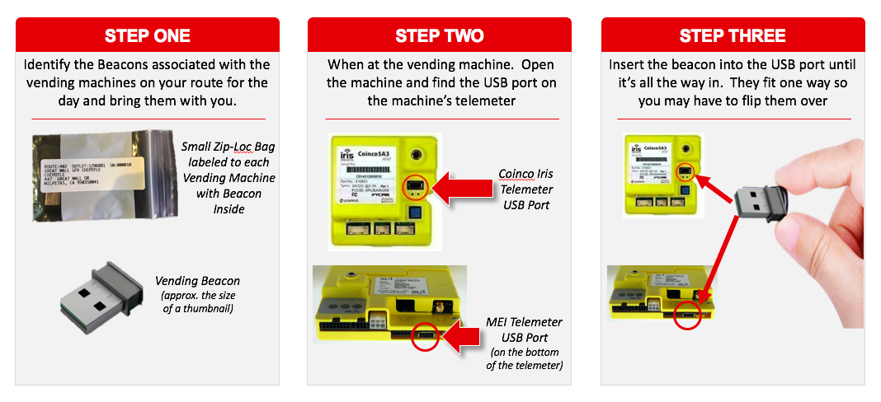

**There are no additional installation steps. Once the beacon is plugged in, it will start communicating.**