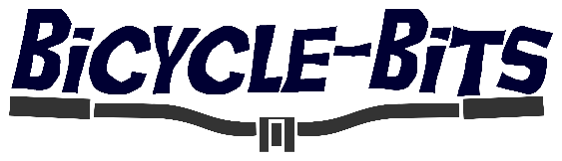
Customized Kit requirements.
Complete by ticking or circling requirements then returning to us at admin@bicycle-bits.com
Name: ________________________ Email Address: _________________________________
Item
Women’s |  | Men’s
Short Sleeve Shirt |  | Long Sleeve Shirt
Shorts |  | Bib Shorts

Required Size
XXS | XS | S | M | L | XL | XXL | XXXL | 4XL | 5XL | 6XL

Other Requirements
Full Length Zip |  | Quarter Length Zip |  | Zipped Rear Pocket
Thermal (Long Sleeve Only) |  | Non-Thermal |  | Remove Elastic Waste Gripper

