|  |  |  |  |
| --- | --- | --- | --- |
| **MATERIAL** | **MEDICAL** | **FDA** | **SIZES** |
| Nitrile: 100% Latex Free and Powder DEHP Free  Textured | Examination Grade  Meets FDA 510K Standards for Medical Application | Meets Federal Food, Drug, and Cosmetic Act for Direct Contact with Food | Small: #9996  Medium: #9997  Large: #9998  X-Large: #9999 |

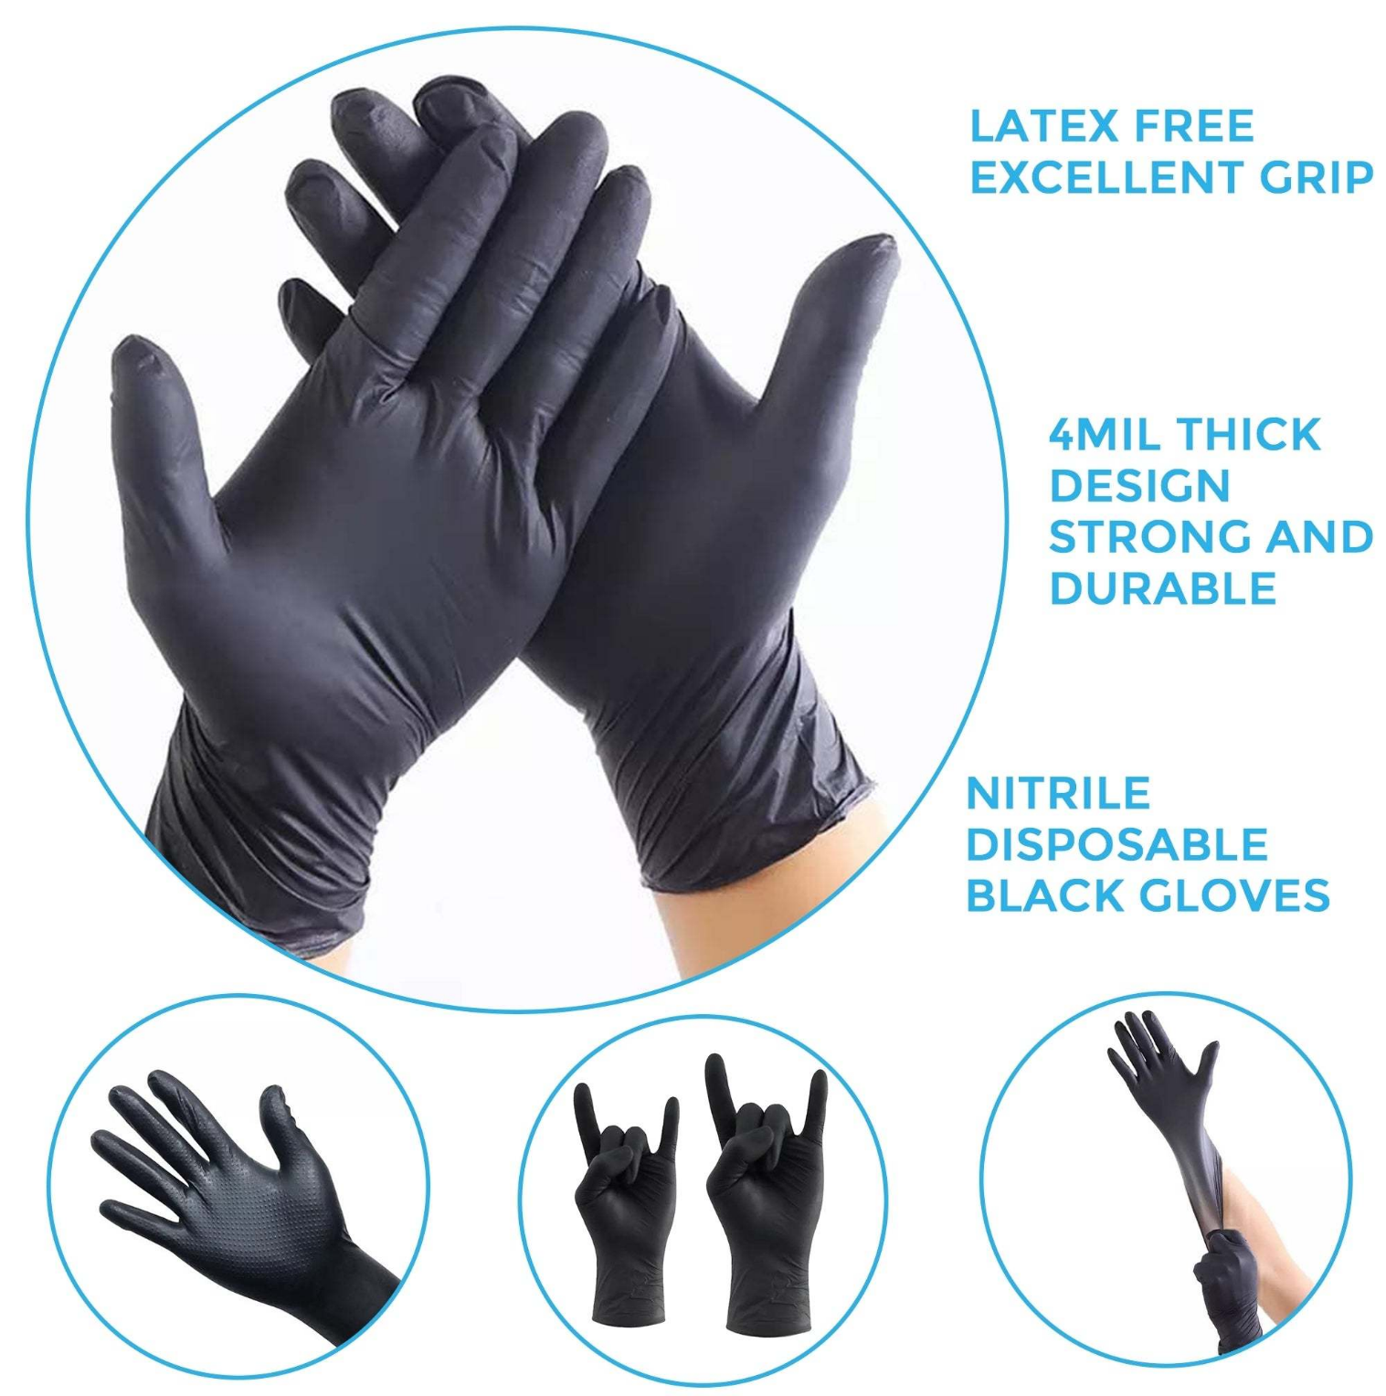

**6MIL THICK DESIGN STRONG AND DURABLE**