PAPER 80 Light Settings
Step 1 Open VIA 3.0
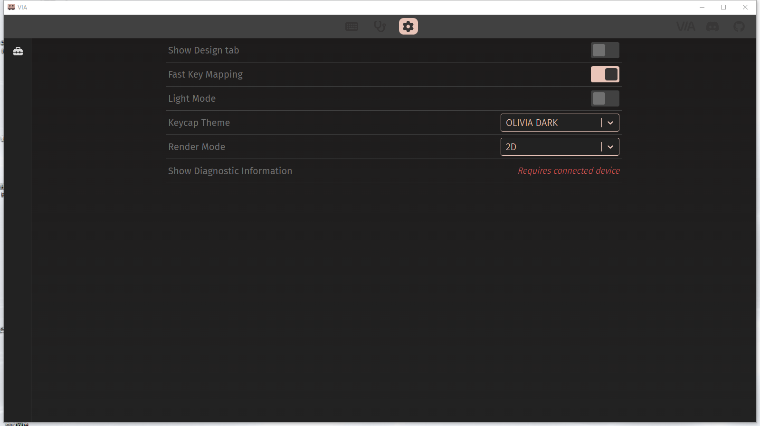
Step 2 Open the Show Design tab
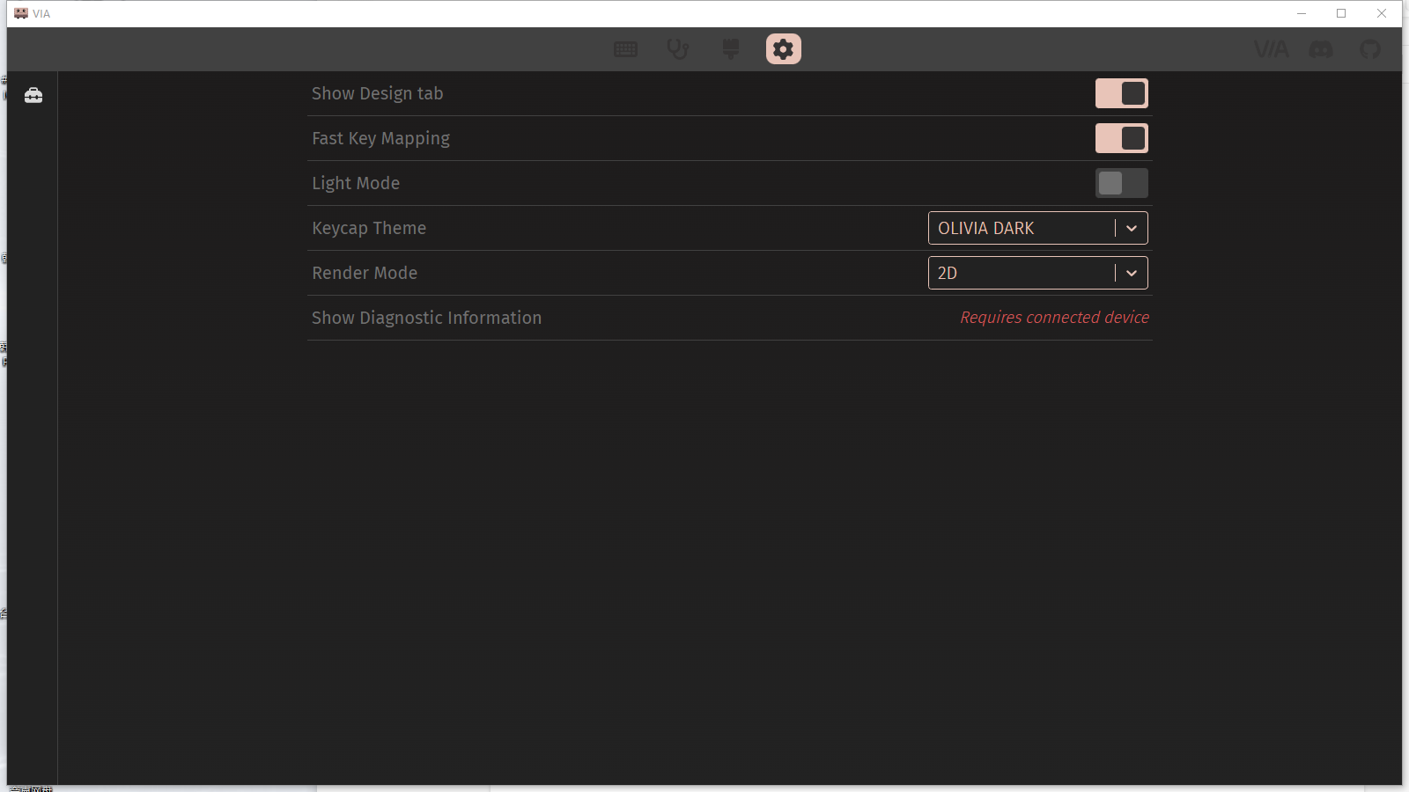
Step 3 Click load to import the PAPER 80.jason file.
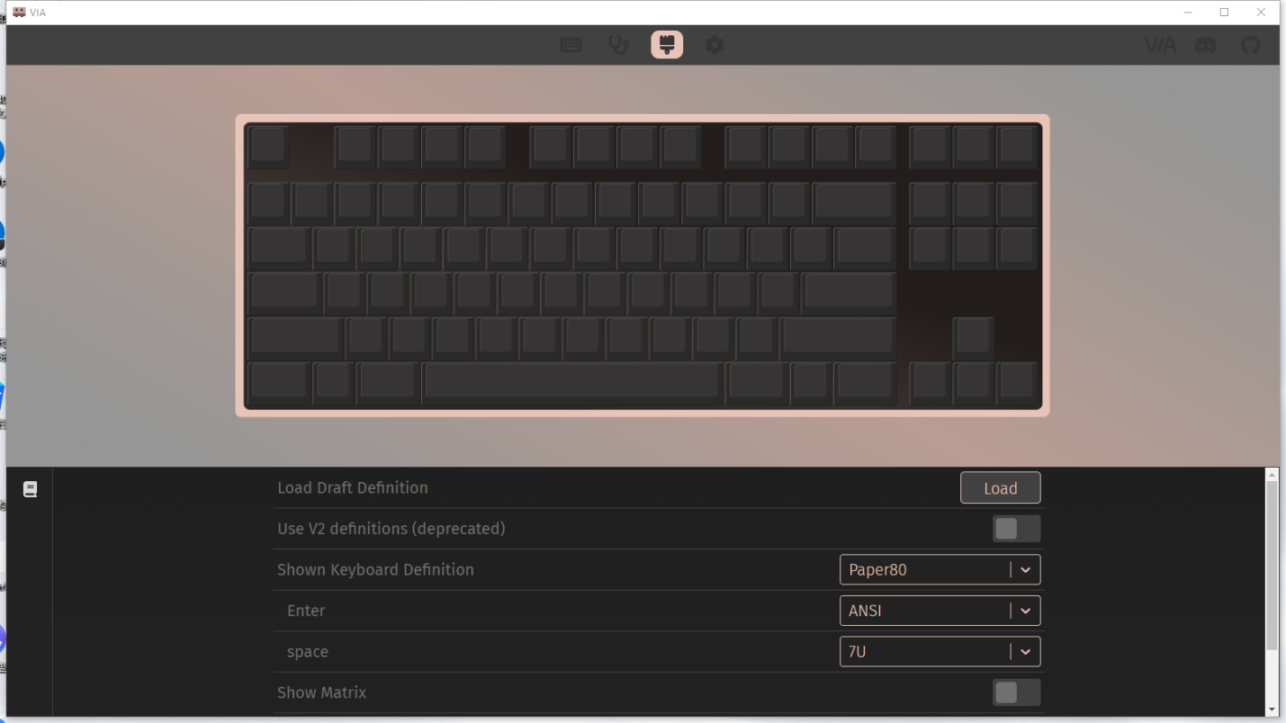
Step 4 Set the light button F24 in the second layer, this button can control the light area, you can only light the logo light and the bottom ambient light. 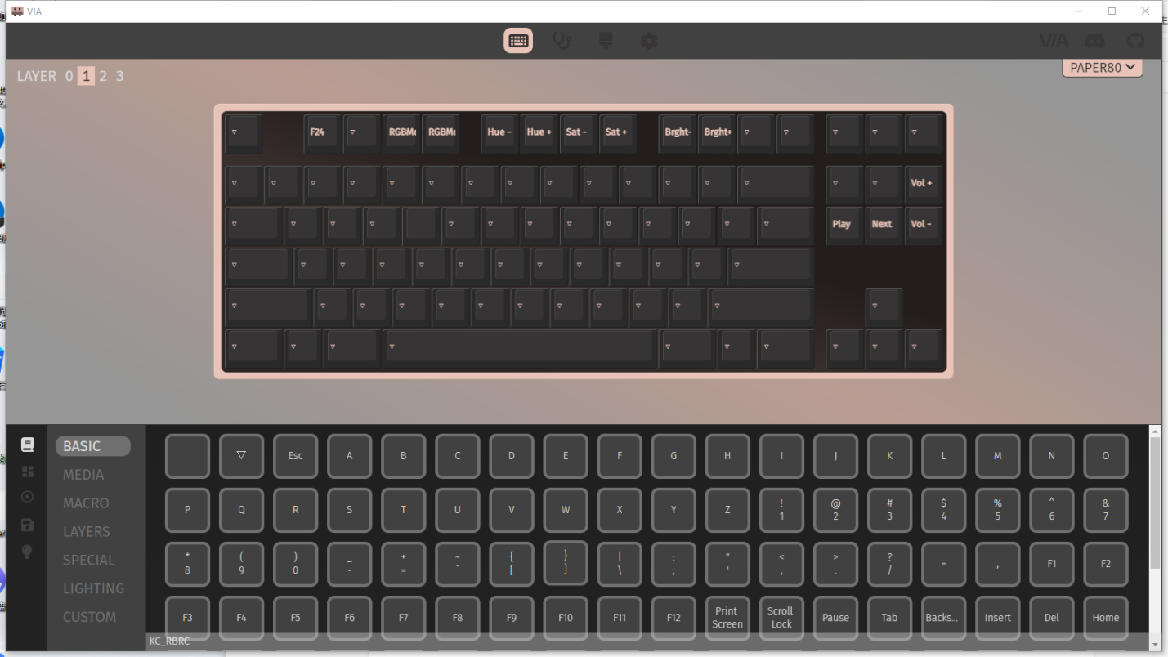

Lighting can be adjusted in the LIGHTING area
