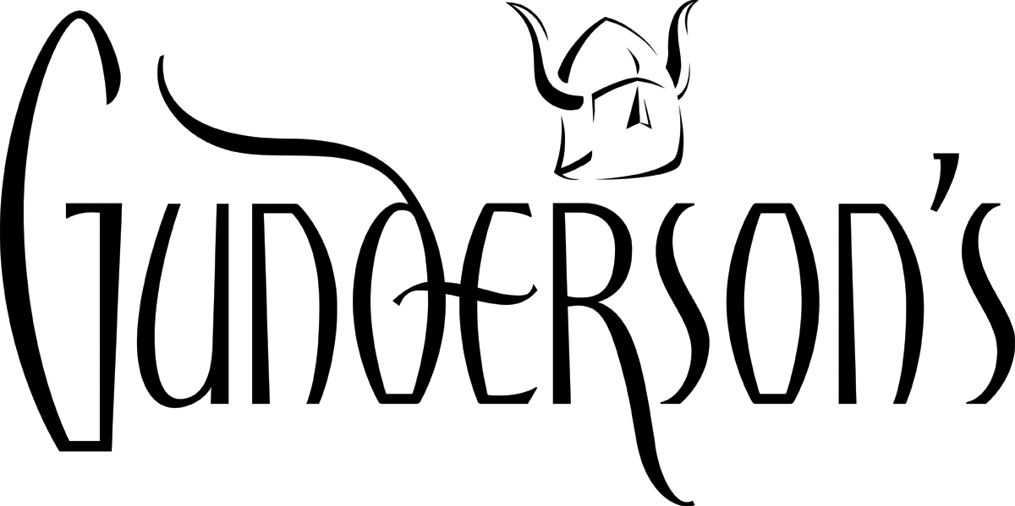

**Job Title**: Sales Assistant

**Location**:

**Reports to**: Store Manager

**Position Summary**: The Sales Assistant supports the Store Manager and Sales team. The Sales Assistant will support sales staff by providing administrative, clerical, and direct customer support as needed.

**Essential Functions:**

* Answer incoming calls, assist callers, and direct to appropriate staff
* Assist sales staff with ringing up sales and wrapping gifts
* Assist customers if sales associates are busy assisting others
* Take in, log, and disseminate repairs to appropriate technician. Ensure that each repair is completed by the date assigned. Prepare all necessary paperwork, and call customers when ready for pickup
* Assist sales staff with cleaning cases and displaying items
* Assist sales staff with store set-up
* Assist sales staff with writing appraisals
* Maintains proper levels of sales supplies

**Job Requirements:**

* High school diploma or equivalent required
* General office experience, telephone, typing, documentation skills required
* Demonstrated ability to develop relationships with customers and co-workers required
* Ability to quickly learn new procedures and processes required
* Ability to work in a fast-paced, changing environment required
* Proficiency in Microsoft Outlook/email required
* Experience with POS systems desired
* Attention to detail required
* Strong organizational and follow-through skills required
* Excellent communication and interpersonal skills required
* High level of ownership, accountability and initiative required
* High level of confidentiality required

**Supervision of Others:**

* No supervisory responsibilities

**Effort:**

* Daily lifting of up to 20 pounds required, with occasional lifting up to 50 pounds desired
* Ability to bend/stoop, squat, twist, reach, kneel and balance required
* Ability to concentrate on and accomplish a task or work despite distractions and interruptions required
* Ability to handle multiple tasks required
* Ability to work under time pressures created by due dates and deadlines required
* Ability to work with great precision with tiny objects required

**Consequence of Error:**

Errors in completion of position duties can result in:

* Misplaced or misrepresented merchandise, which can impact the Sales or Repair staff
* Customer dissatisfaction, which can directly or indirectly affect the entire company

**Working Conditions:**

This position requires retail working hours including evenings and weekends, and special events; and overtime required during holidays and inventory

The activities listed above are those anticipated as being necessary for performance of the duties of this position. Other non-essential functions may be assigned at the discretion of management.

**Acknowledgment:**

I have read and understand this job description and I am capable of performing the duties and requirements of this position.

______________________________________ ____________________________________

Employee Signature Date Manager Signature Date

______________________________________ _____________________________________

Employee Print Name Manager Print Name