JIANGSU LINGHUI INTELLIGENT TECHNOLOGY CO.,LTD

LCD-M5 Hand Control Panel Operation Instruction
2017Latest Edition-V1.1 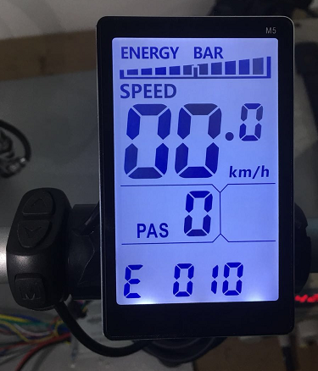
- Out shell Size and Material
Out shell material is ABS, Liquid crystal transparent window material is high hardness acrylic。

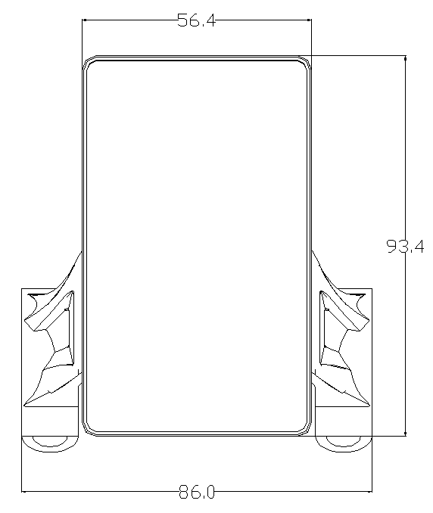 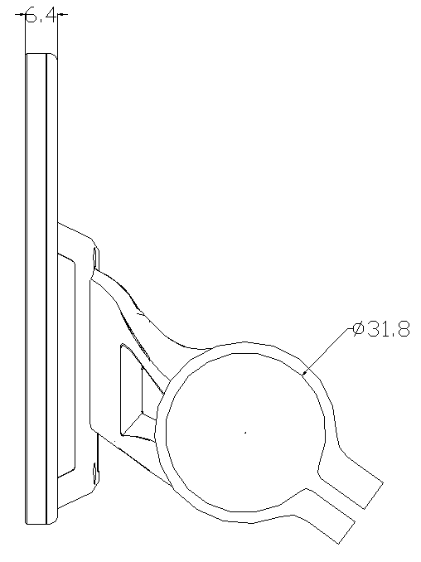 Front view Side view
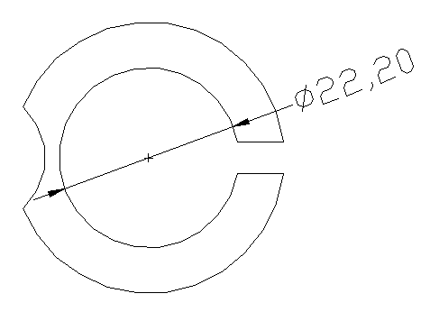31.8mm stent is available 22.2mm、25.4mm、28.6mm Transfer Ring Selection

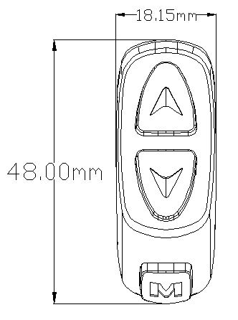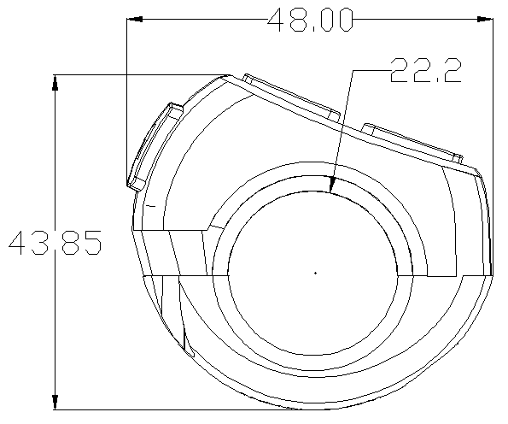
Switching view Switch Side View

- Work Voltage and connection mode

- Work voltage：DC24V 、36V、48V、60V 、64V(which you can choose on the meter),the others you can customized.
- Connection mode ：
Line sequence of the label connector

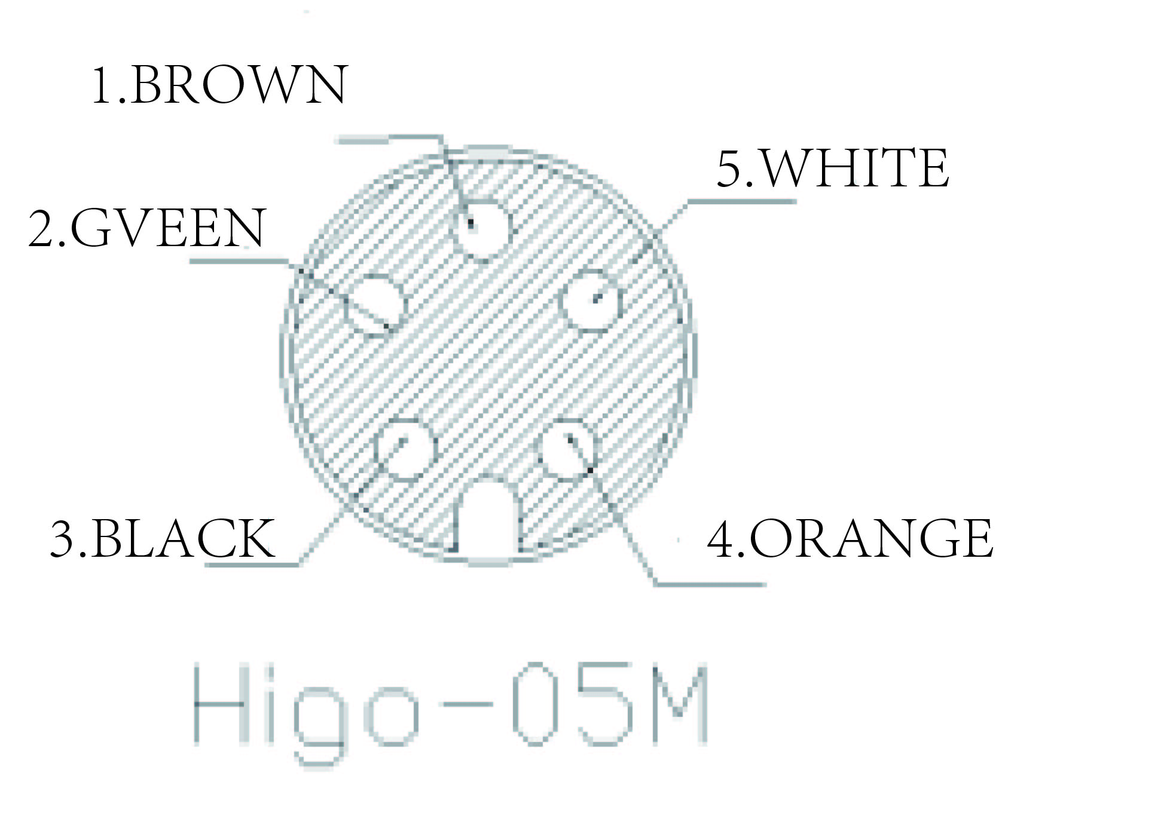
Instrument Outlet

Table: Line sequence of the label connector table
Order of line | Color of line | Function
1 | Brown（VCC） | Instrument power cord
2 | Green（RX） | Meter data receiving line
3 | Black（GND） | Meter earth wire
4 | Orange（K） | Controller power line
5 | White（TX） | Data transmission line of instrument

Notes: Part of the products lead wire use waterproof connection. User cannot see
the color of lead line.

3、Function description
1) Display function
Speed display, power level display, power indicator, failure warning, total mileage, single mileage, headlight display, single driving time display
- Control, setting up functions
Power switch control, headlight switch control, 6Km/h point control, wheel diameter setting, maximum speed setting, idle automatic hibernation time setting, backlight brightness setting, voltage level setting
- Communication protocol：UART
All the contents of the display screen(full display in boot 1S)

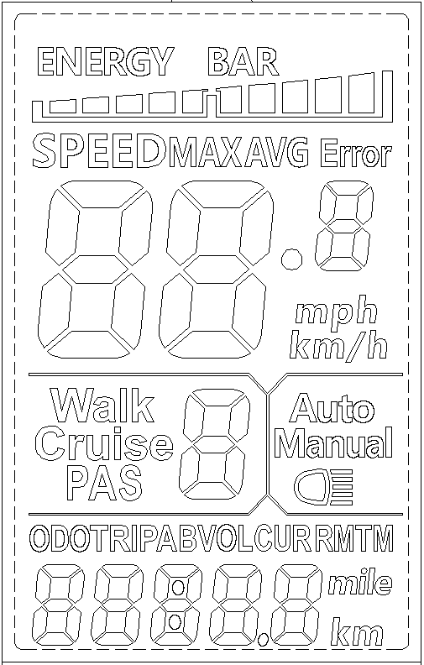

Show content introduction
3.1 Headlight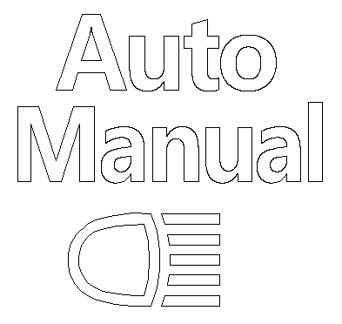 The instrument can be manually turned on and the brightness of the sensing environment is automatically turned on(light sensitivity support is required).
3.2 Battery power display BATTERY 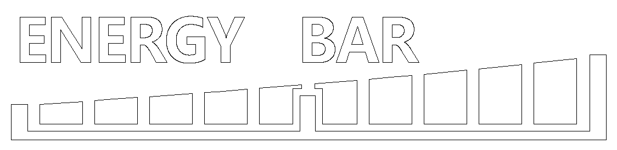
3.3 Multifunctional display area
Total mileage ODO, single mileage TRIP A, single mileage TRIP B, battery current voltage VOL, current operating current CUR, remaining mileage RM; Instrument boot time TM
3.4 Vehicle mode
Walk boost mode; Cruise: constant speed cruise mode; PAS: Power file position: 0 ~ 9 adjustable;
3.5 Speed display area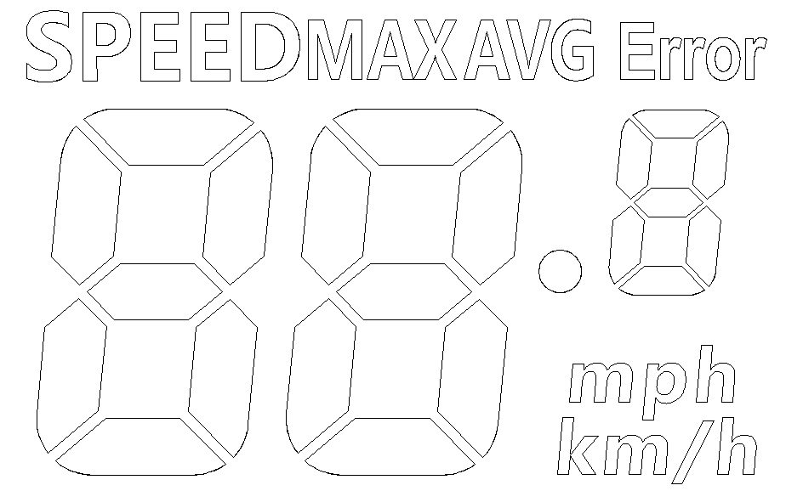
Maximum speed MAX, average speed AVG
Unit MPH, KM/H
The meter will calculate the true speed based on the wheel diameter and signal data
3.6Vehicle Status Display Area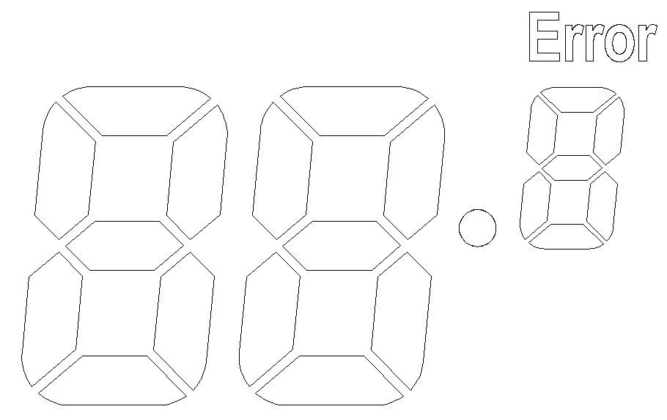
Vehicle Status Code Meaning：
Status Code(Decimal) | State Meaning | Remarks
0 | Normal
1 | Reservation
2 | Brakes
3 | Power Sensor Fault(Riding Mark) | Not Realized Here
4 | 6KM/H cruise
5 | Real-time cruising
6 | Battery undervoltage
7 | Motor failure
8 | turn malfunctioning
9 | Controller failure
10 | Communication reception failure
11 | Communication dispatch failure
12 | BMS communication failure
13 | Headlight failure

5S Protocol Vehicle Status Code Meaning：
Status Code(Decimal) | State Meaning | Remarks
33 | Current anomaly
34 | Turn the anomaly
35 | Motor phase deficiency
36 | Motor Hall anomaly
37 | Brake anomaly.
30 | Communication anomaly

3.7.install
P01：Backlight brightness, the darkest level 1, the brightest level 3;
P02: mileage unit, 0: KM; 1: MILE;
P03: Voltage level: 24V, 36V, 48V, 60V, 64V default 36V;
P04: Dormancy time: 0, not dormancy; Other numbers are dormancy times, range: 1-60; Unit minutes;
P05: Help file bit: 0, 3 file mode:
1,5 gear mode:
P06: Wheel diameter: unit, inch;
Protocol 2 wheel diameter value: 5.0 ~ 50 Precision: 0.1 inch
5S protocol wheel diameter value: 0:16 inch, 1:18 inch, 2:20 inch, 3:22 inch,
4:24 inch, 5:26 inch, 6:700 C, 7:28 inch;
This parameter is related to the meter display speed and needs to be entered correctly;
P07: Speed gauge magnetic steel number: range: 1-100;
This parameter is related to the meter display speed and needs to be entered correctly;
If it is an ordinary hub motor, the number of magnetic steel is input directly;
If it is a high-speed motor, it is also necessary to calculate the deceleration ratio, and the input data = the number of magnetic steel × deceleration ratio;
For example: number of motor magnets 20, deceleration ratio 4.3: input data is: 86 = 20 × 4.3
P08: Speed limit: Agreement No. 2 range 0-100km / H, 100 means no speed limit;
5S protocol 0-41km / H;
The input data here represents the maximum operating speed of the vehicle: for example, input 25, indicating that the maximum operating speed of the vehicle will not exceed 25km/h; The drive speed is maintained at the set value,
Error: ± 1km/h; (The speed limit for power and turning is equal)
Note: The value here is based on kilometers. When the unit setting is converted from kilometers to miles, the speed value of the display interface automatically converts to the correct mile value, but the speed limit value data set at this menu under the mile interface is not converted. Is inconsistent with the actual speed limit of the mile speed;
P09: zero start, non-zero start setting, 0: zero start; 1: Non-zero start;
P10: The drive mode is set to 0: Power Drive(how much power is output is determined by the power file bit, and the switch is invalid at this time).
1: Electric drive(by turning the handle drive, the power file bit is invalid at this time).
2: Power Driven and Electric Driven Coexistence
P11: Help sensitivity setting range: 1-24;
P12: Help start intensity setting range: 1-5;
P13: Power Magnetic Steel Disk Type Setting 5, 8, 12 Magnetic Steel Types
P14: Controller limit value set default 12A range: 1-20A
P15: Controller undervoltage
P16: ODO zero setting length press key 5 seconds ODO zero
P17 :0: No enabling cruising, 1: enabling cruising; Automatic cruise optional(valid for protocol 2 only)
P18: Display speed ratio adjustment range: 50 % ~ 150 %,
P19: 0 power bit, 0: 0 file, 1: does not include 0 file
P20 :0:2 Protocol 1:5 S Protocol 2: Standby 3: Standby

4.Key Introduction：
The specific combination of keys is as follows
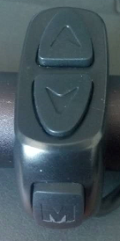

Press the button to use the brief
Key operation is divided into short press and long press, and combination key length press
Short press is used for rapid/frequent operations, such as the specific key combination position as follows
1. 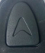 When riding, you need to modify the power/speed file, short press

2. 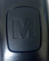 Toggle display data for multi-function areas during cycling, short click
Single key length is mainly used to switch the mode / switch state
Composite keys(long presses) are used to set parameters because the operation is complex, which can reduce errors
(Short press does not make the composite key, because it is easy to trigger mistakenly, so it is too difficult to do）

Specific operational explanations:
1，modify the power ratio / power file
Let's say the current is power mode.
  - Short press， Help + 1
  - Short press， Help - 1
2，Toggle speed display
Long press,+Toggle speed display

3，Set / Disable 6Km/h Cruise, Switch Headlight, ODO Clear Zero
Static state of vehicles，long press，Will enter 6KM/h cruise mode, let go of cruise mode;long pressTurn the lights on and off；
P16Menu Interface，long pressfive seconds，ODO clear zero。

4，Switching liquid crystal display
If the current display is working，long press，Will turn off the screen, instead turn on the screen

5，Toggle multi-function display area content

ShortCan switch the value of the multifunction display area

6，Set Parameters

Long press+ Will enter the parameter setting interface. Parameters that can be set include,Wheel diameter(in: inches), number of magnetic steel, liquid crystal brightness, low pressure points, etc.(see settings: P01-P20)；
Under Settings Interface，Can be short press，orSet the value to perform a minimum-precision unit value operation，you can also long press ，or Continuous Fast Modify Parameters：
1.Short pressSwitch to Next Parameter；Exit settings and save parameters. If not operated, the modified parameters will automatically exit and be saved after 8 seconds.

Note: due to the upgrade of the company's products, the content of the product will be different from the specifications, but it will not affect your normal use.

