Tension Screen
User Manual

Product Electrical specification

Voltage: 100V~120V 60Hz 220V~240V 50Hz
Power: 130W (MAX)

Method of installation
lnstall the screen in the location where the audience
can see the whole screen when it is fully extended.
The screen can be wall mounted or ceiling mounted,
users may choose the mounting method according to
their needs. Whichever method of mounting is used,
ensure the right equipment is used. For mounting on
the wall or on wooden surface ceiling, use ø5x35 mm
Screws.

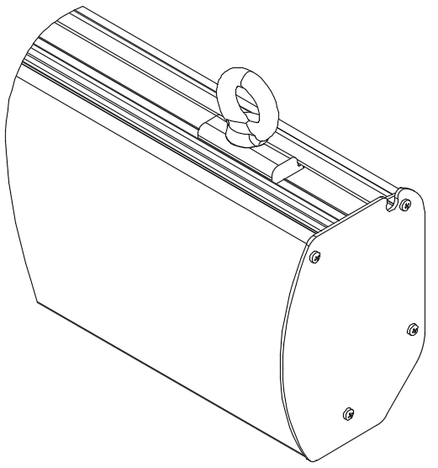
Ceiling Hanging:
Unscrew the locking screws
on both sliding pieces.

Move the sliding pieces to desired position. Tighten the holding ring on both sliding pieces until the sliding pieces do not slide freely on the housing.

The “J” hook should in installed at least 50mm from the wall
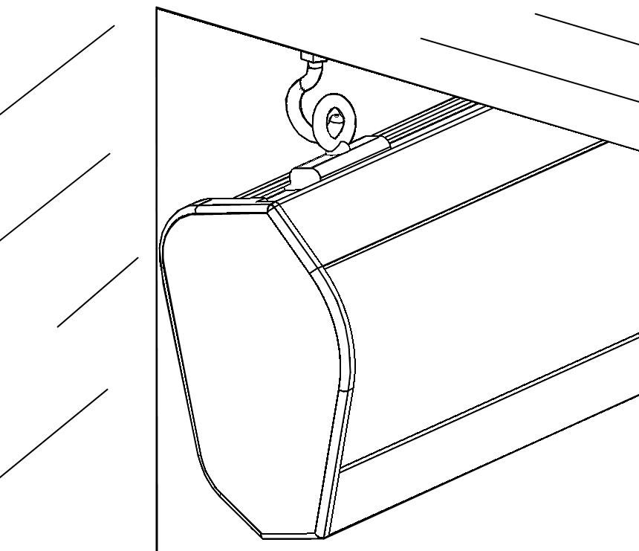
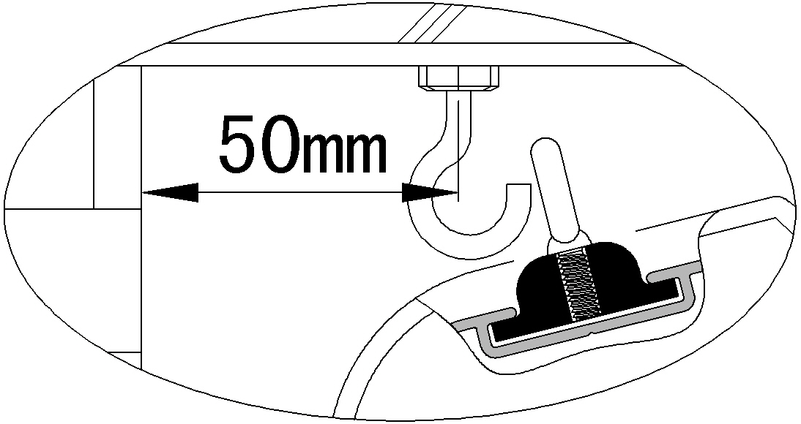

There is a 10mm clearance between the wall and the screen housing after installation
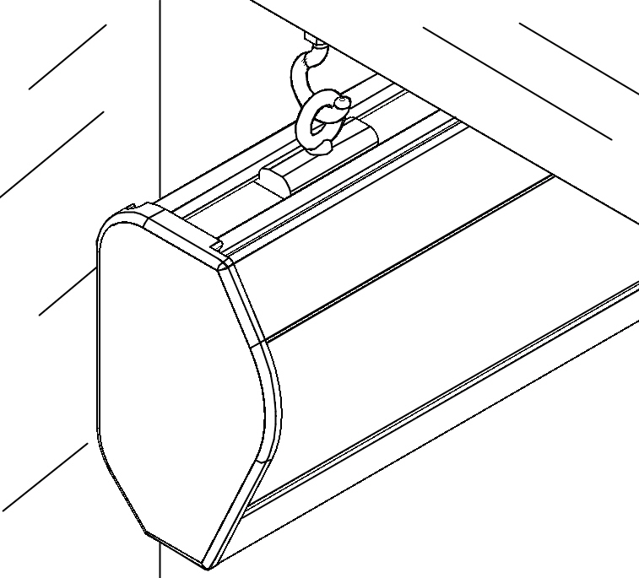
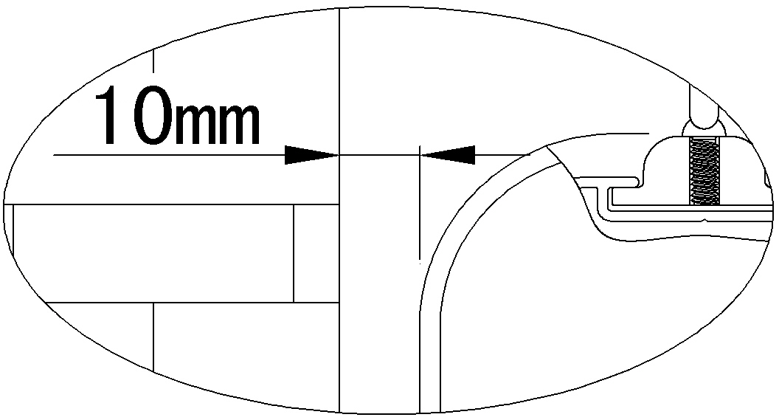

Wall Mounting:
For mounting on a brick, concrete or plaster surface use
ø5x35mm screws with screw anchors or wall plugs.
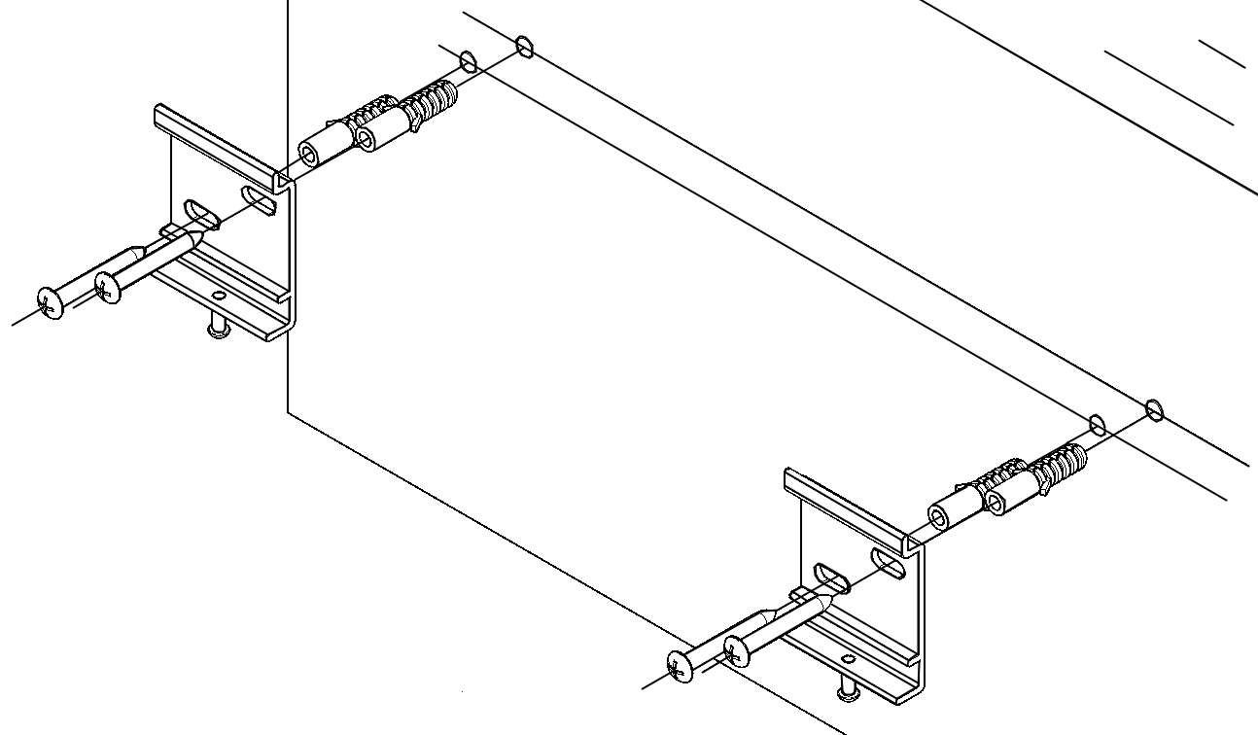
Mark 2 horizontal parallel
lines on wall at desired
height. Drill holes on wall
According to the openings
on wall mount bracket
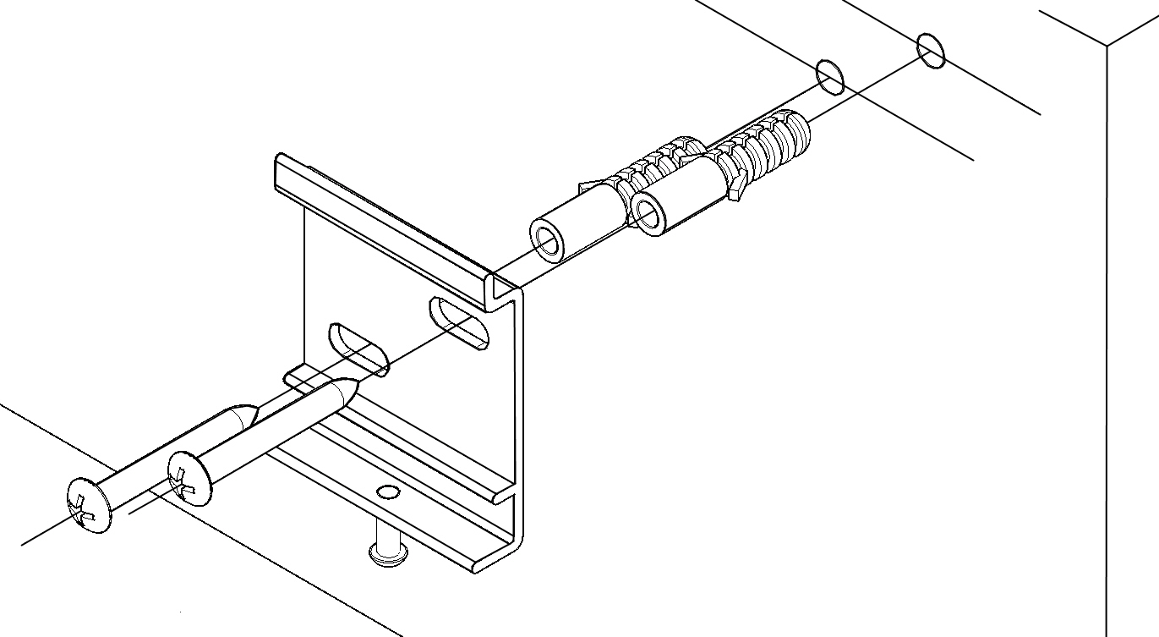
Insert the provided plastic anchor into the holes.
The fasten the wall mount brackets on wall.
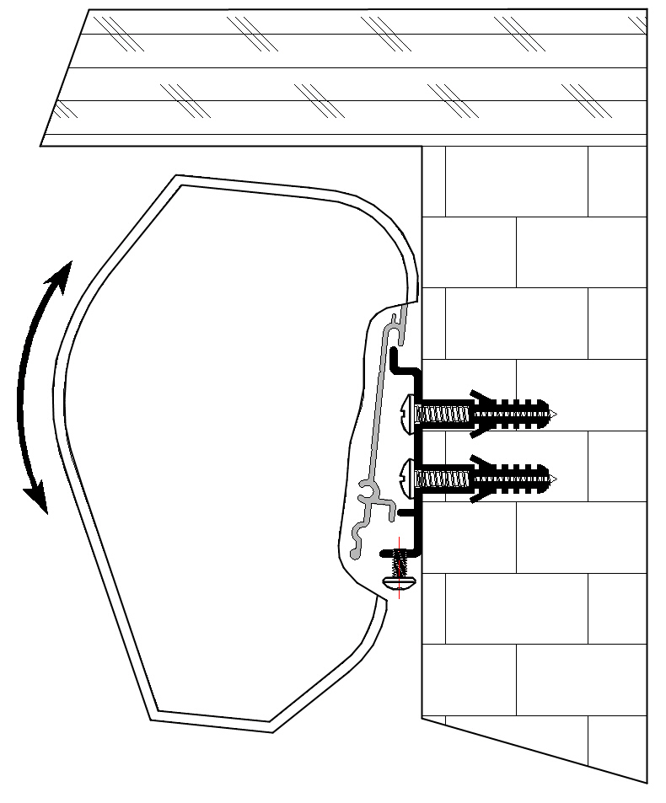

Hang the screen onto the
wall mount bracket as
shown on diagram

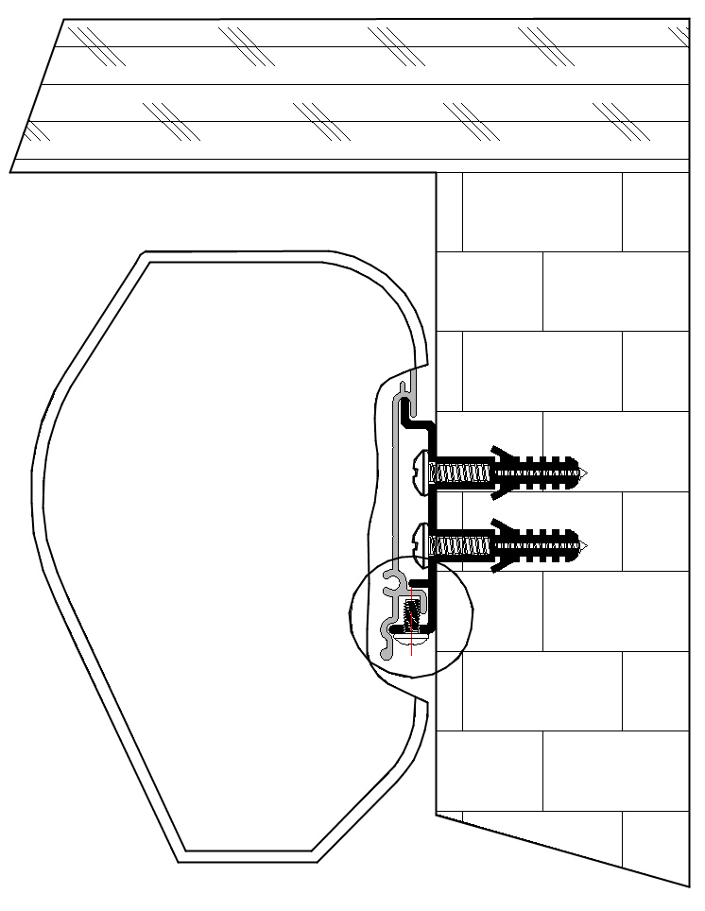
Afterwards tighten the
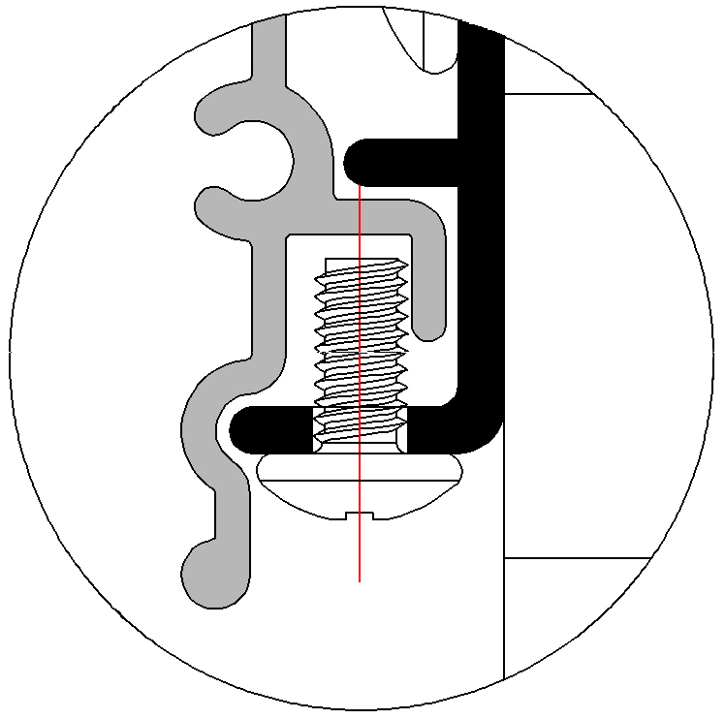
securing screw, Prevention
the screw comes out from
wall mount bracket.

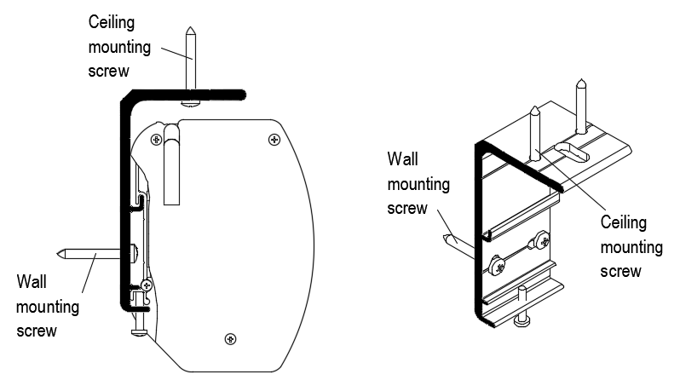

Screen operation

Wireless control unit operation
To lower the projection surface
press the bottom button on the control unit, the projection surface will lower
itself, when it is fully extended it will stop automatically.
To retract the projection surface
press the top button on the control unit, the projection surface will retract
into its case, when it is fully retracted it will stop automatically.
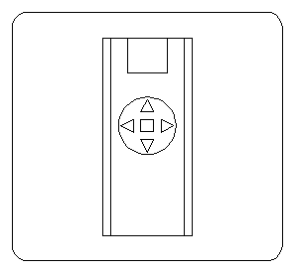
To stop the projection surface
Press the middle button on the control unit. For detail remote control set-up, please refer to the individual remote Control Manual.

