**Using the MBus_IoFlashUpload.exe utility to load updated programs onto io12 or io14 devices in the field.**

The MBus_IoFlashUpload.exe utility can be used to update programs on io12 or io14 devices. This is valuable tool for anyone that doesn’t want to use MBus_ioFlash PRO or by anyone that shouldn’t have access to the source project file. Basically, anyone that needs to update a device in the field but doesn’t need to change or access the program in MBus_ioFlash should use this tool. A good example would be a tech that needs to update some devices in the field with a new program that has already been provided to them.

**Use MBus_ioFlash PRO to export the program in its compiled form to a BIN file:**

1. 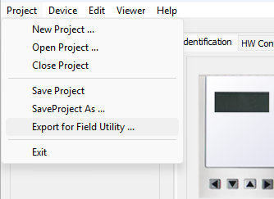Use MBus_ioFlash PRO V626 or newer to open the project file that you want to be uploaded to a device.
2. Go to “Project/Export for Field Utility” to export the compiled version of that project file as a .bin file and save that .bin file somewhere on your computer.

**Use MBus_ioFlashUpload.exe and the .bin file (compiled version of the program) to update a device:**

1. Save the “MBus_IoFlashUpload.exe” utility and the .bin file containing the compiled version of the program (created in step 2 above) on the computer that will be used to update the devices.
   1. NOTE: The “MBus_IoFlashUpload.exe” utility can be found in the installation folder of MBus_ioFlash Pro. It is recommended that the “MBus_IoFlashUpload.exe” file is saved in its own folder somewhere on the computer because when it runs it will create a log file and an app data file in whatever folder that it resides in.
2. Use the “Scan” feature on the MBus_ioFlashUpload utility to check what firmware is currently on the device, and update the device with the most current version of the firmware hex file if necessary. The most current firmware hex files for each device can be found in the install folder of the most current version of MBus_ioFlash PRO.
   1. Under “Devices”, enter the Device ID of the device that you want to scan. (254 will always work)
   2. Click on “Scan”.
   3. 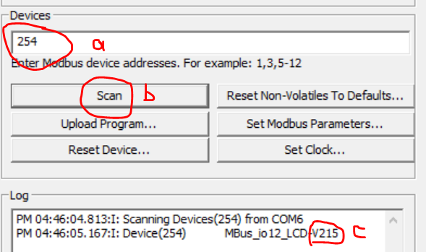The results in the “Log” window will show what version of the firmware is currently on that device.
   4. If the firmware version currently on the device is not the most current version available, then use the “MBus_ioFlash_ISP.exe” utility to upload the newest firmware hex file to the device. (See separate instructions on how to use the MBus_ioFlash_ISP.exe utility to do the firmware update.)
3. 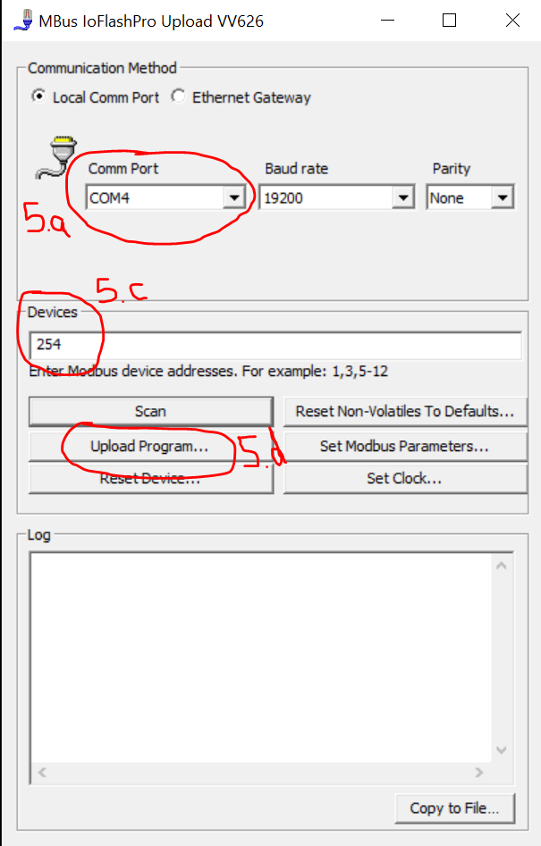Once it has been confirmed that the device has the most current firmware, the MBus_ioFlashUpload.exe utility can be used to send the updated program to the device:
   1. Select the proper Comm Port to match whatever comm port their USB->RS485 converter was installed to on their computer. (check Device Manager/Ports)
   2. Leave the Baud Rate at 19200 and Parity at “None”.
   3. Under “Devices”, enter the Device ID that the .bin file will be uploaded to. (254 will always work)
   4. Click on the “Upload Program” button.

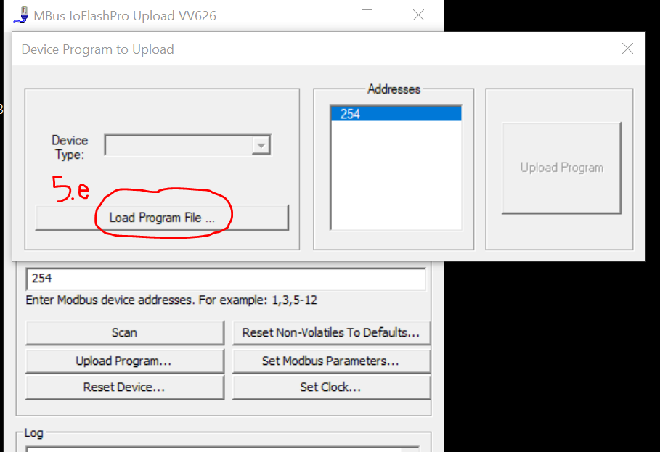

* 1. Click on “Load Program File”, browse to find the .bin file that was provided for that program, and then click “Load File”.

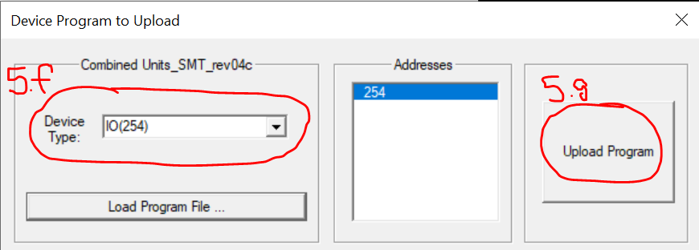

* 1. Select the proper Device from the “Device Type” dropdown. (typically, there will only be one choice)
  2. Click on “Upload Program”.

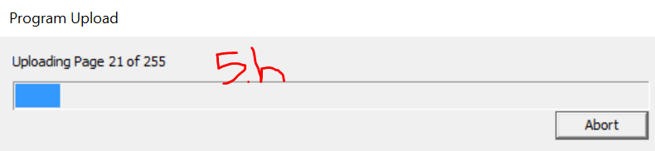

* 1. A progress bar will appear as the program uploads to the device.

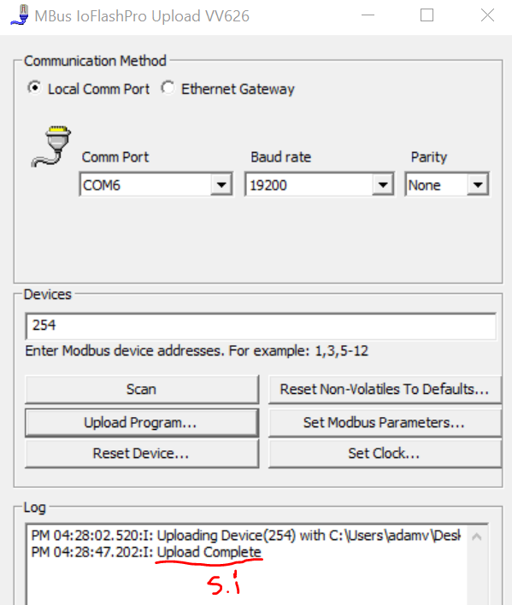

* 1. Once complete the progress bar will disappear and the Log window will show “Upload Complete”. The program has now been successfully uploaded and should be running on the device.