**HoofLox Urethane - Frequently Asked Questions**

**Q** What makes HoofLox Urethane unique?

**A** PU adhesives and methylene diphenyl diisocyanate (MDI): All PU glues on the market contain MDI, a substance known to cause allergic reactions, asthma, and even cancer. Due to these health risks, the European Union introduced a regulation effective from August 24, 2023, which requires mandatory training and certification for industrial or professional use of products containing MDI.

HoofLox is the only urethane formula with less than 0.1% diisocyanates. This makes our product exempt from the training and certification requirements, and more importantly, makes it the safest and most user-friendly urethane glue on the market for both farriers and animals.

HoofLox products are more weather-resistant and do not crystallize at low temperatures.

Our HoofLox Urethane adhesives do the same work as the classic urethanes (or even better) but are a much healthier option.

**Q** How should HoofLox Urethane be stored before use?

**A**Optimal Storage Temperatures: 35 to 60 degrees Fahrenheit, or 2 C to 25 Celsius. Most refrigerators are 35 to 38 degrees Fahrenheit. Make sure to store in a cooler/ice while in your farrier truck, trailer, or car. Extreme heat and cold are the enemy of adhesives.

**Q** Does temperature affect set times for HoofLox Urethane?

**A**Optimal working temperature is 65 to 77 degrees Fahrenheit or 18 to 25 Celsius.

Open time (where product can be still moved or altered) at these temps between 90-120 seconds. Set time, loadable in 7 minutes. Warmer temperatures will shorten open time, colder temperatures will lengthen open time.

**Q**After use, can the product be capped and stored for future use?

**A** Yes, apply the cap and store at optimal storage temperatures (35 to 60 degrees Fahrenheit, or 2 C to 25 Celsius)

**Q** Should protective gloves be used when applying adhesives?

**A** Yes, protective gloves keep the oils in your hands from contaminating a prepped hoof and clean shoes. Protective gloves also keep adhesives off your hands and lessen clean up.

**Q** Do I need a special caulking gun?

**A**Yes, HoofLox Urethane takes the standard 200ml dispensing gun used by all brands. You can find the 200ml dispensing gun here on our website.

**Q** Does the cartridge need to be equalized before adding a mixing tip?

**A** Yes, make sure both components are coming out before applying a mixing tip.

**Q** Does HoofLox Urethane need to be purged from mixing tip before applying to a hoof or shoe?

**A** Yes, the first inch or 25mm should be purged in a plastic bag and thrown away.

**Q** How many cuff shoes can be glued with HoofLox Urethane?

**A** Between 6 and 8 shoes depending on size of hoof.

**Q**What shoes can be glued using HoofLox Urethane?

**A** Any of the cuff-style EasyShoes (EasyShoe One Glue, Race, Roller, Speed, Versa Grip Glue) or steel and aluminum horseshoes.

**Q**How do you prep a hoof before gluing with HoofLox Urethane?

**A** The hoof needs to be clean, dry, and rough. See hoof prep video here.

**Q**How long does it take HoofLox Urethane to cure?

**A**Set time, loadable in 7 minutes.

**Q** What is the best way to finish HoofLox Urethane applications?

**A**Finish with a top coat of HoofLox Super Glue and spray with HoofLox Super Glue Activator.

**Q** What is the best way to remove HoofLox Urethane from the hoof?

**A** The best way is using a rasp or hoof buffy. Do not peel from hoof.

**Q** What is the best way to remove HoofLox Urethane from a shoe?

**A** Dremel with a 9931 bit.

How to Properly Measure Your Horse's Hoof

We cannot over stress the importance of resizing! You wouldn't go for a jog in ill-fitting sneakers, so why would you expect your horse to do the same?

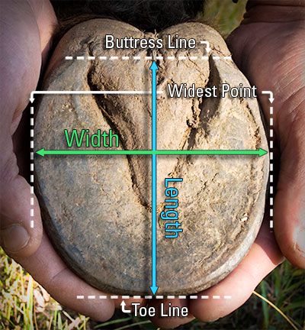

1. After a fresh trim, measure the width of the hoof across the bottom at the widest point.
2. Measure the length of the hoof from the toe to the buttress line of the heel. The buttress line is the farthest weight bearing point of the heel where the hoof wall ends. Do not include the heel bulbs in the measurement.
3. Compare your measurement with the appropriate size chart. Please note that each boot style has its own unique size chart.
4. Ideally, the length and width measurement will fit into the same size. If the length and width measurements indicate different sizes, select the larger size. If the hoof measurements fall closely to the maximum length or width, we recommend choosing the next size up. If the width and length measurements are different by more than one size, your selected boot style is not recommended. * Be sure to check your measurements against an alternative boot in the EasyCare line—another style may accommodate your horse’s hoof shape better.  
   *Note: If you are fitting an Easyboot Glue-On or Glove, width and length must fall into the same size category.