DRAWER 16 LITRE

DRAWER 30 LITRE

FRIDGE / FREEZER

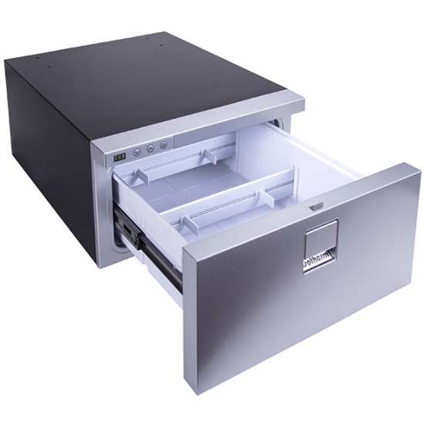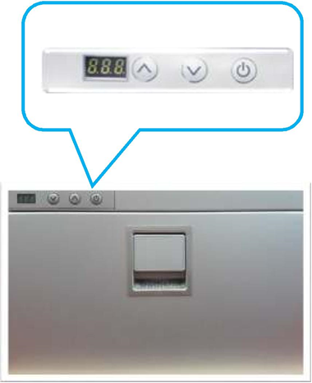

|  |  |  |
| --- | --- | --- |
|  |  |  |
| **MODEL** | **DRAWER 16** | **DRAWER 30** |
| **Effective Volume（L）** | **16 Litres** | **30 Litres** |
| **Product Dimensions** | **H250 x W380 x D540mm\*\*** | **H260 x W440 x D700 mm\*\*** |
|  | **\*\*Depth without remote compressor 395 mm** | **\*\*Depth without remote compressor 540mm** |
| **Rated Voltage/Frequency** | **DC 12V/24V** | **DC 12V/24V** |
| **Power Consumption** | **20.8 amp/24 @12volt** | **22.8 amp/24 @12volt** |
| **Refrigeration Performance** | **-6℃~+10°C** | **-6℃~+10°C** |
| **Price** | **$1195.00 inc** | **$1395.00 inc** |