Mustang GT 11-14
#GWFM-1114-1
GATE-WAY by RACE LLC
Instruction
( DO NOT MODIFY the GATE-WAY HARNESS. It will DAMAGE the GATE-WAY!! )
Important Information
If you have trouble lights on the dash before you install the Gate-Way, you will continue to have them after you install the Gate-Way. The codes are kept in the body control module and the only way to clear them is through the OBD2 port with a OBD2 scanner.
Before you install the Gate-Way. You should know.
2011-2014 Mustang GT: You will lose traction control and cruise control
2013-2014 Mustang GT with premier dash: You will lose Cyl. temp/trans temp and one touch start.
Automatic cars that wish to retain the 6R80 trans will need to purchase a US shift controller and a Race US-1114 harness.
Download Gate-Way software off a RACE's website. Raceproductsusa.com
Use the mini USB to a micro USB harness included to connect and program the Gate-Way.
The Gate-Way will power up off of your laptop so you can program the Gate-Way before it is
installed into your car.
To program in the Gate-Way software. You will need to set the:
- VIN: Must have the Vin or fault codes will show on the dash.
- MPH adjustment: good start is 28 for 3.31 gears and 26 for 3.73. Adjust if needed.
- Odometer adjustment: Should be 43 for 3.31 gears and 48 for 3.73. Adjust if needed.
- Type of transmission: Choose Manual or Automatic.
HOW TO MOUNT THE GATE-WAY
The Gate-way will set in front of the ECU under the plastic cover. Start with removing the factory ECM. Before you remove the ECM, get a silver felt tip marker and mark the center connector on the ECU connector with a C. This needs to be done because the two larger connectors can be interchanged and you do not want to get them switched.
Take the two bolts out of the factory ECU and remove it from the bracket. Take the three connectors that plug into the factory ECU and follow the wiring back to the main harness. You will see that the ECU harness has mounts on both sides of the fuse box. Remove the harness from those mounts. That will give you more length in the harness to help install the Gate-Way where it should go.
Put the Dominator or Terminator X Max into the stock ECU bracket. The bracket will have to be removed and modified to install the Dominator. The Terminator X Max will fit right in. You can drill a support hole if you wish. Now slide the Vi-TCT under the fuse box with the part # facing the fender.
If you are not going to use the Holley Vi-TCT controller, tape up the connector for the Ti-VCT. This connector will plug in to the J2A on a Dominator ECU. Do not plug that connector into the J2A on a Dominator or you will damage the ECU and the Gate-Way.
Make sure you have plenty length of the factory harness. Take the Gate-Way unit with the RACE sticker up and plug it into the factory connector. Make sure the C is in the center.
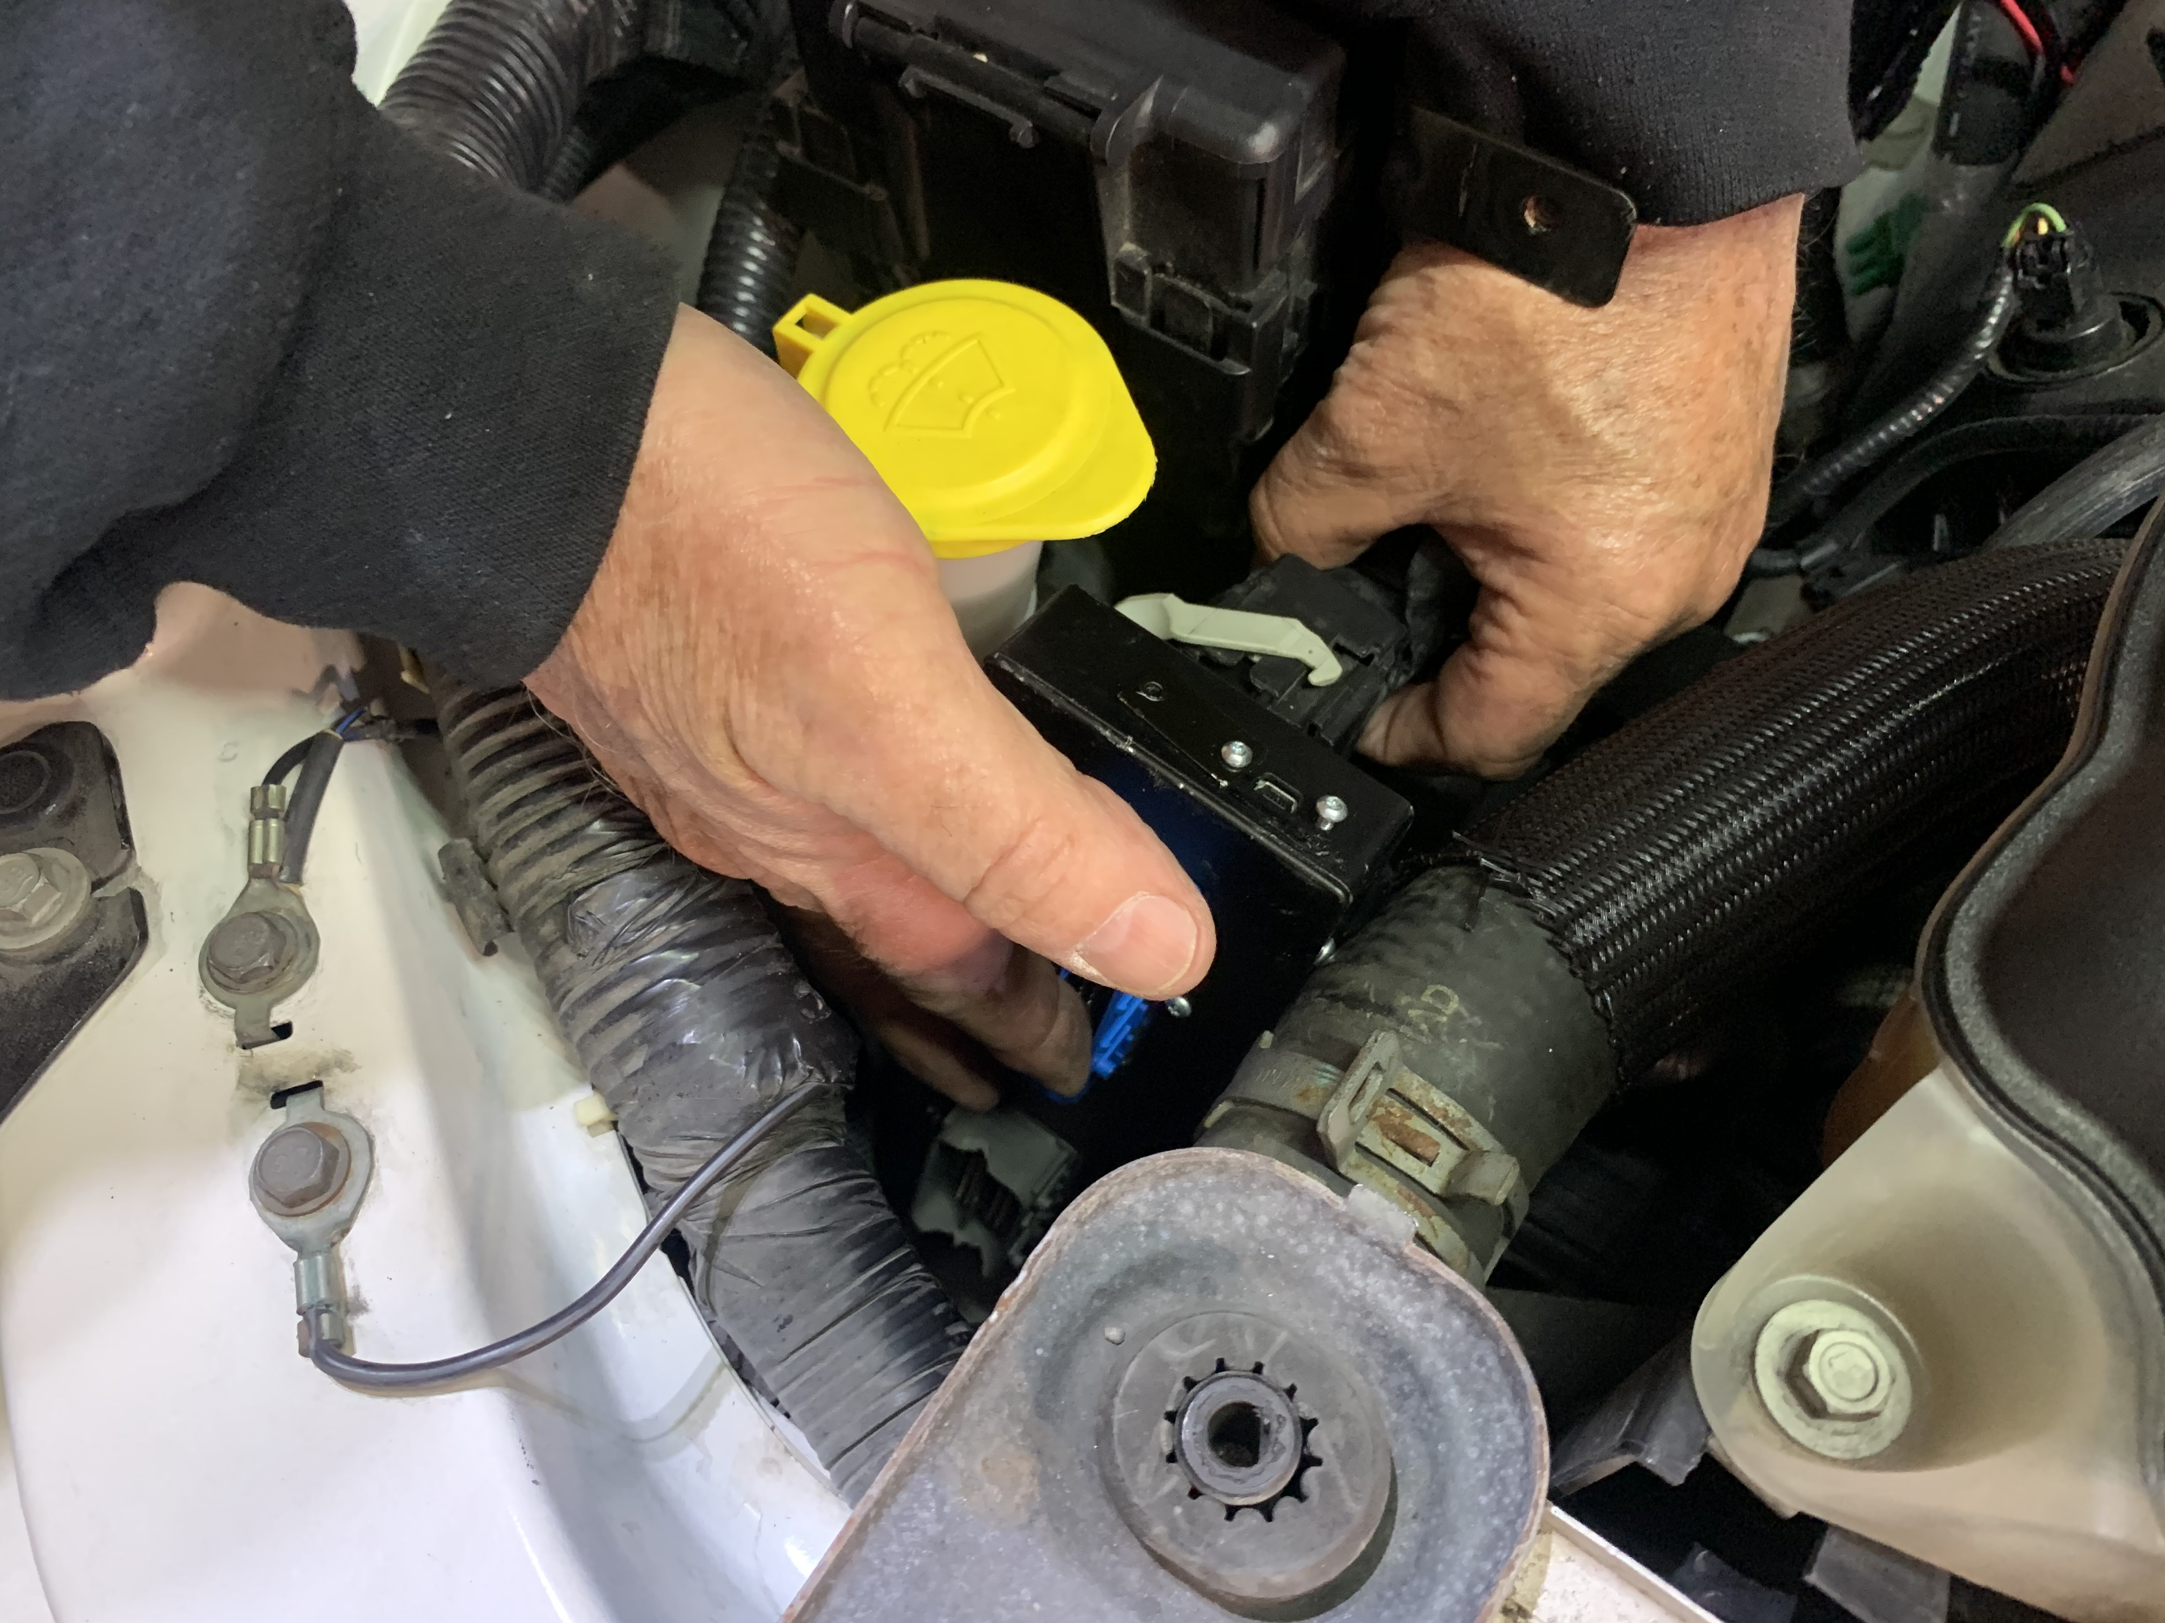
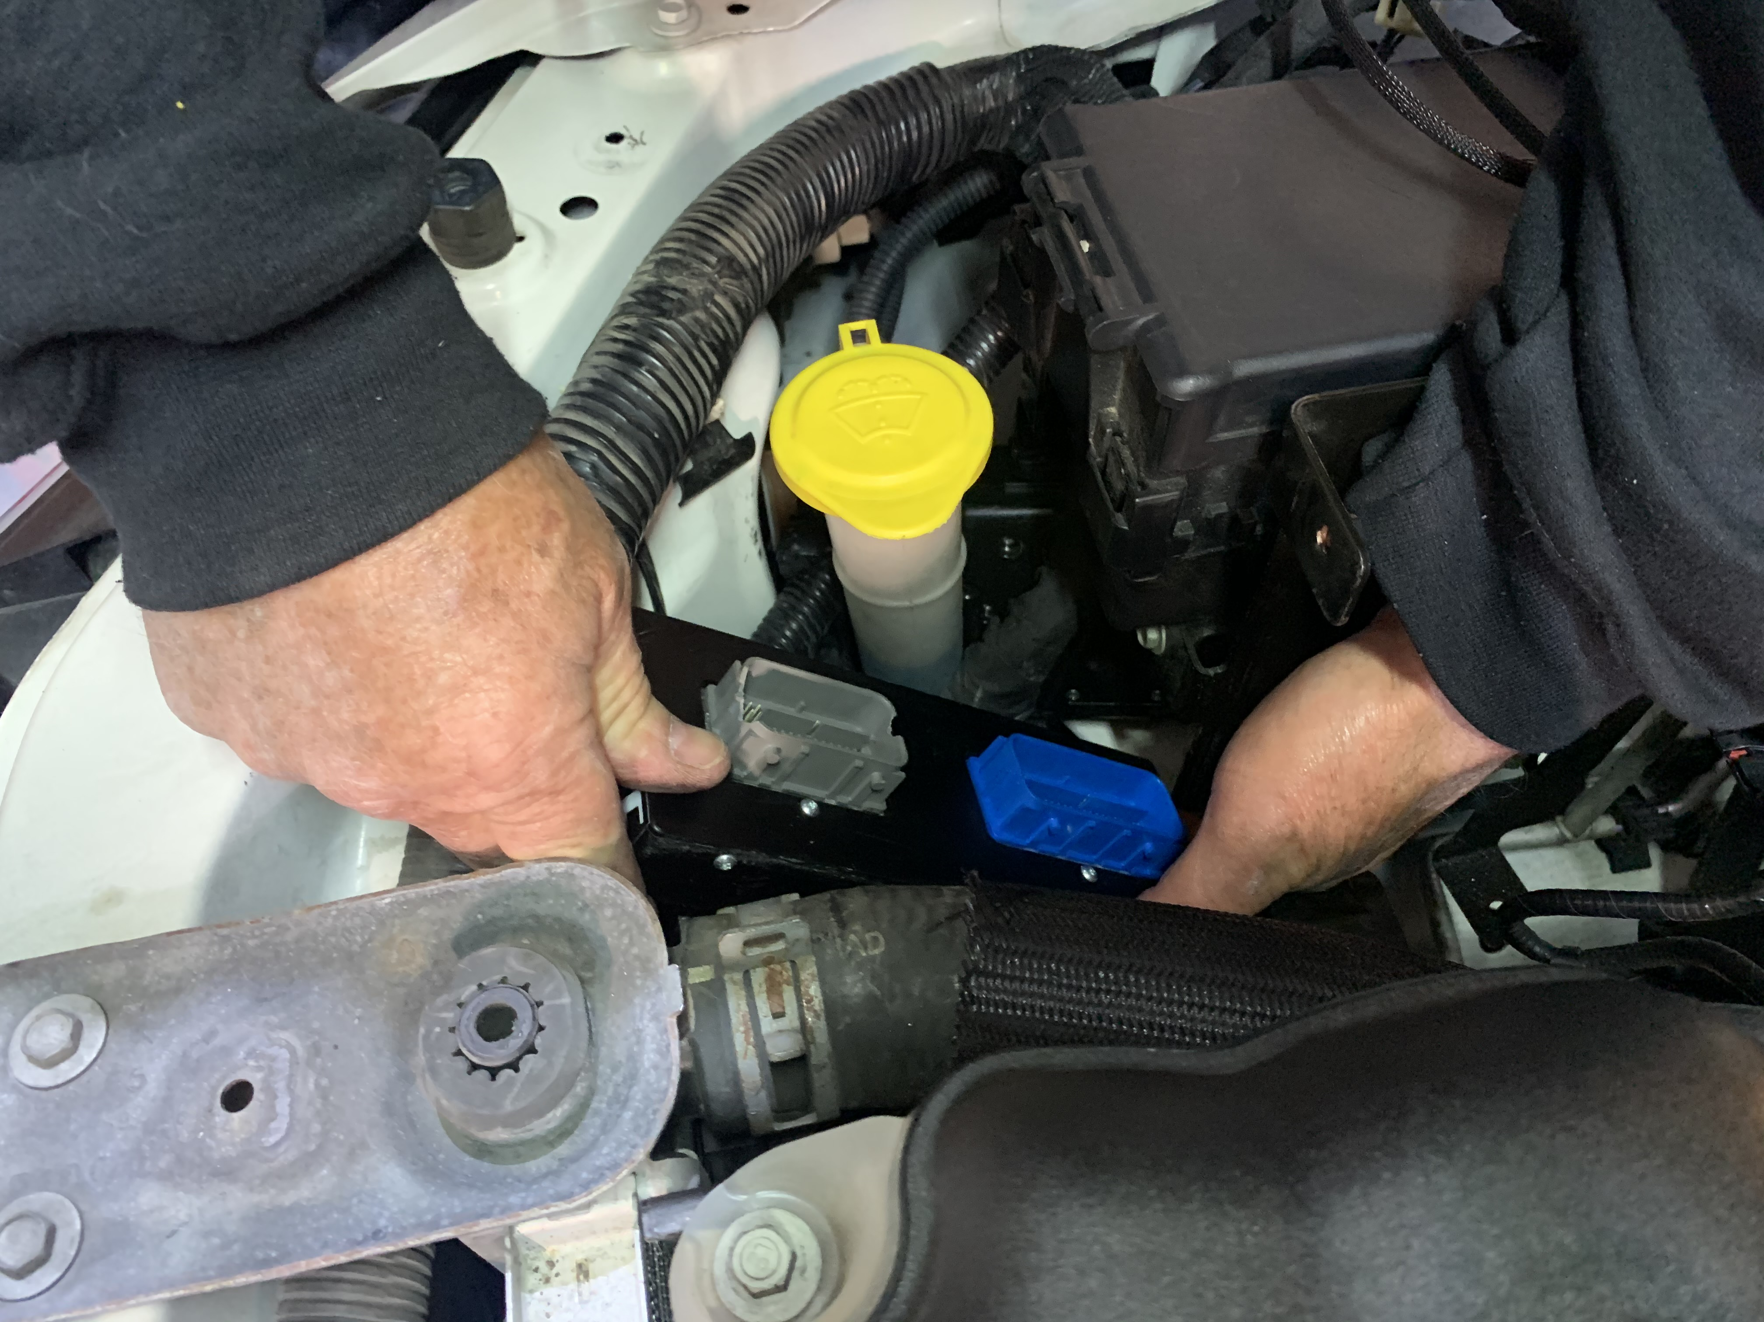
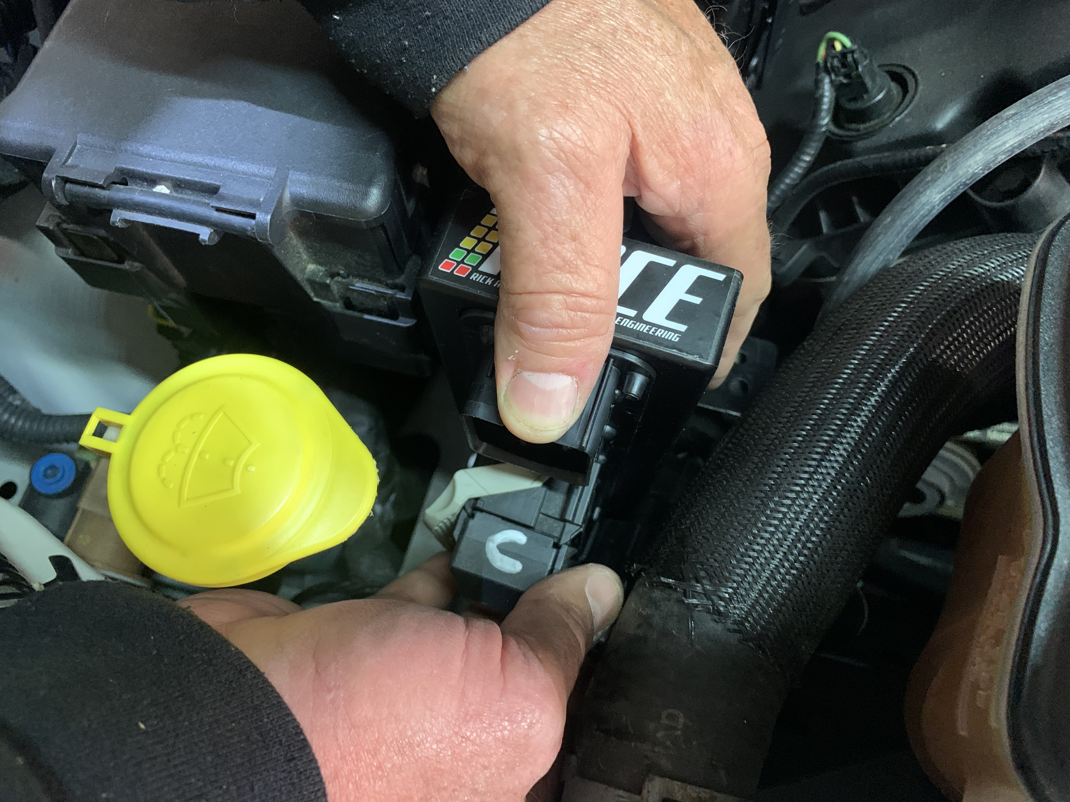
Take the Gate-Way and slowly work and flip it over so Holley EFI connector face the front of the car and the trap door is facing up
Plug the Gate-Way harness into the Vi-VCT then into the Holley EFI. Best to lift up Hollley ECU and start with the bottom plugs first and work up. Don't forget the Power cable. Loop the main Gate-Way connector and plug into the blue connector.
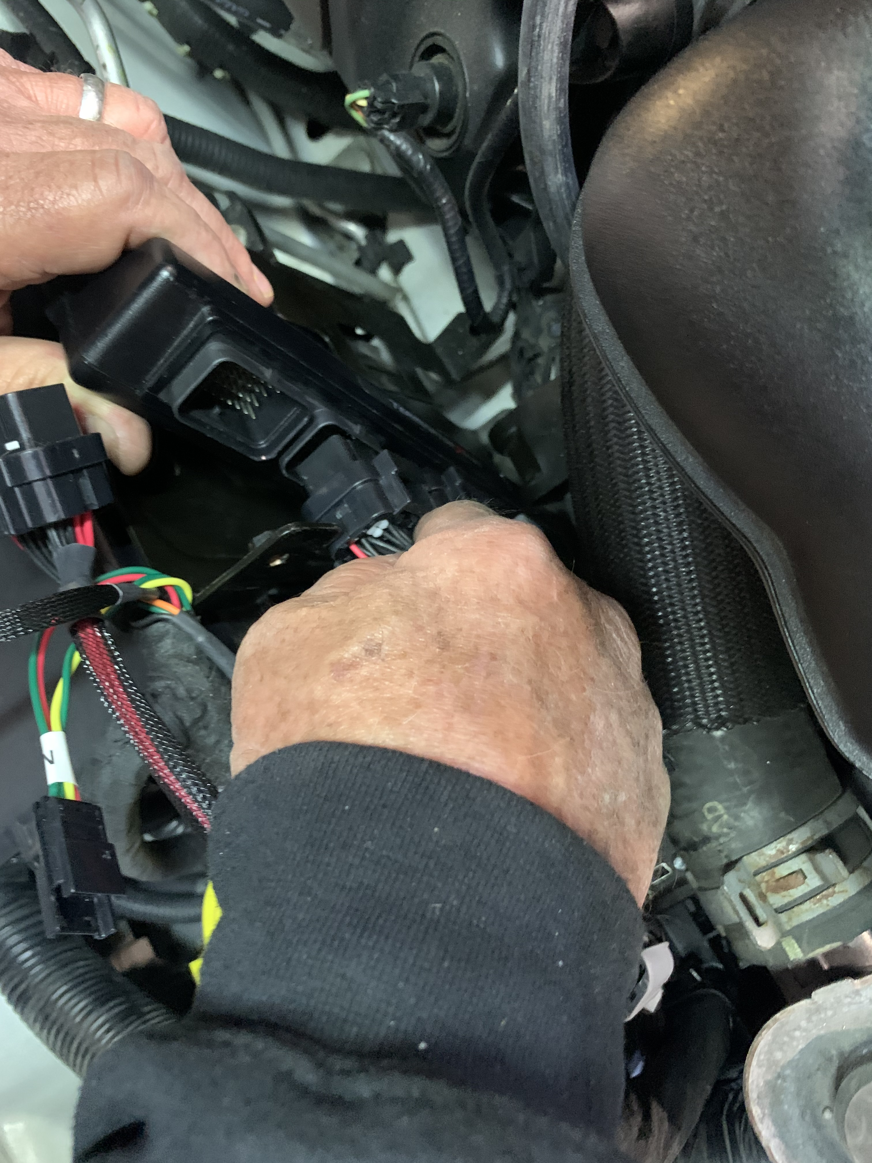
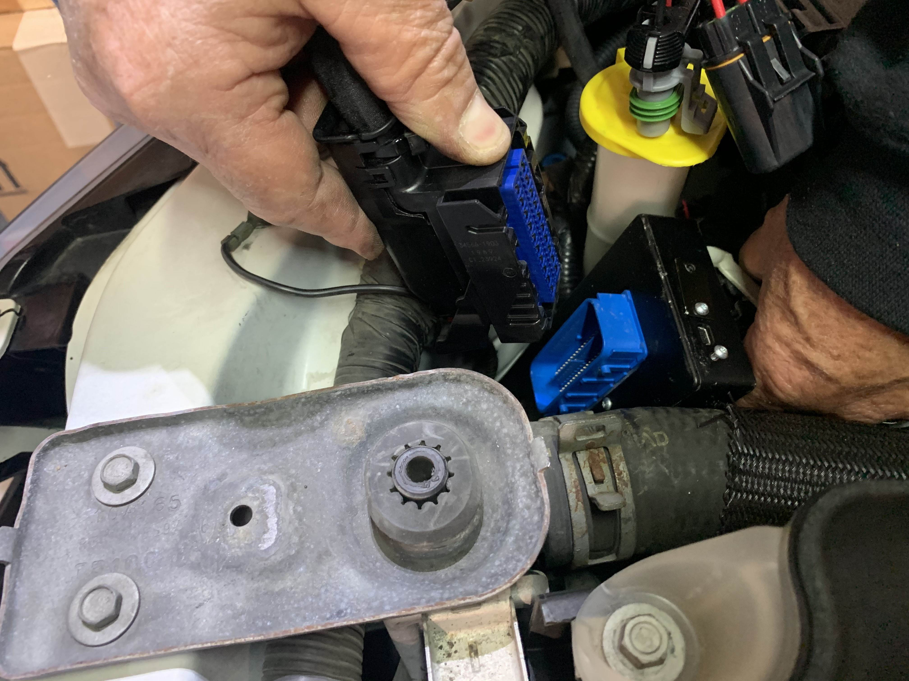
Hook up the loose black (ground) and the red (power) wires to the battery terminals.
The only things left are:
Plug in a 1 to 3 bar MAP sensor to the connector labeled MAP or use the internal 1 bar on Terminator X Max. Fine a good vacuum source off the intake to hook the MAP sensor to. If you need to change the MAP connector. Do this by connector labels. A is sensor ground B is signal and C is 5 volts reference
If you are using the Holley Terminator X MAX ECU, that will work with the existing factor 4.9 Ford wideband. Plug the connector that is labeled WB to the connector that is labeled 4.9 WB to use the factory 4.9 WB.
If you are using the Holley EFI Dominator ECU, you must change one of the factory WB to a 554-100 NTK wideband and plug that into the connector marked WB.
If you wish to monitor or adjust from the Manifold Air Temp sensor, you will need to get a Motorcraft DY 1159 MAT sensor. You will need to remove one guides on the Dy-1159 sensor. For it to plug it into the connector labeled MAT.
The Gate-Way and harness is a tight fit but it will all fit into place
Once you have the harness and Gat-Way installed. You will see you have five loose wires.
CAN – is used to connect to ECU for tuning or optional 3.5 monitor / Dash
Power Tap- is a ground, sensor ground,12 volts & 5 volts for Optional I/O
FUEL- Holley 100 psi fuel pressure sensor (Optional for Holley to monitor)
Oil- Holley 100 psi pressure sensor (Optional for Holley to monitor. Ford oil sensor is just a oil switch)
I/O- Inputs/ Outputs (Optional) see below
NOTE 1: When setting up your tune in the Dominator or Terminator X Max. You must set up the basic I/O as grounds as follows
I/O set up with a Terminator X Max ECU
NOTE 1: When setting up your tune. You must set up the basic I/O as follows.
Grounds Outputs Ground Inputs
J1B B10 will be Fan 1 J1A A12 will be AC IAC Kick
J1B B3 will be Fan 2
J1B B12 will be AC shutdown
NOTE 2: In the I/O connector A, E, G & H are already connected to fans, IAC kick & AC shutdown.
Do not use A, E, G & H for anything else. You could damage the Gate-Way!
NOTE 4: Holley EFI has a safety on the DBW throttle body. If you wish to apply the brakes to do a burn out, you will have to install a toggle switch on the B24 wire coming out of the J3 connector, to switch the safety off and on.
NOTE 5: If you need to do a Terminator X or Holley EFI firmware upgrade using the CAN connection. You will need to turn the Gate-Way CAN off. You can do this by turning the ignition key on (Do not start).
Holding down the brake and fuel pedal down at the same time. The wrench light will blink until it goes solid. The Gate -Way CAN is now off. Now do your firmware upgrade. Then turn key off and on. The Gate-Way CAN is back on.
I/O set up with a Dominator ECU
You will need to replace one of the factory narrow bands O2 sensors with a Holley wideband O2. You will need a Holley 554-100 NTK wideband O2.
NOTE 1: When setting up your tune. You must set up the basic I/O as follows.
Grounds Outputs Ground Inputs
J1B B10 will be Fan 1 J1A A12 will be AC IAC Kick
J1B B3 will be Fan 2
J3 B12 will be AC shutdown
NOTE 2: In the I/O connector A, E, G & H are already connected to fans, IAC kick & AC shutdown.
Do not use A, E, G & H for anything else. You could damage the Gate-Way!
NOTE 3: Holley EFI has a safety on the DBW throttle body. If you wish to apply the brakes to do a burn out, you will have to install a toggle switch on the B24 wire coming out of the J3 connector, to switch the safety off and on.
NOTE 4: If you need to do a Terminator X or Holley EFI firmware upgrade using the CAN connection. You will need to turn the Gate-Way CAN off. You can do this by turning the ignition key on (Do not start).
Holding down the brake and fuel pedal down at the same time. The wrench light will blink until it goes solid. The Gate -Way CAN is now off. Now do your firmware upgrade. Then turn key off and on. The Gate-Way CAN is back on.

