HOW TO CONVERT A 2011-2014 CAMARO TO USE A 4L60/80E CONTROLLED BY YOUR HOLLEY TERMINATOR X OR DOMINATOR ECU  
  
IF YOUR CAMARO SS WAS ORIGANALY EQUIPED WITH A 6L80 TRANSMISSION. READ THE FOLLOWING. IF IT CAME WITH A MANUAL. SKIP TO PARTS YOU WILL NEED:  
  
**To set up a Camaro SS that came equipped with a 6L80 transmission and utilize the Gate-Way module with its option to convert from manual to a 4L80 transmission.   
FIRST: The E38 ECU must be flashed to a manual transmission before removing for the Gate-Way.   
SECOND: Take the original wires that went to the 6L80 transmission. You have two set off tan wires and two set of tan/black wires. These are CAN low and CAN high wires. Join the two tan wires together and the two tan/black wires together.  
LAST: After completing the following instructions and you have installed the Gate-Way. In the software choose the manual converted to 4L80.  
Now continue follow the Gate-Way 4L80 conversion instruction.**

PARTS YOU WILL NEED:

MAKE SURE YOU HAVE A 2 CONNECTOR STYLE PARK/NEUTRAL POSITION (PNP) SWITCH (A/C DELCO PART # D2263C WITH PIGTAILS 7 PIN PART # PT1031 AND 4 PIN PART # PT1676 OR EQUIVALENT)  
  
HOLLEY EFI 558-405 TO CONTROLE THE 4L80 TRANSMISSION.

ONCE YOU HAVE THE CORRECT PNP SWITCH INSTALLED

YOU WILL NEED TO TAKE THE MANUAL TRANSMISSION REVERSE LIGHT SWITCH WIRES AND GO TO PIN C & PIN F OF 7 PIN RANGE SEELECTOR SWITCH C2.

YOU WILL ALSO NEED TO TAKE PIN E FROM 7 PIN CONNECTOR TO A CLEAN GROUND AND THEN RUN PIN G FROM PNP SWITCH CONNECTOR C2 TO HOLLEY PIN J1 A4

YOU WILL THEN NEED TO GO INTO YOUR HOLLEY AND SET UP INPUT 1 (MUST BE INPUT 1) AS A GROUND AND CALL IT Park_Neutral_SW AND PIN MAP IT TO J1A4  
  
 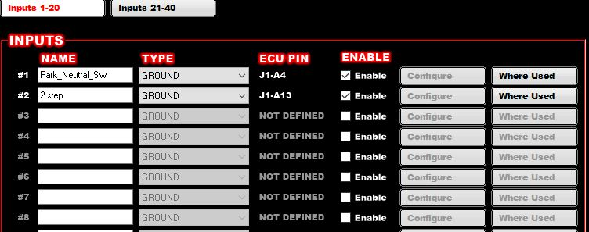

IF YOU ALREADY HAVE SOMETHING IN J1A4 YOU WILL HAVE TO MOVE IT SOMEWHERE ELSE

NOW TIME TO UPDATE YOUR GATEWAY TO PROPERLY WORK.

MAKE SURE YOU HAVE DOWNLOADED AND ARE USING SOFTWARE VERSION: bld_3.92

ONCE THIS IS COMPLETED YOU WILL NEED TO UNHOOK YOUR GATEWAY FROM THE VEHICLE AND HOOK IT UP WITH YOUR USB CABLE AND UPDATE THE FIRMWARE TO   
THE GWCC_1014_V2_112923A.RACE firmware.   
Found on RACEPRODUCTSUSA.com website

THEN YOU WILL NEED TO CHANGE YOUR GATEWAY SETTINGS TO MANUAL CONVERTERED TO 4L80 AND MPH ADJUST AND OD ADJUST TO 100 TO START WITH. THEN YOU CAN ADJUST FROM THERE IF   
  
THE SPEEDOMETER WILL WORK FROM THE MPH IN THE HOLLEY CAN NETWORK. IT IS IMPORTANT THAT YOU HAVE THE CORRECT INFORMATION FOR SPEEDOMETER IN THE HOLLEY WITH THE SPEEDOMETER OUTPUT ENABLE AND SET AT 4000 ppmile. MAKE SURE THE SPEEDO READS CORECTLY IN THE HOLLEY. YOU SHOULD NOT HAVE TO ADJUST THE GATEWAY SIDE.