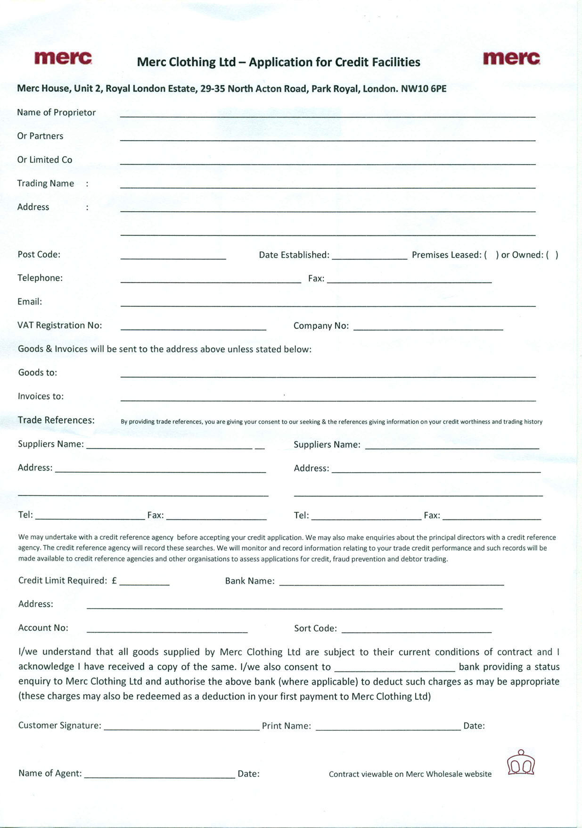

 | Standard terms and conditions of sale for Merc Clothing Limited
 | THE CONDITIONS OVERLEAF SHALL APPLY TO THIS ORDER AND TO ANY CONTRACT BETWEEN US FOR THE SUPPLY OF ITEMS DETAILED IN THIS ORDER (SEE CONDITION 1). PLEASE READ ALL OF THEM CAREFULLY. THEY CONTAIN EXCLUSIONS AND LIMITATIONS OF OUR LIABILITY UNDER ANY SUCH CONTRACT
1 | Formation of contract
1.1 | The Purchaser (or its nominated agent as the case may be) shall place orders for the delivery of goods with the Seller.
1.2 | Any order sent to Merc Clothing Limited (“the Seller”) by you (“the Purchaser”) shall be accepted entirely at the discretion of the Seller and, if so accepted, will only be accepted upon these conditions (hereafter referred to as the “Conditions”) and by means of the Seller’s express acknowledgment of an order or the Seller’s supply of goods pursuant to an order (whichever occurs first). The Seller reserves the right to stipulate that acceptance of an Order shall be conditional upon its receipt of a deposit on or pre-payment of the relevant price.
1.3 | Each order which is so accepted shall constitute an individual legally binding contract between the Seller and the Purchaser and such contract is hereafter referred to in these Conditions as an “Order”.
1.4 | These Conditions shall override any contrary different or additional terms or conditions (if any) contained on or referred to in an order form or other documents or correspondence from the Purchaser, and no addition alteration or substitution of these terms will bind the Seller or form part of any Order unless they are expressly accepted in writing by a person authorised to sign on the Seller’s behalf.
2 | Specification
2.1 | In these Conditions, “Product Description Leaflet” means any of the product descriptions set out on the Seller’s website and the Seller’s hard copy or electronic look books and catalogues.
2.2 | All goods supplied by the Seller shall be in accordance with (i) the current edition of the relevant Product Description Leaflet as published from time to time by the Seller (copies of which are available from the Seller upon request) and (ii) those further specifications or descriptions (if any) expressly listed or set out on the face of the Order. No other specification, descriptive material, written or oral representation, correspondence or statement, promotional or sales literature shall form part of or be incorporated by reference into the Order.
3 | Acceptance
3.1 | The Purchaser shall be deemed to have accepted all goods upon their delivery by the Seller to the address specified in the Order.
3.2 | Where the Purchaser places a quick order (as defined in Condition 6.1 below), it hereby acknowledges that not all goods ordered may be available for despatch at the time of the order and therefore hereby acknowledges and agrees that the order will remain valid but be modified by the omission of those unavailable goods. In such cases where the Seller accepts an order it is accepting the order so modified.
4 | Delivery and risk
4.1 | Unless otherwise stated in the Order, the price quoted includes delivery to the address specified in the Order, provided that the Seller reserves the right to make an additional charge to cover any increase in transport costs occurring before the date of delivery.
4.2 | Any time or date for delivery given by the Seller is given in good faith, but is an estimate only.
4.3 | Risk in the goods shall pass to the Purchaser upon delivery.
5 | Payment and title
5.1 | Unless otherwise stated in the Order, payment of the price of the goods comprised in each consignment delivered pursuant to an Order shall become due within 30 days of delivery and invoice and shall be made without any set-off, counterclaim or deduction whatsoever. Where such payment is made prior to the Seller’s despatch of the goods, the Purchaser shall receive a 5% discount off the relevant price.
5.2 | All prices are exclusive of VAT unless otherwise stated in the Order
5.3 | Time for payment shall be of the essence of these Conditions.
5.4 | If the Purchaser shall default in payment, the Seller shall be entitled, without prejudice to any other right or remedy, to do all or any of the following:
5.4.1 | To suspend any or all further deliveries under this Agreement and under any other contract or contracts between the Seller and the Purchaser then current, without notice;
5.4.2 | To charge interest on any amount outstanding at the rate of 2 % per annum above the base rate of Barclays Bank Plc, such interest being charged as a separate, continuing obligation not merging with any judgment together with any statutory debt recovery costs;
5.4.3 | To serve notice on the Purchaser requiring immediate payment for all Products supplied by the Seller under this Agreement and all other contracts with the Purchaser whether or not payment is otherwise due; and
5.4.4 | To sue for the Price of the Products even though (in the case of the Products) title may not have passed to the Purchaser.
5.5 | Payment by the Purchaser to any person other than the Company shall not constitute a valid discharge of Purchaser’s obligation to pay the Price.
5.6 | The Seller warrants that the Seller has good title to the goods.
5.7 | Title to the goods comprised in each consignment shall not pass to the Purchaser until the Purchaser has paid their price to the Seller, but, even though title has not passed, the Seller shall be entitled to sue for their price once its payment has become due.
5.8 | The Seller may recover Products in respect of which title has not passed to the Purchaser at any time and the Purchaser irrevocably licences the Seller, its officers, employees and agents to enter upon any premises of the Purchaser, with or without vehicles, for the purpose either of recovering any Products in respect of which title has not passed to the Purchaser.
5.9 | Until title to the Products has passed to the Purchaser it shall possess the Products as fiduciary agent and bailee of the Seller. If the Seller so requires, the Purchaser shall store the Products separately from other goods and shall ensure that they are clearly identifiable as belonging to the Seller. During such time as the Purchaser possesses the Products with the Seller's consent, the Purchaser may in the normal course of its business sell or hire the Products as principal but without committing the Seller to any liability to the person dealing with the Purchaser.
5.10 | Where the Purchaser is a limited liability company, any acceptance of an Order by the Seller is on the basis that the director(s) of the Purchaser company agree to indemnify the Seller for all payments due to the Seller under the relevant Order if the Purchaser company does not pay. By placing an Order under these Conditions, the director agrees to so indemnify the Seller.
6 | Amending and cancelling an Order
6.1 | In these Conditions, “pre-book order” means an order for goods not yet manufactured and “quick order” means any order other than a “pre-book order” Seller.
6.2 | There shall be no right of cancellation of a pre-book order under these Conditions. However, should the Purchaser make a written cancellation request outlining the reasons and in good time prior to the despatch of a pre-book order, the Seller may at its sole discretion grant such cancellation request in writing.
6.3 | The Purchaser shall not be entitled to cancel a quick order unless the Seller is notified in writing prior to the relevant goods being dispatched for delivery to the Purchaser, in which case an Order may be cancelled at no cost to the Purchaser.
7 | Storage
 | If the Seller shall be unable, through circumstances beyond its control (including without limitation lack of shipping instructions from the Purchaser), to deliver the goods within 14 days after notification to the Purchaser or its agent that the goods are ready for delivery, the Seller shall be entitled to arrange storage on behalf of the Purchaser, whereupon delivery shall be deemed to have taken place, all risk in the goods shall pass to the Purchaser, and delivery to the Purchaser of the relevant warehouse receipt shall be deemed to be delivery of the goods for the purposes of Condition 4. All charges incurred by the Seller for storage or insurance shall be paid by the Purchaser within 30 days of submission of an invoice.
8 | Damage in transit
 | The Seller will replace free of charge any goods proved to the Seller’s satisfaction to have been damaged in transit provided that within 24 hours after delivery both the Seller and the carriers have received from the Purchaser notification in writing of the occurrence of the damage and also, if and so far as practicable, of its nature and extent.
9 | Force majeure
9.1 | The Seller shall not be under any liability for any failure to perform any of its obligations under the Order due to Force Majeure. Following notification by the Seller to the Purchaser of such cause, the Seller shall be allowed a reasonable extension of time for the performance of its obligations.
9.2 | For the purposes of this Condition, “Force Majeure” means fire, explosion, flood, lightning, Act of God, act of terrorism, war, rebellion, riot, sabotage, or official strike or similar official labour dispute, or events or circumstances outside the reasonable control of the party affected thereby.
10 | Guarantee
10.1 | For goods which are manufactured by the Seller or which bear one of the Seller’s trade marks, the Seller grants the following guarantee:
10.1.1 | The Seller shall free of charge either repair or, at its option, replace defective goods where defects appear on visual inspection or under proper use within 1 month from the date of delivery, PROVIDED THAT:
10.1.1.1 | In the case of defects apparent on visual inspection, notice in writing of the defects complained of shall be given to the Seller within 14 days of delivery;
10.1.1.2 | In relation to defects not apparent on visual inspection, notice in writing of the defects complained of as promptly as reasonably practicable upon their appearance, and
10.1.1.3 | Such defects shall be found to the Seller’s reasonable satisfaction to have arisen solely from the Seller’s faulty design, workmanship or materials, and
10.1.1.4 | The defective goods shall be returned to the Seller’s factory at the Purchaser’s expense if so requested by the Seller.
10.1.1.5 | If the Purchaser fails to give such a notice, except in respect of any defect which is not one which should be apparent on reasonable inspection, the goods shall be conclusively presumed to be in all respects in accordance with the Product Description Leaflet and accordingly the Purchaser shall be deemed to have accepted the delivery of the goods in question and the Seller shall have no liability to the Purchaser with respect to that delivery.
10.1.2 | Any repaired or replaced goods shall be redelivered by the Seller free of charge to the original point of delivery but otherwise in accordance with and subject to these Conditions of Sale save that the period of one month referred to in Condition 10.1.1 shall be replaced by the unexpired portion of that period only.
10.1.3 | Alternatively to Condition 10.1.1, the Seller shall be entitled at its absolute discretion to refund the price of the defective goods in the event that such price shall already have been paid by the Purchaser to the Seller, or, if such price has not been so paid, to relieve the Purchaser of all obligation to pay the same by the issue of a credit note in favour of the Purchaser in the amount of such price.
10.2 | The Seller’s liability under this Condition shall (subject to Condition 13) be to the exclusion of all other liability to the Purchaser whether contractual, tortious or otherwise for defects in the goods or for any loss or damage to or caused by the goods, and (subject to Condition 14) all other conditions, warranties, stipulations or other statements whatsoever concerning the goods, whether express or implied, by statute, at common law or otherwise howsoever, are hereby excluded; in particular (but without limitation of the foregoing) the Seller grants no warranties regarding the fitness for purpose, performance, use, nature or quality of the goods, whether express or implied, by statute, at common law or otherwise howsoever.
11 | Confidentiality
 | Both the Seller and the Purchaser shall each keep confidential and shall not without the prior consent in writing of the other disclose to any third party any technical or commercial information which it has acquired from the other as a result of discussions, negotiations and other communications between them relating to the goods and the Order.
12 | Economic loss
 | Subject to Condition 14, and notwithstanding anything contained in these Conditions (other than Condition 14) or the Order, in no circumstances shall the Seller be liable, in contract, tort (including negligence or breach of statutory duty) or otherwise howsoever, and whatever the cause thereof (i) for any loss of profit, business, contracts, revenues, or anticipated savings, or (ii) for any special indirect or consequential damage of any nature whatsoever.
13 | Limitation of liability
 | Subject to Condition 14, and notwithstanding anything contained in these Conditions (other than Condition 14) or the Order, the Seller’s liability to the Purchaser in respect of the Order, in contract, tort (including negligence or breach of statutory duty) or howsoever otherwise arising, shall be limited to the price of the goods specified in the Order.
14 | Unfair Contract Terms Act 1977
14.1 | If and to the extent that s.6 and/or s.7(3A) of the Unfair Contract Terms Act 1977 applies to the Order, no provision of these terms and conditions shall operate or be construed to operate so as to exclude or restrict the liability of the Seller for breach of the express warranties contained in Condition 5, or for breach of the applicable warranties as to title and quiet possession implied into the terms and conditions of the Order by s.12(3) of the Sale of Goods Act 1979, or s.2(3) of the Supply of Goods and Services Act 1982, whichever Act applies to the Order.
14.2 | If and to the extent that s.2(1) of the Unfair Contract Terms Act 1977 applies to the Order, nothing in these terms and conditions shall operate or be construed to operate so as to exclude or restrict the liability of the Seller for death or personal injury caused by reason of the negligence of the Seller or of its servants, employees or agents.
14.3 | No provision of these terms and conditions shall have effect or operate so as to exclude any liability of one of the parties in respect of fraud or a fraudulent misrepresentation made by that party to the other, or to restrict or exclude any remedy which the other party may have in respect of such fraud or fraudulent misrepresentation.
15 | Applicable law
 | The Order shall be considered a contract made in England and shall be governed in all respects by the law of England and the parties agree to submit to the exclusive jurisdiction of the English courts.

