TR-4153D
(2016) POLARIS RZR TURBO STAGE 5 FULL SYSTEM EXHAUST
INSTALLATION INSTRUCTIONS
- REMOVE THE STOCK SYSTEM FROM THE TURBO EXHAUST SIDE TO THE SILENCER.
- REMOVE THE HEATSHIELD AS YOU WILL NOT NEED IT WITH THE NEW EXHAUST SYSTEM
- BOLT ON THE TRINITY RACING HEAD PIPE BY SLIDING SYSTEM APART AND BOLTING THE FLANGE TO THE TURBO.
- SLIDE THE PIPE BACK ONTO THE FLANGE AND ATTACH THE SPRINGS TO HOLD THEM TOGETHER;
- LOOSELY PRE ASSEMBLE THE MUFFLERS USING THE DOUBLE BILLET MOUNTING BRACKET
- ATTACH THE 4-BOLT FLANGE ONTO THE SILENCERS WITH THE SPRING TABS GOING ON THE TOP OUTSIDE BOLT HOLE LOCATIONS
- SLIDE THE NEW STAINLESS “Y” COLLECTOR INTO THE SILENCERS
- SLIDE THE “Y” COLLECTOR AND MUFFLER ASSEMBLY ONTO THE NEW HEADPIPE
- USING THE 8MM X 60MM ALLEN BOLTS, NYLOCK NUTS, FLAT WASHERS, BILLET SPACERS, SQUARE WASHERS, AND LONG BILLET BAR WITH THE TRINITY LOGO, BOLT THE MUFFLERS TO THE FRAME OF THE VEHICLE.
- ATTACH THE SPRINGS FROM THE “Y” COLLECTOR TO THE HEADPIPE
- ALIGN THE ENTIRE EXHAUST SYSTEM AND SECURE ALL HARDWARE
- ATTACH ALL SPRINGS.

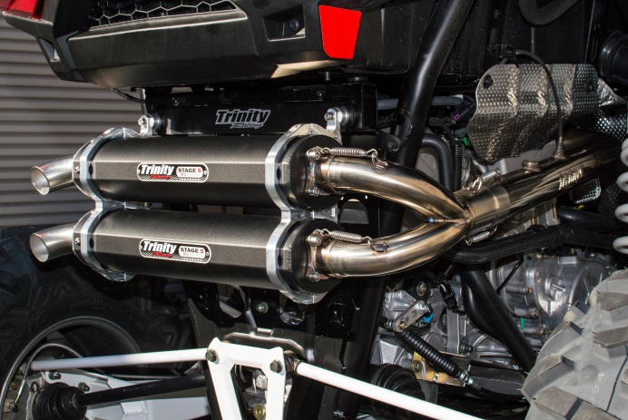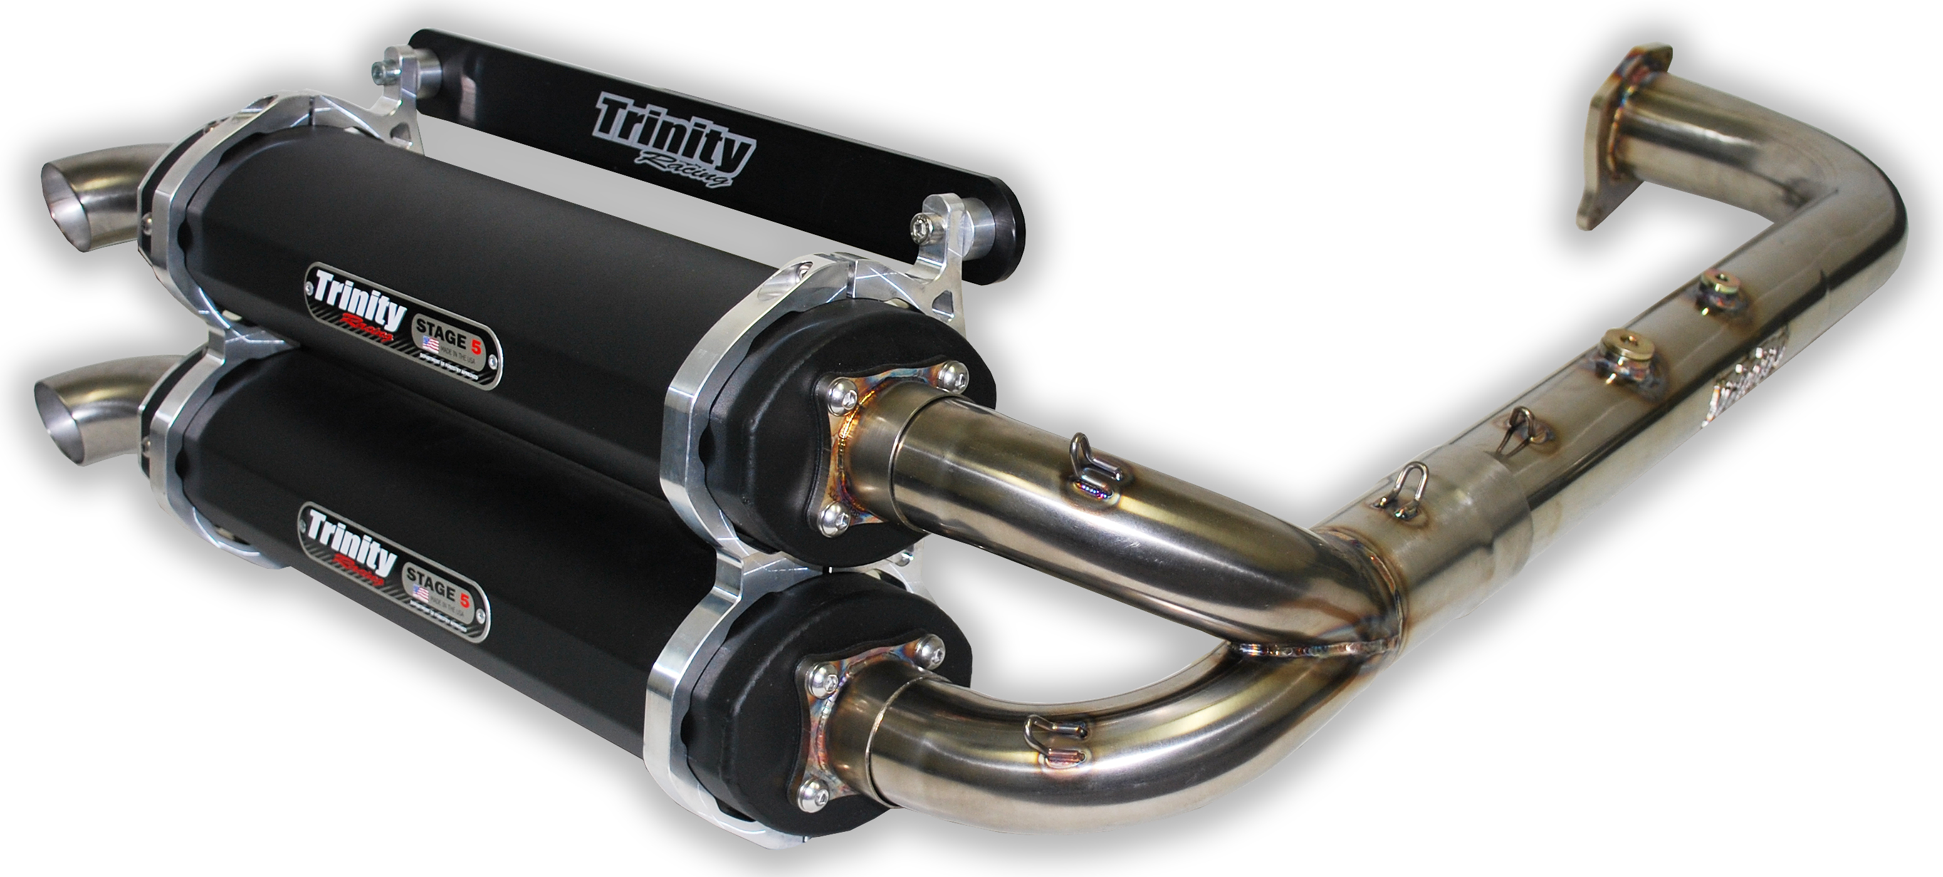

WARNING
*Trinity Racing exhaust systems will require adjustment to OEM fuel settings such as jetting changes or installation of an EFI programmer. Trinity Racing will not be held responsible for damages that occur during operation of your vehicle under improper fuel settings. Ultimately, it is the responsibility of the owner/rider to adjust fuel settings to specific riding conditions and elevation changes before riding.

*Inspection of the muffler packing is recommended following every 15 hours of runtime. Failure to maintain muffler packing will result in power loss, increased sound output, and damage to the muffler body or muffler components.

*Trinity Racing exhausts systems are designed for high performance applications and are legal for closed course competition only. This product is not applicable nor intended for use on emissions controlled street, highway, or off-road vehicles.

