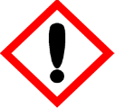 | Cupcake Celebration
 | Warning
 | May cause an allergic skin reaction Avoid release to the environment. Wear protective gloves and eye protection IF ON SKIN: Wash with plenty of water. If skin irritation or rash occurs: Get medical advice. Dispose of contents/container to approved disposal site, in accordance with local regulations.
Contains 1-Benzopyran-2-one (Coumarin). May produce an allergic reaction
Your business Name, Address Line 1, Town/City, Postcode Tel: 01234 567890
123g Net Weight

