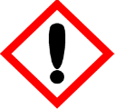 | Aussie Shampoo | 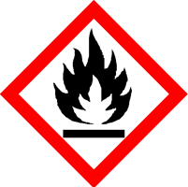
 | Danger
 | Highly Flammable. May cause an allergic skin reaction. Causes serious eye irritation. Harmful to aquatic life with long lasting effects. Avoid breathing vapour or dust. Avoid release to the environment. Wear protective gloves/eye protection/face protection. IF ON SKIN: Wash with plenty of soap and water. IF IN EYES: Rinse cautiously with water for several minutes. Remove contact lenses, if present and easy to do. Continue rinsing. If skin irritation or rash occurs: Get medical advice/attention. Dispose of contents/container to approved disposal site, in accordance with local regulations
Contains ALLYL CYCLOHEXYLPROPIONATE, BENZYL SALICYLATE, CITRONELLOL, CYCLAMEN ALDEHYDE. May produce an allergic reaction.
Your business Name, Address Line 1, Town/City, Postcode Tel: 01234 567890
123g Net Weight

