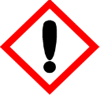 | Pure Tuberose & Golden Musk | 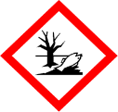
 | Warning
 | May cause an allergic skin reaction. Causes serious eye irritation. Toxic to aquatic life with long lasting effects. Avoid breathing vapour or dust. Avoid release to the environment. Wear protective gloves/eye protection/face protection. IF ON SKIN: Wash with plenty of soap and water. IF IN EYES: Rinse cautiously with water for several minutes. Remove contact lenses, if present and easy to do. Continue rinsing. If skin irritation or rash occurs: Get medical advice/attention. Collect spillage. Dispose of contents/container to approved disposal site, in accordance with local regulations.
Contains (E)-1-(2,6,6-TRIMETHYL-1,3-CYCLOHEXADIEN-1-YL)-2-BUTEN-1- ONE, BENZYL SALICYLATE, CITRAL, CITRONELLOL, ETHYL METHYLPHENYLGLYCIDATE, EUGENOL, GERANIOL, HYDROXYCITRONELLAL. May produce an allergic reaction.
Your business Name, Address Line 1, Town/City, Postcode Tel: 01234 567890
123g Net Weight

