 | Comfortably Strawberry & Lily | 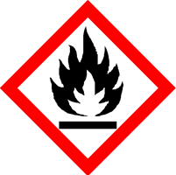
 | Danger
 | Highly Flammable: May cause an allergic skin reaction. Harmful to aquatic life with long lasting effects. Avoid breathing vapour or dust. Avoid release to the environment. Wear protective gloves/eye protection/face protection. IF ON SKIN: Wash with plenty of soap and water. If skin irritation or rash occurs: Get medical advice/attention. Dispose of contents/container to approved disposal site, in accordance with local regulations.
Contains Ligustral, METHYL CINNAMATE, amyl cinnamic aldehyde, hexyl cinnamic aldehyde, limonene, linalool. May produce an allergic reaction.
Your business Name, Address Line 1, Town/City, Postcode Tel: 01234 567890
123g Net Weight

