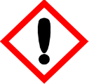 | Japanese Cherry Blossom | 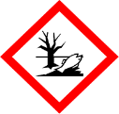
 | Warning
 | Causes serious eye irritation Toxic to aquatic life with long lasting effects Avoid release to the environment. Wear protective gloves and eye protection If skin irritation occurs: Get medical advice/attention. If eye irritation persists: Get medical attention. Dispose of contents/container to approved disposal site, in accordance with local regulations.
Contains d-Limonene (p-Mentha-1,8-diene) , alpha-iso-Methylionone, Benzyl salicylate (Phenylmethyl-2-hydroxybenzoate), dl-Citronellol (3,7-Dimethyl-6-octen-1-ol) (Dihydrogeraniol) , Geranyl acetate, Helional (Heliogan) (3-(3,4-Methylenedioxyphenyl)-2-methylpropanal), Hexyl salicylate (Hexyl-2-hydroxybenzoate) and Iso E super (Octahydro-2,3,8,8-tetramethyl-2-acetonaphthone). May produce an allergic reaction.
Your business Name, Address Line 1, Town/City, Postcode Tel: 01234 567890
123g Net Weight

