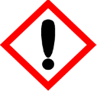 | Only The Bravest
 | Warning
 | May cause an allergic skin reaction Harmful to aquatic life with long lasting effects Avoid release to the environment. If skin irritation or rash occurs: Get medical advice. Dispose of contents/container to approved disposal site, in accordance with local regulations.
Contains d-Limonene (p-Mentha-1,8-diene) , Iso E super (Octahydro-2,3,8,8-tetramethyl-2-acetonaphthone) and alpha-Hexyl cinnamic aldehyde (HCA) (2-Hexyl-phenyl-2-propenal). May produce an allergic reaction.
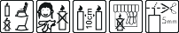
Your business Name, Address Line 1, Town/City, Postcode Tel: 01234 567890
123g Net Weight

