Snowy Splendour
Safety data sheet available on request.
Contains EUCALYPTOL, LIMONENE, LINALOOL. May produce an allergic reaction.
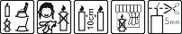
Your business Name, Address Line 1, Town/City, Postcode
Tel: 01234 567890
123g Net Weight

