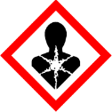 | Sandalwood | 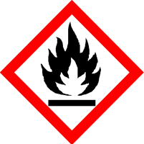  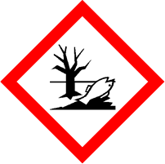
 | Danger
 | Highly flammable liquid and vapour May be fatal if swallowed and enters airways Causes serious eye irritation Very toxic to aquatic life with long lasting effects Keep away from heat, hot surfaces, sparks, open flames and other ignition sources. No smoking. Avoid release to the environment. Wear protective gloves and eye protection IF SWALLOWED: Immediately call a POISON CENTRE. IF ON SKIN (or hair): Take off immediately all contaminated clothing. Rinse skin with water. Do NOT induce vomiting. If skin irritation occurs: Get medical advice/attention. If eye irritation persists: Get medical attention. Store in a well-ventilated place. Keep cool. Dispose of contents/container to approved disposal site, in accordance with local regulations.
Your business Name, Address Line 1, Town/City, Postcode Tel: 01234 567890
123g Net Weight

