 | Sweet Jasmine | 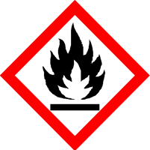
 | Danger
 | Highly flammable liquid and vapour May cause an allergic skin reaction Causes serious eye irritation Harmful to aquatic life with long lasting effects Keep away from heat, hot surfaces, sparks, open flames and other ignition sources. No smoking. Avoid release to the environment. Wear protective gloves and eye protection IF ON SKIN: Wash with plenty of water. If skin irritation or rash occurs: Get medical advice. If eye irritation persists: Get medical attention. Store in a well-ventilated place. Keep cool. Dispose of contents/container to approved disposal site, in accordance with local regulations.
Contains Cinnamic aldehyde (3-Phenyl-2-propenal) (Cinnamaldehyde), Indole, 2-Phenylpropionaldehyde (Hydratropic aldehyde) , Eugenol (2-Methoxy-4-(2-propenyl) phenol) (Allylguaiacol), Aldehyde C-16 fraise (Strawberry aldehyde) (Et-me-ph glycidate), alpha-Amyl cinnamic aldehyde (ACA) (2-Pentyl-3-phenyl-2-propen-1-al) and Benzyl salicylate (Phenylmethyl-2-hydroxybenzoate). May produce an allergic reaction.
Your business Name, Address Line 1, Town/City, Postcode Tel: 01234 567890
123g Net Weight

