 | L'eau De'Issy | 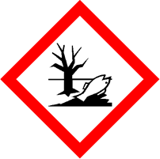
 | Danger
 | Highly flammable. May cause an allergic skin reaction. Toxic to aquatic life with long lasting effects. Avoid breathing vapour or dust. Avoid release to the environment. Wear protective gloves/eye protection/face protection. IF ON SKIN: Wash with plenty of soap and water. If skin irritation or rash occurs: Get medical advice/attention. Collect spillage. Dispose of contents/container to approved disposal site, in accordance with local regulations
Contains 3-(O&PETHYLPHENYL)-2,2-DIMETHYLPROPIONALDEHYDE, ALPHAISOMETHYL IONONE, CITRONELLOL, DELTA-DAMASCONE, EUGENOL, PENTADECALACTONE, SCENTENAL. May produce an allergic reaction.
Your business Name, Address Line 1, Town/City, Postcode
Tel: 01234 567890
123g Net Weight

