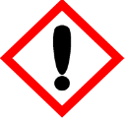 | Vanilla | 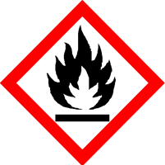
 | Danger
 | Highly flammable liquid and vapour Causes serious eye irritation Keep away from heat, hot surfaces, sparks, open flames and other ignition sources. No smoking. Wear protective gloves and eye protection IF ON SKIN (or hair): Take off immediately all contaminated clothing. Rinse skin with water. If eye irritation persists: Get medical attention. Store in a well-ventilated place. Keep cool. Dispose of contents/container to approved disposal site, in accordance with local regulations
Contains Eugenol (2-Methoxy-4-(2-propenyl) phenol) (Allylguaiacol). May produce an allergic reaction.
Your business Name, Address Line 1, Town/City, Postcode Tel: 01234 567890
123g Net Weight

