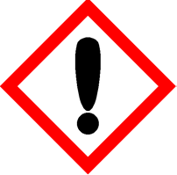 | Clementine & Sparkling Bubbles | 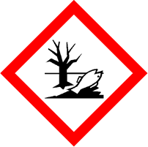
 | Warning
 | May cause an allergic skin reaction Causes serious eye irritation Toxic to aquatic life with long lasting effects Avoid release to the environment. Wear protective gloves and eye protection IF ON SKIN: Wash with plenty of water. If skin irritation or rash occurs: Get medical advice. If eye irritation persists: Get medical attention. Dispose of contents and container in accordance with local regulation.
Contains d-Limonene (p-Mentha-1,8-diene) , Citral, Geranyl acetate and Anethol (isomer unspecified) (Anethole). May produce an allergic reaction.
Your business Name, Address Line 1, Town/City, Postcode Tel: 01234 567890
123g Net Weight

