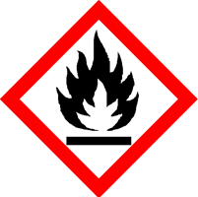 | Mango & Starfruit
 | Danger
 | Highly flammable. Safety data sheet available on request.
Contains 3-(2H-1,3-BENZODIOXOL-5-YL)-2-METHYLPROPANAL, ETHYL LINALOOL. May produce an allergic reaction.
Your business Name, Address Line 1, Town/City, Postcode Tel: 01234 567890
123g Net Weight

