 | Candy Cane | 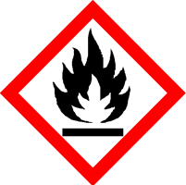
 | Danger
 | Highly flammable. Safety data sheet available on request.
Contains CARVONE, EUCALYPTOL, L-MENTHANONE. May produce an allergic reaction.
Your business Name, Address Line 1, Town/City, Postcode
Tel: 01234 567890
123g Net Weight

