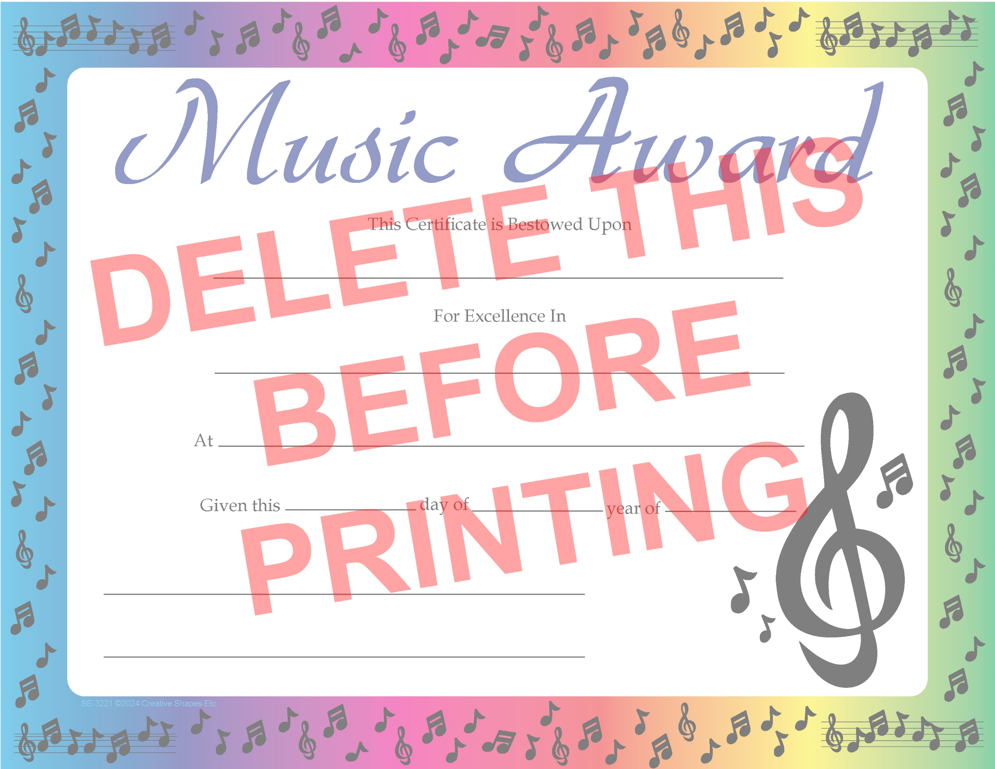

Enter text here

Enter text here

Enter tex­t

Enter text

Enter text

Enter Date Here

Signature

Enter text here, change fonts and move it to the correct position