

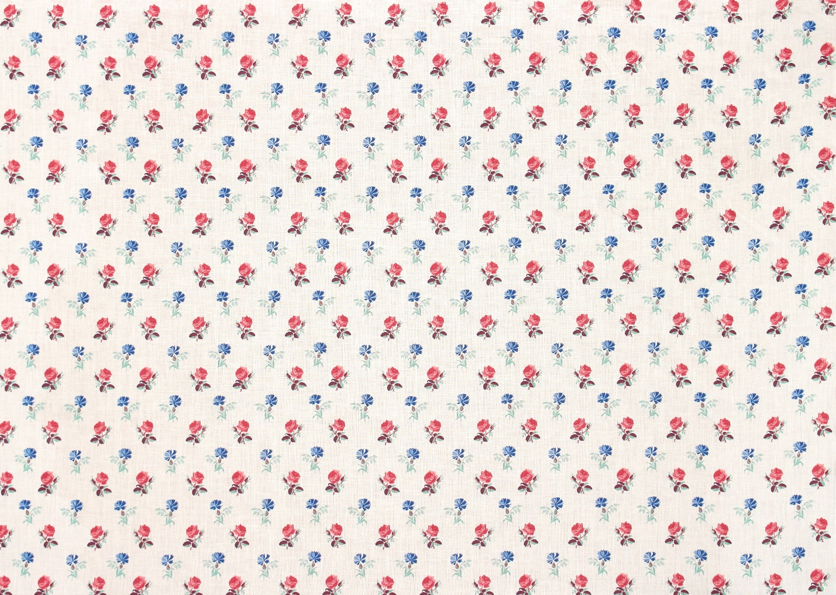

**OFFERED IN TWO GROUNDS**

**PRINT NAME:** PETITE FLEUR

**ITEM #:** SPL 7000-98 *(PINK AND BLUE)*

**COLORS:** OCHRE AND INDIGO,

PINK AND BLUE

**WIDTH:** 54”

**REPEAT:** 6” H, 6.5” V

**GROUND:** 100% LINEN

**ITEM #:** SPF 7000-98 *(PINK AND BLUE)*

**COLORS:** OCHRE AND INDIGO,

PINK AND BLUE

**WIDTH:** 54”

**REPEAT:** 6” H, 6.5” V

**GROUND:** 100% COTTON