**COVID 19 Employee & Guest Safety Plan**

**Introduction**

* As an employer, we have a duty of care to our employees and our guests; this includes managing and reducing the risk of COVID - 19 transmission in our store, and in this task, we ask for
* the full support of our employees. This work safe briefing, is designed to educate and train our staff, ensuring the COVID - 19 Transmission Control measures we implement are effective and complied with.

Version 6

Note, this Safety Plan has been created inline with Work Safe BC Retail Specific guidelines and recommendations.

**Table of Contents**

1. Summary of WHISLIFE COVID – 19 Control Measures
2. Understanding COVID – 19
3. Identifying Symptoms
4. Managing COVID – 19
5. WHISLIFE Specific COVID – 19 Hazards & Controls
6. Front Door Signage
7. Till Signage
8. Cleaning & Hygiene Schedule
9. Employee Infection Policy
10. Guest Infection Policy
11. Raising Safety Concerns & Employee Comments
12. Acknowledgement of Training

**Summary of WHISLIFE COVID – 19 Control Measures**

* **Store Entry & Occupancy Limits** 
  + - * Hand sanitizer station at store entry.
      * Signage displaying symptoms, occupancy limit and merchandise touching policy
* **Store Layout** 
  + - * Store layout with physical barriers to promote social distancing
      * Staff to wear face masks when guests are in store
* **COVID Hygiene and Cleaning Policy implemented** 
  + - * Card reader to be cleaned in between each use, contactless payment promoted. Signage displayed at till.
      * Till Area to be cleaned at the start and end of your shift or before you use the till.
* **Employee COVID infection Policy implemented & Rosta** 
  + - * Rosta rationalized to reduce overlap in shifts where possible.
      * Staff experiencing symptoms to self-isolate for 10 days.
  + **Employees Trained in new protocols and Procedures** 
    - * Employees to stay behind till in safe area as much as possible
      * Follow cleaning protocols
      * Tidy and re stock shelving when customers are not present / maintain safe physical distance
      * Actively limit the number of guests in store to conform to our occupancy limits (Posted at door)
* **Open Door Policy**
  + - * Store door to remain open to reduce Surface Transmission Risk

**Understanding COVID - 19**

* To understand the rational of the control measures we implement in our store, it is imperative to have an understanding of what COVID- 19 is, how it is transmitted and how this transmission can be managed to reduce the risk of exposure.
* COVID - 19 is a virus that spreads seemingly in two major ways:
  1. ***Person to Person Transmission***: droplets in the air when someone coughs or sneezes
  2. ***Surface Transmission***: when someone touches contaminated objects and proceeds to touch their face (Mouth, Noes or Eyes).

What factors increase the successful transmission of COVID - 19 ?

1. ***Person to Person Transmission:*** 
   * + The closer you come near somebody
     + The longer you spend around them
     + The amount of people you come near

2. ***Surface Transmission:***

* + - When many people contact the same object
    - When those contacts come in a short time intervals.

**Identifying Symptoms**

* The symptoms of COVID – 19 are like other respiratory illness including the flue and common cold.   
    
  They include:
  + - Fever
    - Chills
    - Cough
    - Shortness of breath
    - Sore Throat & Painful swelling
    - Stuffy or Runny Noes
    - Loss of sense of smell
    - Headache
    - Muscle aches
    - Fatigue
    - Loss of Appetite

If you have any of these symptoms, notify WHISLIFE management, isolate for 10 days and contact health professionals is need by via following their guidance.

**Managing COVID 19**

* Work-Safe BC define four tiers of action in the managing of COVID - 19 to safely reduce transmission rates, they are:

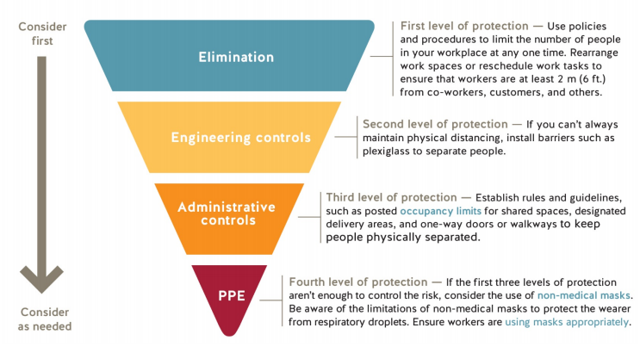

‘

We will be utilizing a combination of these WorkSafe BC measures to ensure your safety and the safety of our guests in regard to doing all that we can to reduce the transmission of COVID 19.

**WHISLIFE Specific COVID – 19 Hazards & Controls**

* With the Work Safe BC’s recommendations in mind, and a review of our daily operations highlight the hazards that exist, and the controls that we are implementing to reduce the successful transmission of COVID - 19 through Surface or Person:

**Store Layout & Customer Occupancy Limits**

* + 1. **Small Store Footprint:**

The footprint of the WHISLIFE store is limited, meaningwe must carefully consider the amount of people in our store at one time in order to reduce the population of store and ensure there is enough space to keep a safe distance from others.

**Control:** *Elimination & Administrative*

Two guest / group of guests to be allowed in our store at any one given point.  
Staff to actively limit the amount of guests in our store.   
Staff to wear face masks at all time when guests are in store.

* + 1. **Store Layout & Guest Interaction**

As mentioned above, the footprint of WHISLIFE is small and even with one guest in our store, we need to consider how to ensure safe distancing can be maintained.

**Control:** *Elimination*Staff members are to remain behind the till area as much as possible when customer enter the store as this naturally provides a physical barrier promoting safe distancing (of 2 meters or more).   
In our floor plan we have a clothing rail in the middle which further provides a physical barrier promoting physical distancing.

**Freebies**At WHISLIFE we offer many freebies such as sticker for all guests who turn up and even free key chains for each purchase made. Whilst we do not want to stop doing this, we must consider that this increases the risk of Surface Transmission.

**Control:** *Elimination, Administrative & PPE* **Stickers:** Hand sanitizer station is positioned by door. All customers to sanitize hands before touching stickers. **Free Key Chains:** Normally staff would pass the key chain to the customer, but this increases risk of Person to Person and Surface Transmission. From here on out, staff will now demonstrate how the product works from behind the physical barrier and put into the customers bag on checkout.

* + 1. **Work Schedules**We have a fair number of staff working for WHISLIFE, and in the unfortunate event a member of staffhas COVID – 19, we must ensure the number of staff each individual is in contact with is limited to reduce COVID – 19 transmission between all our staff.   
         
       **Control:** *Elimination & engineering Controls*   
       To reduce the likelihood of COVID – 19 transmission amongst our employees, careful consideration is taking place when we put together the staff rosta as to ensure staff overlap in shifts is limited. If a member of staff is infected or experiencing symptoms of COVID – 19, we will follow ‘Employee COVID Protocol’ This includes a deep clean of the work area, the worker to self-isolate for 10 days.

**Welcoming Customers into Store**

* + - 1. **Incoming Customers**   
         We are relying on the general public to understand the symptoms of COVID – 19 and understand how they should act if they are experiencing such symptoms. Unfortunately, not everyone holds this knowledge. And therefore, could put our staff or others at risk if they enter our stores unknowingly being infected with COVID – 19.

**Control:** *Elimination & Administrative Controls*At entry to the store we have posted a store occupancy limit (posted at store entry) to be instore at any one given time. Staff are to actively manage guests and request they wait outside whilst another customer is in store. A sign displaying symptoms requesting those with symptoms do not enter our store.   
A hand sanitizer station will also be positioned at entry to our store for all those entering to use, reducing Surface Transmission risk.   
We have an open door policy, so that the front door remains open to reduce Surface Transmission Risk.

**Stocking Shelves and product displays**

1. **Re Stocking Shelves and Rails**When we leave our till area (Safe zone) we are putting ourselves at an increased risk of person to person transmission when customers are in the store.

**Control:** *Elimination & Administrative Controls*

To eliminate this risk, staff should only re stock and tidy the store when no customers are present in store where possible. At times this will be near impossible to maintain so we must be realistic, if we are re stocking and customers are present, staff are reminded to be cautious and maintain a safe social distance of two meters. Following Work safe BC Guidelines, staff are to sanitize their hands before and after store restocking.

1. **Guests Touching Merchandise**The more our guests touch our merchandise, thehigher the risk of Surface Transmission becomes. And therefore, we need to implement ways and means to limit this exposure.   
     
   **Control:** Elimination *& Administrative Controls*We have already displayed signage and a hand sanitizer station at the entry point of our store which will drastically reduce Surface Transmission Risk; this sign also details our Touching Merchandise Policy, essentially being to limit the products you touch and only touch things you intend on buying.

**Payment and Till Area**

1. **Payment of Goods**As we know, the rate of COVID – 19 transmission increases when you are closer to another induvial for increased periods of time. This is notable when a customer pays for goods, during this period, the guest may also use the pin card reader, this promotes Surface Transmission.

**Control:**  *Engineering Controls*When customers are checking out, they will naturally be in close proximity to our staff, and also use the card machine by touch. However this is only for a brief period of time, and for this reason, briefness of time, transmission risk is naturally reduced. In regards to surface touch transmission and the card reader, we have implemented  
a hygiene policy to ensure the card reader is sanitized between each use, at the start and end of each use. We also encourage the public to use tap and go checkout.

1. **Handling Cash & Packing Items**The more we touch, the higher risk of surface transmission. This includes cash handling and packing items into customers reusable bags.

**Control:**  *Elimination & Administrative* When handling cash, employees are trained and expected to frequently wash their hands.The use of customer reusable bags is acceptable if the customer packs their own bag.

**Front Door Signage**

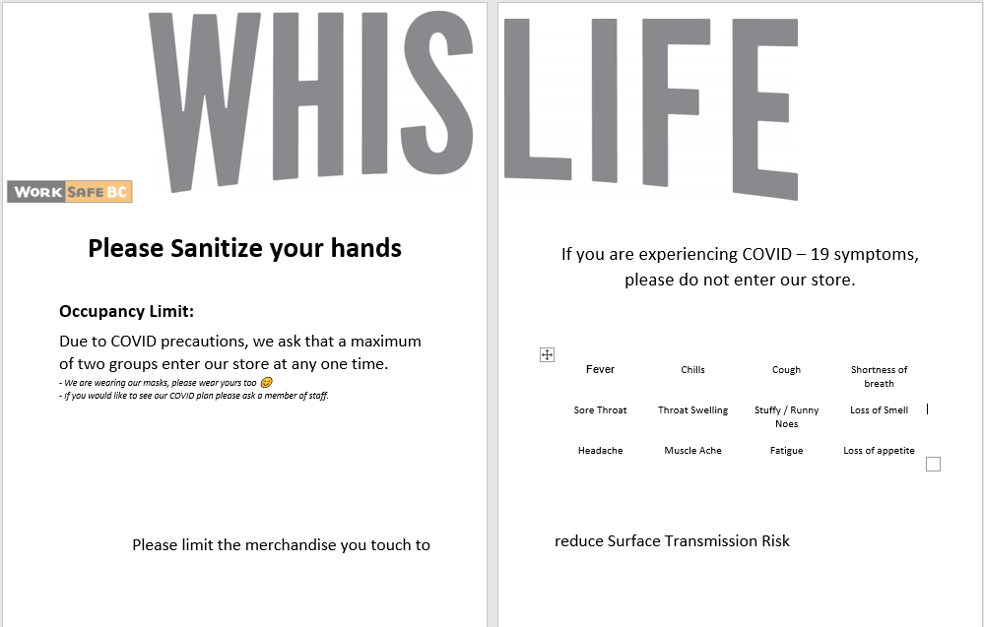

**.**

**Till Signage**

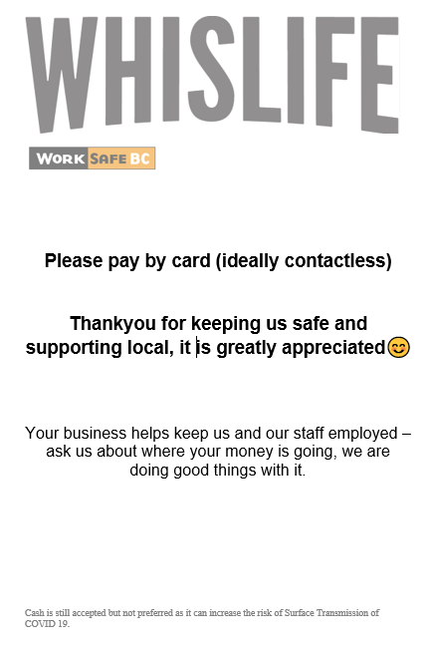

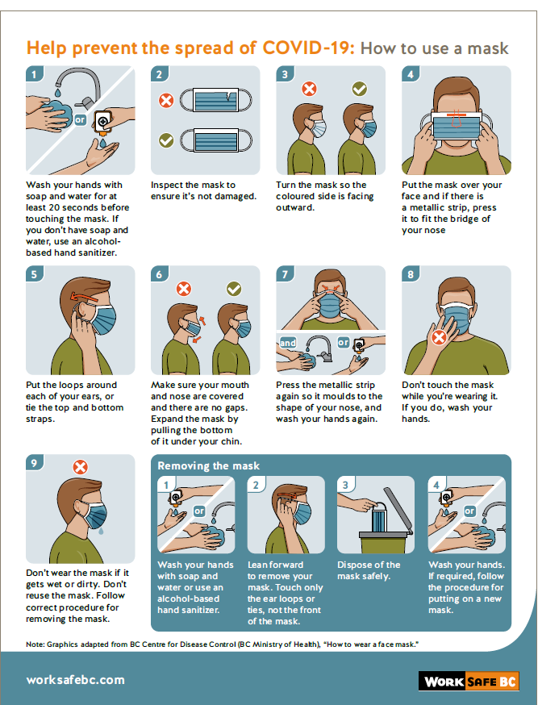

**COVID Cleaning & Hygiene Schedule – Reference Guide**

This section provides a chronological order of operations to be carried out by staff during the COVID pandemic:

* When opening the store in the morning, sanitize hands before putting rails out.
* Ensure signage is displayed & hand sanitizer station set up
* Turn on lights and heating, sanitize all switches
* Sanitize keyboard, mouse, card reader, plexi glass, hands & store phone
* Continue with normal opening procedure.
* Sanitize hands before putting new stock out / re folding etc and after.
* Wait for customers to leave before putting new stock out / folding & tidying.
* Stay behind the till as much as possible throughout the day to maintain a safe working distance.
* Sanitize the card reader after each use (unless contactless) and after each cash handling transaction.
* Actively manage gusts in accordance with the occupancy limit.
* Ask all guests to sanitize hands before entering store.
* Sanitize till area and all when swapping shifts / start of shift / end of shift
* When closing for the day, hoover and mop, sanitize hands and handles after use.
* Sanitize hands after cash up
* Bring in rails and close.
* Sanitize store phone after each time you answer it, at the start and end of your shift or shift cross overs.

Each member of staff is responsible for cleaning and maintaining store hygiene inline with the above.

Clean surfaces inline with Work Safe BC Cleaning and Disinfecting guidance (Full guide printed for reference):

1. Remove Surface Dirt  
2. Disinfect Surface - Using disinfectant provided (Approved by Health Canada, COSHH data labelled on product.

**Employee Sickness at Work**

* *If you are experiencing any COVID like symptoms, do not come to work.   
  Inform WHISLIFE management and self-isolate for 10 days.*
* *If you have been directed by Public Health, please isolate, do not turn up for work.*
* *If you have travelled internationally, you must isolate for 14 days.*
* *Workers who live in the same household as a confirmed or clinical COVID 19 case must not turn up to work.*

If an employee experiences symptom of COVID 19 whilst at work, please follow these steps:

* Sanitize your hands
* Put on a face mask following the Work Safe BC Poster of correct fitting (Displayed in store)
* Maintain a safe physical distance from others
* Shut the store doors
* Contact WHISLIFE Management
* Self-Isolate for 10 days and monitor symptoms
* Contact health professionals if required and follow their guidance
* Even if you only have mild symptoms

Consult the BC COVID – 19 Self-Assessment Tool or call 811 for further guidance (related to self isolation).

If you are severely ill, call 911 (Breathing Difficulty, Chest pain etc)

**WHISLIFE Actions**- If an employee is infected with COVID 19, as an employer we must now act responsibly and in a way that does not pose a risk to other employees or guests.

Once management has been contacted about an employee experiencing symptoms of COVID 19, we must:

**Step 1: Check the procedure as above has been followed**  
- Remotely check if the employee has sanitized their hands, put a face mask on following the Work Safe BC poster for correct fit and closed the store door.

**Step 2: Deep Clean of Store**- Following the cleaning and disinfecting Work Safe BC guidance, we must perform a deep clean of anything they may have come into contact with, this includes:

* + - Switches & Controls (Light Switches, Heating Controls)
    - Hand sanitizer bottle
    - Door Handles
    - Till, Computer Screen, Keyboard, Mouse, Card Reader and Work Top
    - Floor to be mopped and sanitized
    - Rail tops that get wheeled outside and all other items regularly lifted to take outside
    - Store Phone
    - Pens & Stationary

**Step 3:** Identify the member of staff they have been working with on a regular basis and ask them to self-isolate. The rosta has been set up so employees regularly work with the same people to limit company wide transmission.

**Step 4: Open for normal operation**

**.**

**If a Guest is Showing Symptoms of COVID 19**

If a guest enters our store and we recognize that they are showing symptoms of COVID 19, we need to act in a calm, responsible and professional manner and follow much the same steps as if an Employee experience sickness / displays COVID symptoms at work:

* + Inform the guest that we suspect they are displaying symptoms of COVID 19
  + Ensure a safe social distance and ask they sanitize their hands
  + Provide them with a face mask and provide instruction on how to fit it correctly following the displayed Work Safe BC poster.
  + Ask them politely to leave the premises, return home and self-isolate and contact the local health authority following their guidance
  + Once they are removed from the premises, close the store and sanitize any objects they may have touched.
  + Record the incident and actions taken, inform a WHISLIFE manager.
  + Once management are happy all of the correct steps have been taken to safeguard yourselves and our guests, we will instruct you / proceed to re - open store.

Consult the BC COVID – 19 Self-Assessment Tool or call 811 for further guidance (related to self isolation).

If the guest is severely ill, call 911 (Breathing Difficulty, Chest pain etc)

**Raising Safety Concerns & Employee Comments**

As we brief each of you on our COVID 19 protocols, we welcome any feedback and suggestions in how we can strengthen our processes. Please do speak up , record your concerns, comments and suggestions and we will pick them up in our next amendment.

-

-

-

-

-

-

-

-

**Acknowledgement of Training and Education of the WHISLIFE COVID Protocols – Version 6**

I (as listed) hereby certify that I have received briefing and training as outlined in the WHISLIFE COVID 19 Guest and Employee Safety Plan, and can adequately and safely conduct myself to maintain the safety of myself and our guests, working the slow the transmission of COVID 19.

I hereby certify that I have not experienced any COVID 29 symptoms in the past 14 days, been home with or in close contact with someone with a confirm COVID 19 infection, and will inform WHISLIFE management of any changes to this and will act accordingly (Not turn up to work, self-isolate for 10 days, follow local health care advice).

Contact WHISLIFE Management, Tom Millar and / or Matt Hall with any safety concerns.

|  |  |  |
| --- | --- | --- |
| Employee Name | Signature | Date |
|  |  |  |
|  |  |  |
|  |  |  |
|  |  |  |
|  |  |  |
|  |  |  |
|  |  |  |
|  |  |  |
|  |  |  |
|  |  |  |
|  |  |  |
|  |  |  |
|  |  |  |