

Puma IV Series User Manual

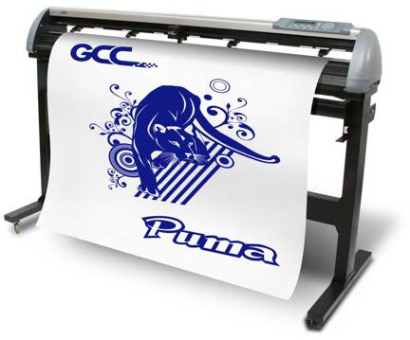

[http://www.GCCworld.com](http://www.GCCworld.com/)

**NOTICE**

GCC reserves the right to modify the information contained in this user manual at any time without prior notice; un-authorized modification, copying distribution or display is prohibited. All comments, queries or

suggestions concerning this manual please consult with your local dealer.



**Important Information**

Thanks for your purchase of GCC ***Puma IV Series*** Cutting Plotter. For your safety and to optimize the performance of the Puma IV, please read the user manual completely and keep it in a correct location.

# PRECAUTIONS IN USE

* For safety concern, please always hold the cutter firmly **from the bottom** when moving it. Do not move the cutter by clasping the depression area on both sides.

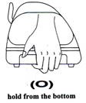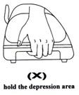

* Do not shake or drop the blade holder, a blade tip maybe fly out.
* During operation, keep away from any moving parts of the cutter (such as the carriage, drums). Also be careful that your clothing and hairs do not be caught.
* Always connect the power cable to a grounded outlet.
* Always use the accessory power cable that is provided. Do not wire the power cable so that it becomes bent or caught between objects.
* Do not connect the power cable to branching outlet to which other machines are also connected, or use an extension cable. There is danger of overheating and of misoperation of the machine.
* Keep the tools away from children where they can reach.
* Always put the pinch rollers within position of the white marks.

Important Information

Important Information

Contents

1. **General Information**
   1. Introduction 1-1
   2. Package Items 1-1
   3. Product Features 1-2
   4. Appearance of Puma IV 1-3
      1. The Front View 1-3
      2. The Back View 1-4
      3. The Whole View 1-5
      4. The Left-hand Side 1-6
      5. The Right-hand Side 1-6
2. Installation
   1. Precaution 2-1
   2. Stand & Flexible Media Support System (for P4-132LX / P4-132) 2-3
   3. USB Cable Tie and Saddle 2-7
   4. Desktop Flexible Media Support System (for P4-60LX / P4-60

only) 2-9

* 1. Blade Installation 2-11
  2. Cable Connections 2-13
     1. USB Interface 2-13
        1. Connecting your GCC cutter 2-15
        2. Installing the driver 2-15
        3. Driver Un-installation 2-18
     2. RS-232 Interface 2-21
     3. Ethernet Connection 2-21
     4. Data Transmitting 2-23
     5. Printer Sever Shared Setting 2-23
  3. Software Installation 2-26
     1. GreatCut-S Auto Installation 2-26
     2. Manually Activate GreatCut-S 2-31
     3. Re-install GreatCut-S Software 2-33
     4. Reset GreatCut-S Serial Code 2-33

1. The Control Panel
   1. The LCD Panel 3-1
   2. Menu in On-line Mode 3-2
   3. Menu in Off-line Mode 3-3
   4. Menu Items 3-5
2. Operation
   1. Media Loading 4-1
      1. Loading the Sheet Media 4-1
      2. Loading the Roll Media 4-3
   2. Tracking Performance 4-6
   3. Cutting Force and Offset Adjustment 4-6
   4. When Completing the Cutting Job 4-8
   5. Puma IV Print Driver setting 4-9
      1. Puma IV Print Driver setting>Option Page 4-9
      2. Puma IV Print Driver setting>Pen Page 4-13
      3. Puma IV Print Driver setting>Paper Page 4-16
   6. Reference Parameter setting for different materials 4-17
   7. How to set die/kiss cut through plug-in software for Adobe Illustrator and CorelDraw

4-18

### Automatic-Aligning System

* 1. Introduction 5-1
  2. Calibrating the System 5-2
     1. Media Calibration 5-2
     2. AAS Calibration 5-2
     3. AAS II on Puma IV LX 5-3
  3. Printer Test 5-5
  4. Registration Mark Offset Range
  5. Contour Cutting

5-7

5-7

* 1. Tips for AAS 5-9

### Basic Maintenance

* 1. Cleaning the cutting Plotter 6-1
  2. Cleaning the Grid Drum 6-2
  3. Cleaning the Pinch Rollers 6-2

### Trouble Shooting

* 1. Non-Operational Problems 7-1
  2. Operational Problems 7-2
  3. Communication Problems 7-3
  4. Software Problems 7-4
  5. Cutting Quality Problems 7-5

**Appendix**

|  |  |
| --- | --- |
| A-1 Puma IV Specifications | A-1 |
| A-2 Blade Specification | A-2 |
| A-3 CorelDRAW Output Instruction | A-3 |
| A-4 CorelDRAW Plug-In Instruction | A-4 |
| A-5 Illustrator Plug-In Instruction | A-5 |
| A-6 Greatcut-S quick manual | A-6 |

**Chapter 1 General Information**

# Introduction

Puma IV series cutting plotters have been designed to produce computer-generated images or perform contour cutting on sheets or rolls of vinyl media.

This manual covers the following models of Puma IV series cutting plotters:

|  |  |
| --- | --- |
| ‧ P4-60LX / P4-60 | for media width: 70mm (2.76”) ~ 719mm (28.3”) |
| ‧ P4-132LX / P4-132 | for media width: 70mm (2.76”) ~ 1470mm (57.87”) |

# Package Items

The package of the Puma IV model contents the items listed below, please check carefully. If you find any item missing, please consult your local dealer for further assistance.

|  |  |
| --- | --- |
| **Standard Item** | **Quantity** |
| **1. Cutting Plotter** | **1** |
| 1. **Stand Set (for P4-132LX / P4-132 only, optional for P4-60LX / P4-60)**    * 2 piece of T-shape stand    * 1 piece of stand beam    * 20 pieces of M6 screws    * 1 piece of M5 L-shape hexagon screw driver    * 1 piece of Installation Guide for Stand Set | **1** |
| **3. Flexible Media Support System Package** | **1** |

|  |  |  |
| --- | --- | --- |
| Items | P4-60LX /  P4-60 | P4-132LX /  P4-132 |
| 1 set of Roll Media Flange (2 pieces) |  | V |
| 1 set of Roll Holder (2 pieces) |  | V |
| 1 set of Roll Holder Guide Bushes (4 pieces) |  | V |
| 1 set of Roll Holder Support (2 pieces) |  | V |
| 32 pieces of M6 screws |  | V |
| 1 piece of M6 L-shape hexagon screw driver |  | V |
| 1 piece of Roll Base | V |  |

|  |  |
| --- | --- |
| 1. Accessories    * 1 piece of AC power Cord    * 1 piece of data cable (USB cable: 3m)    * 1 piece of Ethernet cable    * 1 set of Blade Holder Assembly (Installed in tool carriage of the cutting plotter )    * 1 piece of Blade (Installed in Blade Holder)    * 1 piece of Safe Blade    * 1 piece of Cutting Pad    * 1 piece of Tweezers    * 1 piece of Promise Card | **1** |

# Product Features

The following are the main features of the Puma IV LX / Puma IV series cutting plotters:

* Triple-port connectivity provides you with greater flexibility
* Up to 500 gram cutting force
* Up to 1020 mm per second (40.16 ips) cutting speed (at 45° direction)
* Guaranty 5-meter tracking
* User-friendly and multi-language control panel
* Enhanced Automatic-Aligning System for automatic contour cutting

# Appearance of Puma IV

### The Front View

**Grid Drums**

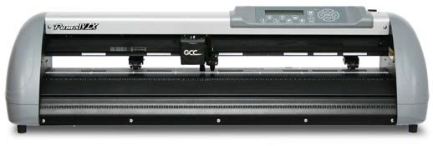

Move the media back and forth during operation.

**Slicer Groove** Cut off the extra media easily along this groove.

**Tool Carriage** Perform the cutting with the installed blade or pen with AAS module.

**Control Panel**

14 buttons and 1 LED and 1 LCM showing messages and menus.

**Platen**

Provide the surface for supporting media while cutting

**Alignment Rulers** Media can be aligned with the clear guide line marks

**Cutting Pad**

Provide the protection of blade when the blade is cutting.

**Figure 1-1**

### The Back View

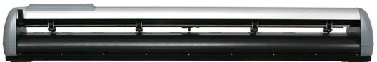

**Lever**

Raise or lower the pinch rollers.

**Pinch Rollers**

Hold the media during cutting.

**Figure 1-2**

### The Whole View

**Stand for Puma IV 60 is an optional item.

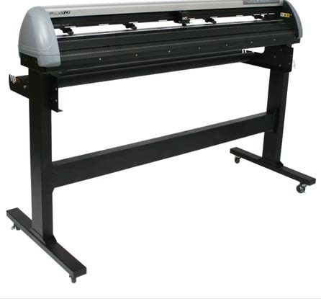

**Roll Holder Guide Bushes**

Serve to keep the roll media in place when media is pulled from the

roll.

**Stand for Puma IV 132S is a standard item.

**Roll Holder**

Hold and supplies the roll media for cutting.

**Roll Holder Support**

Support roll holders.

**T-Stand**

Support the cutting plotter body.

**T-Stand**

Support the cutting plotter body.

**Stand Beam**

Stabilize the body.

**Figure 1-3**

### The Left-hand Side

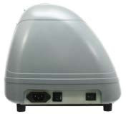

**AC Power Connector**

**Fuse** – 3 Amp.

**Power Switch** – On when switches to [I]; Off to [O]

**Figure 1-4**

### The Right-hand Side

**Ethernet Connector**

Used to connect your cutting plotter to a local area network.

**Figure 1-5**

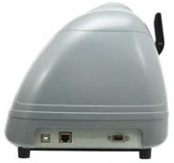

**USB Connector**

Used to connect the cutting plotter to a computer through a USB cable.

**Serial Interface Connector (RS232C)**

Used to connect the cutting plotter to a computer through a serial interface cable.

**Chapter 2 Installation**

# Precaution

### Notice 1

* Carefully handle the cutter to prevent any injuries.
* Make sure the power switch is off before installing the cutting plotter.

### Notice 2 A proper place for installation the cutting plotter

Please select a proper location that meets the following conditions.

* The machine can be approached easily from any direction.
* Keep at least 60 cm space in front and behind the machine.
* Make sure the cutter is placed on a flat, level and sturdy surface
* The operation temperature should be between ***15 and 30℃ (60-86oF)*** in the workshop.
* Keep the relative humidity between **25*% and 75%*** in the workshop.
* Protecting the machine from dust and air current.
* Preventing the machine from direct sunlight.
* The machine should be installed in a proper place where only well-trained professionals are allowed to operate the machine.
* This product should be installed only in a restricted access location (Professional printing rooms, service closets, etc.)

### Notice 3 Connecting the Power Supply

Check the plug of the power cord to see if it matches the wall outlet. If not, please contact your dealer.

* Insert the plug (male) into a grounded power outlet.

Note: The equipment power supply cord shall be connected to a socket-outlet with earthing connection.

* Insert the other end (female) of power cord into the AC connector of cutting plotter.

### Notice 4 Tightening or Loosing Screws with Screwdriver

Whether manual or electric screwdriver, be careful not to use excess torque force when tightening or loosing screws. When tightening or loosing iron and stainless steel screws, please refer to the following screw torque standard table, other materials screws are not included.

|  |  |
| --- | --- |
| Screw diameter | Torque value (kgf-cm) |
| Torque standard for high hardness materials |
| M3 | 6 |
| M4 | 16 |
| M5 | 30 |
| M6 | 50 |

# Stand & Flexible Media Support System (for P4-132LX / P4-132)

Please follow procedure below to assemble stand and media support system.

**Step 1** Please examine supplied items in the accessory box of stand carton before you install:

**Stand is a optional item for Puma IV 60 LX / Puma IV 60, Item List：**

* 2 piece of T-shape stand
* 1 piece of stand beam
* 20 pieces of M6 screws
* 1 piece of M5 L-shape hexagon screw driver
* 1 piece of Installation Guide for Stand Set

**Step 2**

* Remove the plotter body and the accessories from the shipped carton.
* Place the stand beam upright on the T-stand and follow the number ❶❷ to assemble (See Figure 2-1 & 2-2).
* There is hexagon socket head screws fasten on the T-stand on both side taken as locating pins.

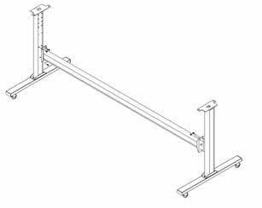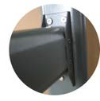

❶ **T-Stand**

❷ Stand beam

**Figure 2-1**

**Figure 2-2**

**Step 3** Position the stand beam perpendicularly to part ❶and put the screws into the holes and tighten them as Figure 2-2. Then the complete picture of stand will be like Figure 2-1.

**Step 4** Remove the cutting plotter from the carton. Position your stand under the plotter, on the bottom of the plotter, there is one hole on each side in the position corresponding to the locating pins, so the locating pins can be located into the holes. Then insert the screws into the holes on the stand to fix the plotter and tighten them up as shown in Figure 2-3.

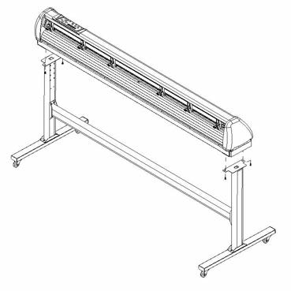

**Figure 2-3**

### Screws

**Step 5**

Insert the roll holder support with the screws into the holes of the stand, and then tighten them up as shown in Figure 2-4. You could decide roll holder support’s position by inserting into different holes.

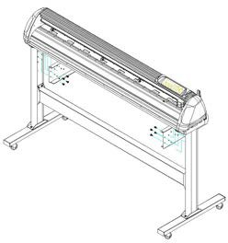

4 screws

**Figure 2-4**

Roll holder

### Step 6

Place two roll holders onto the roll holder support. (Figure 2-5)

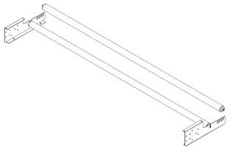

**Figure 2-5**

Roll holders

Roll holder support

### Step 7

Lastly, the complete picture will be shown like below. (Figure 2-6)

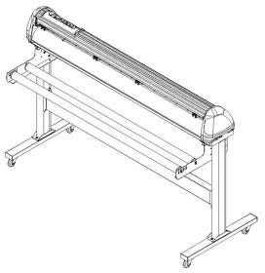

**Figure 2-6**

# USB Cable Tie and Saddle

The USB cable tie and saddle assembly for the stands with Flexible Media Support System only.

**Step 1** Insert the cable tie into the upper hole of cable saddle from bottom to top.

This side up

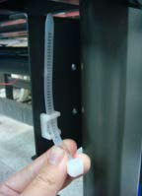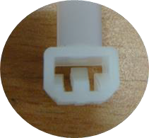

**Step 2** Place the USB cable into the cable tie and tighten the cable tie.

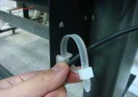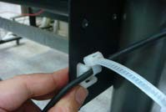

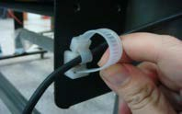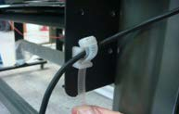**Step 3** Insert the cable tie end into the lower hole of cable saddle to finish the job.

Untied way: pull out the cable tie→ pull up the pin→ release the cable tie.

Pull out the cable tie

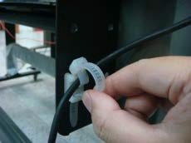

Pull up the pin 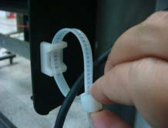 Release the cable tie

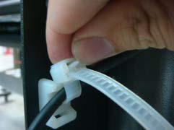

# Desktop Flexible Media Support System (for P4-60LX / P4-60 only)

### Step 1

Check three spacer supports on the back of the machine.

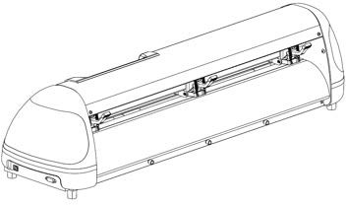

### Step 2

Insert the left and right roll holder base into the spacer supports on the left and right side when 2 inches roll media is used.

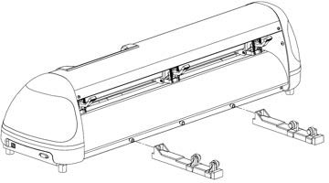

### Step 3

Press the roll holder base and the installation is complete.

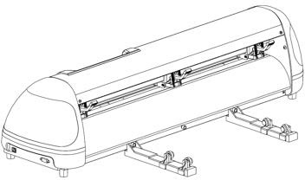

**Note:** Insert the left roll holder base into the middle spacer support and right roll holder base into the right one when 1 inches roll media is used.

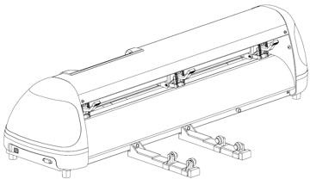

# Blade Installation

**! Caution**

Do not touch the tip of the blade by your fingers.

**! Notice**

The blade is a consumable item, which will affect the cutting quality significantly. Please replace with a new blade when having the following situations:

1. The tip of blade is broken.
2. The cutting traces are not as good as they were.
3. Uncut area remains the same even the blade force has been raised significantly.

Figure 2-11 is the picture of the blade holder. Insert a blade into the bottom of the blade holder. Pushing the pin on the top of blade holder can remove the blade. Be sure to keep your fingers away from the blade tip.

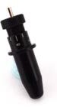

Outward ring

Adjustment depth knob

Pin

### Figure 2-11

**Step 1** Install blade. (Figure 2-12)

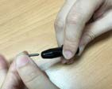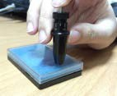

### Figure 2-12 Figure 2-13

**Step 2** Push the blade to the bottom of the blade holder. (Figure 2-13)

**Step 3** Adjust the blade tip to suitable length by rotating “Blade tip adjustment screw” clockwise or counterclockwise. (Figure 2-14)

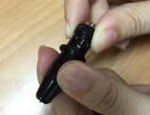

**Tips:** “The proper length” means the blade length is about 0.1mm more than film’s thickness. For example, if the thickness of film is 0.5mm, then the blade length is properly adjusted to 0.6mm and it can completely cut through the film layer without cutting though the paper backing.

### Figure 2-14

**Step 4** Insert the blade holder into tool carriage. Please note the outward ring of the holder must put into the groove of carriage firmly (Figure 2-15) and lock the grip. (Figure 2-16)

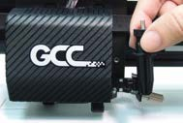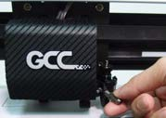

### Figure 2-15 Figure 2-16

**Step 5** Reverse steps mentioned above to remove the blade holder.

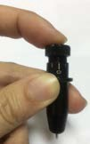**Step 6** Press the push-pin to remove the blade from the blade holder when replacing blade (Figure 2-17).

**Figure 2-17**

# Cable Connections

Puma IV communicates with a computer through **USB (Universal Serial Bus)**, a **Serial port (RS-232C)** or **Ethernet**. This chapter shows you how to connect the cutting plotter to a host computer and how to set up the computer/cutting plotter interconnection.

!! **Notice:**

When USB connection is enabled, serial port will be disabled automatically.

Serial Interface Connector (RS232C) – used to connect the cutting plotter to a computer through a serial interface cable.

### Figure 2-18

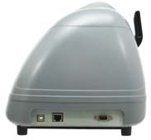

Ethernet Connector– used to connect your computer to a local area network.

### USB Interface

USB Connector – used to connect the cutting plotter to a computer through a USB cable.

Puma IV build-in USB interface are based on the Universal Serial Bus Specifications Revision 2.0 (Full Speed).

### Connecting your GCC cutter

Turn on the machine.

Connect the USB connector to the machine and then USB driver will installed automatically. It will take a few minutes to find the device. Please DO NOT disconnect the USB cable until the installation has completed.

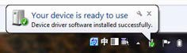You can double click the USB icon on the taskbar to make sure the USB device is detected.

### Installing the driver

Use the USB One-click Installation for quick driver installation. Follow the simple steps below for driver setup.

* **If you are using Windows 7 and above as your operating system, make sure you log in using the “Administrator” account.**

**Caution!!**

**Step 1** Visit GCC website and go to “SUPPORT” page to download the user manual, driver and software (<https://www.gccworldnew.com/download.php>).



**Step 2** You may use search function or directly click the product category to choose the model you want.

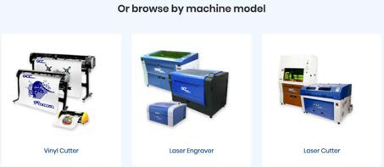

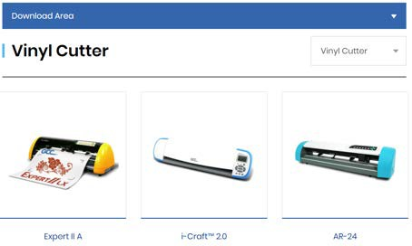

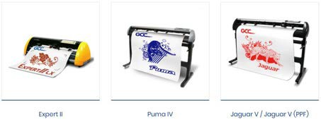

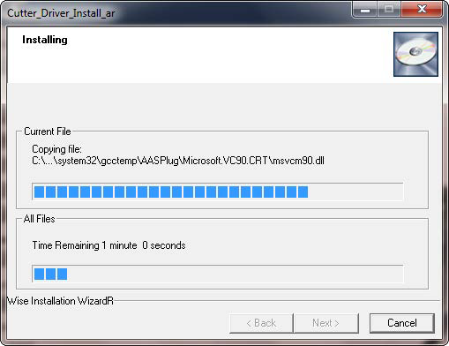**Step 3** Unzip the file and double clip the driver.exe to start installing the Driver and AAS plug-in.

**Step 4** If you were Windows 7 and above users, please click on the **red words** to instruct you how to disable Windows Update to allow success driver installation. And then click OK to next step.

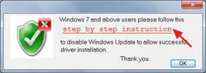

**Step 5** Please make sure the cutting plotter is powered on and connected to theUSB device, and then click OK to next step.

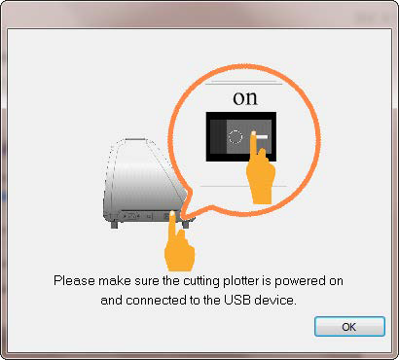 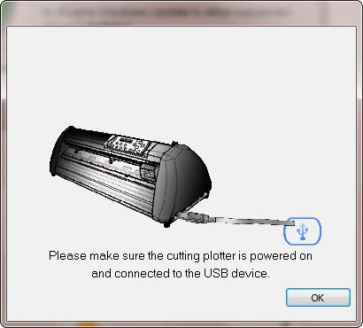

**Step 6** Confirm to close all running application programs before you start installing the driver, and then click OK.

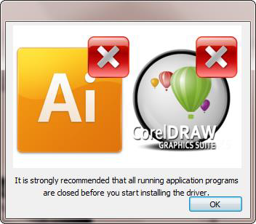

**Step 7** The installation will take a few minutes to complete and you will see a message below and click on “OK” upon completion. Enjoy your GCC cutter!

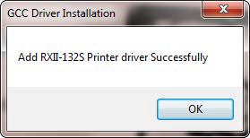

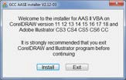**Step 8** If you want to install AASII VBA on CorelDRAW and Adobe Illusatrator, exit CorelDRAW and Adobe Illusatrator program, and then click on“Install.”

**Step 9** Check Install Message to confirm CorelDRAW and AI version and then click OK.

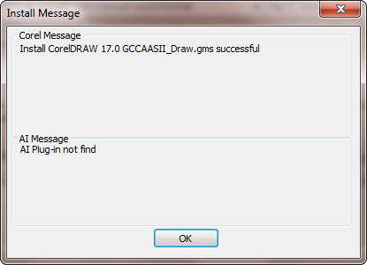

### Note:

If the driver is being installed for a second time, the user will be prompted as to whether a second copy of the driver installation is required.

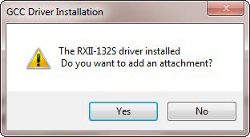

If the user selects yes, a second copy of the driver will be installed.

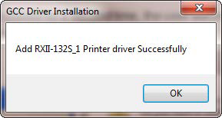

For users who have upgraded Adobe Illustrator or CorelDRAW, please go to the **AAS Installer** page in the **Printer Properties** window and click “**Install**” to access the latest version of GCC AAS Plug-in.

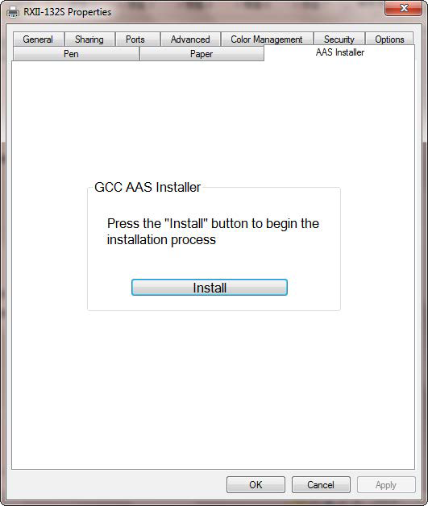

### Driver Un-installation

You have to remove previous version driver installed on your PC system completely before you can install the latest version successfully. Please refer to below steps.

**Step 1** Go to Control Panel\Hardware and Sound\Devices and Printers window. Right click the printer and select “**Remove device**.”

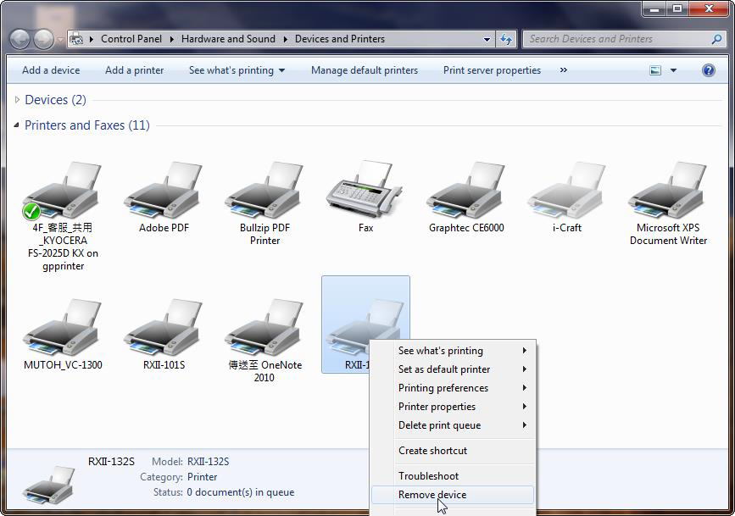

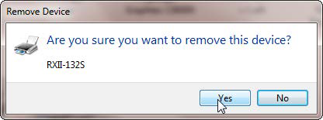

**Step 2** After removing the unit, click on any printer on the page and select “**Print server properties**.” (For Win 7and above) Or right click on blank space and then select “**Print server properties**.” (For Windows XP)

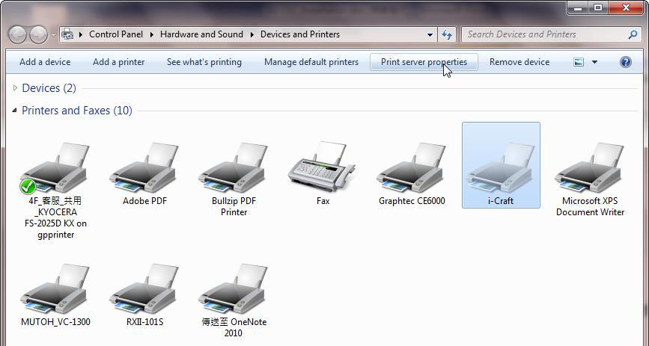

**Step 3** Select “Driver” page

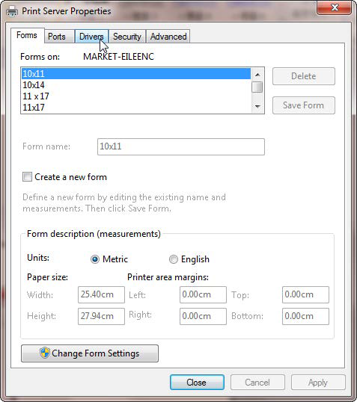

**Step 4** Select the model and click on “Remove”.

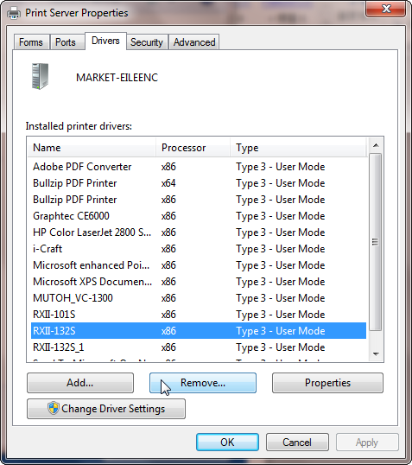

**Step 5** Select “Remove driver and driver package” and click OK.

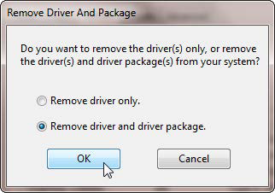

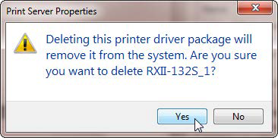**Step 6** Click Yes and then click “Delete” and “OK,” and the driver installed on PC is completely removed.

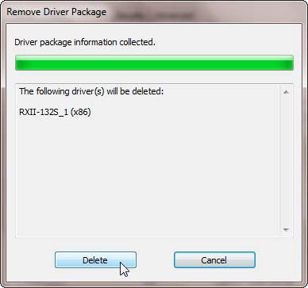 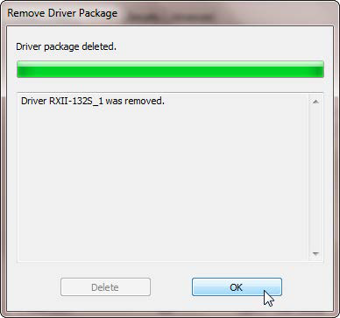

### RS-232 Interface

* Connecting to the RS-232 (Serial) Port

1. For IBM PC, PS/2 users or compatibles, connect the RS-232C cable to the serial connector of the assigned serial port (COM1 or COM2) of your host computer.
2. Set up the communication parameters (Baud Rate and Data Bits/Parity) to match the setting of software package, refer to chapter 3 – “Misc” key description.

**Caution!! Please turn off the plotter before plugging the RS-232C**

### Ethernet Connection

#### Networking Connectivity Setup

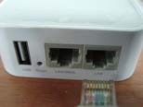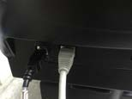**Step 1** Connect the LAN port and Ethernet port on GCC cutting plotter with RJ45 Ethernet cable, and turn on the machine.

**Step 2** Press **On/Off line** and then **MISC** button on your control panel.

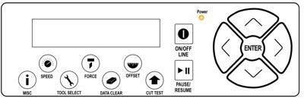

**1**

**2**

**Step 3** Go to the **DHCP** page and select **Enable** through the up and down arrow keys, then press Enter.



**Step 4** The IP Address will be shown on the screen automatically. Please make notes of it.



#### Ethernet Connectivity Setup

If you output your plot through Adobe Illustrator or CorelDRAW, please follow the instruction

### Output through the Ethernet Driver below.

**Step 1** Connect Ethernet cable to PC and install **Cutter Ethernet driver**. Then click OK to continue.

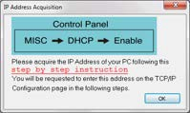

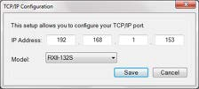**Step 2** Enter the IP Address shown on the control panel and select the model. (Please refer part 1 instruction.)

**Step 3** The driver is installed. You can output from AI or CorelDRAW directly now.

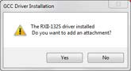

### Data Transmitting

There are two options to transmit the data from the computer to the cutting plotter:

**Option 1:** With proper interface settings, the data can be transmitted from your application software package to the cutting plotters directly.

**Option 2:** Most cutting software packages are able to emulate **HP-GL** or **HP-GL/2** commands. As long as the file is **HP-GL** or **HP-GL/2** format, the cutting plotter can output the data precisely.

### Printer Sever Shared Setting

In “A-PC”, set the printer driver as a shared printer, then use B-PC to connect A-PC’s printer driver via Intranet.

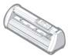

B-PC

USB or

A-PC

**Step 1** Set A-PC’s printer driver as a shared printer (Right-click on printer icon, choose “Printer properties”. Click “Sharing” tab then check “Share this printer.”)

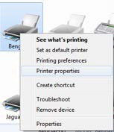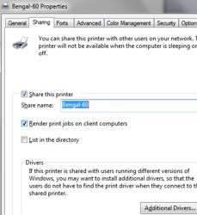

**Step 2** Click “Advanced” tab, then choose “Print directly to the printer” option.

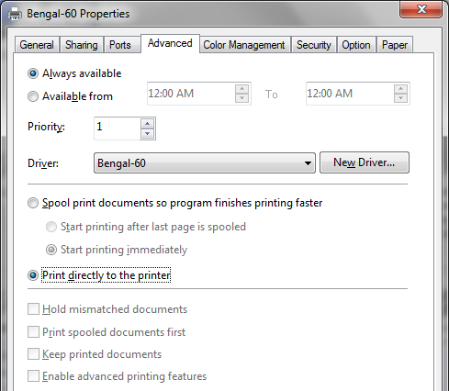

**Step 3** Send a job from A-PC to the machine to check if A-PC is connected to the machine.

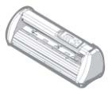

Try to send a job to check if the port is working.

**Step 4** Activate A-PC’s Printer Driver from B-PC’s Network.

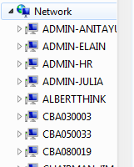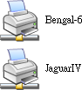

**Step 5** Right-click on the printer icon, and select “Connect” to A-PC’s printer.

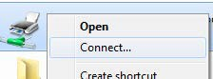

# Software Installation

### GreatCut-S Auto Installation

1. Visit <http://gccf.gcc.com.tw/gccclub/login.aspx> and log in your GCC Club account.



or create a new GCC club account if you do not have one. Click “I Agree”, fill in the required information and click “Submit” to sign up.

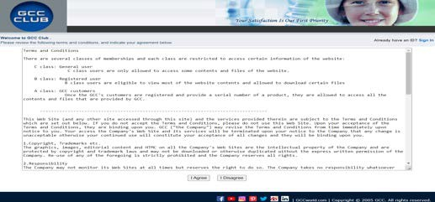

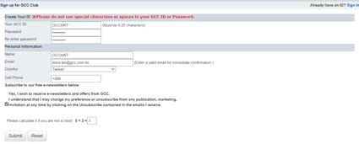

You should receive an eMails with activation link and click the link to activate your account.

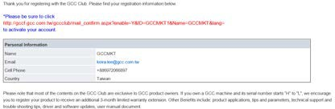

1. Go to GCC Club, click “GreatCut-S voucher code” on the left side.

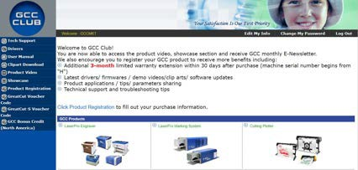

1. Enter your voucher code and click “submit”.
2. You will get your GreatCut-S serial number.

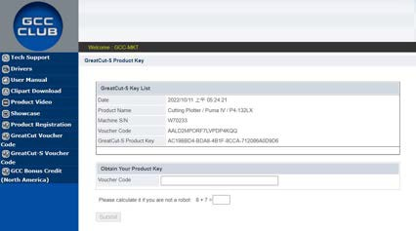

1. Visit <https://www.gccworld.com/download.php> click the product category and choose aproper model.

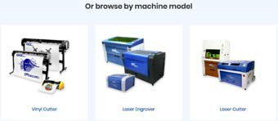

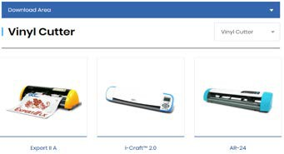

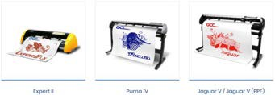

1. Download GreatCut-S to start the installation.

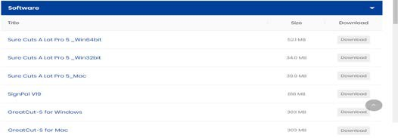

1. Press Next to continue, tick “Launch GreatCut-S” and then press “Finish” to compete the installation.

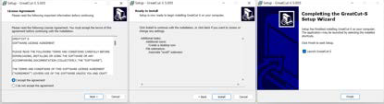

1. Run GreatCut-S and press “Activate…”to activate GreatCut-S. Please make sure it is connected to the internet.

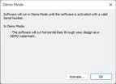



1. Enter your name in the Name column and GreatCut-S serial number to the Serial column and press “OK” to complete the activation.

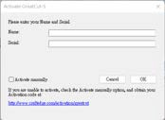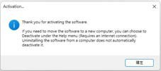

1. 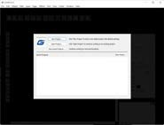GreatCut-S is ready to use.

**Note**

* If you use a trial version to output graphics, meaning you do not enter the software key to activate the Sure Cuts A Lot mentioned above, there will be two extra lines cut through the design, therefore, make sure the Sure Cuts A Lot software is activated before implementing cutting jobs.

### Manually Activate GreatCut-S

If the computer connected to the cutter doesn't have an internet connection to complete the software activation process, you can alternatively use the "Activate manually" function to enter the "Activation Code" and begin using GreatCut-S. However, you will need to find another computer with internet access in advance to obtain the "Activation Code" by following the instructions

below.

1. Check the "Activate manually" checkbox and you should see the Site Code and Activation Code fields appear. The Site Code field will be pre-filled in and cannot be changed.

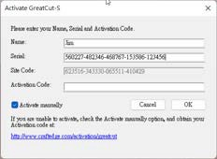

1. Visit <https://craftedge.com/activation/greatcut/> via an internet connected computer. Enter your name, serial and site code.

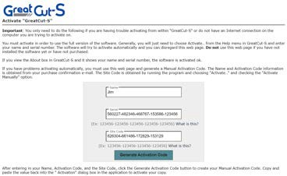

1. Click on the "Generate Activation Code" button, and your activation code will be shown in the Activation Code field.

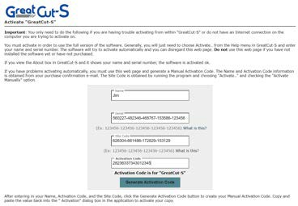

1. 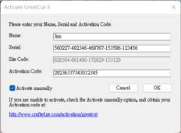Copy and paste the activation code back into the activation dialog box of Sure Cuts A Lot program and hit ok.
2. Click OK and GreatCut-S is ready to use.

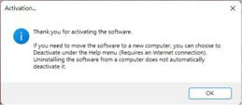

### Re-install GreatCut-S Software

If you change a new computer, you may need to deactivate your GreatCut-S software and re-install it on your new device.

Go to “Deactivate…” under Help and press Yes to confirm, then follow the installation procedure and use **the same code** to activate it on another computer.

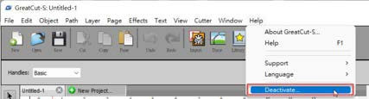

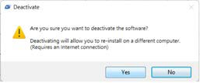

### Reset GreatCut-S Serial Code

If you need to re-install the software again due to problems such as a computer crash/reformat where you were not able to de-activate your copy off the computer first, you may visit <https://craftedge.com/activation/deactivateGC.php> to reset your serial number

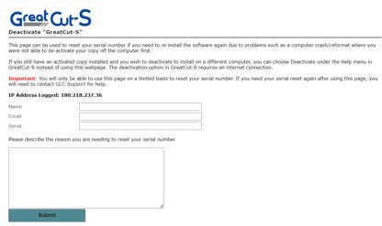

**Chapter 3 The Control Panel**

This chapter describes the button operations with the LCM menu flowcharts of Puma IV. When the cutting plotter is ready for use as described in Chapter 1 & 2, all functions are under default parameters.

# The LCD Panel

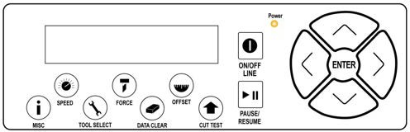

< LCD Control Panel on Puma IV series >

|  |  |
| --- | --- |
| Key | Function |
| LCD Screen | To display functions and error messages. |
| Power LED | To indicate the power status ( light up: power on; light off: power off ) |
| 4 Arrow Keys | To move position, select function, or change setting. |
| ENTER | To set item or register the immediately preceding input value. |
| PAUSE/RESUME | To temporarily halt cutting process or to continue |
| ON/OFF LINE | To switch modes, stop cutting job, or abort changes of settings. |
| OFFSET | To adjust the value of blade’s offset. |
| FORCE | To adjust the value of cutting force. |
| SPEED | To adjust the value of cutting speed and quality. |
| CUT TEST | To perform cutting tests on different media |
| DATA CLEAR | To clear up buffer memory. |
| TOOL SELECT | To select tools. |
| MISC | To set up functions. |

Please see details in “3.4 Menu Items”

# Menu in On-line Mode



S F O

Set Smoothing Cut

Select: OK:ENTER

Top menu

Sending data

Set Tangential Mode

Select: OK:ENTER

Up Accel.: Select:

72 cm/s OK: ENTER

Force:80 gf

OK:ENTER

72 cm/s OK: ENTER

Pause Setup Resume

AAS Speed: Medium Select: OK: ENTER

[TOOL SELECT ]

W T1M

0.00mm OK:ENTER

[FORCE]

L

Clear Data Memory N:ONLINE OK:ENTER

Offset: 0.275 mm

OK:ENTER

[SPEED]

Speed: Select:

1S:72 F:80 O:0.275 M

Select: OK:ENTER

OverCut: Select:

[ OFFSET ]

Roll Edge Single

Key Key Key

Place Media And Then Lower Down The Lever

[ DATA CLEAR ]

Sizing Media Length Lever Up To Abort

UP Speed: normal Select: OK: ENTER

Sizing Media Width Lever Up To Abort

Use to select; [ENTER] to enable the

Medium OK: ENTER

Quality: Select:

Jaguar V

Firmware: Copyright:

Cutter

LCM Version- - -

**Power On** Puma IV (LX) in processing

use    to select

[PAUSE]

# Menu in Off-line Mode

**Press [ON/OFF LINE] to switch to the offline mode**



#1

OK:ENTER

51 cm/s OK:ENTER

Quality: Select:

Ratio Setting

Select: OK:ENTER

Normal OK:ENTER

Square Cut Select:

Repeat AAS Job

Select: OK:ENTER

move origin M Y:

Pattern Setting

Select: OK:ENTER

Recut Select:

Force:80 gf

OK:ENTER

Ratio: Change:

100% OK: ENTER

UP Speed: 51 cm/s Select: OK:ENTER

X:

Pattern: Arrow

Change: OK: ENTER

Up Accel.: Medium Select: OK:ENTER

OK:ENTER

Speed: Select:

Copy Select:

#1

OK:ENTER

Offline For System Setup

[ ]

**[ SPEED ]**

Speed: 3~72 with an increment of 3(cm/s)

UP Speed: 3~72 with an increment of 3(cm/s)

Draft, Fair, Normal, Fine

High, Medium, Low

**[ FORCE]**

**[ OFFSET]**

5~500 with an increment of 5(gram force)

0.000~1.000 with an increment of 0.025(mm)

Offset: 0.275 mm

OK:ENTER

**[ DATA]**

Clear Data Memory N:ONLINE OK:ENTER

**[CUT TEST ]**

Recut number: 0-99

|  |  |
| --- | --- |
| Redo Jobs in Memory Select: OK:ENTER |  |
|  |
|  | |

Copy number: 1-999

After sending AAS job (Puma only)

Ratio: 100%, 200%, 300%, 400%

Pattern: Cross, Arrow

Vacuum Select:

OK:ENTER

DHCP

Select:

OK:ENTER

**[TOOL SELECT]**

**[MISC]**

Offline For System Setup

MAC Address 00:CF:52:72:03:01

Auto Unrolled Media Select: OK:ENTER

Rear Paper Sensor Select: OK:ENTER

First Back To Origin Select: OK:ENTER

IP Address

Select: OK:ENTER

AAS Offset

Select: OK:ENTER

AAS Detect Mode

Select: OK:ENTER

OverCut: 0.00~1.00mm with an increment of 0.05mm

Enabled, Disabled



OFF

Change:

OK: ENTER

ON

Change:

OK: ENTER

|  |
| --- |
| 1S:72 F:80 O:0.275 M  Select: OK:ENTER |
| Set Smoothing Cut  Select: OK:ENTER |
| OverCut: 0.00mm Select: OK:ENTER |
| Set Tangential Mode Select: OK:ENTER |
| Panel Setup  Select: OK:ENTER |
| Factory Default ?  Select: OK:ENTER |

|  |  |
| --- | --- |
| Section Cut  Select: OK:ENTER |  |
|  |

|  |  |
| --- | --- |
| Die/Kiss Cut: ON  Select: OK:ENTER |  |
|  |

Enabled, Disabled



Die/Kiss Cut: Force: 450 g

45 g

Die/Kiss Cut: Length: 9.0 / 0.2 mm

Enabled, Disabled

Enabled, Disabled

IP Address set, Submask set, Gateway set

Enabled, Disabled

Forward Direction, Auto Detection, Reverse Direction

(LX model only)

Both Expanded Mode, Length Expanded Mode, Width Expanded Mode, Both Unexpanded Mode,

|  |
| --- |
| Paper Saving Mode Select: OK:ENTER |

|  |
| --- |
| Set communication Select: OK:ENTER |

|  |
| --- |
| Firmware x.x.xx FPGA: xx.xx |

English, Francais, Türkce, Polski, Ingles, Japanese, Deutsch, Italian, Espanol

|  |
| --- |
| Select Language  Select: OK:ENTER |

Metric (cm/g), Unit (inch/ g), Unit (cm/ oz), English (inch/ oz)

|  |
| --- |
| Select Unit  Select: OK:ENTER |

|  |
| --- |
| Scale Length  Select: OK:ENTER |

|  |
| --- |
| Scale Width  Select: OK:ENTER |

# Menu Items

Below describes the functions of menu items

|  |  |  |  |
| --- | --- | --- | --- |
| Menu or Key | Function | Setting | Default |
| **--- Media sizing ---** | | | |
| Roll | To measure media width. | Maximum Tracking  150 meters |  |
| Edge | To measure media width and pull the media back till the front paper sensor open. | Maximum Tracking 150 meters |  |
| Single | To measure media width and length. | Maximum Tracking  10 meters |  |
| **--- POWER ---** | | | |
|  | To indicate the power status. |  |  |
| **[ Arrow Keys ]** | | | |
|  | 1. To move the tool carriage position on X or Y axis. 2. To select functions or change values of settings. |  |  |
| **[ ENTER ]** | | | |
|  | 1. The displayed parameters will be saved automatically. 2. To set a new origin at the present tool carriage position.   In “offline” mode, moving the tool carriage to desired position by [Arrow Keys], then press [ENTER] key to set a new origin. While moving with the parameters of XY-axes displayed, press [MISC] key will enable fine-tune movement; press [MISC] key again to disable the function. |  |  |
| **[ PAUSE/RESUME ]** | | | |
|  | To temporarily halt the cutting process.  To resume the process by press [Pause/Resume] key again. |  |  |
| **[ ONLINE/OFFLINE ]** | | | |
|  | 1. To switch between online mode and offline mode. 2. To stop the cutting job or abort the change of setting. Once press this key, the cutting job will be terminated immediately and cannot be resumed. |  |  |
| **[ OFFSET ]** | | | |
|  | To set or modify the distance between the blade tip and the center axis. | 0.000~1.000mm | 0.275mm |
| **[ FORCE ]** | | | |
|  | To set or modify the value of tool force. | 5~500gram;  5 gram/per step | 80 gram |
| **[ SPEED ]** | | | |
| Speed | To set or modify tool speed at horizontal moving. | 3~72 cm/sec; 3cm/sec per step | 51cm/sec |
| Up Speed | To set or modify tool speed while the tool move from endpoint to next start point at horizontal moving. | 3~72 cm/sec; 3cm/sec per step | 51cm/sec |
| Quality | To set or modify cutting quality.  [Slower speeds / higher quality - Faster speeds / lower quality]  The Set Cutting Quality Page allows you to adjust and balance vector mode’s quality and speed settings based on your specific job. Draft Mode offers the highest output speed, sacrificing quality. Whereas Quality Mode offers the highest quality,  sacrificing output speed. Keep in mind that speed and quality are  usually at a tradeoff. | Draft, Normal, Fair, Fine | Normal |

|  |  |  |  |
| --- | --- | --- | --- |
| Up Accel. | To set or modify tool acceleration levels while the tool move from endpoint to next start point at horizontal moving. | High, Medium, Low | Medium |
| **[ CUT TEST ]** | | | |
| Square Cut | To perform a cutting test at present blade position.  For more information, please refer to “4.3 Adjusting the Cutting Force and Offset” to adjust blade force and cutting speed. |  |  |
| Redo Jobs in Memory | To redo the cut test jobs saved in memory by recutting or producing cut test copies. Recut number: 0 means limitless. If you want to set number as 0, you should set that between repowering the cutter and putting down the lever. | Recut (number of jobs: 0-99)  Copy (number of jobs: 1-999) | Recut |
| Repeat AAS Job | To repeat AAS jobs automatically without having to operate on the computer side.  Please be noted that this feature is mainly applied to the Single paper mode; please ensure a new piece of material you wish to apply this feature on is loaded and the origin repositioned to the first registration mark before starting. When the first AAS job repeat completes, the user will be offered the choice of “Repeat AAS Job Again”, please press ”Online/Offline” to return to the main menu.  This option will appear after finishing reading all registration marks (Puma only). |  |  |
| Ratio Setting | To adjust the size of the pattern | 100%, 200%,  300%, 400% | 100% |
| Pattern Setting | To provide two patterns for cut test  Note: It is recommended to select “Cross” if you are working on thick pieces of materials. | “Arrow” and  “Cross” patterns | “Arrow” |
| **[ DATA CLEAR ]** | | | |
|  | To clear up buffer memory. |  |  |
| **[ TOOL SELECT ]** | | | |
| Save Parameter | To save pattern(s) of cutting parameters for later use.  There are 4 sets of parameters saved in the panel. Use Page Up and Page Down keys to select the set of parameters you wish to adjust, press “Enter” to confirm (the number shown on the upper left corner will change accordingly). Each set of parameters includes Speed, Force, Offset, Up Speed, Quality and Scaling though the latter three will not be displayed in this section. To  adjust or check individual parameters, go back to the responding keys on the panel and press “Enter” to confirm. | Patterns1~4 | Pattern 1 |
| Set Smoothing Cut | To enable smooth-cutting function. |  | Enable |
| Over Cut | To generate an overcut to facilitate weeding. | 0.00mm-1.00mm 0.05mm/per step | 0.00mm |
| Set Tangential Mode | To enable the emulated tangential-cutting mode for thicker media types and small letter cuts.  Note: while the Offset value setting at 0.000 mm, “Set Tangential Mode” will automatically be disabled. |  | Disable |
| Panel Setup | Accept setup command:  To accept commands of the Force, Speed, Cutting Quality, and Offset only via software. |  |  |
| Control panel only:  To accept commands of the Force, Speed, Cutting Quality, and  Offset only via control panel of the cutter. |  |  |
| Factory Default? | To turn all parameters of the menu items to factory-default settings. |  |  |
| **[ MISC ]** | | | |

|  |  |  |  |
| --- | --- | --- | --- |
| Auto Unrolled Media | To avoid paper jam and motor crash by automatically unroll media (50cm and up) before cutting while enabled. .   * Auto-unroll only effects on roll/edge media. * Using Single mode to size media will disable this function automatically. * If the length of the rolled media is less than 2 meters or the weight is light, it is recommended to set this mode disabled. |  | Enable |
| Section Cut | To divides the long plot data into sectional output jobs to gain higher cutting quality and increase precision.  Users can set the section by registration marks or input the value manually. |  | 200mm intervals |
| Die/Kiss Cut | To perform die cut/kiss cut in one cutting line simultaneously by designating the outline to green color RGB 255 and defining the length and force setting on control panel (Please refer to Chapter 4.9 for details). | Length: 0.2 ~9mm  Force: 45 g~ 450 g |  |
| Rear Paper Sensor | To detect if the rear paper sensor is covered to determine the following process; when it is enabled, the cutter will detect if the material has covered the rear paper sensor under the Roll and Edge mode; when disabled, the rear paper sensor will not be functioning.  Note: Rear paper sensor only functions under “Roll” and “Edge” mode. | Enable Disable | Enable |
| Vacuum | To help improve tracking and cutting accuracy by turning on the fans. If you turn off the vacuum system, the fans will remain inactive during cutting or plotting. |  | Enable |
| First Back to Origin | To enable the carriage back to the previous origin; when “Enable” is  selected, the carriage will not go back to the previous origin while the selection of “Disable” allows the carriage to do so. | Enable Disable | Enable |
| AAS Detect Mode | To recognize the printed sheet media is fed in forward direction or reversed direction by detecting the registration marks.   1. Forward direction: to detect the registration marks in forward media feeding direction 2. Auto detection: to distinguish the media feeding direction automatically by detecting the registration marks. 3. Reverse direction: to detect the registration marks in reversed media feeding direction |  |  |
| DHCP | Shows your IP address for TCP/IP Configuration |  | Disable |
| IP Address | Shows the IP Address of your cutting plotter. |  |  |
| MAC Address | Shows the MAC Address of your cutting plotter. |  |  |
| AAS Offset | To set or modify AAS offset value. (Puma only)  You can refer to “5.3 Printer Test” for more details. |  |  |
| Paper Saving Mode | To save media by four different modes:   1. Length expanded mode 2. Width expanded mode   3. Both expanded mode 4. Both unexpanded mode |  | Length expanded  mode |
| Set  Communication | To build up the communication between host computer and cutter.  *Baud Rate* is to determine the speed of data transmission. *Data Bits* refers to the size of one block of data.  *Parity* is used to check if data was revived correctly or not. 9600, n, 7, 1, p 9600pbs, 7 Bits with NO Parity  9600, o, 7, 1, p 9600pbs, 7 Bits with ODD Parity  9600, e, 7, 1, p 9600pbs, 7 Bits with EVEN Parity  9600, n, 8, 1, p 9600pbs, 8 Bits with NO Parity  9600, o, 8, 1, p 9600pbs, 8 Bits with ODD Parity  9600, e, 8, 1, p 9600pbs, 8 Bits with EVEN Parity  19200, n, 7, 1, p 19200pbs, 7 Bits with NO Parity  19200, o, 7, 1, p 19200pbs, 7 Bits with ODD Parity  19200, e, 7, 1, p 19200pbs, 7 Bits with EVEN Parity |  |  |

|  |  |  |  |
| --- | --- | --- | --- |
|  | 19200, n, 8, 1, p 19200pbs, 8 Bits with NO Parity  19200, o, 8, 1, p 19200pbs, 8 Bits with ODD Parity  19200, e, 8, 1, p 19200pbs, 8 Bits with EVEN Parity |  |  |
| Firmware Version | To display the version number of Firmware and FPGA code. |  |  |
| Select Language | To select displayed languages on LCM panel in English, Spanish, Italian, Deutsch, Japanese, Portuguese, Polish, Turkish or French. |  | English |
| Select Units | Provide four-unit systems for users convenient. | cm/s; inch/oz; cm/oz; inch/gram | Metric |
| Scale Length | Fixed scaling, for maintenance only. |  |  |
| Scale Width |

**Chapter 4 Operation**

# Media Loading

### Loading the Sheet Media

To load the media properly, please follow the procedures listed below:

Pull the lever upward to raise the pinch rollers. (Figure 4-1)

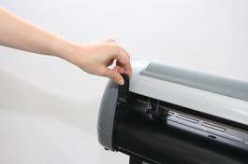

### Figure 4-1

Load your media on the platen and slide it under the pinch rollers from either the front side or the backside. The **alignment rulers** on the platen extension will help you to adjust the media precisely.

**Note:**

Be sure that the media must be covered by the paper sensors on the platen when loading the media. At least one of the two paper sensors should be covered. Once the media covers the sensor, the cutting plotter will size width and length of media

automatically.

Then move the pinch rollers manually to the proper position. Be sure the pinch rollers must be positioned above the grid drum. The **white marks** on top trail will help you position pinch rollers when media on the platen. (Figure 4-2)

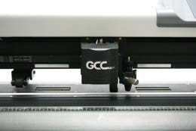

White Marks

### Figure 4-2

Push the lever downward to lower down the pinch rollers.

Turn on the power; the machine will be initialized. Then follow the instruction of LCM to measure the size of the media.

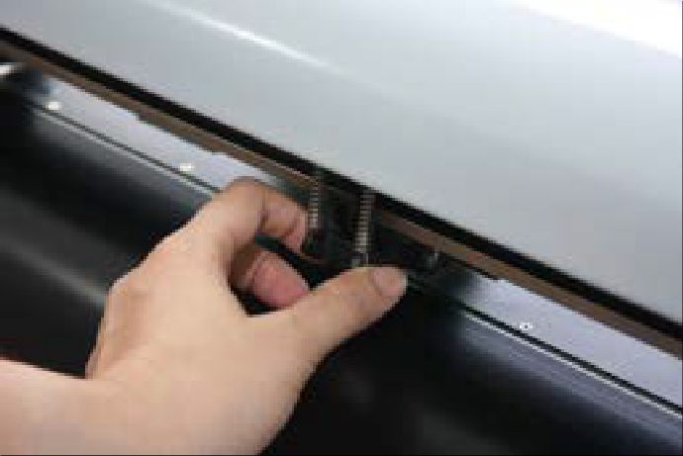

**Note:**

Move the pinch roller by applying force at the rear portion of the pinch roller support. Do not move it by holding its front rubber roller.

**Figure 4-3 correct way to move pinch rollers**

### Loading the Roll Media

**Step 1**

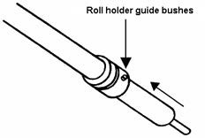Firstly, put the roll media guide bushes on two roll holders. (Figure 4-4)

**Figure 4-4**

**Step 2**

**Option A (Use the media flange)**

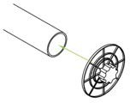Insert a roll media flange at the end of each roll media and tighten the thumbscrew until the roll media is firmly gripped. (Figure 4-5)

### Figure 4-5

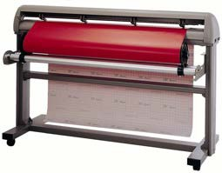Then put the roll media on the roll holders. Adjust the position of the roll media ensure that the media flange is able to run in the groove of roll holder guide bushes. (Figure 4-6)

### Figure 4-6

**Figure 4-7**

**Step 3**

Load the media on the platen. After loading the roll media, flatten the media on the platen and hold the front edge of the roll media firmly (Figure 4-8)

**Figure 4-8**

Operation 4-4

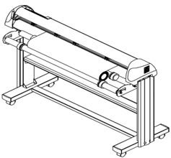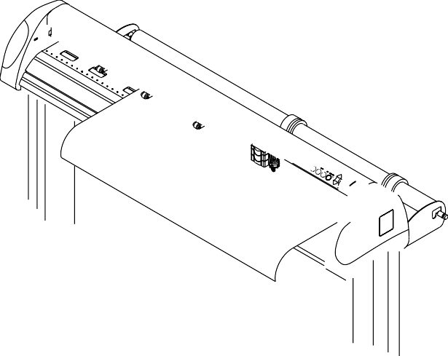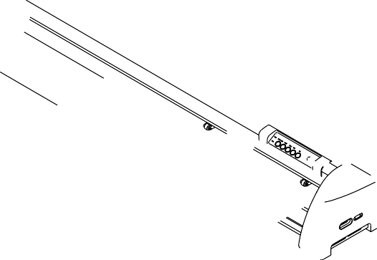

**Option B**

Insert the two roll holders into the roll media support set, and then place the roll media directly between the two roll holders. (Figure 4-7)

60 LX / Puma IV 60) to feed a roll media. Please adjust the position of roll base to get a g

esult. (Figure 4-10)

Figure 4-10

n 4-5

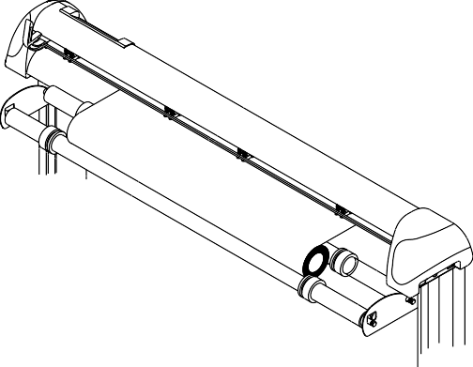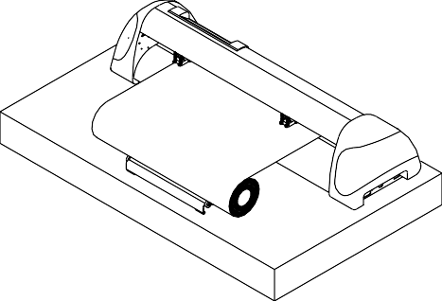

Puma IV

cutting r

ood

### Figure 4-9

Puma IV User Manual

**Step 4**

Then turn the roll downward to make an equal tension across the media. (Figure 4-9)

**Step 5**

Move the pinch rollers to the precise location and be careful that the pinch rollers must be positioned above the grid drums.

**Step 6**

Push the lever downward to lower down the pinch rollers.

**Step 7**

Fixes roll holder guide bushes on the roll holder to secure the roll media.

**Step 8**

Turn on the power switch and select Roll, Edge or Single mode appropriate for one time setup, or set to Default Roll in Sizing Setting and Roll type sizing will be performed when the machine is turned on. Then the cutting plotter is ready to work.

### Step 9

Unloading media：Reversing steps mentioned above to remove the media.

For the users of Puma IV 60 LX / Puma IV 60, you can also use the “Roll Base” (a standard accessory of

# Tracking Performance

In order to achieve the best tracking performance for a long plot, please leave the margin of 0.5mm~25mm in the left and right edges of the media.(Figure 4-11)

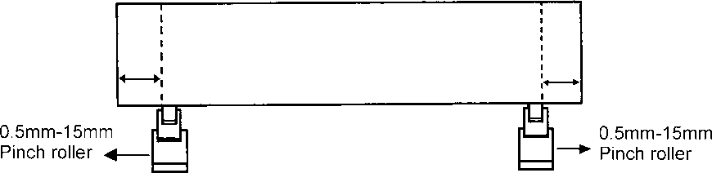

0.5mm-25 mm

0.5mm-25mm

Pinch roller

**Figure 4-11**

Pinch roller

# Cutting Force and Offset Adjustment

Before sending your designs from computer to Puma IV for cutting, please make “Cut Test” to adjust cutting force and offset value.

The “Cut Test” should be repeated several times until the optimum settings are achieved. Please follow procedure below to optimum the cutting force and offset settings.

### Step 1

After sizing the media, press [CUT TEST] button to select the “Square Cut”, and press [ENTER KEY] to confirm.

The default cutting force and offset value of the cutting test are 80gf and 0.275mm respectively.

### Step 2

Press [ARROW KEY] to move the tool carriage to the position where you would like to cut. Then, press the [ENTER KEY] to make a “Cut Test”.

Note: At the same time, the new origin is also set at the cut test position.

### Step 3

When the “Cut Test” is completed, a pattern appears (please refer to Figure 4-12). Peel off the pattern to see if it can be easily separated from the media base. If the output result is good, the cutting force is set appropriately. If not or it cut through the back paper of media, press [FORCE KEY] to adjust the tool force

80 mm

80 mm

80 mm

until an optimum force is obtained.

### Step 4

If the pattern appears to be BB or CC layout (see Figure 4-12), press [OFFSET KEY] to adjust the offset value until AA pattern is shown.



Press ENTER_KEY

Press ENTER_KEY

AA

BB

CC

Press ENTER_KEY

Press SPEED_KEY, FORCE_KEY, OFFSET_KEY to

setup or

Press arrow keys to desired position for next square cut

Finish square cut

Press ENTER_KEY

Pre s s CANCEL_KEY

3mm

3mm

Machine

C o n t i n o u s S q u a r e C u t N : C A N C E L O K : E n t e r

X :

t e s t M

c u t

Y :

M o v e

S q u a r e C u t

S e l e c t : O K : E n t e r

**Figure 4-12**

# When Completing the Cutting Job

After completing the cutting job, raise the sheet-loading lever, and then remove the material. You can also cut off the finished job by the Safe Blade (a standard accessory) along the knife guide. (Figure 4-13)

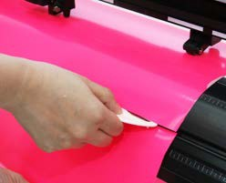

**Figure 4-13**

# Puma IV Print Driver setting

### Puma IV Print Driver setting > Option Page

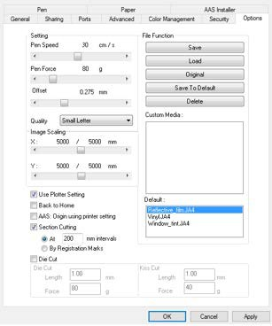

**Setting:** You can adjust the following settings, depending on your application or results you would like to achieve.

### Quality:

[Small Letter / Fine / Normal / Fair / Draft]

The Cutting Quality setting function allows you to adjust and balance vector mode’s quality and speed settings based on your specific job. Draft Mode offers the highest output speed, sacrificing quality.

Whereas Small letter Mode offers the highest quality, sacrificing output speed. Keep in mind that speed and quality are usually at a tradeoff.

### Use Plotter Setting:

The parameter settings will be set according to those set from the control panel.

### Back to home:

The carriage will return to the original position when this option is selected.

### Section Cutting:

Users can output long picture by section cutting which could make cutting more stable and get superior cutting quality. Users can set the section by registration marks or input the value manually. When cutting plotter finishing cutting in section 1, it will continue to cut in section 2. The picture is shown as below:

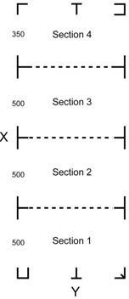

### File Function:

The file function section allows users to set the parameters of Speed, Force, Offset and Quality for later use. This section is useful when performing repeated jobs on a variety of objects, allowing you to save your frequently used cutter parameters and load them in the future.

* **Save:** This function will save current print driver parameter settings to a file under the specified location on your computer. (Saved parameter setting files will be tagged with the Puma series extension)
* **Load:** This function allows you to load previously saved print driver parameters.
* **Original:** This function will load the print driver’s original factory parameter settings.
* **Save To Default:** This function allows you to save your current print driver parameters as the default startup settings.
* **Delete:** This function will delete the file you select from the Custom Media section, whereas the settings in Default section cannot be deleted. Please note the delete function only removes the list shown in Custom Media section, it does not remove the file from your hard drive, if you wish to completely remove the file from your hard disk, you will have to manually delete the file from your operating system.
* **Custom Media**: This section lists the files for the parameter settings that you have recently created and worked. You can save more than 50 files to simplify your cutting job.
* **Default:** This section contains the reference settings that are applicable with the verified materials to achieve the best cutting results. Please note that the setting value might need to be adjusted according to different suppliers of materials.

### Die Cut:

The Die Cut function must be activated with the Kiss Cut function to avoid the falling of cut-through materials and material jam beneath the carriage. Die Cut helps you to cut through the backing of the material while Kiss Cut cuts through only the top layer but not the backing. This will leave only tiny bits of the backing attached to the top layer, creating complete individual patterns with backing sheets (see figure 1 and 2).

Vinyl

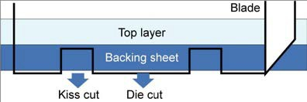

**Figure 1**

Cutting line

### Figure 2

To activate the Die Cut function, go to “Option”, tick “Die Cut”, and enter the amount you wish for the “Length” and “Force” of both Die Cut and Kiss Cut, then click “OK” (see figure 3).

**Note:**



The length setting for the cutting line of Die Cut is in the range of 0-2000mm whereas that of Kiss Cut is 0-100mm.

### Figure 3

When the job is completed and you untick the Die Cut function, you will be able to adjust the pen speed, pen force, and offset in the section on the top following normal operating procedures (see figure 4).

**Note:** the extension of the blade has to be set to cut through both the top layer and the backing in the very beginning. You then adjust the tool force for the best cutting performance.



### Figure 4

* + 1. **Puma IV Print Driver setting > Pen Page**

The Puma series incorporates the use of 6 different colors to represent 6 different parameter settings including cutting speed, force and blade offset settings when cutting. These colors are referred to as “Pens”. Think of each pen as a designated cutter setting, rather than as a color. An image that is made up of black, red and blue colors will be processed using the cutter settings designated for each particular color. In order to utilize up to 6 different pens (cutter parameter settings), make sure your graphics software can recognize and utilizes the 6 pen colors designated by the GCC Puma series print driver.

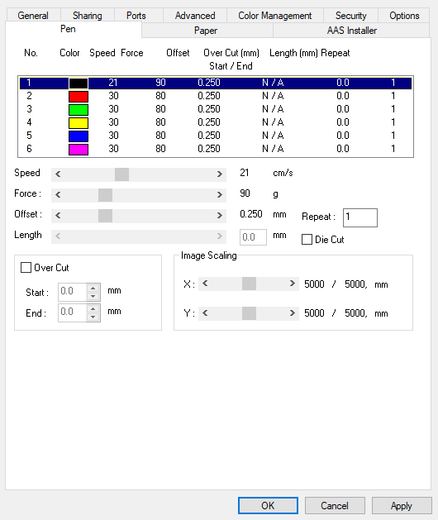

If you would like to specify your own colors to designate to a particular cutter setting, then all you have to do is to double-click on that particular pen color from the pen menu and a color manager window will open where you can select “define custom colors” to define your own color (shown in the picture below). This is useful when your image is composed of colors that are not part of the pen menu’s default color selection, and instead of modifying your image, you simply would like to assign the cutter settings based on the existing colors from your current image.

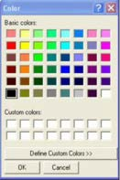

**Note:**

The GCC Puma series driver cannot store more than 6 pen colors or different cutter

parameter settings per file.

### Speed (Pen Page) [DEFAULT SETTING: 30cm/sec]

The speed slider controls the cutter’s cutting speed during operation.

### Force (Pen Page) [DEFAULT SETTING: 80g]

The force slider controls the cutting force during operation.

### Offset (Pen Page) [DEFAULT SETTING: 0.25mm]

The offset slider controls the blade offset depending on the blade you used.

### Die Cut (Pen Page)

The Die Cut function can allow you to cut through the backing of the material. You can only use the first 3 pen for this function. If you choose Pen No.1 and click the Die Cut function, the Pen No.4 will become Pen No.1* for setting different parameter for the same cutting line.

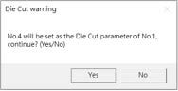

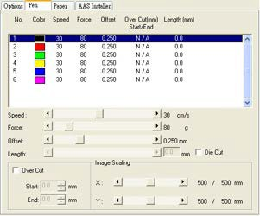

You can adjust the parameter such as force and length in both Pen No.1 and Pen No. 1* as you need. For example:

Pen No.1*: Cutting through the backing of the material



Pen No.1: Cutting through the vinyl only

Sticker

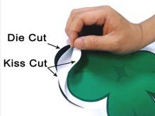

### Image Scaling (Pen Page)

The Image Scaling function can allow you to set the image scale of media length and width to decrease the difference between the actual length and the ideal length caused by various media used while processing cutting job.

### Puma IV Print Driver setting > Paper Page

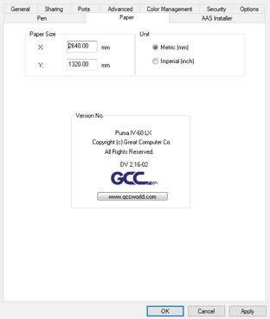

**Paper Size (Paper Page) [DEFAULT SETTING:** Y = the width of machine; X will be automatically set to be twice the length of Y]

The paper size represents your total work area. The X value represents the length and the

Y value represents the width. The paper size should be set as the same as your image so you can get a better cutting quality.

### Unit (Paper Page) [DEFAULT SETTING: Metric (mm)]

Here you can set your preferred measurement standard in which you would like use with the Jaguar V print driver. You can choose between metric or imperial standards.

# Reference Parameter setting for different materials

The following reference parameter is used on GCC verified materials shown in the table.

|  |  |  |  |  |
| --- | --- | --- | --- | --- |
| Material | Personalized/ Wall stickers | Vehicle stickers | Window decoration | Window tint |
| Blade | red | red | red | red / yellow |
| Blade tip length (mm) | 0.28 | 0.27 | 0.25 | 0.09 |
| Force (g) | 105 | 85 | 95 | 70 |
| Speed (cm/sec) | 72 | 60 | 65 | 72 |
| Offset (mm) | 0.25 | 0.25 | 0.25 | 0.25 |
| Recommend model | RX, Jaguar, Puma, EX, AR | RX, Jaguar, Puma, EX, AR | RX, Jaguar, Puma, EX, AR | RX, Jaguar, Puma, EX, AR |
| Material | Stencil | Reflective film | Flock | Cardboard |
| Blade | red / green | green | green | green |
| Blade tip length (mm) | 0.3 | 0.5 | 0.3 | 0.3 |
| Force (g) | 180 | 380 | 135 | 165 |
| Speed (cm/sec) | 15 | 3 | 30 | 30 |
| Offset (mm) | 0.25 / 0.5 | 0.5 | 0.5 | 0.5 |
| Recommend model | RX, Jaguar, Puma, EX, AR | RX, Jaguar, Puma, EX | RX, Jaguar, Puma, EX, AR | RX, Jaguar, Puma, EX, AR |
| Material | Magnets | Protective tint | Rhinestone | Sandblast mask |
| Blade | green | green | green | blue |
| Blade tip length (mm) | 0.8 | 0.3 | 0.8 | 0.27 |
| Force (g) | 580 | 320 | 190 | 85 |
| Speed (cm/sec) | 3 | 3 | 15 | 60 |
| Offset (mm) | 0.5 | 0.5 | 0.5 | 0.25 |
| Recommend model | RX, Jaguar | RX, Jaguar, Puma, EX | RX, Jaguar, Puma | RX, Jaguar, Puma, EX, AR |
| Material | Small text (vinyl) |  | | |
| Blade | black |
| Blade tip length (mm) | 0.27 |
| Force (g) | thick: 150  thin: 90 |
| Speed (cm/sec) | 9 |
| Offset (mm) | 0.175 |
| Recommend model | RX, Jaguar, Puma |

# How to set die/kiss cut through plug-in software for Adobe Illustrator and CorelDraw

Die/kiss cut function allows you to define two cutting parameter in one cutting line, you can set through plug-in software for Adobe Illustrator and CorelDraw directly instead driver setting by designate the line to green color RGB 255 and then set the length and force from the control panel.

1. Select an outline that you want to do die/kiss cut in working area.

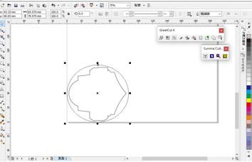

### Figure 4-27

1. Change the color to **green color code RGB 255** then click “OK”

(Note: Only green color code RGB 255 is identified as die/kiss cut function, please don’t select other color otherwise the function cannot work)

### Figure 4-28

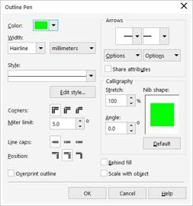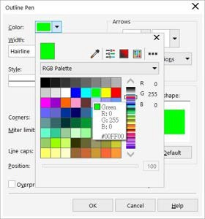

**Figure 4-29**

1. Outline color has been changed to Green.

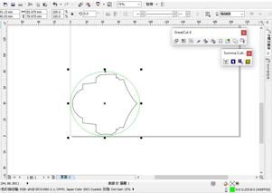

### Figure 4-30

1. Select “ On/Off Line” > “MISC”, use arrow key to select “Die/Kiss Cut” function then press “Enter”.

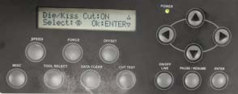

1. Click the left arrow key to the next page to adjust the length value (0.2mm ~ 9.0mm) then click “ENTER”.

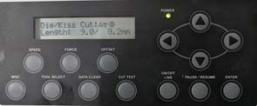

1. Click the left arrow key to the next page to adjust the force value (45g ~ 450g) then click “ENTER” and finish the setting.

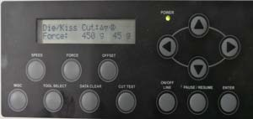

**Chapter 5 Automatic-Aligning System**

Please note that this chapter is only an instruction to AASII. **Puma IV LX models** feature AAS function, but **Puma IV models** don’t. If you are **Puma IV models** user, please skip this chapter. For step-by-step instructions, please refer to the following chapters: A-4 CorelDRAW Plug-In, A-5 Illustrator Plug-In, A-6 Greatcut-S quick manual.

# Introduction

The Puma IV LX models cutting plotters feature a standard Automatic-Aligning System (AAS II) to guarantee precise contour cutting quality by detecting the registration marks printed around the graphic.

### Notice

* Avoid any kind of light source horizontally illuminating the AAS module.



### - PROHIBITED - ACCEPTABLE

* DO NOT take off the cover of AAS module while in operation.

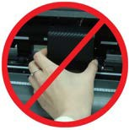

- **PROHIBITED**

# AAS Calibrating the System

The AAS system has one calibration procedures to ensure maximum accuracy of AAS operation. To operate the AAS you need to learn about the method of media feeding firstly. (Refer to 4.1 Media Loading.)

### Media Calibration

Media Calibration is to ensure the sensor being able to recognize the registration marks.

The factory default works on a wide range of materials. However, certain types of materials may not work properly. Performing a media calibration may become necessary while working with such materials to change the sensitivity of AAS for greater reliability.

Media calibration adjusts the media feeding according to media type for better accuracy during cutting.

### When to use

We suggest white media for best cutting result. It is not necessary to perform media calibration every time unless the registration marks on the printed media become undetectable in AAS sensing process.

### AAS Calibration

The first registration mark is designed to be different in order to identify the origin for AAS auto-detection. The following precaution must be aware for registration marks to be read automatically.

* + - * Type of media
      * Registration mark pattern
      * Reading range required for detection the registration marks
      * Position for registration marks and medium The registration marks have to be:
      * Created by cutting software like SignPal or GCC CorelDRAW plug-in
      * In black color (printing quality of registration marks is essential; incorrect, misaligned colors, blurry or smeared printout might leading to inaccurate cutting result)
      * Length: The length of marks

→ Range: 5mm~50mm

→ Optimized Setting: 25mm

* + - * Thickness: The line thickness of marks

→ Range: 1mm~2mm

→ Optimized Setting: 1mm

* + - * Margin: The distance between marks and images

→ Range: 0mm~50mm

→ Optimized Setting: 5mm

The cutter can not detect the marks while:

* + - * Cutter carriage is not located near the outside area of first mark before detecting (See the picture in page 5-7 for auto-detecting area of first mark.)
      * Medium thickness is more than 0.8mm
      * Transparent medium is used
      * Non-monochrome drawing. The marks can’t be read if is printed on colored medium
      * Dirty or creased medium surface

### AAS II on Puma IV LX

There are three types of AAS II mark patterns: 4-Point Positioning, Segmental Positioning, and Multiple Copies. Note that before print out your designs by inkjet printers, the registration marks have to be created on your graphic designs by cutting software like SignPal, EasySign or GCC CorelDraw plug-in. Hand-made marks or drawings won’t be reorganized by GCC cutting plotters. For more details about registration mark setting in cutting software, please refer to **Appendix A-4 CorelDraw Plug-In, A-5 Illustrator Plug-In, A-6 GreatCut Plug-In.**

### 4-Point Positioning

This is the basic mark pattern that AAS II will auto detect four registration marks and contour cut images inside those marks.

* + Command: Esc.D1;(XDist);(YDist):
  + 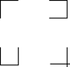Layout: 4 registration marks at the 4 corners around the design

### Segmental Positioning

In addition to 4 original points, the intermediate registration marks are added on both X axis and Y axis to help contour cut accurately, especially for cutting large images.

* + **Command:** Esc.D2;(XDist);(YDist);(XStep);(YStep):

### Layout:

In-between distance on X: 200~600mm, default 300mm In-between distance on Y: 200-600mm, default 300mm

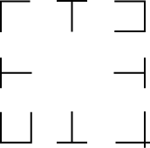

### Multiple Copies

The function is used to duplicate images to let you cut quantities of images at a time.The AAS II sensor will automatically scan registration marks for each individual image to ensure the contour cutting precision.

* + **Command:** Esc.D3;(XCopies);(YCopies);(Space):
  + **Layout:**

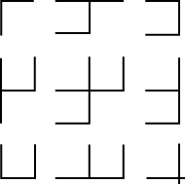

# Printer Test

Before performing AAS contour cutting, it’s recommended to print out a test file to make sure the AAS II cutting accuracy. Please visit GCC website and go to Download Area to download the test files.

<https://www.gccworld.com/download.php?act=view&id=20>

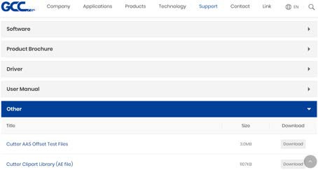

There are two testing files for AASII:

1. AAS II_X_Y_Offset_Caberation_A4 .eps (A4 size)
2. AAS II_X_Y_Offset_Caberation_600_600 .eps (Default setting, it is recommended for testing)
   * Print out the testing graphic. ( Please use high precision printer)
   * Load the graphic to Puma IV LX models and sent the file to test the cutting job
   * If there are any adjustments to be made, you can change the offset value by following the steps:
     + Measure the offset values from the printed line and the actual cutting line.
     + Enter the AAS Offset under MISC function for the values you just measured, then press Enter
     + Test the cutting again
     + AAS II offset X and Y value is defined as following:

**Horizontal line is defined as X and vertical is defined as Y (when facing the cutting plotter)**

* + - When the actual cutting line and the printed line need to be changed towards the direction of origin mark, then simply add the negative value of the offset. If the

direction is from the opposite of the origin mark, then enter positive values for the offset (see the following figures). This method applies to both X and Y axes.

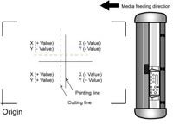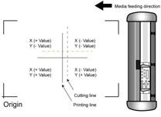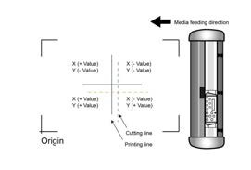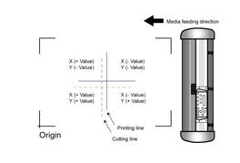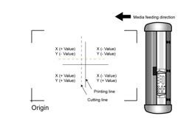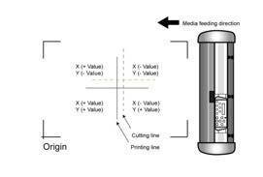

### Note:

* Before adjusting the AAS II settings, please proceed scaling for width and length.
* The blade offset value isn’t set for this test graphic, please set it according to the blade you use.
* If you have any question, please contact us or your local distributor for assistance.

# Registration Mark Offset Range

Please correctly load your media (refer to the alignment ruler on the platen) to make sure the registration marks are successfully detected. Deviation exceeds the range below will lead to detection failure.

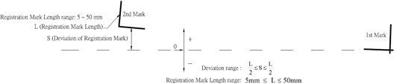

# Contour Cutting

For accurate contour cutting with AAS function, please proceed the following steps:

### Step 1 Creating Graphics

* Create the graphic that you want to print and cut in your software.



* Create a contour for cutting around the graphic.



TIPS1: Leave some space between the graphic and contour line.

TIPS2: Create the contour in a separate layer and assign a different color for it.

* Add registration marks around the graphic.

### Note:

The Multiple Copies function is also available. It automatically copy the graphic and registration marks.

### Step 2 Placing the Registration Marks

* + The AAS Layout Instruction:

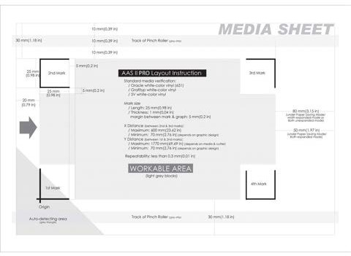

* Auto-detection function on the 1st mark covers the grey area
  + Suggested 30mm margin on both left and right sides of media sheet.
  + Suggested 20~30mm margin on top of media sheet, and at least 50mm margin on the bottom edge to prevent sheets dropping or any error occurred while media sizing.

### Step 3 Print the Graphics

* Print the graphic and the marks with your printer

(Scaling = 100%). 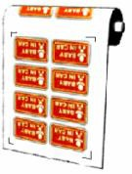

* When printing on a roll media, make sure the orientation as following:

### Step 4 Load the printout onto cutter

* The Origin Mark is different from the rest registration marks. Please make sure the media is fed with correct direction.

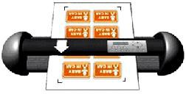

### Step 5 Cut the Contour

* Send out the command from software to perform the contour cutting job.

# Tips for AAS

For getting better results of contour cutting, there are some tips below for your reference.

* Keep light sources simple and avoid illuminating from the sides of cutter.
* Before operating AAS, change the maximum paper size in Puma IV driver property. Find the **Puma IV LX model** in the “Printer & Fax” folder of your PC.

**Step 2**

**Step 1**

Open the Properties window and select the “Paper” tab. Change the maximum Paper Size of X to **1200**mm.

**Step 3**

* Adjust the cutting speed to between 300~600mm/sec.
* Avoid the registration marks locating on the tracks of pinch rollers.
* Make sure the edge of the media is not bent up when detecting registration marks.

**Chapter 6 Basic Maintenance**

This chapter explains the basic maintenance (i.e. cleaning the cutting plotter) required for the cutting plotter. Except for the below mentioned, all other maintenance must be performed by a qualified service technician.

# Cleaning the Cutting Plotter

In order to keep the cutting plotter under good condition and best performance, you need to clean the machine properly and regularly.

### Precaution in Cleaning

* + - Unplug the cutting plotter before cleaning
    - Never use **solvents, abrasive cleaners or strong detergents** for cleaning. They may damage the surface of the cutting plotter and the moving parts.

### Recommended Methods

* Gently wipe the cutting plotter surface with a lint-free cloth. If necessary, clean with a damp cloth or an alcohol-immersed cloth. Wipe with water to rinse off any residue and dry with a soft, lint-free cloth.
* Wipe all dust and dirt from the tool carriage rails.
* Use a vacuum cleaner to empty any accumulated dirt and media residue beneath the pinch roller housing.
* Clean the platen, paper sensors and pinch rollers with a damp cloth or an alcohol-immersed cloth, and dry with a soft, lint-free cloth.
* Wipe dust and dirt from the stand.

# Cleaning the Grid Drum

* Turn off the cutting plotter, and move the tool carriage away from the area needed to be cleaned.
* Raise the pinch rollers and move them away from the grid drum for cleaning.
* Use a bristle brush (a toothbrush is acceptable) to remove dust from the drum surface. Rotate the drum manually while cleaning. Refer to Figure 6-1

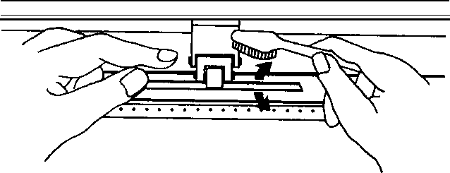

**Figure 6-1**

# Cleaning the Pinch Rollers

If the pinch rollers need a thorough cleaning, use a lint-free cloth or cotton swab to wipe away the accumulated dust from the rubber portion of the pinch rollers. To prevent the pinch rollers from rotating while cleaning, use finger to hold the pinch rollers not to rotate.

If needed to remove the embedded or persistent dust, use the lint-free cloth or cotton swab moistened with rubbing alcohol.

**Note:** The daily maintenance of your cutting plotter is very important. Be sure to clean up the grid drum and pinch rollers regularly for better cutting accuracy and output quality.

**Chapter 7 Trouble Shooting**

This chapter is to help you correct some common problems you may come across. Prior to getting into the details of this chapter, please be sure that your application environment is compatible with the cutting plotter.

**Note:**

Before having your cutting plotter serviced, please make sure that the malfunction is in your cutting plotter, not the result of an interface problem or a malfunction in your computer or a software problem.

*Why doesn’t the cutting plotter operate?*



***Possible Causes:***

# Non-Operational Problems

Check the following first:

* + - Does the AC power cord plug in properly?
    - Does the AC power cord connected to the power connector properly?
    - Does the power LED still illuminate?

### Solutions:

If the LCM is able to display the message, the cutting plotter should be in a normal condition. Switch off the cutting plotter and turn it on again to see if the problem still existing.

If the LCM is not able to display any message, contact the technician from your dealer.

# Operational Problems

Some mechanical problems or failure during operation will cause some problems. The error messages shown on the LCM present the problem first, and followed by recommended actions. If the problem still exists after the recommended actions have been done, have your cutting plotter serviced.

This message indicates that there might be a problem on the **X axis**. Check if the drum is working well and if the media is well loaded. Correct the problem and re-power on to reboot system.

**Error, Check Media Or Drum or X Motor**

This message indicates that there might be an obstruction to carriage relating to a problem on the **Y axis**. Correct the problem and re-power on to reboot system.

**Error, Check Media Or Y Motor**

This message indicates that the blade up/down sensor malfunction. Re-power on to re-boot system. If the problem still exists, find a serviceman.

**Error, Check Carriage Sensor or VC Motor**

This message indicates that the cutting exceeds the cutting limit. Reload larger media or re-scale the plot to a smaller size; then press the key followed by the display of LCM to continue.

**Graph Was Clipped. Data In Buffer**

# Cutting Plotter/Computer Communication Problems

The messages showed below present problems in relation to cutting plotter/computer communication.

Yes No

Has the interface setting been done correctly?

Is the connection cable connected to the cutting plotter and computer properly?

Communication Error Setup: **MISC.** key

Refer to Chapter 2- Connecting your cutting plotter.

Yes No

Try the communication between your cutting plotter and computer. If it still does not work, have your cutting plotter serviced.

Refer to the “**MISC**” key in Chapter 3 - Description of Operation for the port setup.

**Note:**

The computer also needs to set up compatible communication parameters to the cutting plotter set up.

If your cutting plotter can not recognize the HP-GL/2 or HP-GL commands, please check the HP-GL/2 or HP-GL commands applied to your cutting plotter are used properly.

HP-GL/2 Cmd. Error

# Software Problems

### Check the following first:

Yes No

Does the cutting plotter interface match the requirements of your software?

Does your software package indicate that it will work with your computer and cutting plotter?

Does your software support HP-GL and HP-GL/2 drivers? (* check the configuration settings of your software.)

Most well known cutting softwares in the world have drivers for our cutting plotters. If not, use software that has HP-GL and HP-GL/2 emulation supports and you can chose the following three drivers:

* A3 size: HP7475A
* A1 size: HP7580A
* A0 size: HP Draf Pro Exl or HP Draf Master

Try using the recommende d cable.

Does your software recommend using a different cable?

Re-power on the cutting plotter and try to send the file again.

Does the software vendor provide a sample file?

Do something about the error message display on LCM, or consult your software vendor.

No

Yes No

Refer to Chapter 2 - Connecting your cutting plotter.

Yes

Yes No

# Cutting Quality Problems

**Note:** The daily maintenance of your cutting plotter is very important. Be sure to clean up the grid drum and pinch rollers regularly for better cutting accuracy and output quality.

Yes No

Is the blade dull or chipped?

Refer to Chapter 2.3

“ Blade Installation”

Is the blade installed correctly and the blade holder fastened securely?

Replace with a new blade

Is tool force set up properly? (The default for tool force is 80 gf)

Is the tool offset set up properly?

Adjust the tool force to obtain an optimum blade force. Refer to Chapter 4.3 “Cutting Force and Offset Adjustment”

Is there any dirt adhered to the blade?

Adjust the tool offset to obtain an optimum value.

Please contact your dealer for technician support.

Yes No

Yes No

Yes No

Yes No

Remove the blade and clean

it.

**Puma IV Specification**

|  |  |  |
| --- | --- | --- |
| **Model Name/No.** | **P4-60/P4-60LX** | **P4-132/ P4-132LX** |
| Operational Method | Roller-Type | |
| Max. Cutting Width | 600 mm (23.6 in.) | 1300 mm (51.18 in.) |
| Max. Cutting Length | 50 m (164 ft.) | |
| Max. Media Loading Width | 719 mm (28.3 in.) | 1470 mm (57.87 in.) |
| Min. Media Loading Width | 50 mm (1.97 in) | 300 mm (11.8in) |
| Acceptable Material Thickness | 0.8 mm (0.03 in) | |
| Number of Pinch Rollers | 2 | 4 |
| Motor Drive | DC Servo Control | |
| Cutting Force | 5~500 g | |
| Max. Cutting Speed | 1020 mm /sec (40.2 ips) (at 45° direction) | |
| Offset | 0~1.0 mm (with an increase of 0.025 mm) | |
| Mechanical Resolution | 0.009 mm (0.00035") | |
| Software Resolution | 0.025 mm (0.00098") | |
| Distance Accuracy | ±0.254 mm or ±0.1% of move, whichever is greater | |
| Repeatability | ±0.1mm within 3 meters (* certified media) | |
| Automatic-Aligning System | Available on Puma IV LX models, including Segmental Positioning and Auto Rotation  functions | |
| Memory Buffer | 32 MB / 16 MB (when using AAS) | |
| Interfaces | USB 2.0 (Full Speed), Serial (RS-232C) and Ethernet | |
| Type of Command | HP-GL, HP-GL/2 | |
| Control Panel | LCD (20 digits x 2 lines), 14 Keys, 1 Power LED | |
| Diameter of Blade | 2.5 mm | |
| Dimension (HxWxD) mm | 220x 879x258  8.67 x34.61x10.16 in | 1065 x 1632 x 620  41.93 x62.25x24.41 in  (including stand) |
| Net Weight | 13kg / 28.6lb | 53 kg / 116.4 lb |
| Stand | Optional | Standard |
| Power Supply | AC 100-240V, 50~60 Hz (auto switching) | |
| Power Consumption | Max.170 watts | |
| Environment Temperature | 15°C ~35°C / 60°F ~86°F (operating) | |
| Environment Humidity | 25%~ 75% relative humidity (operating) | |

* Compatible with Windows 7and above and MAC OS X 10.6 and above.
* The specification and data sheet may vary with different materials used. In order to obtain the best output quality, please maintain the machine regularly and properly.
* GCC reserves the right to change the specifications at any time without notice.
* GCC certified material in tracking is Avery MPI 3000.
* The above listed specification values are effective only when operated with media certified by GCC.

**Blade Specification**

|  |  |
| --- | --- |
| 202003480G | For cutting thick fluorescent and reflective vinyl. Also for cutting detailed work in standard vinyl. |
| The blade is 45° with **Red Cap** (5-unit package), 0.25 mm offset, and  2.5 mm blade diameter. |
|  | |
| 290088080G | For cutting reflective vinyl, cardboard, sandblast, flock, and stencil sharp edge. |
| The blade is 60° with **Green Cap** (2-unit package), 0.50 mm blade offset, and 2.5 mm blade diameter. |
|  | |
| 265017550G | For cutting thin sandblast mask and stencil. The blade with sharp angle and special design, allowing it to maneuver around sharp  corners. |
| The blade is 60° with **Blue Cap**, 0.25 mm blade offset, and 2.5 mm blade diameter. |
|  | |
| 265017560G | For Cutting small text and fine detail. Sharp blade with smallest offset. |
| The blade is 50° with **Black Cap**, 0.175 mm blade offset, and 2.5 mm blade diameter. |
|  | |
| 265017530G | For thin and delicate media such as window tint. |
| The blade is 25° with **Yellow Cap**, 0.25 mm blade offset, and 2.5 mm blade diameter. |
|  | |

## About the Tool

A generic term referring to the blade that cuts the sheet, the pen that does plotting, and the LED bombsight (option) used for pointing to the reference point.

OFFSET is the distance that the blade tip is displaced from the centerline of the blade.

**Blade**



**Central line**

**Blade tip **

**offset**

## Protrusion Length of the Blade

**Protrusion length of the blade**

**Thickness of the media (t1)**

**Thickness of the base paper (t 2)**

Length of protrusion = t1 + t 2/ 2, but for your convenience you may just make it about 0.3mm ~ 0.5mm beyond the blade holder tip.

**CorelDRAW Output Instruction**

The following is an example of how to output the file through CorelDRAW.

# User Instructions

1. Open CorelDRAW, finish editing all the files you wish to plot and select all the images at once.
2. Select “Outline Pen” to adjust the outline for cutting.

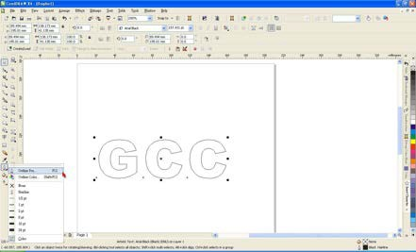

1. Adjust the value of pen width to 0.001 mm and click “OK” to save your input.

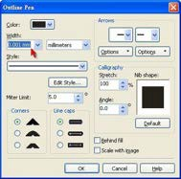

1. Select “ File → Print” to output the file to your cutters.

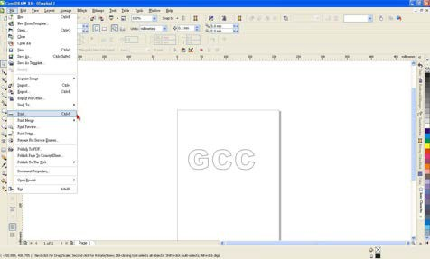

1. Choose the correct model you have installed.

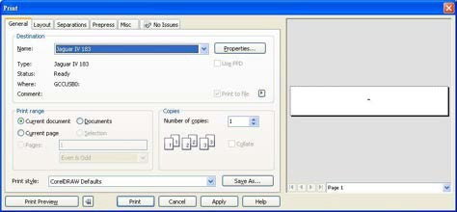

1. Choose the “Layout page” and click the “Reposition images to: → Bottom left corner”. **Please note that you must put your image at the bottom left corner.**

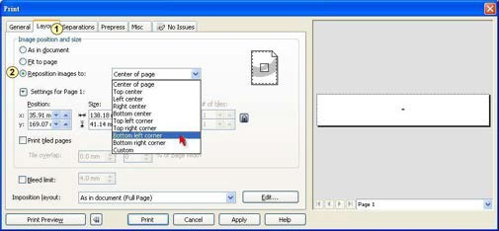

1. Go back to the General page and check that your image is at the bottom left corner. Click “Print” and get a wonderful cutting image.

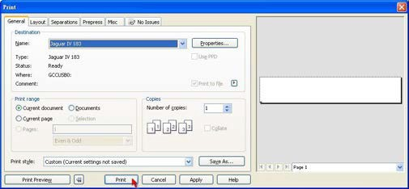

**CorelDRAW Plug-In Instruction**

**Puma IV LX** cutting plotter features AAS function, but **Puma IV** doesn’t. If you are **Puma IV** user, please skip this chapter.

AASII VBA Installer is applicable for CorelDRAW Version 13, 14, 15, 16, 17, 18

# Installation

Please refer to Step 8 in Chapter **2.6.1.2** Driver Installation to install AAS plug-in for CorelDRAW.

# Run CorelDRAW AAS Plug-in

**Step 1** Run CorelDRAW to edit your graphics and select all images at once when you wish to plot.

**Step 2** Select “Tools→Macros→Run Macro.” Then select Global Macros (GCCAASII_Draw13.gms) under the “Macros in” manual, and press “Run”.

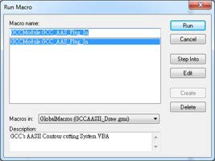

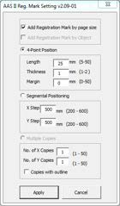**Step 3** Click on “Apply” and select whether you would like to add the registration marks by page size or by object.

**Step 4** Now you can print out the image file with registration marks.

**Note:** “Add Registration Mark by Object” will be the default selection if you click on the image whereas “Add Registration Mark by page size” will be the default one when the blank area on the page is clicked.

# You can also add a Hot Icon for the AAS Plug-in

Select “Tools→ Options→ Workspace→ Customization→ Commands→ Macros→ GCCMadual.GCC_AAS_Plug_In” and Click OK.

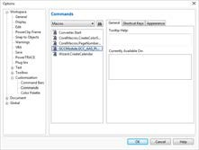

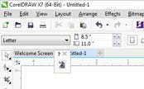

# Add Registration Mark by page size

If you tick “Add Registration Mark by page size” as shown in the figure below and click “Apply”, your registration marks will be created automatically (please see Figure A3-1).

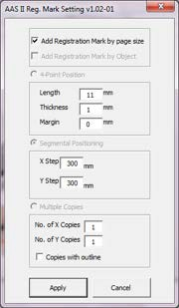

**Note:**

1. The length setting will be in the range of 5-25mm according to your page size.
2. Please DO NOT make any changes to the “Origin” section when you choose to add registration marks by page size as indicated below otherwise the position of the marks will be changed (please see Figure A3-2).

### Figure A3-1

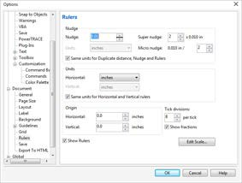

**Figure A3-2**

The system will create the 4 marks on the 4 corners of the page as shown in the picture below wherever you move your image.

### Figure A3-3

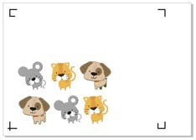

**Workable area**

It allows users to edit and cut graphics in the area outside the registration marks when adding registration marks by page.

For A4 size media sheet, the workable area is 2.5mm extended from the registration mark on left and right sides and 4.5mm extended from the registration mark on top side. On the bottom side, it is suggested to leave at least 25mm margin from the edge of media sheet to prevent sheets dropping or any error occurred while media sizing.

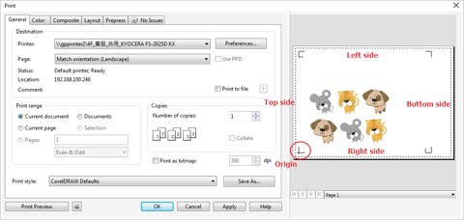For A3 size media sheet, the workable area is 10mm extended from the registration mark on the left side, 9mm extended from the registration mark on the right side and 11mm extended from the registration mark on top side. On the bottom side, it is suggested to leave at least 25mm margin from the edge of media sheet to prevent sheets dropping or any error occurred while media sizing.

**Note:** Select “**Edge**” mode when media sizing to allow the media sheet to be unrolled. If you select “**Single**” mode, the media sheet will not be able to be moved back and hence fail to be detected by front paper sensor.

# Add Registration Mark by Object

If you tick “Add Registration Mark by Object”, you will be offered three options of registration marks as shown below. **4-Point Positioning**

* Length: The length of marks

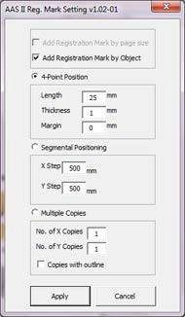

→ Range: 5mm~50mm

→ Optimized Setting: 25mm

* Thickness: The line thickness of marks

→ Range: 1mm~2mm

→ Optimized Setting: 1mm

* Margin: The distance between marks and images

→ Range: 0mm~50mm

→ Optimized Setting: 5mm

**Segmental Positioning**

* X Step: The distance of intermediate position on the X axis
* Y Step: The distance of intermediate position on the Y axis

→ Range: 200mm~600mm

→ Optimized Setting: Less than 500mm

### Figure A3-4

**Multiple Copies**

* No. of X Copies: The numbers of copies on X axis
* No. of Y Copies: The numbers of copies on Y axis

→ Range: 1~50. (The more copies you make, the more time is needed for data transmission.)

→ Numbers of X Copies * Numbers of Y Copies = The total amount of image copies

* Copies with outline：To show outlines of image graphics

**Note:** The values entered in the “4-Point Positioning” section (length, thickness and margin) will still be applied when you tick “Segmental Positioning” or “Multiple Copies”.

### 4-Point Positioning

**4-Point Positioning**



* + Length: The length of marks

→ Range: 5mm~50mm

→ Optimized Setting: 25mm

* + Thickness: The line thickness of marks

→ Range: 1mm~2mm

→ Optimized Setting: 1mm

* + Margin: The distance between marks and images

→ Range: 0mm~50mm

→ Optimized Setting: 5mm

### Figure A3-5

The system will create the 4 marks as shown in the picture below.

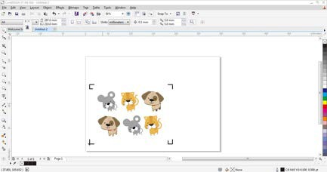

### Figure A3-6

**Note:**

1. To save your materials, in addition to amending object margins, you can also adjust the length of the registration marks (5mm minimum) when you apply 4-Point Positioning (see table 1 for suggestions based on different material sizes). The smaller the size is, the smaller the distance between the object and the registration marks is (see the figures below).

Area to be cut

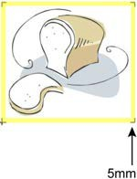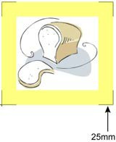

### Figure A3-7 Figure A3-8

|  |  |
| --- | --- |
| Page size  (unit: mm) | Suggested mark length  (unit: mm) |
| A6 (105 x 148) | 5 |
| A5 (148 × 210) | 8 |
| A4 (210 × 297) | 11 |
| A3 (297 × 420) | 16 |
| A2 (420 × 594) | 23 |
| A1 (594 × 841) and above | 25* |

**Table 1**

*25mm is the suggested value for the registration mark length

1. The size of the registration marks would affect the accuracy of registration mark detection so please make sure the amount you enter is reasonable.
2. If you change the paper size, you will have to reset the registration marks otherwise the previous setting will be applied.

### Segmental Positioning

For precise cutting quality, it is suggested to select “Segmental Positioning” when you are working on an extra long or large-sized image to increase cutting accuracy.

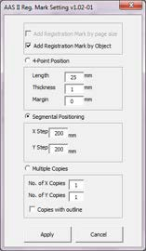

**Segmental Positioning**

* + X Step: The distance of intermediate position on the X axis
  + Y Step: The distance of intermediate position on the Y axis

→ Range: 200mm~600mm

→ Optimized Setting: Less than 500mm

### Figure A3-9

The system will create the as shown in the picture below

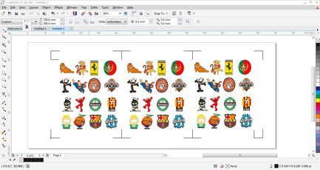

**Segmental Positioning**

### Figure A3-10

Segmental Positioning will be applied to Multiple Copies when the object to be copied is of large size (with the length or width over 200mm) to increase the accuracy of registration mark detection.

### Multiple Copies

It is suggested to select “Multiple Copies” when you would like to make several copies of one image on your material to increase cutting accuracy.

**Multiple Copies**

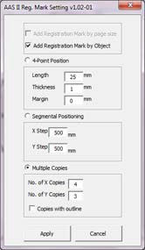

* + - No. of X Copies: The numbers of copies on X axis
    - No. of Y Copies: The numbers of copies on Y axis

→ Range: 1~50. (The more copies you make, the more time is needed for data transmission.)

→ Numbers of X Copies * Numbers of Y Copies = The total amount of image copies

* + - Copies with outline：To show outlines of image graphics

### Figure A3-11

The system will create the as shown in the picture below.

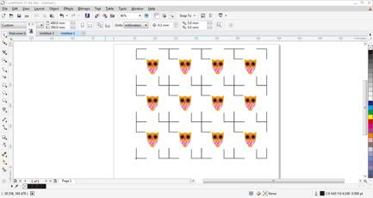

**Y axis**

**X axis**

### Figure A3-12

**Contour cutting through CorelDraw**

**Step 1**

**Step 2**

Position the paper with registration marks printed by your printer on the GCC cutter. Select “Files→Print”.

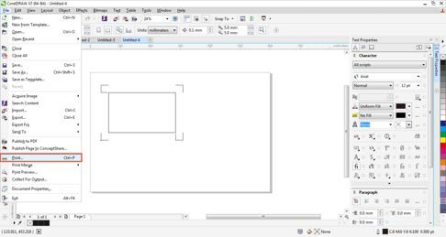

### Figure A3-13

**Note:** if you use CorelDraw X5 and later, you must follow the steps below.

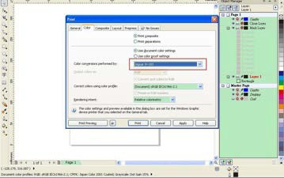**Step 1** Click the “color” page and go to the “Color conversions performed by:” and then select the model name of you cutter (please refer to Figure A3-14).

### Figure A3-14

**Step 2** Go to the “Layout” page and select Bottom left corner at “Reposition images to”.

### Figure A3-15

**Step 3** Click “Print”.

**Illustrator Plug-In Instruction**

**Puma IV LX** cutting plotter features AAS function, but **Puma IV** doesn’t. If you are **Puma IV** user, please skip this chapter.

AASII VBA Installer is applicable for Adobe Illustrator Version CS4, CS5, CS6, CC.

# Installation

Please refer to Step 8 in Chapter 2.6.1.2 Driver Installation to install AAS plug-in for Adobe Illustrator.

# Printer Setting

**Step 1** Go to Control Panel, right click on the printer and select Printer Properties to open the Printer Properties page

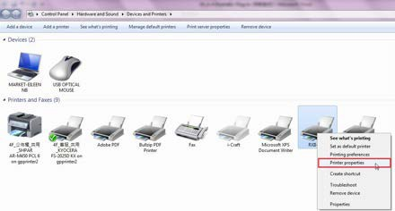

**Step 2** Go to the Advanced page and make sure the “Enable advanced printing features” box is unchecked.

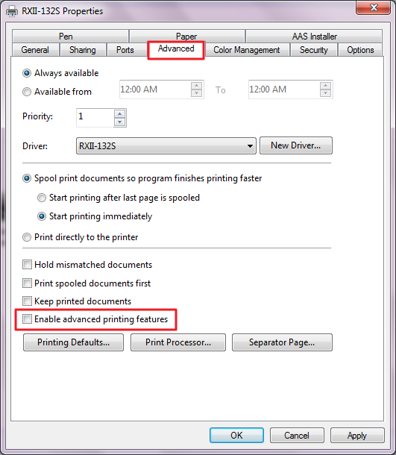

# User Instructions

**Step 1** Open Illustrator.

**Step 2** Edit your image and create a contour line (**Note:** you must have the line width set as 0.001mm).

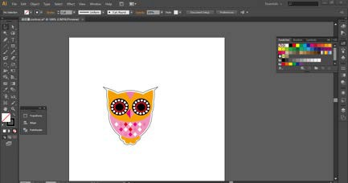

Contour line

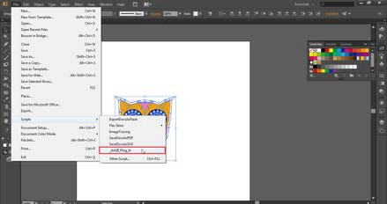**Step 3** Click on the image and apply the AAS function (File→Scripts→_AASII_Plug_In).

**Step 6** Confirm the registration marks (the 4-Point Position mark is used as an illustration in the

following steps).

**Step 4** Select the registration marks needed

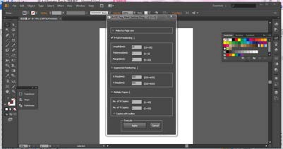

**Step 5** Three types of registration marks are introduced here: 4-Point Positioning, Segmental Positioning and Multiple Copies.

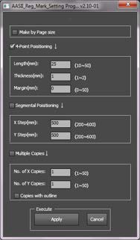

**Note:**

The values entered in the “4-Point Positioning” section (length, thickness and margin) will still be applied when you tick “Segmental Positioning” or “Multiple Copies.”

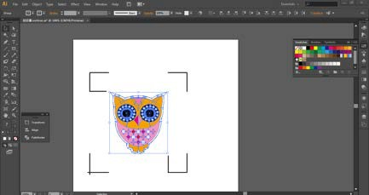**Step 6** Confirm the registration marks (the 4-Point Position mark is used as an illustration in the following steps).

**Step 7** Click on the blank area on the page and then click “Document Setup”.

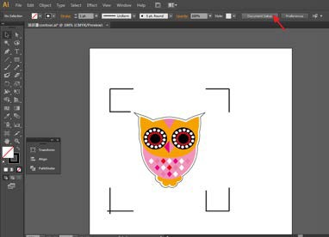

**Step 8** Hit “Edit Artboards”.

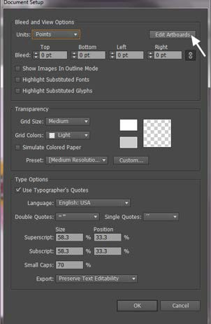

**Step 9** Click on “Presets → Fit Artboard to Artwork bounds”.

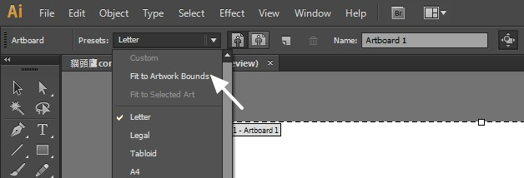

**Step 10** Please move your mouse to the tool bar on the left when step 9 is finished and then click “Selection Tool”.

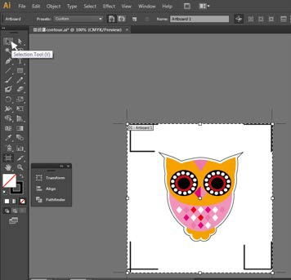

**Step 11** This will take you back to the edit mode.

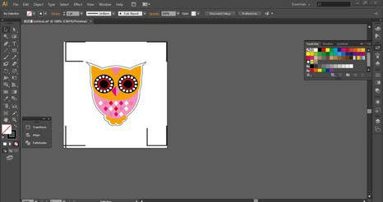

**Step 12** Print out the file with the contour line and the registration marks.

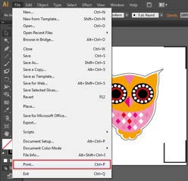

**Step 13** Place the printed file on the cutter, lower the pinch rollers and then position the carriage at the origin of the registration marks.

**Step 14** Send the file to the cutter.

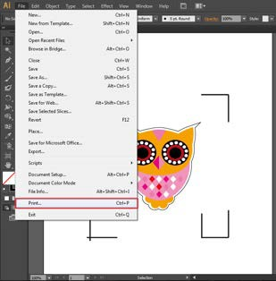

**Step 15** Select the cutter model, position the object in the bottom left corner.

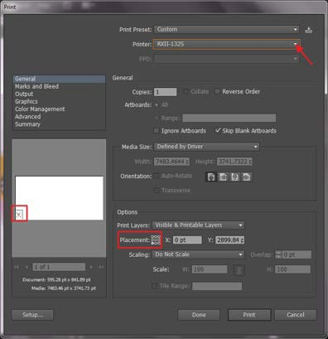

**Step 16** Your job is now completed.

# Add Registration Mark by page size

If you want to create registration mark by page size, select the object, go to “Scripts” under “File” and select “_AASII_Plug_In”

Tick “Make by page size” and click “Apply” and the registration mark will be created on the 4 corners of the page automatically, sown as below.

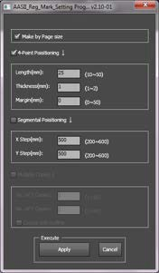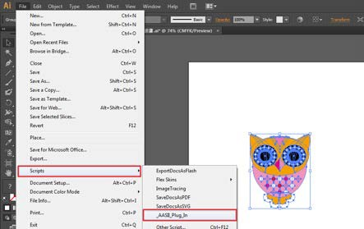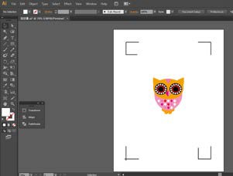

**Note:**

The length setting will be in the range of 10-50mm according to your page size.

### Workable area

It allows users to edit and cut graphics in the area outside the registration marks when adding registration marks by page.

For A4 size media sheet, the workable area is 2.5mm extended from the registration mark on left and right sides and 4.5mm extended from the registration mark on top side. On the bottom side, it is suggested to leave at least 25mm margin from the edge of media sheet to prevent sheets dropping or any error occurred while media sizing.

For A3 size media sheet, the workable area is 10mm extended from the registration mark on the left side, 9mm extended from the registration mark on the right side and 11mm extended from the registration mark on top side. On the bottom side, it is suggested to leave at least 25mm margin from the edge of media sheet to prevent sheets dropping or any error occurred while media sizing.

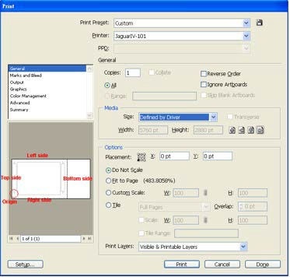

**Note:** Select “**Edge**” mode when media sizing to allow the media sheet to be unrolled. If you select “**Single**” mode, the media sheet will not be able to be moved back and hence fail to be detected by front paper sensor.

# Add Registration Mark by Object

If you add registration mark by Object, you will be offered three options of registration marks.

Firstly, select the graphic which you want to add registration mark on and go to “Scripts” under “File” and select “_AASII_Plug_In”.

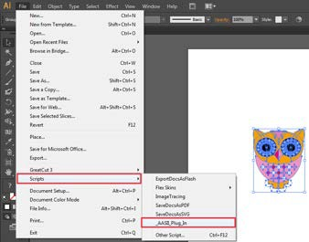

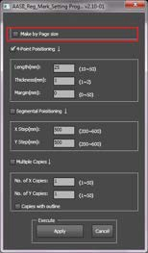Make sure to untick “Make by page size” and choose one of the registration mark types whichever is suitable.

# Three types of registration marks

### 4-Point Positioning

**4-Point Positioning**

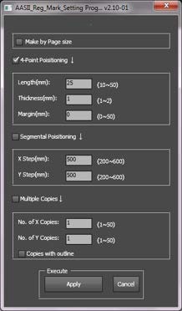

* Length: The length of marks

→ Range: 5mm~50mm

→ Optimized Setting: 25mm

* Thickness: The line thickness of marks

→ Range: 1mm~2mm

→ Optimized Setting: 1mm

* Margin: The distance between marks and images

→ Range: 0mm~50mm

→ Optimized Setting: 5mm

The system will create the 4 marks as shown in the picture below.

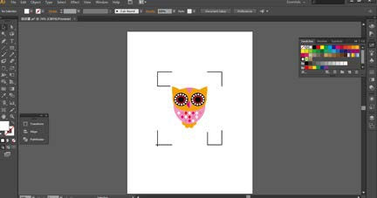

### Note:

1. To save your materials, in addition to amending object margins, you can also adjust the length of the registration marks (5mm minimum) when you apply 4-Point Positioning (see table 1 for suggestions based on different material sizes). The smaller the size is, the smaller the distance between the object and the registration marks is (see the figures below).

Area to be cut

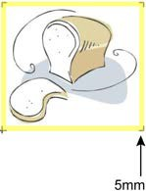

|  |  |
| --- | --- |
| Page size  (unit: mm) | Suggested mark length  (unit: mm) |
| A6 (105 x 148) | 5 |
| A5 (148 × 210) | 8 |
| A4 (210 × 297) | 11 |
| A3 (297 × 420) | 16 |
| A2 (420 × 594) | 23 |
| A1 (594 × 841) and above | 25* |

Table 1

*25mm is the suggested value for the registration mark length

1. The size of the registration marks would affect the accuracy of registration mark detection so please make sure the amount you enter is reasonable.
2. If you change the paper size, you will have to reset the registration marks otherwise the previous setting will be applied.

### Segmental Positioning

For precise cutting quality, it is suggested to select “Segmental Positioning” when you are working on an extra long or large-sized image to increase cutting accuracy.

### Segmental Positioning

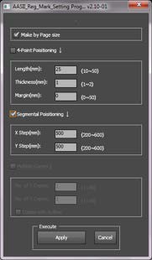

* + X Step: The distance of intermediate position on the X axis
  + Y Step: The distance of intermediate position on the Y axis

→ Range: 200mm~600mm

→ Optimized Setting: Less than 500mm

The system will create the marks as shown in the picture below.

### Segmental Positioning

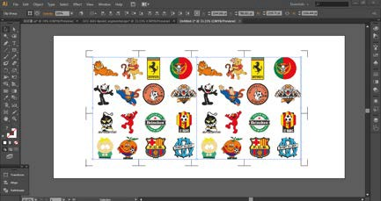

**Multiple Copies**

It is suggested to select “Multiple Copies” when you would like to make several copies of one image on your material to increase cutting accuracy.

### Multiple Copies

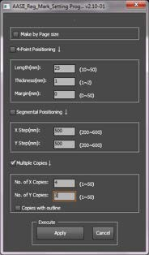

* + - No. of X Copies: The numbers of copies on X axis
    - No. of Y Copies: The numbers of copies on Y axis

→ Range: 1~50. (The more copies you make, the more time is needed for data transmission.)

→ Numbers of X Copies * Numbers of Y Copies = The total amount of image copies

* + - Copies with outline：To show outlines of image graphics
    - Margin: Space between marks; must be 0 or ≧ 20, no negative numbers allowed

The system will create the as shown in the picture below.

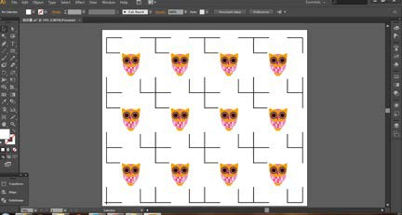

**Y axis**

**X axis**

**GreatCut-S Quick Manual**

There are basic instructions of GreatCut-S below. If you need detailed instruction, please refer to GreatCut-S Help.

### Select the cutter you want to output and change the work area.

* 1. Run GreatCut-S software.

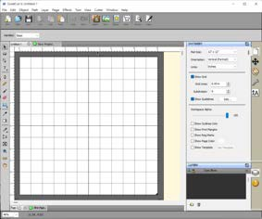

* 1. Select “Cutter” and select “Manage Cutters” under My Cutter to change the work area.

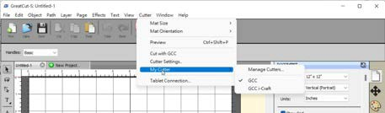

* 1. Select company / brand as GCC and select model you want to output and then click the “<--Add to list” button.

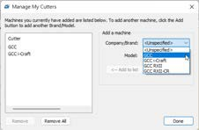

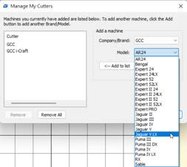

* 1. Select GCC on the left and click “Done.”

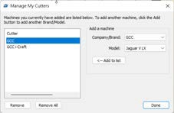

* 1. If you want to change the material size and orientation, you can fill a proper value in the Document window.

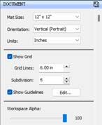

### Insert Graphics from Library

Select graphics from library to insert a selected design.

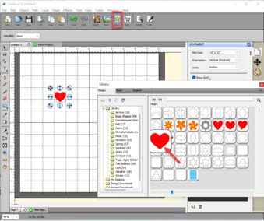

### Draw Text

Click on the T icon at left side to create the text and select the font you like at text window.

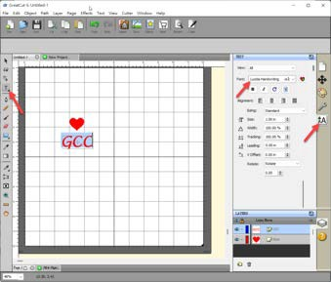

### Import Design

If you have created your design in other design software, go to “import” or “place image” under file to import it, GreatCut-S supports svg, scut, scal, pdf, ai. wpc eps, bmp, gif, jpg and png files.

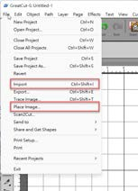

**Tips Thousands of SVG files available on SVGCuts!**

* [http://SVGCuts.com](http://svgcuts.com/) is the top of source for designer SVG files. Thousands of high quality elements including: shapes for card-making, scrapbooking, as well as gift bags, boxes and 3D flowers.

### Convert Image to Cutting File

* 1. Go to Trace Image under File, or select Trace Image icon on the toolbar to open the setting window.

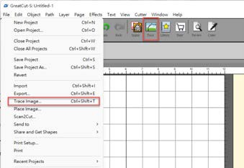

* 1. Click on “Choose an image” to input the image, adjust Image Settings and Output Settings, and click OK. Then the outline of the image will be outputted automatically.

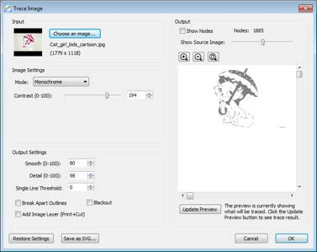

**Note**

* The **contrast** and **pixels** of import images will affect the trace image result. High contract graphics are recommended.

### Cut the Design

* 1. Click on the “Cutter” button on the toolbar and Cut Settings window will pop up.

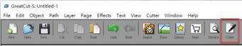

* 1. Click on “Settings…” to open GCC Cutter Settings window.

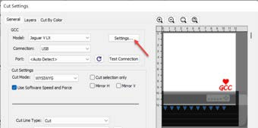

**Note**

* The origin point is on the bottom right.
  1. 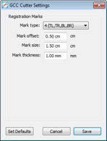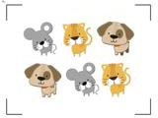Adjust Registration Marks setting under GCC Cutter Settings window if needed.

**\*Registration Marks:** set the distance between the edge of the material and the registration marks in Mark Offset; set the size of marks in Mark Size; set the line thickness of marks in Mark Thickness.

* 1. Adjust Blade Offset, Overcut Value, Multi-Cut and Quality under Cut Settings window if needed.

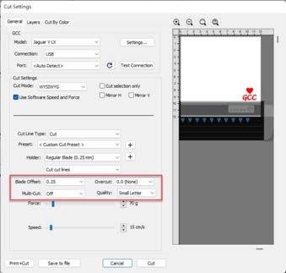



**\*Blade Offset:** set the offset value according to different blade, for a standard blade, set the offset value at 0.25mm, 0.5mm for an optional advanced blade and 0mm for an optional plotting pen.

**\*Quality:** associated with the cutting result; please note the better cutting quality, the slower cutting speed.

**\*Multi-Cut:** to repeat the cutting job at same position which is suitable for cutting thick material.

**\*Overcut:** allows for easier weeding and makes up for incomplete cut lines.

* 1. Under “Cut Settings” section, there are some useful functions. After setting the parameters, click on “Cut” to send the data to the GCC cutter and the GCC cutter will start the cutting job.

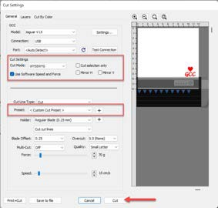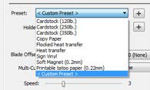

**\*Cut Mode:** there are “WSIWYG” and “Origin Point” options, WSIWYG means what you see is what you get, the cutter will output the graphic at same position in preview window. While with Origin Point mode, the cutter will cut the graphic from bottom right origin point of the material.

**\*Use Software Speed and Pressure:** tick this section, and you can set the values of speed and pressure manually.

**\*Preset:** select a proper material to apply the preset speed and pressure parameter automatically.

**\*Speed & Pressure:** you may adjust values of speed and pressure manually to get quality results.

### Print and Cut Your Design

The Print and Cut function allows you to print the graphics from GreatCut-S to printer, and then put the printed materials on the GCC cutter to cut out the contour of printed jobs from GreatCut-S.

* 1. Open an image file in GreatCut-S.

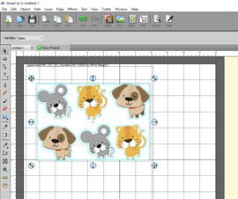

* 1. Click on the Cutter icon on the toolbar, set the parameters and click on “Print+Cut” to add the registration marks and print out the image.

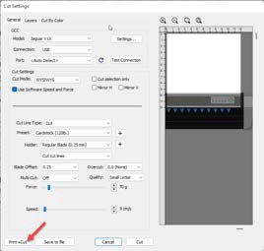

* 1. Click on “Print…” to open printer setting window and click OK.

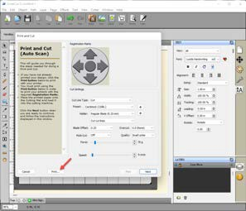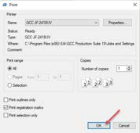

* 1. Print your design with registration marks out.

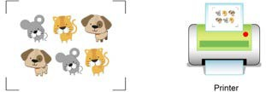

* 1. Load the printed media to the GCC cutter.
  2. Press “Next” and then press “Scan+Cut”, and then the GCC cutter will detect the registration marks and cut the contour lines automatically.

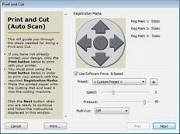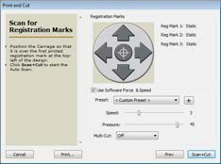

**Test Connection function can save your materials.**

* Click on “Test Connection” to exam if set the connection properly.

**Tips**

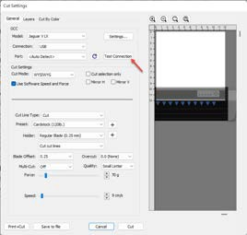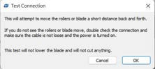

### Cut by Color

The Cut by Color function allows you to choose which colors in your design you want to cut, and designate different parameters to each color. You can cut your designs in a single job or separate jobs for each color.

* 1. Select a design and specify a color for it.

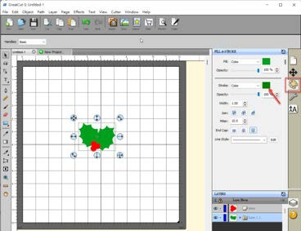

Then define cut type and parameter.

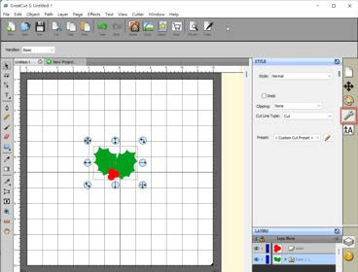

* 1. Click on “Cut” to open Cut Settings window.

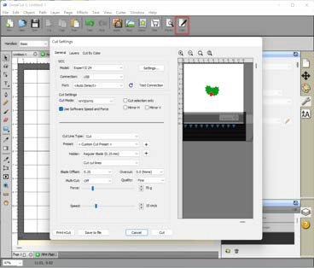

* 1. Click on the Cut by Color tab and choose to either Cut all Colors in a single job or Cut each color separately as an individual job.

When Cut each color separately is selected, GreatCut-S will prompt you between each color before starting to cut so you can load the appropriate color or corresponding tool into your cutting machine.

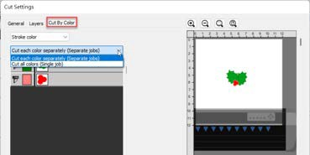

Note: If the same tool is being used for all colors in a cutting job, it is suggested to use “Cut all colors (Single job)” .

* 1. Click on the blade icon to choose the colors you want to cut. The preview will display which colors are currently enabled for cutting.

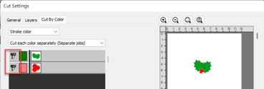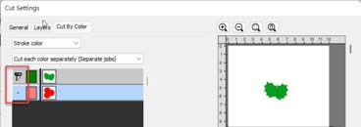Note: You can adjust the order of the layer arrangement by clicking and dragging the layer.

* 1. Click on “Cut” to start cutting.

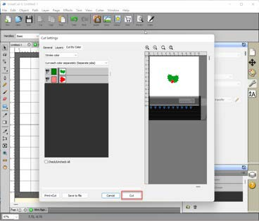

### I. How to create Registration mark in Greatcut-S for contour cutting

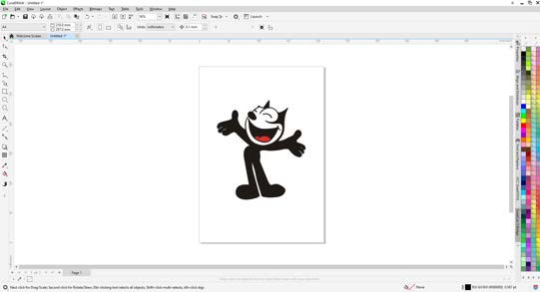Step1 Create a file

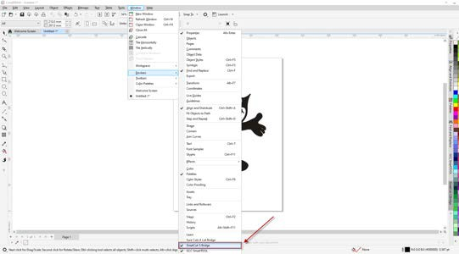Step2 Go to Windows ➜Dockers ➜GteatCut-S Bridge

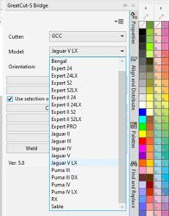Step3 Select the model with AAS function from the model menu in GreatCut-S Bridge.

Step4 Select Contour Outline, and define the offset value of contour line from the size option in Shadow Layer menu.

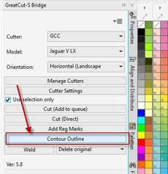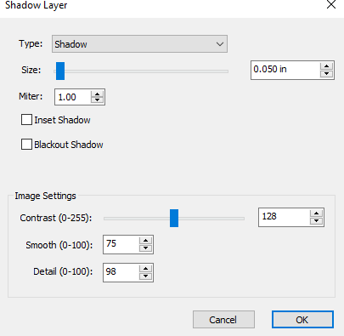

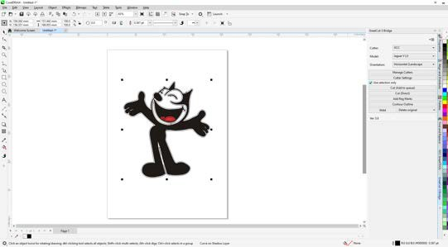Step5 The contour line is created.

Step6 Select “Add Reg Marks” to add registration marks.

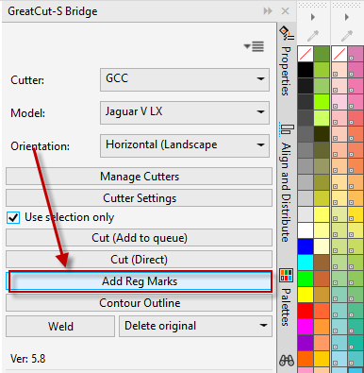

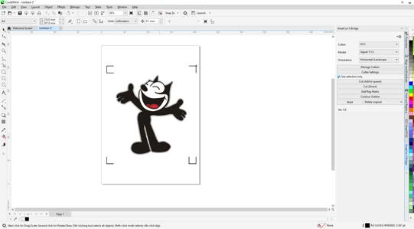Step7 The registration marks are added.

Step8 Select “Cut (Add to queue)” to send the file.

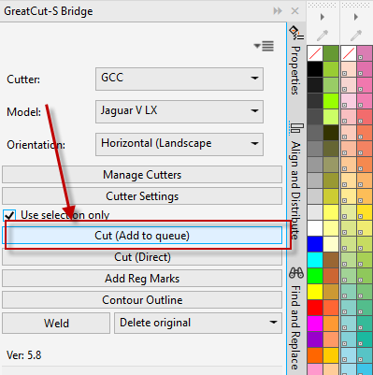

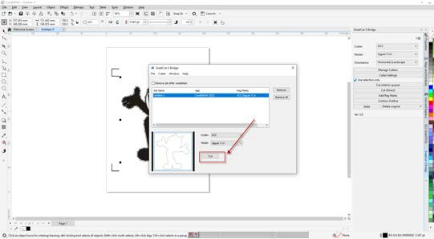Step9 Clink on “Cut” in GteatCut-S Bridge window.

Step10 Define the parameters in Cut Settings window and select “Cut”.

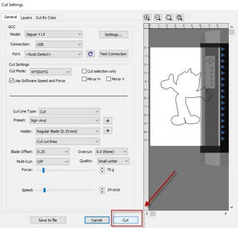

Step11 The process is complete.